…33
User’s Guide for the
Range-wide Programmatic Consultation for Indiana Bat and Northern Long-eared Bat

Version 5.0, updated March 2022

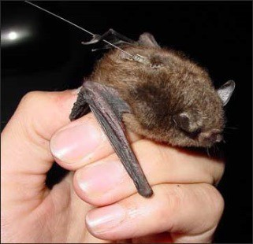
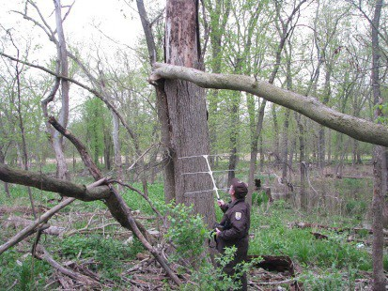
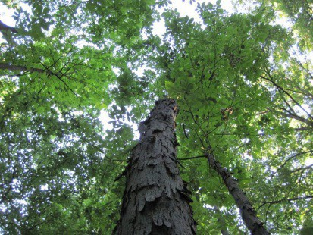

Federal Highway Administration Federal Railroad Administration Federal Transit Administration
U.S. Fish and Wildlife Service

Table of Contents
1. Introduction 3
2. Programmatic Scope and Effects Analysis Summary 4
2.1 Actions outside the Scope of the Range-wide Programmatic Consultation 7
2.2 Actions That Will Have No Effect on Bats and/or Indiana Bat Critical Habitat 9
2.3 Actions That May Affect Bats 10
Actions NLAA 10
Actions NLAA with AMMs 11
Actions LAA 13
3. Standard Operating Procedure for Site-Specific Project(s) Submission 17
3.1 Process for Transportation Agencies 17
Step 1 - Begin Notification/Submittal Process 17
Step 2 – Determine Adherence to Scope and Submit Form 20
Step 3 – Mitigation Implementation Process (for projects LAA Indiana bat only) 20
3.2 Process for Lead Service Field Office 20
Appendix A – IPaC Assisted Determination Key 22
Appendix B – Project Submittal Form 22
Appendix C – Avoidance and Minimization Measures 22
Appendix D – Bridge/Abandoned Structure Assessment Guidance and Form 22
Appendix E – Post Assessment Discovery of Bats at Bridge/Structure Form 22

This version of the User’s Guide reflects changes in response to input from users and in response to the 2018 revised Programmatic Biological Opinion. The most current versions of supporting documents for this range- wide programmatic consultation, including the appendices listed above, are posted on the U.S. Fish and Wildlife Service’s website: https://www.fws.gov/node/266042.

Introduction
Any questions regarding the Range-wide Programmatic Consultation and/or User’s Guide should be addressed at the local FHWA/FRA/FTA/ State Department of Transportation/Service field office level. If resolution cannot be achieved, contact:

U.S Fish & Wildlife Service
Catherine Liller 303-236-4318
catherine_liller@fws.gov

Federal Highway Administration
Brian Yanchik 443-522-9446
brian.yanchik@dot.gov

Federal Railroad Administration
Andrea Martin 202-493-6201
andrea.martin@dot.gov

Federal Transit Administration
Antoinette Quagliata
(202) 366-4265
antoinette.quagliata@dot.gov

This document provides guidance for the implementation of the range-wide programmatic consultation for the Indiana bat and northern long- eared bat (NLEB). This document is based on the revised November 2016 Federal Highway Administration (FHWA), Federal Railroad Administration (FRA), and Federal Transit Administration (FTA) Programmatic Biological Assessment for Transportation Projects in the Range of the Indiana Bat and Northern Long-eared Bat (BA), and the U.S. Fish and Wildlife Service (Service) revised Programmatic Biological Opinion, dated February 5, 2018 (BO). The BO encompasses the previously released programmatic informal consultation, which has undergone minor revisions and now includes FTA projects. The Service, FHWA, FRA, and FTA jointly developed this User’s Guide to be instructional for both transportation agencies and Service Field Offices. Since the completion of User Guide Version 4.0, the Service has developed an Assisted Determination Key in the Information for Planning and Consultation (IPaC) System as a means of identifying a project’s effect determination under the BO and electronically submitting to the Service. We encourage the use of the IPaC Key to submit your site-specific projects to the Service. We also encourage feedback on the IPaC tool as well as this User’s Guide to facilitate updates and improvements, as necessary.

This User’s Guide provides:

  - Programmatic Scope and Effects Analysis Summary: Actions appropriate for use of the range- wide programmatic consultation and key effects analysis decision points;
  - Standard Operating Procedure (SOP) for Project(s) Submission: Guidance for project submission under the range-wide programmatic consultation for FHWA, FRA, FTA, and their respective designated non-federal representatives (henceforth “transportation agencies”) and SOPs for the Service’s review and tracking of the range-wide programmatic consultation;
  - IPaC Assisted Determination Key: A web-based tool to assist in the identification of potential project effects on both bat species and applicable AMMs to reduce potential impacts to both bat species (Appendix A);
  - Project Submittal Form: A form for transportation agencies to use for submitting project-level information to the appropriate Service Field Office (Appendix B);
  - Avoidance and Minimization Measures: Summary of Avoidance and Minimization Measures (AMMs) to be implemented, as applicable, to reduce the potential effects of projects so as to be within the scope of the range-wide programmatic consultation (Appendix C);
  - Bridge/Abandoned Structure Assessment Guidance and Form: Guidelines to determine if any bat species are likely using bridges/structures, and a form for documenting and submitting a site-specific bridge/abandoned structure assessment (Appendix D); and
  - Post Assessment Discovery of Bats at Bridge/Structure Form: A form used to report incidental take of bats that may occur during construction of bridge activities (Appendix E).

The Service encourages all parties who plan to use the range-wide programmatic consultation to review the BA if there are questions regarding interpretation. The BA contains detailed information on the proposed action, an analysis of the potential effects to the species and their resources, and support of effect determinations. The BA and implementation documents relevant for compliance with the range- wide programmatic consultation, as well as Service Field Office contacts are available at the Service’s website at: https://www.fws.gov/node/266042.

The BA covers the full range of both bat species within the United States, which includes all or part of the following States (plus the District of Columbia): Alabama, Arkansas, Connecticut, Delaware, Georgia, Illinois, Indiana, Iowa, Kansas, Kentucky, Louisiana, Maine, Maryland, Massachusetts, Michigan, Minnesota, Mississippi, Missouri, Montana, Nebraska, New Hampshire, New Jersey, New York, North Carolina, North Dakota, Ohio, Oklahoma, Pennsylvania, Rhode Island, South Carolina, South Dakota, Tennessee, Vermont, Virginia, West Virginia, Wisconsin, and Wyoming.

Programmatic Scope and Effects Analysis Summary

The range-wide programmatic consultation can be used for projects that may affect Indiana bats and/or NLEBs. However, Transportation Agencies may use any other applicable Endangered Species Act Section 7 consultation for projects that may affect the Indiana bat and/or NLEB. The Intra-Service Programmatic BO on the Final 4(d) Rule for the NLEB may be used for projects only affecting the NLEB. If both species are present in the project action area, the range-wide programmatic consultation may be used in conjunction with the Intra-Service Programmatic BO on the Final 4(d) Rule, although it is not necessary. Projects impacting designated Indiana bat critical habitat are not included in this programmatic consultation.

As defined in the ESA Section 7 regulations (50 CFR 402.02), “action” means “all activities or programs of any kind authorized, funded, or carried out, in whole or in part, by federal agencies in the United States or upon the high seas.” The “action area” is defined as “all areas to be affected directly or indirectly by the federal action and not merely the immediate area involved in the action.” The Service has determined that the action area for the range-wide programmatic consultation, hereby referred to as the “action area” is all lands within the range of the Indiana bat and northern long-eared bat affected directly or indirectly by the project’s components described in the Description of the Proposed Action of the BO. For the sake of this consultation, the action area for individual projects analyzed by the range-wide programmatic consultation will be referred to as “project action area”.

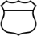
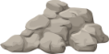
Project Footprint
Project Action Area
Lighting
Noise
Water Quality and Quantity
Staging
Area

Figure 1. Project Action Area

Section 2 provides examples of: 1) actions that are outside the scope of the programmatic consultation and may require additional or separate coordination with the appropriate Service Field Office; 2) actions that have no effect on either bat species, in which consultation with the Service is not required; and 3) actions that may affect either bat species. The IPaC Assisted Determination Key is a web-based tool that assists in determining potential project effects on both bat species, and the applicable AMMs to be implemented in order to reduce potential impacts.

Note: In certain cases, the transportation agency or the Service Field Office may request additional up- front coordination to determine whether a project adheres to the scope of the range-wide programmatic consultation. This coordination could be initiated in one of two ways: 1) the transportation agency is uncertain whether or not a project is covered and contacts the appropriate Service Field Office, or 2) the transportation agency submits the project under the programmatic consultation, but the Service Field Office requests more information following the receipt of the Project Submittal Form or effects determination letter from the IPaC System. The Service’s request for additional information must be made within the 14-calendar day evaluation period for informal consultation or the 30-calendar day review period for formal consultation under the range-wide BO. The official evaluation period starts following the receipt of a complete Project Submittal Form or effects determination letter from the IPaC System. Transportation agencies are encouraged to coordinate with Field Offices in advance of their project submittal to minimize potential process delays.

There are also two outcomes for projects requiring additional coordination: 1) upon the acquisition of additional information (e.g., summer roosting, hibernacula, bridge roosting activity, etc.) or the implementation of site-specific AMMs, the project is determined to be within the scope of the range- wide programmatic consultation and the transportation agency and Service proceed using the range- wide BO, or 2) the project is determined to be outside the scope of the range-wide programmatic consultation, in which case separate consultation with the appropriate Service Field Office is necessary.

No Effect to Indiana Bat and/or NLEB  NO ACTION (NE)  INFORMAL CONSULTATION (NLAA)  FORMAL CONSULTATION (LAA)  Coordination  Not Required  A) Use Programmatic  Informal Consultation and/or  A) Use Programmatic  Formal Consultation and/or  B) NLEB 4(d) Framework  (NLEB only)  B) NLEB 4(d) Framework  (NLEB only)  or  Projects outside the scope of the  rangewide programmatic consultation (e.g., near hibernacula)  C) Individual Consultation  with Service Field Office or  D) Other Programmatic  Consultations | May Affect, Not Likely to Adversely Affect Indiana Bat and/or NLEB | May Affect, Likely to Adversely Affect Indiana Bat and/or NLEB

Figure 2. Consultation processes for Indiana bat and NLEB.

Actions outside the Scope of the Range-wide Programmatic Consultation

The Description of the Proposed Action includes a general description of all types of transportation agency-involved activities. However, the transportation agencies and the Service have made a preliminary determination that some proposed activities do not meet the criteria for inclusion in the range-wide programmatic consultation. These projects may or may not result in adverse effects to NLEBs and/or Indiana bats. Additional coordination with the appropriate Service Field Office is necessary to make a final effect determination on these projects. Separate individual consultation with the appropriate Service Field Office may be required.

The following categories of activities are NOT covered by the range-wide programmatic consultation:

    - Activities that remove documented Indiana bat roosting/foraging habitat or travel corridors between May 1 and July 31;

    - Activities that remove documented NLEB roosts and/or trees within 150 feet of those roosts between June 1 and July 31;

    - Activities involving percussives (or other activities that increase noise above existing traffic/background levels) that are not associated with tree removal/trimming or bridge/structure work when conducted during the active season within areas that contain documented habitat;

    - Activities that impact a known hibernaculum, or a karst feature (e.g., sinkhole, losing stream, or spring) that could result in effects to a known hibernaculum;

    - Activities that raise the road profile above the tree canopy within 1,000 feet of documented habitat at any time of year;

    - Activities that involve slash pile burning within 0.5 miles of a hibernaculum;

    - Bridge and/or structure removal, replacement, or maintenance activities that do not maintain suitable roosting habitat (when assessment documents signs of bat use or when bat use is assumed);

    - Bridge and/or structure removal, replacement, or maintenance activities that are likely to disturb bats when a maternity colony of bats is documented or assumed to be present;

    - Any activity within 0.5 mile from an Indiana bat and/or NLEB hibernaculum unless those activities:
      - Do not involve any construction(e.g., bridge/abandoned structure assessments, surveys, planning and technical studies, property inspections, and property sales); or
      - Do not cause any stressors to the bat species, including as described in the BA/BO (i.e. do not involve ground disturbance, habitat removal, tree removal/trimming, bridge or structure activities, temporary or permanent lighting, or use of percussives) (e.g., lining roadways, unlighted signage , rail road crossing signals, signal lighting, and minor road repair such as asphalt fill of potholes, etc.); or
    - Are limited to the maintenance of the surrounding landscape at existing facilities (e.g., rest areas, stormwater detention basins)
      - For activities with no suitable summer habitat present, tree removal/trimming may occur but no ground disturbing activities.
      - For activities with suitable summer habitat present, no tree removal/trimming or ground disturbing activities.

- Any activity greater than 0.5 mile from an Indiana bat and/or NLEB hibernaculum and outside 300 feet from existing road/rail surfaces at any time of year, unless those activities:
  - Do not involve any construction (e.g., bridge/abandoned structure assessments, surveys, planning and technical studies, property inspections, and property sales); or
  - Do not cause any stressors to the bat species, including as described in the BA/BO (i.e. do not involve habitat removal, tree removal/trimming, bridge or structure activities, temporary or permanent lighting, or use of percussives) (e.g., lining roadways, unlighted signage , rail road crossing signals, signal lighting, and minor road repair such as asphalt fill of potholes, etc.)); or
- Are inside the species range but no suitable summer habitat within the project action area; or
  - Are limited to wetland or stream protection activities associated with compensatory wetland/stream mitigation that do not clear suitable habitat (i.e. tree removal/trimming); or
  - Only involve slash pile burning; or
  - Are inside the species range and within suitable habitat, but have negative presence/probable absence (P/A) summer surveys.

Note: The maximum acreage anticipated for any given project addressed in this programmatic range-wide consultation is approximately 20 acres of suitable habitat (generally per 5-mile section of road/rail), unless approved by a local USFWS Field Office on case-by-case basis that the effects of the action fit in the programmatic.

Actions That Will Have No Effect on Bats and/or Indiana Bat Critical Habitat

Some projects for reasons of location or activity type will have “no effect” on either bat species or Indiana bat designated critical habitat.

The following categories of activities result in “no effect” to the Indiana bat and/or NLEB:

- Project(s) outside the species’ range;

- Project(s) inside species range but no suitable summer habitat within the project action area (must also be outside 0.5 miles of a hibernaculum);

- Activities (anywhere, including within 0.5 mile of hibernacula) that do not involve any construction activities (e.g., bridge/abandoned structure assessments, surveys, planning and technical studies, property inspections, and property sales);

- Activities (anywhere, including within 0.5 mile of hibernacula) that do not cause any stressors to the bat species, including as described in the BA/BO (i.e., do not involve habitat removal, tree removal/trimming, bridge or structure activities, temporary or permanent lighting, or use of percussives) (e.g., lining roadways, unlighted signage, railroad crossing signals, signal lighting, and minor road repair such as asphalt fill of potholes, etc.);

- Activities within 0.5 miles of hibernacula that are limited to the maintenance of the surrounding landscape at existing facilities (e.g., rest areas, stormwater detention basins) located outside suitable summer habitat -- no new ground disturbance; and

- Activities within 300 feet of the existing road/rail surface (must also be greater than 0.5 miles of a hibernacula) that include percussives or other activities that increase noise above existing traffic/background levels:
  - within areas that contain suitable habitat (documented or undocumented)
  - conducted during the inactive season
  - does not involve tree removal/trimming or bridge/structure work;

- Bridge and/or structure removal, replacement, or maintenance activities without any signs of bats (bridge/structure assessment documents no signs of bats or bat use (bats, guano, etc.)) and does not impact suitable summer habitat within the project action area;

For activities identified above that result in “no effect” to the Indiana bat or NLEB, the transportation agency documents “no effect” on the Project Submittal Form (Appendix B) or retains the “no effect” consistency letter from the IPAC Assisted Determination Key for their files. No coordination with the Service is required.

Actions That May Affect Bats

For projects within the range of either the Indiana bat or NLEB in which suitable habitat is present, and no bat surveys have been conducted, the transportation agency will assume presence of the appropriate species. This assumption of presence should be based upon the presence of suitable habitat and the capability of bats to occupy it because of their mobility.

Actions NLAA

Projects occurring near suitable habitat (e.g., non-forested area between patches of suitable habitat that Indiana bat or NLEB would typically cross) or within suitable habitat may affect the Indiana bat or NLEB. Some of these projects may have a discountable or insignificant effect on either bat species and thus are considered NLAA actions.

Such activities that are NLAA include:

    - Projects inside the species range and within suitable bat habitat, but with negative bat P/A summer surveys, (must also be greater than 0.5 mile from any hibernaculum);

- Activities within 300 feet of the existing road/rail surface (must also be greater than 0.5 miles of a hibernacula) that include percussives or other activities that increase noise above existing traffic/background levels:
  - within areas that contain undocumented habitat,
  - conducted during the active season
  - does not involve tree removal/trimming or bridge/structure work;

    - Activities anywhere that are limited to slash pile burning (must also be greater than 0.5 miles of a hibernaculum);

    - Activities anywhere that are limited to wetland or stream protection activities associated with compensatory wetland/stream mitigation that do not clear suitable habitat (i.e. tree removal/trimming) (must also be greater than 0.5 miles of a hibernaculum); and

- Activities within 0.5 miles of hibernacula that are limited to the maintenance of the surrounding landscape at existing facilities (e.g., rest areas, stormwater detention basins) located within suitable summer habitat -- no new ground disturbance or tree removal/trimming.

For activities identified above that result in “may effect, NLAA” to the Indiana bat or NLEB, the transportation agency will complete and email the Project Submittal Form (Appendix B) to the lead Service Field Office or submit the NLAA Concurrence Verification Letter via the IPaC Assisted Determination Key, which will observe a 14-calendar day evaluation period from receipt of submittal form.

Actions NLAA with AMMs

As identified above, transportation projects occurring near or within suitable habitat “may affect” the Indiana bat or NLEB. In many such circumstances, the implementations of AMMs (Appendix C) are required for the project to reach NLAA for both bat species.

Transportation projects that meet the conditions listed below, and implement all applicable AMMs are NLAA Indiana bats or NLEBs:

    - Tree removal/trimming that:
      - Occurs greater than 0.5 mile from any hibernacula; and
      - Occurs within 100 feet of existing road/rail surfaces; and
      - Is clearly demarcated, and
      - Does not alter documented roosts and/or surrounding summer habitat within 0.25 mile of documented roosts; and
      - Occurs:
- outside the active season (i.e., winter), or
- clears 10 or fewer trees per project during the active season and a visual emergence survey is conducted and no bats are observed, and
- Includes all applicable lighting minimization measures (See AMMs in Appendix C).

AND / OR

    - Structure or bridge activities that:
      - Are outside the active season and work does not disturb bats; and
      - Maintain suitable roosting habitat (if signs of bat use); and
      - Include all applicable lighting minimization measures.

AND/OR

    - Structure activities that:
      - Are during the active season, and does not disturb or harass roosting bats in any way (e.g. activity away from roosts inside common rooms and structures, normal cleaning and routine maintenance); and
      - Maintain suitable roosting habitat (if signs of bat use); and
      - Includes all applicable lighting minimization measures.

AND/OR

    - Bridge activities that:
      - Are during the active season, and does not disturb or harass roosting bats in any way, including:
        - Above deck work where construction equipment or materials do not extend to the underside of the deck where bats may be located (e.g., materials that may drip down to the underside of deck), and does not include percussives (vibration) or noise levels above general traffic (e.g., road line painting, wing-wall work);
        - Below deck work that is conducted away from roosting bats and does not involve percussives or noise levels above general traffic (e.g., wing-wall work, abutment, beam end, scour, or pier repair); and/or
        - Any other bridge repair, retrofit, maintenance, and/or rehabilitation (which may include percussives) conducted in the evening while the bats are feeding, starting one hour after sunset, and ending one hour before daylight excluding the hours between 10 p.m. and midnight and keep the light localized.
      - Maintain suitable roosting habitat (if signs of bat use); and
      - Includes all applicable lighting minimization measures.

For activities identified above that result in “may effect, NLAA” to the Indiana bat or NLEB with the implementation of all applicable AMMs , the transportation agency will complete and email the Project Submittal Form (Appendix B) to the lead Service Field Office or submit the NLAA Concurrence Verification Letter via the IPaC Assisted Determination Key, which will observe a 14- calendar day evaluation period from receipt of submittal form.

Actions LAA

If adverse effects to either bat species cannot be avoided, formal consultation with the Service is required. Transportation projects within the scope of the range-wide programmatic consultation, and meet the conditions listed below, and implement all applicable AMMs are likely to adversely affect the Indiana bat and/or NLEB.

Project Criteria for Tree Removal/Trimming Conditions (that are likely to adversely affect the bat species):

    - All tree removal/trimming must:
      - Occur greater than 0.5 mile from hibernacula; and
      - Be within 300 feet of existing road/rail ballast; and
      - Be clearly demarcated; and
      - Include all applicable lighting minimization measures.

    - Projects within suitable bat habitat, but no documented Indiana bat roosting/foraging habitat or travel corridors must:
      - Occur during the winter season 100-300 feet from existing road/rail surface; or
      - Occur during the active season within 0-100 feet from the existing road/rail surface, and clears 10 or fewer trees; visual emergency survey is conducted and bats are observed; or
      - Occur during the active season (except May, June, July) within 0-300 feet from existing road/rail surface (no visual emergence survey); or
      - Occur May, June, July of the active season and 0-300 feet from existing road/rail surface (no visual emergence survey is conducted and all trees <9 inches dbh); or
      - Occur during May, June, July of the active season within 100-300 feet from existing road/rail surface, and include limited clearing such that all trees can be visually assessed – see BA for more instructions.

    - Projects within documented Indiana bat roosting/foraging habitat or travel corridors must:
      - Occur during the winter season within 0-300 feet from existing road/rail surface; or
      - Occur during the active season (except May, June, July) within 0-300 feet of existing road/rail surface.

    - Projects within suitable bat habitat, but no documented NLEB roosting/foraging habitat or travel corridors must:
      - Occur during the winter season 100-300 feet from existing road/rail surface; or
      - Occur during the active season within 0-100 feet from the existing road/rail surface, and clears 10 or fewer trees; visual emergency survey is conducted and bats are observed; or
      - Occurs during the active season 0-100 feet from the existing road/rail surface and no visual emergence survey is conducted; or
      - Occur during the active season within 100-300 feet from existing road/rail surface.

    - Projects within documented NLEB roosting/foraging habitat or travel corridors must:
      - Occur during the winter season within 0-300 feet from existing road/rail surface; or
      - Occur during the active season (except known NLEB roosts and trees within 150 feet of those roosts in June and July) within 0-300 feet from existing road/rail surface.

Project Criteria for Bridges/Structures:

    - Structure or bridge activities that:
      - Are conducted during the active season; and
      - Have no signs of a maternity colony (no more than 5 bats estimated to be present); and
      - Maintain suitable roosting habitat (if signs of bat use); and
      - May or may not result in disturbance or death to a small number of bats; and
      - Include all applicable lighting minimization measures.

For activities identified above that result in “may effect, LAA” to the Indiana bat or NLEB with the implementation of all applicable AMMs, the transportation agency will complete and email the Project Submittal Form (Appendix B) or the LAA Consistency Letter from the IPaC Assisted Determination Key to the lead Service Field Office. The lead Service Field Office will respond with a Confirmation Letter within 30-calendar days from receipt of submittal form or LAA Consistency Letter.

Table 1: Project criteria for tree removal/trimming activities within the scope of the range-wide programmatic consultation. Note: All tree removal/trimming must occur greater than 0.5 mile from hibernacula.

Distance to existing road/rail surface | Bat Information | Timing | Conclusion
Anywhere | Negative P/A summer surveys | Any time | NLAA
≤100 ft. | No documented Indiana bat or NLEB roosting/foraging habitat or travel corridors | Winter | NLAA
≤100 ft. | No documented Indiana bat or NLEB roosting/foraging habitat or travel corridors; 10 or fewer trees proposed for clearing; visual emergence survey is conducted and no bats are observed | Active Season  (including May 1 to July 31) | NLAA
≤100 ft. | No documented Indiana bat or NLEB roosting/foraging habitat or travel corridors; 10 or fewer trees proposed for clearing; visual emergence survey is conducted and bats are observed | Active Season | Coordinate results with local FO and follow guidance below for clearing in documented roosting/foraging habitat or travel corridors.
<100 ft. | No documented NLEB roosting/foraging habitat or travel corridors; no visual emergence surveys conducted | Active Season | LAA
≤300 ft. | No documented Indiana bat roosting/foraging habitat or travel corridors; no visual emergence survey is conducted. | Active Season except May 1 to July 31 | LAA
<300 ft. | No documented Indiana bat roosting/foraging habitat or travel corridors; no visual emergence survey is conducted and trees > 9 inch dbh. | May 1 to July 31 | outside scope
≤300 ft. | No documented Indiana bat roosting/foraging habitat or travel corridors; no visual emergence survey is conducted and all trees <9 inches dbh. Limit clearing so that all trees can be visually assessed. | May 1 to July 31 | LAA
100-300 ft. | No documented Indiana bat or NLEB roosting/foraging habitat or travel corridors | Winter | LAA
100-300 ft. | No documented NLEB roosting/foraging habitat or travel corridors | Active Season | LAA
100-300 ft. | No documented Indiana bat roosting/foraging habitat or travel corridors; negative visual emergence survey and trees >9 inch dbh. Limit clearing such that all trees can be visually assessed | May 1 to July 31 | LAA
100-300 ft. | No documented Indiana bat roosting/foraging habitat or travel corridors; positive visual emergence survey and trees >9 dbh. | May 1 to July 31 | Outside Scope
≤300 ft. | Documented Indiana bat or NLEB roosting/foraging habitat or travel corridors | Winter | LAA
≤300 ft. | Documented Indiana bat roosting/foraging habitat or travel corridors | May to July 31 | outside scope
≤300 ft. | Documented Indiana bat roosting/foraging habitat or travel corridors | Active Season except May 1 to July 31 | LAA
≤300 ft. | Documented NLEB roosts and trees within 150 ft. of those roosts | June 1 to July 31 | outside scope
≤300 ft. | Documented NLEB roosts and trees within 150 ft. of those roosts | Active Season except June 1 to July 31 | LAA
>300 ft. | Impacts to suitable bat habitat (assumed or known summer habitat) | Any time | outside scope
>300 ft. | No suitable bat habitat present | Any time | NE

Standard Operating Procedure for Site-Specific Project(s) Submission

Please use the following procedure to submit site specific transportation project(s) for inclusion in the range-wide programmatic consultation and to record project-specific information.

Process for Transportation Agencies

Step 1 - Begin Notification/Submittal Process

To begin this step, the applying transportation agency should access the Information for Planning and Conservation (IPaC) website at https://ipac.ecosphere.fws.gov/. Login to your IPaC account (first time users need to create an account and activate as directed) and follow these steps:

    - Under My Projects, select “Create New Project”.
    - Enter project location, define the area, confirm, and select “Continue”.
    - A resources page will be displayed that provides trust resource information in the project action area.
    - Select "Define Project”.
    - Give project name, description and “Save”.
- Include agency name, project #, and project name,
- E.g., IDOT, Project #, County Road 23 Bridge Replacement.
    - The project home page will be displayed; select "Start Review", and then "Continue”.
    - Request an official species list or skip this step (not required for using the Assisted Determination Key but may be required by local Service field office as part of their project review process).
    - Select “Next Step: Determination Keys”.
    - If not using the Assisted Determination Key, request an official species list, enter contact information, submit, and skip to Step 2 below.
    - If using the Assisted Determination Key (recommended), continue through Step 1.
    - Select “Evaluate” under the FHWA, FRA, FTA Programmatic Consultation for Transportation Projects affecting NLEB or Indiana Bat.
    - A description will be displayed for the Assisted Determination Key that is applicable to the Service’s revised February 2021 programmatic biological opinion for transportation projects.
    - Select “Check if my project qualifies”.
    - Answer the questions in the Qualification Interview.
    - A preliminary effects determination is displayed, select “Save and Continue”.
    - Complete the Project Survey and select “Continue”.
    - The Determination Key Result is displayed.
- If the effects determination is “no effect”:
- Select “Save and Continue”,
- Request to generate a “Consistency Letter”,
- Complete questions about the project, your agency or organization, and contacts,
Note: The lead agency is either FHWA, FRA, or FTA; The State DOTs are “designated non-federal representatives”; and the roles of the agencies are as follows: FHWA, FRA, or FTA is the “lead project proponent” and State DOTs are “supporting project proponents”. Consultants should enter the information below as if they are acting on behalf of a State or County.

Example: If a Federal Agency is using the Assisted Determination Key

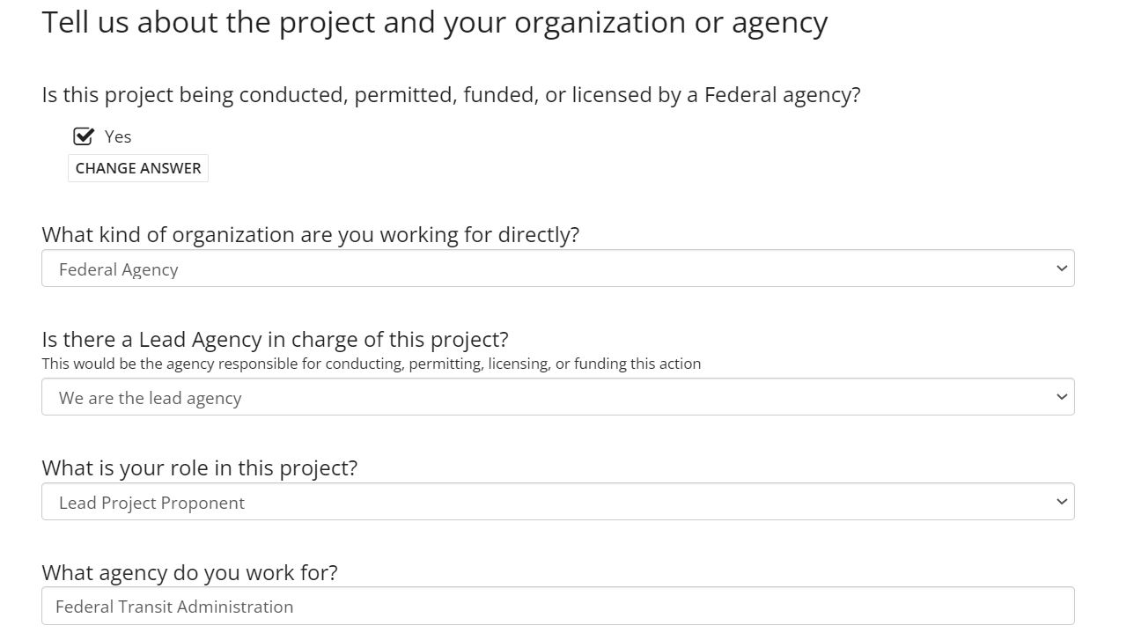
Example: If a State DOT/County or Consultant is using the Assisted Determination Key

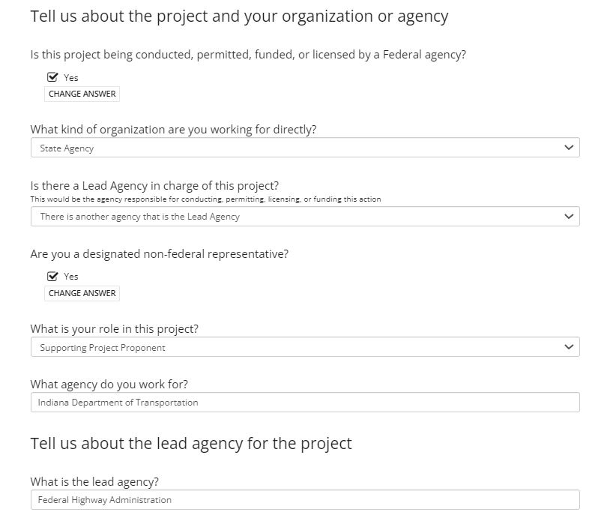
- Select “Generate Consistency Letter”,
- Select “View Consistency Letter” and save for your files.
- If the effects determination is “NLAA” or “LAA”, continue as described below.
- If you are a federal action agency or designated non-federal representative:
- Select submit to the Service for “Concurrence Verification” (if NLAA), or “Generate Consistency Letter” for a “LAA Verification Letter” (if LAA),
- Complete questions about the project, your agency or organization, and contacts.
Note: The lead agency is either FHWA, FRA, or FTA; The State DOTs are “designated non-federal representatives”; and the roles of the agencies are as follows: FHWA, FRA, or FTA is the “lead project proponent” and State DOTs are “supporting project proponents”. Consultants should enter the information below as if they are acting on behalf of a State or County.
- Select “Conclude NLAA and Submit” or “Generate Consistency Letter” (if LAA),
- Select “View Concurrence Verification Letter” and save for your files (if NLAA); or select “View Consistency Letter”, save for your files, and follow instructions in letter for submitting to the Service via email (if LAA),
- The local Service field office will receive notice of your project and will contact you within 14 days for NLAA determinations, if necessary; or for LAA determinations, the local Service field office will respond with a Confirmation Letter within 30 days of receipt of LAA Consistency Letter.
- If you are not a federal action agency or designated non-federal representative (e.g., consultant or local transportation agency):
- Request to generate a “Consistency Letter”,
- Complete questions about the project, your agency or organization, and contacts,
Note: The lead agency is either FHWA, FRA, or FTA; The State DOTs are “designated non-federal representatives”; and the roles of the agencies are as follows: FHWA, FRA, or FTA is the “lead project proponent” and State DOTs are “supporting project proponents”. Consultants should enter the information below as if they are acting on behalf of a State or County.
- Select “Generate Consistency Letter”,
- Select “View Consistency Letter” and save for your files,
- Provide Consistency Letter to the federal action agency or designated non-federal representative for submittal to the Service.

Step 2 – Determine Adherence to Scope and Submit Form (Skip this step and continue to Step 3 if using the Assisted Determination Key)

The transportation agency will determine whether or not the proposed project adheres to the scope and criteria of the range-wide BA (use of the IPAC Assisted Determination Key may be used to help make this determination). If it is determined that the project is within the scope of the range-wide BA, the transportation agency shall submit a Project Submittal Form-Appendix B (or a comparable Service approved form), which includes the identification of AMMs and if applicable, compensatory mitigation measures required to offset adverse effects on the Indiana bat, to the email addresses of the appropriate Service Field Offices. If the determination is NE, then do not submit the Project Submittal Form to the Service Field Office, but rather retain a copy for your files.

Step 3 – Mitigation Implementation Process (for projects LAA Indiana bat only)

If the effects determination is may affect, likely to adversely affect, and compensatory mitigation is required to offset adverse effects on the Indiana bat, the transportation agency must notify the local Service Field Office of the mechanism it has selected to implement compensatory mitigation. Mechanisms included the range-wide in lieu fee program, a Service-approved state or regional specific in lieu fee program, a conservation bank, or local conservation site (see Section 2.11 of the BA). If using the range-wide in lieu fee program sponsored by The Conservation Fund, the transportation agency shall send notification to the Program Coordinator, Natasha Skelton (540-271-0746) via IbatILFCoordinator@conservationfund.org, as well as to the local Service Field Office in order to begin the mitigation process.

Process for Lead Service Field Office

FWS Response
No response from the lead Service Field Office is required if you agree that the transportation agency’s project correctly falls within the scope of the programmatic NLAA determination. The lead Service Field Office should contact the transportation agency immediately if there are any questions or concerns about their determination.

The lead Service Field Office must respond to the transportation agency for any projects that fall within the scope of the programmatic LAA determination for either the Indiana bat and/or the NLEB. This response should happen within 30 days of receipt of the complete consultation package. There is a template Service Confirmation Letter available for use.

ECOSphere
When a species list request is submitted through IPaC, the IPaC contact(s) for each field office intersected by the project will receive an email notification that includes:
- The project name,
- The project location (county and State),
- The project code,
- A link to the project in Ecosphere, and
- An attached copy of the official species list.

Should a project span multiple Service Field Office jurisdictions, the Service Field Office that contains the largest portion of the project will be identified as the lead office in Ecosphere by IPaC. The lead office can be changed in Ecosphere if needed. For transportation actions that cross jurisdictional boundaries (e.g., from one State DOT to another), one transportation entity should take the lead in the consultation.

Upon receiving a Concurrence Verification Letter (i.e., NLAA) from the IPaC Assisted Determination Key, the associated ECOSphere Section 7 Workflow Event is automatically populated. Only the Workload Staff is not entered, thus one may wish to include this in the Section 7 Workflow. The project may be accessed in ECOSphere using the web link provided in the email from ECOSphere when receiving notification that the project has been created, or by searching with the Project Code from the Concurrence Verification Letter.

Upon receiving notice of a LAA Consistency Letter via email from the lead Federal Agency or designated non-federal representative, the lead Service Field Office will need to enter additional, project-specific information into ECOSphere to complete the consultation. In particular, the Incidental Take and Mitigation Information for the project should be entered, and the Confirmation Letter (which is sent back to the lead Federal agency or designated non-federal representative) should be up-loaded into ECOSphere as a Section 7 Event.

Upon receiving a Project Submittal Form (NLAA or LAA), the project-specific information will need to be entered manually into ECOSphere to complete the consultation. In addition, under Related Projects, the project needs to be “linked” to the PBO Project Code #2022-0000364 (see upper right corner of Project Home Page).

Appendix A – IPAC Assisted Determination Key (Recommended)
The IPaC Assisted Determination Key has replaced the scoping worksheet of version 4.0 of the User Guide. The IPaC Assisted Determination Key is a web-based tool that may be used to help determine what type of an effect a project may have on either bat species; identify AMMs to be implemented, as applicable; and electronically submit project(s) information to the Service. The Assisted Determination Key is available at the Service’s website: https://ipac.ecosphere.fws.gov/

Appendix B - Project Submittal Form
In order to use the range-wide programmatic consultation, project-level information shall be provided to the appropriate Service Field Office for all “may affect” determinations. The most current Project Submittal Form is available at the Service’s website: https://www.fws.gov/sites/default/files/documents/appendix-b-project-submittal-form-june-2019.pdf

Appendix C - Avoidance and Minimization Measures
The most current summary of AMMs necessary to reduce the potential effects of projects so as to be within the scope of the range-wide programmatic consultation is available at the Service’s website: https://www.fws.gov/sites/default/files/documents/appendix-c-avoidance-and-minimization-measures-february-2018.pdf

Appendix D – Bridge/Abandoned Structure Assessment Guidance and Form
The guidelines in this document describe favorable characteristics of bridges/structures that may provide habitat for many bat species, and preliminary indicators intended to determine if any bat species are likely using bridges/structures. An assessment form is also included for use in documenting a site-specific bridge/abandoned structure. The most current bridge/abandoned structure assessment guidance and form are available at the Service’s website: https://www.fws.gov/sites/default/files/documents/appendix-d-bridge-structure-bat-assessment-form-guidance-april-2020.pdf

Appendix E – Post Assessment Discovery of Bats at Bridge/Structure Form
This form is used to report the incidental take of bats that has occurred during construction of bridge activities. The PBO anticipated that there may be instances where bridge assessments are completed in fulfillment of requirements of the PBO but fail to detect Indiana bats that are later detected during construction. The Service anticipated that, in these instances, construction could result in incidental take in the form of harassment, injury, or death to as many as 5 Indiana bats for any particular project, with no more than 50 Indiana bats taken range-wide in any particular 12-month period. This amount of incidental take was exempted in the incidental take statement of the PBO for all projects utilizing the PBO, provided that the take is reported to the Service. In order to track the incidental take exempted, please use this form to report the number of bats taken and the form of take that occurred within 2 working days of the incident to the local Service field office. The most current Post Assessment Discovery of Bats at Bridge/Structure Form is available at the Service’s Region:
https://www.fws.gov/sites/default/files/documents/appendix-e-post-assessment-discovery-of-bats-form-august-2017.pdf

Provide feedback on the User Guide and Appendices to the appropriate agency contact listed in the box above.
If additional information is required or if site-specific AMMs are implemented in order to employ the programmatic consultation, the relevant transportation agency and Service Field Office are responsible for documenting those actions on the Project Submittal Form or through the IPaC Assisted Determination Key.
Documented roosting or foraging habitat – for the purposes of this consultation, we are considering documented habitat as that where Indiana bats and/or NLEB have actually been captured and tracked using (1) radio telemetry to roosts; (2) radio telemetry bi-angulation/triangulation to estimate foraging areas; or (3) foraging areas with repeated use documented using acoustics. Documented roosting habitat is also considered as suitable summer habitat within 0.25 miles of documented roosts.
Documented travel corridor - for the purposes of this BA, we are considering documented corridors as that where Indiana bats and/or NLEB have actually been captured and tracked to using (1) radio telemetry; or (2) treed corridors located directly between documented roosting and foraging habitat.
Structure assessments for occupied buildings refers to a cursory inspection for bat use. For abandoned buildings a more thorough evaluation is required (See Appendix D for bridge/abandoned structure assessment guidance).
Construction refers to activities involving ground disturbance, percussive noise, and/or lighting.
Ground disturbance is defined as any activity that compacts or disturbs the ground. Ground disturbance can be caused by the use of hand tools (shovels, pick axe, posthole digger, etc.), heavy equipment (excavators, backhoes, bulldozers, trenching and earthmoving equipment, etc.), and heavy trucks (large four wheel drive trucks, dump trucks and tractor trailers, etc.). Note that ground disturbance can be a component of other actions (e.g., bulldozing trees). Contact the local Service Field Office, as needed, to assist in determining if and how ground disturbance may affect bat hibernacula.
Refer to the USFWS’s summer survey guidance for the definition of suitable habitat (https://fws.gov/library/collections/range-wide-indiana-bat-survey-guidelines).
Road surface is defined as the actively used (e.g. motorized vehicles) driving surface and shoulders (may be pavement, gravel, etc.) and rail surface is defined as the edge of the actively used rail ballast.
P/A summer surveys conducted within the fall swarming/spring emergence range of a documented Indiana bat hibernacula (contact local Service Field Office for appropriate distance from hibernacula) that result in a negative finding requires additional consultation with the local Service Field Office to determine if clearing of forested habitat is appropriate and/or if seasonal clearing restrictions are needed to avoid and minimize potential adverse effects on fall swarming and spring emerging Indiana bats.
https://ecos.fws.gov/ecp/species/5949 and https://ecos.fws.gov/ecp/species/9045
Follow bridge/abandoned structure assessment guidance.
Refer to https://fws.gov/library/collections/range-wide-indiana-bat-survey-guidelines
P/A summer surveys conducted within the fall swarming/spring emergence range of a documented Indiana bat hibernacula (contact local Service Field Office for appropriate distance from hibernacula ) that result in a negative finding requires additional consultation with the local Service Field Office to determine if clearing of forested habitat is appropriate and/or if seasonal clearing restrictions are needed to avoid and minimize potential adverse effects on fall swarming and spring emerging Indiana bats.
Areas containing more than 10 trees will be assessed by the local Service Field Office on a case-by-case basis with the project proponent.
Refer to https://fws.gov/library/collections/range-wide-indiana-bat-survey-guidelines
Keeley and Tuttle (1999) indicated peak night roost usage is between 10:00 p.m. to midnight.
Refer to https://fws.gov/library/collections/range-wide-indiana-bat-survey-guidelines
Coordinate results with local FO and follow guidance for clearing of documented roosting/foraging habitat or travel corridors.
Refer to https://fws.gov/library/collections/range-wide-indiana-bat-survey-guidelines
Coordinate results with local FO and follow guidance for clearing of documented roosting/foraging habitat or travel corridors.
Transportation agencies may coordinate with the appropriate Service Field Office to develop a separate process for requesting a site-specific project be included in the range-wide programmatic consultation. However, the information on the Project Submittal Form (Appendix B) must be provided.
The Service is in the process of updating the programmatic biological opinion. A revised opinion should be available in summer 2022.
For NEPA Assignment states, the lead agency is the State DOT, and the role of the agency is “lead project proponent”.

