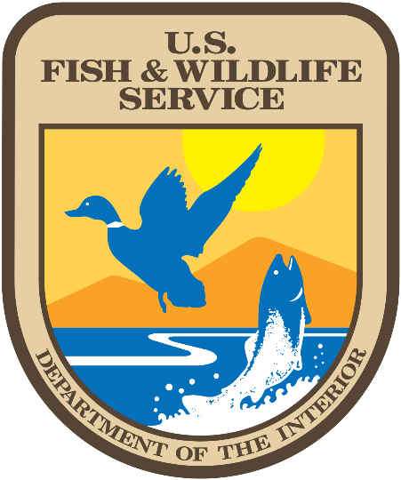Training & Office of Law

Development Enforcement

Unit

FWIP Programs

* **Counter Wildlife Trafficking Seminar (CWTS):** This 1 day (8 hour) seminar partners with other US law enforcement agencies who are conducting training to specifically help other nations non environmental law enforcement officers become aware of the relationship between wildlife trafficking and organized crime and to enlighten law enforcement officers as to the scope and importance of wildlife trafficking in their perspective regions and the global market.  The strength of this seminar is its flexibility to fit the needs and capabilities of the requesting agency. It covers four important topics which include; International wildlife smuggling and its relationship with organized crime, examining different concealment methods used in wildlife trafficking, pandemics via wildlife and recent International Cases.

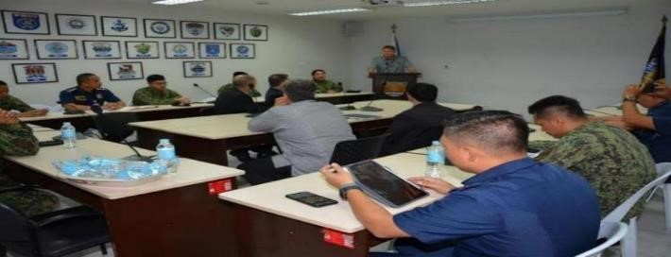

* **International Conservation Chiefs Academy (ICCA):** This two-week academy consists of various operational and management courses and extensive participant interactions and group meetings. The ICCA provides a unique forum, which allows representatives of the FWS, other government agencies, state conservation agencies and NGOs to interact with colleagues and counterparts from various regions around the world. This training is held at the USFWS National Conservation Training Center (NCTC) in Shepherdstown, WV. The course of training given at the ICCA is based on the Adaptive Leadership curriculum from the Harvard Kennedy School. The Practice of Adaptive Leadership is a hands-on, practical guide containing stories, tools, diagrams, cases, and worksheets to help participants develop their skills as an adaptive leader, able to take people outside their comfort zones, and assess and address the toughest challenges. The course encourages interaction between instructors and class participants and concentrates on the exchange of information and techniques used by wildlife law enforcement agencies and participant countries in combating wildlife trade crimes.

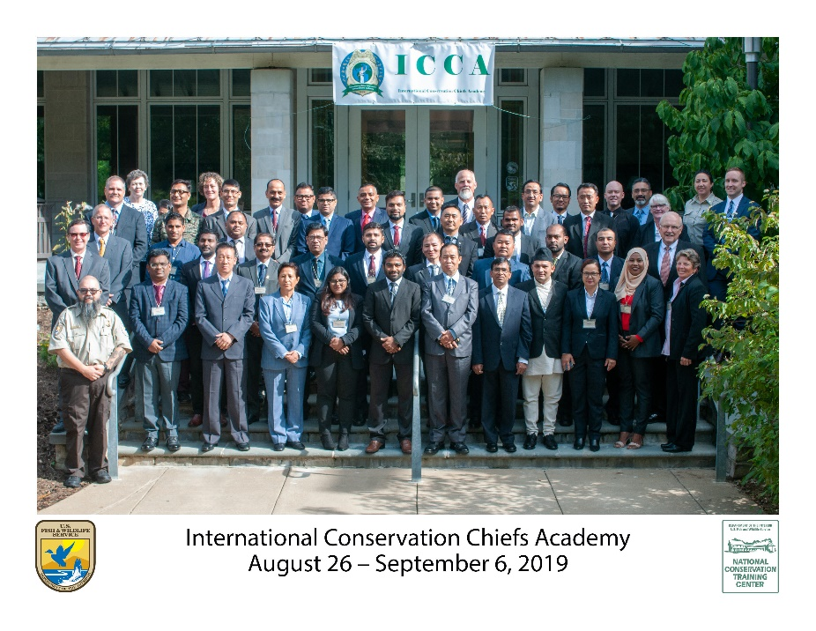

* **ICCA Alumni Training Event (IATE):** This four (4) day curriculum provides for ICCA alumni to attend a virtual alumni event, receive updates, and collaborate on progress toward conservation law enforcement leadership. The mission of IATE is to research, develop, and share information, ideas, and innovations, which assist establishing effective and defensible standards for law enforcement leaders. IATE currently has multiple international communities and the goal is to continue capacity building, share operational, and investigation information to further counter-wildlife trafficking efforts. FWS Attaché from Africa and SE Asia will attend to facilitate investigation sharing.

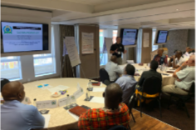

* **Wildlife Seizure Training Program (WSTP):** The three (3) day curriculum provides an overview of wildlife identification, seizure authority, inspection techniques and evidence handling at port of entry environments. This program focuses on the legal authority to seize and the ability to meet the threshold of seizing illegal wildlife and wildlife products. Elephant ivory and rhinoceros horn parts and products are the primary wildlife identification focused on but regional specific wildlife will be included in the curriculum for this program. The WSTP encourages interaction between instructors and class participants and concentrates on exchange of information and techniques by FWS in combating wildlife trafficking using wildlife inspection and identifications techniques in the United States.



* **Wildlife Crime Scene Investigation (WCSI):** This five (5) day course is a wildlife crime scene investigation course for investigators. The curriculum focuses on crime scene processing, forensic techniques, and court preparation using current “best practices”. This course is relevant for those countries that have iconic poached wildlife and investigators that transfer evidence to police agencies for prosecution. The course emphasizes the importance of developing and maintaining national contacts to exchange intelligence between agencies. This open dialogue throughout the course provides the opportunity for host nations to gain insights on specific current wildlife trafficking problems faced by the participating countries and ones they see developing in neighboring countries. Instructors offer techniques and methods available to combat specific wildlife investigative issues. The course covers crime scene management, photography, documentation, impression evidence, trace and biological evidence, wildlife poison evidence collection, firearms evidence, genetics evidence collection, latent print development, evidence preservation and submissions. The trainers teach using current “best practices” and then reinforce through practical exercises.
  + "This popular program directly enhances the participant's ability to perform a necessary law enforcement function vital to their positions as wildlife law enforcement officers.  The excellent evaluations this course constantly receives is testimony to its impact on the participants. It has also been a conduit of positive relationship building with the FWS/OLE and even domestically within the agencies of the the host country. What resonates with me most, when conducting these courses, is the constant enthusiasm and positive attitudes the participants display. This ultimately translates to enhanced wildlife protection which makes this work so rewarding!" – Paul Beiriger, WCSI Program Manager

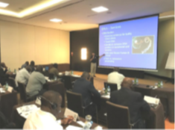

* **Wildlife Trafficking Cybercrime Program (WTCP):** This five (5) day course focuses on digital evidence, cybercrime investigative techniques, online covert operation considerations, and e-mail, social media and online marketplace investigations. Students learn to extract data from computers and cell phones for analysis. The course includes computer hardware, understanding the internet, tracking IP addresses, email exploitation and tracing, metadata, cached webpages, social media, digital currency, mobile device forensics, legal issues and internet investigations. The course emphasizes the importance of developing and maintaining national contacts to exchange intelligence between agencies; this open dialogue throughout the course provides the opportunity for host nations to gain insights on specific cybercrime issues related to wildlife trafficking faced by the participating countries.
  + The Wildlife Trafficking Cybercrime Program (WTCP) is designed in support of the Office of the President of the United States, National Strategy for Combating Wildlife Trafficking and, Executive Order 13773 “Enforcing Federal Law with respect to Transnational Criminal Organizations and Preventing International Trafficking,” The purpose of the WTCP training mission is to strengthen global law enforcement relationships through the sharing of information related to the collection-preservation-examination-investigation of cybercrime related evidence, enhancing the ability to combat worldwide illegal wildlife trafficking. I think the WTCP is important because it addresses the current issue of how to deal with global wildlife criminals in this digital age the world is currently experiencing, which will most certainly continue over time, and become even more prevalent, complicated, and complex in the years to come. I believe cyber evidence exists in ALL significant international wildlife smuggling cases. Substantial information seized and examined from computers, mobile devices, social media and online marketplace investigations can be used by investigators to successfully prosecute or collect vital intelligence data on some of the world’s most notorious wildlife traffickers and crime syndicates. Cyber related evidence must be a priority in all instances and should be properly collected and utilized in conservation law enforcement cases worldwide. The current issue from my perspective is the complexity of dealing with all facets of cyber evidence. How to recognize it, seize it, handle it, extract usable data from it, report on it, present it in court, and share information from it by collaborating with other agencies in-country and global partner countries. Enter the WTCP. The WTCP is a foundational course that teaches through lecture and hands-on practical exercises how to accomplish the collection-preservation-examination-investigation-presentation-sharing of cyber evidence. The course was designed from the ground-up and is delivered by USFWS subject matter experts who are trained and experienced in the field of cyber evidence in the conservation wildlife environment. The course goes a step further by encouraging interaction and collaboration between participants, USFWS Attaches and other fellow WTCP participants who have attended the course in different parts of the world. My experience from delivering this course for the last 3 years is that participants lean a great deal about the subject of cybercrime no matter how much or little experience they had prior to the course. Participants always mention they take what they learned and us that learning to assist them in their daily work as conservation enforcement officers and they now have an enhanced cyber awareness and capability. Participants also mention an added connection they feel to the USFWS and the Attaché program and feel they now have a avenue to effectively collaborate on future wildlife trafficking investigations.

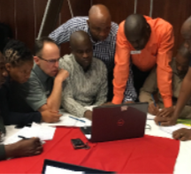

* **Shark Fin ID (SFID):** The one-week in person, four-day virtual (20 hours) curriculum provides an overview of shark identification, CITES listed species, inspection techniques and evidence handling at port of entry environments. This program focuses on the CITES listed shark species traded and trafficked during commercial fishing activities. CITES shark fin parts and products are the primary wildlife identification focused on regional specific shark fin will be included in the curriculum for this program. This training will be reinforced through virtual exercises.

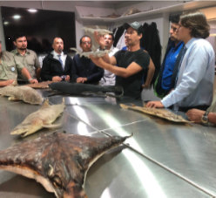

* **Marine Crime Scene Investigation Program (MCSI):** The seven (7) day curriculum provides an overview of varied marine investigative topics and was designed to present core lesson material through lecture with application of training principles performed during practical field exercises. These topics are reinforced through the field exercises in which the class participants collaborate and apply the course material through planning and performing various field operations. The MCSI encourages interaction between instructors and class participants and concentrates on exchange of information and techniques by FWS in combating wildlife trafficking using “best practice” investigative techniques in the United States.

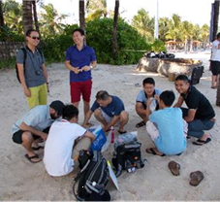

* **South Asia Cybercrime Program (SACP):** The purpose of the SACP is to provide technical assistance, training, and support to authorities in South Asia to strengthen wildlife enforcement and combat wildlife trafficking. The primary countries of engagement will include Bangladesh, India, Nepal, and Sri Lanka. The goal of this project is to develop the wildlife cybercrime enforcement capacity and expertise of the conservation law enforcement officers and other authorities in the natural resources, environment, marine, and justice sector to improve national and trans-border wildlife interception, natural resource and marine investigations, and prosecutions.
  + The trainings will likely include these four primary, “core” modules:
    - Wildlife Trade Analysis (WTA) - Wildlife Trade Analysis (WTA) - provides an analysis of varied wildlife trends and trade online within the four South Asia nations.
    - Wildlife Trafficking Cybercrime Program (WTCP) - This one-week, train the trainer virtual and in-person curriculum provides advanced training on various cybercrime investigative topics related to wildlife trafficking that the trainers reinforce through practical exercises.
    - Wildlife Internet Investigation Program (WIIP) - This one-week, train the trainer virtual and in-person curriculum provides advanced training on various internet investigative topics related to wildlife trafficking that the trainers reinforce through practical exercises.
    - WTCP Instructor Assistance Program (WIAP) - This one-week in-person curriculum provides advanced training on various investigative topics related to wildlife cybercrime enforcement.
* **International Law Enforcement Management Information System (iLEMIS):** This one-week curriculum provides advanced training on the iLEMIS information technology program. This investigative case management system has been in use by the Office of Law Enforcement for 30 years and is the primary criminal investigative management program to organize record and store case information. As part of this program, digital technology will be transferred to the host government and experts will provide training to implement this technology for wildlife enforcement agencies. The iLEMIS has a robust capability to track case information and seized property. The iLEMIS program will facilitate the lack of case management software for conservation law enforcement agencies in those countries. A cloud-based version of iLEMIS will be transferred along with setup and support agreed to by the host government and INL under this agreement.
* **Wildlife Investigative Unit Training (WIUT):** This eight (8) day curriculum provides advanced wildlife enforcement unit training in wildlife crime scene, digital evidence collection, surveillance, wildlife identification, covert operations, search and seizure, evidence tracking and technical investigative equipment. This program focuses on experienced wildlife units established to combat cross border wildlife trafficking. This program will provide training on surveillance equipment and donation of technical surveillance equipment to the host government. This training encourages interaction between instructors and class participants and concentrates on exchange of information and techniques by FWS in combating wildlife trafficking using tactics, training and surveillance equipment used in the United States. This course will utilize a train the trainer model to facilitate instructor upon graduation.
* **Wildlife Trafficking Parliamentarian Forum (WTPF):** The Wildlife Trafficking Parliamentarian Forum (WTPF) is an executive level program conducted at the U.S. Fish and Wildlife Service (FWS) National Conservation Training Center (NCTC). The goal of this forum is to bring together international parliamentarians for the sharing of best practices and policy discussions related to legislation for conservation and the fight against wildlife trafficking, The WTPF provides a unique opportunity for legislative leaders from around the world to share ideas, resources, and intelligence, and to form stronger relationships in the develop of a joint global conservation effort, especially as it relates to law enforcement conservation legislation. By sharing best practices and using the Lacey Act, Migratory Bird Treaty, Endangered Species Act and similar foreign wildlife laws as template legislation for discussions, an opportunity for the creation of a network will be established that has potential to develop new form of legislation or regional laws being put into place supporting law enforcement effectiveness countering international illegal trafficking in wildlife. The location of the program at the FWS NCTC allows for interaction within the National Capitol Region (NCR) providing a unique opportunity for relationship building between the attending international parliamentarians with their U.S. counterparts. Through the sharing of best practices and legal reviews, the attending international parliamentarians will develop their own outlines of draft legislation for capstone presentation by the conclusion of the forum.



Training & Office of Law

Development Enforcement

Unit

ILEA Programs

* **Wildlife Trafficking Cybercrime Program (WTCP):** This one-week in person (40 hours), five-days virtual (20 hours) curriculum provides advanced cybercrime investigative topics related to wildlife trafficking. The curriculum focuses on digital evidence; crime scene processing; basic cybercrime investigative techniques; online undercover operation considerations; e-mail, social media and online marketplace investigations. Interaction and exchange of information and techniques by FWS in combating wildlife trafficking using cybercrime investigative techniques. Open dialogue throughout the course provides the opportunity to gain insights on specific cybercrime issues related to wildlife trafficking being faced by the participating countries. Instructors offer techniques and methods available to combat specific wildlife cybercrime investigative issues.

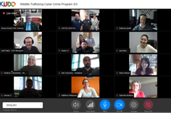

* **Wildlife Trafficking Investigators Program (WTIP):** This two-week in person (80 hours), one-week virtual (20 hours) course provides an overview of various wildlife trafficking investigative topics. The curriculum focuses on endangered species law; CITES wildlife trade data; wildlife identification; case initiation and management; digital evidence; forensics and crime scene processing; surveillance; undercover operations; money laundering; interviewing; ethics and corruptions; raid planning; report writing and court preparation. The course emphasizes the importance of developing and maintaining global contacts to exchange intelligence between countries, this open dialogue throughout the course provides the opportunity for host nations to gain insights on specific wildlife trafficking problems being faced by the participating countries. Instructors introduce and discuss techniques and methods available to combat specific wildlife investigative issues. An open forum session with USFWS Attaché connects the participants for exchange of contact information and an invitation to collaborate in country. This exchange of intelligence and cooperation on investigations is crucial in combating international wildlife trafficking.

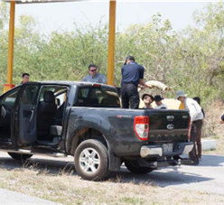

* **Wildlife Border Inspection Training Program (WBITP):** The one-week in person (40 hours), five-day virtual (20 hours) curriculum, taught by USFWS and CBP, provides an overview of various wildlife border inspection topics that are reinforced through classroom exercises. The Wildlife Border Inspection Training Program (WBITP) involves intensive instruction pertaining to interdicting wildlife smuggling at various types of international ports of entry. The curriculum focuses on Convention on International Trade in Endangered Species of Wild Fauna and Flora (CITES); wildlife trade data; wildlife identification; case initiation and management; interviewing; border interdiction; evidence processing; ethics and corruptions; and court preparation. It encourages interaction between instructors and class participants and concentrates on exchange of information and techniques by FWS in combating wildlife trafficking using inspection techniques in the United States. The course emphasizes the importance of developing and maintaining global contacts to exchange intelligence between countries, this open dialogue throughout the course provides the opportunity for host nations to gain insights on specific wildlife trafficking problems being faced by the participating countries. Instructors offer techniques and methods available to combat specific wildlife inspection issues. This exchange of intelligence and cooperation on investigations is crucial in combating international wildlife trafficking. An open forum with USFWS Attaché and the participants lead to inertia of building relations to combat illegal wildlife trafficking our borders.

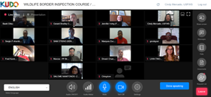

* **Wildlife Trafficking Executive Symposium (WTES):** This two-week in person (80 hours), ten-day virtual (40 hours) symposium will focus on building a comprehensive national response model for combating wildlife trafficking. Delegates will gain essential skills in communication, critical thinking and decision-making that are critical when acting in a leadership role. U.S. Fish and Wildlife Subject Matter Experts identify and explore policy and enforcement guidance; criminal justice, investigating and prosecuting wildlife crimes with the latest policy guidelines and legislative developments. Instructors outline statutes that have been developed to combat these crimes. The symposium will also provide the delegates with instruction on how wildlife traffickers and criminal trafficking organizations commit their crimes, the techniques, tools, and strategies that need to be employed to successfully investigate and prosecute wildlife trafficking. The symposium will explore the process of an investigation and prosecution in order to facilitate the understanding of the structures and strategies needed to effectively combat these crimes. The goal of this symposium is to teach the delegates how to effectively and strategically develop a comprehensive response to the problems of wildlife trafficking. An open forum with WTES Alumni from previous sessions explore the successes with local contacts, USFWS Subject Matter Experts and their closest USFWS Attaché.