Listening Session for a Southern Maryland Land Protection Plan
It is well established that the Southern Maryland region is one of indispensable ecological importance. The Nature Conservancy’s Resilient Land Mapping Tool (below) reveals that the five county expanse houses some of the state’s most resilient landscapes, making this an opportune region for those who wish to conserve their lands. The green hues painting the Southern Maryland region on the map represent abundant biodiversity and landscape connectedness, starkly contrasting the dark grays and browns that characterize the highly developed D.C. region. Although the Southern Maryland region currently houses some of the state’s most diverse species and connected lands, it is not guaranteed to stay this way. So long as land remains unprotected, the region is vulnerable to the omnipresent threat of the expansion of the D.C. Metro area. The good news is that American Chestnut Land Trust, the Southern Maryland Conservation Alliance (SMCA), and the wider land trust community are working hard to preserve as much land as possible to maintain the environmental integrity of our critical region.
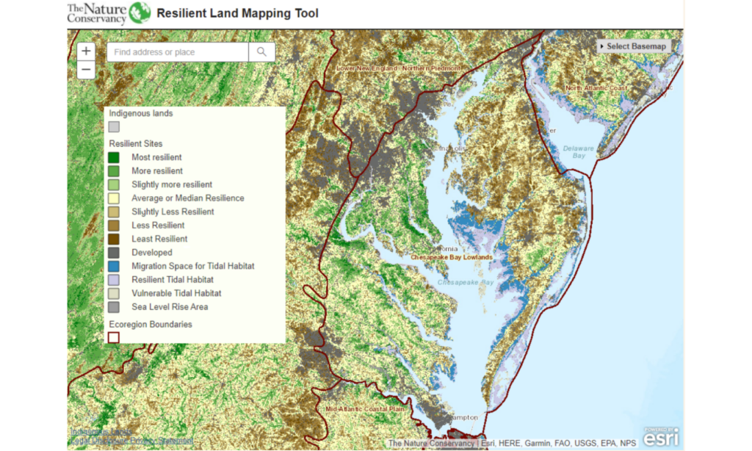
An exciting opportunity to amplify the scale of land protection in Southern Maryland is underway. The U.S. Fish and Wildlife Service proposes the creation of a new wildlife refuge in Southern Maryland, and SMCA is assisting with the preparation of a Land Protection Plan/Environmental Assessment (LPP/EA) to do so. In short, the Land Protection Plan details the rationale for establishing a refuge in Southern Maryland, including a map of the acquisition boundary (the draft of which is below) and why it supports the USFWS mission to protect fish and wildlife habitat.
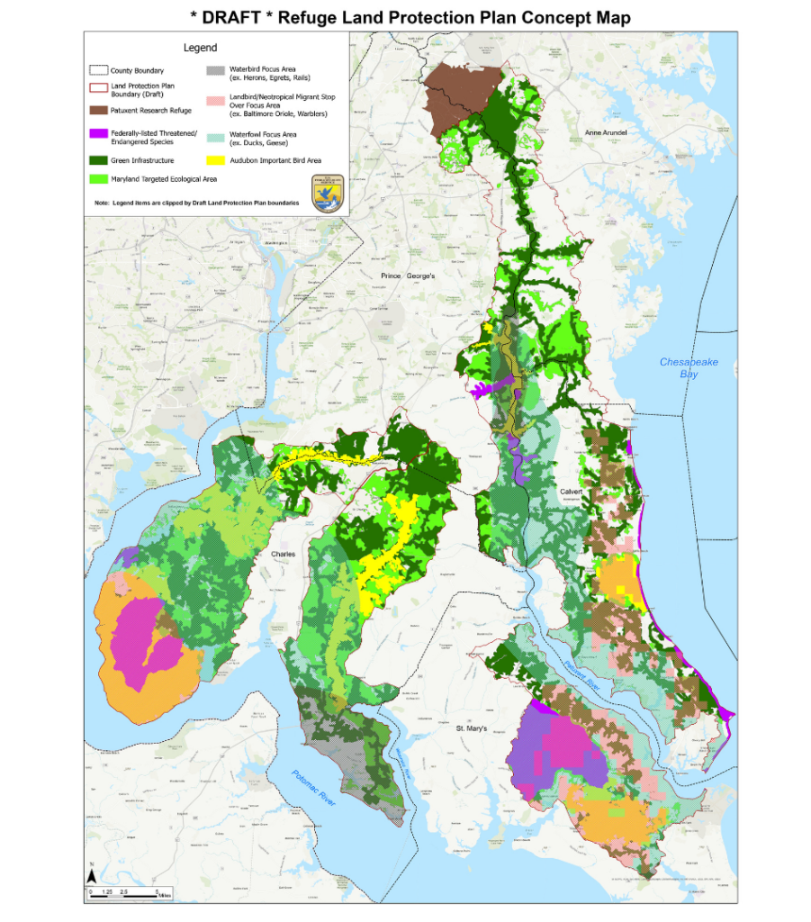
As of March 2023, the Service is in the process of drafting the plan and actively soliciting public input before seeking the document’s approval from higher ups. The approval of this plan could be a critical juncture for land preservation in Maryland. There has never been a more urgent time to protect lands in Maryland, and an approved LPP/EA for Southern Maryland could greatly accelerate land protection, as it would allow USFWS to purchase via fee or easement up to 30,000 total acres of land within the acquisition boundary.
In September 2022, USFWS held a meeting to engage stakeholders and hear feedback about the proposal. On March 23, 2023, the Service held the first of three public listening sessions to further engage public opinion before finalizing the proposal. Between the two sessions, one of the most notable recurring concerns was how landowners would receive the plan. The term “acquisition boundary” may seem threatening to those whose properties fall within the border, but USFWS wants to be clear that the establishment of an acquisition boundary actually presents an opportunity. Joe McCauley, Chesapeake Fellow at the Chesapeake Conservancy and member of the LPP/EA core team, explained at the March 23 session that “this plan gives the Service the same right as everyone in this room, which is the right to purchase land from willing sellers.” The plan, although necessarily laced with technical terminology, is as simple as this.
Two more public listening sessions are scheduled for March 30 at the St. Charles County Administration Building in La Plata and April 18 at the Calvert Marine Museum in Solomons. Both sessions will be from 7-8pm, with ample time to ask questions. Public support is highly important to the Service, and this is a great opportunity for Southern Maryland citizens to inform their consent and offer valuable feedback, making the final proposal as effective as possible. For more information visit
https://www.fws.gov/media/faqs-about-proposed-refuge-lands-southern-maryland

