Hagerman National Wildlife Refuge  6465 Refuge Road  Sherman, Texas 75092  Contact: Kathy Whaley or Paul Balkenbush (903) 786-2826 |  | 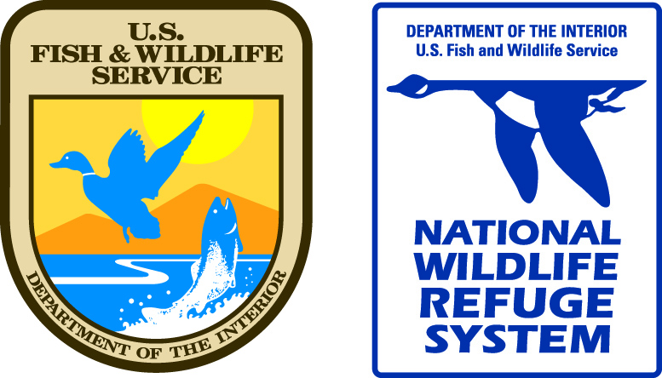

April 4, 2023
Downed Cedar Trees Available for Public Removal
Hagerman National Wildlife Refuge is seeking companies or individuals who are interested in removing downed eastern red cedar trees. The trees, some of which are quite large, are scattered across a 70-acre segment of the Sandy Unit adjacent to Old Sadler Road on the south side of Sandy Creek. The purpose of the removal is to clear the understory of cedar trees to reduce the potential for wildfire and improve habitat for native birds and wildlife. The removal will be performed at no cost to the Refuge and the trees will become the property of the company or individual after they are removed from government property.
Cedar tree removal will take place under a Special Use Permit (SUP) issued free of charge by Refuge staff. The SUP will provide guidelines for site access and operational requirements. There is a requirement for any interested party to agree to remove all downed cedar trees from a minimum of 10 acres within the designated 70-acre restoration area. All parties who wish to remove downed cedar trees will be responsible for providing their own equipment to access the area, load the trees, and remove the trees from Refuge property in a safe manner. The work will need to be completed within four weeks of the SUP issue date.
If you are interested in learning more about this project or being considered for a SUP to remove trees from one or more 10-acre section, please contact the Refuge at (903) 786-2826. Depending on the level of interest received, permits will be issued to between one and seven parties. The deadline to indicate interest in the project is April 14, 2023.
For more information, contact Hagerman National Wildlife Refuge at (903) 786-2826.

