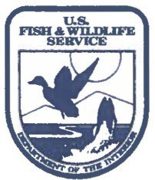
United States Department of the Interior
FISH AND WILDLIFE SERVICE
Dale Hollow National Fish Hatchery 145 Fish Hatchery rd.
Celina, TN 38551

November 8, 2021

To: US Army Corps of Engineers

From: Thomas Reeves, Project Leader/Hatchery Manager

Subject: Potable water supply line install

The U.S. Fish and Wildlife Service currently utilizes a dual drum filter system for the routine removal of solids prior to discharge into the local waterways (hatchery creek, then Obey River).

Issue: There is a design flaw in the current system; water used for the backwash self-cleaning stage is sourced from the water being filtered, leading to consistent clogging of the nozzles.

Correction: Install a clean potable water supply line from Celina City Water to provide water to the hatchery effluent building. This water will provide water for the drum filters, water for cleaning the building, and support potential future visitor improvement efforts reliant on a potable water source in the area.

Request: USFWS at Dale Hollow NFH is requesting authorization concurrence to trench a line to minimum state standards to run potable water from the service line at [Dale Hollow Dam rd] to the Southeast corner of the station’s effluent building.

Results: Greater consistency in effluent filtration operations providing improved reliability for meeting/exceeding EPA agriculture/aquaculture discharge requirements.

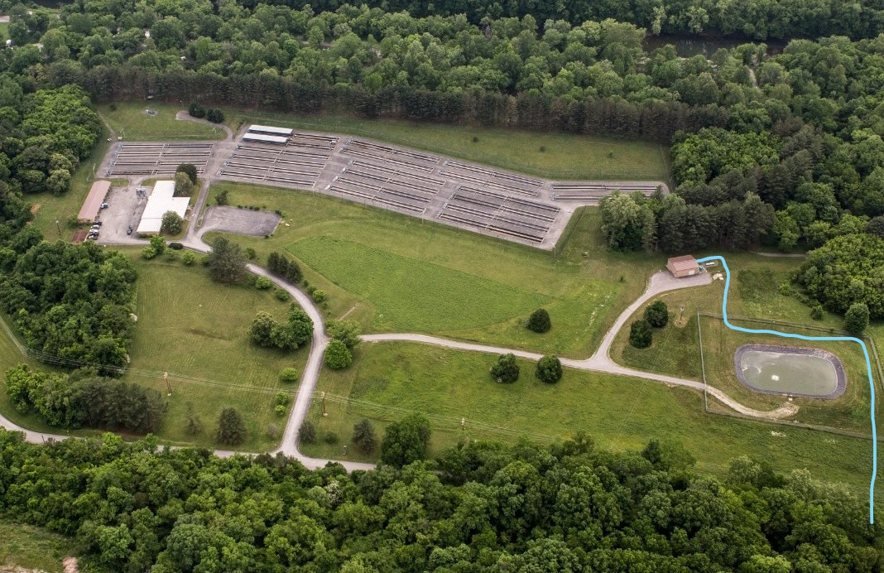
Timeline: within 60 days. Concerns: none noted

Thomas Reeves
Project Leader Dale Hollow NFH
(931) 243-2443

