Building a Pine Cone Bird Feeder
Materials Needed
Pine cone
Bird seed
String
Vegetable shortening (alternative: peanut butter)
Plate
Popsicle stick
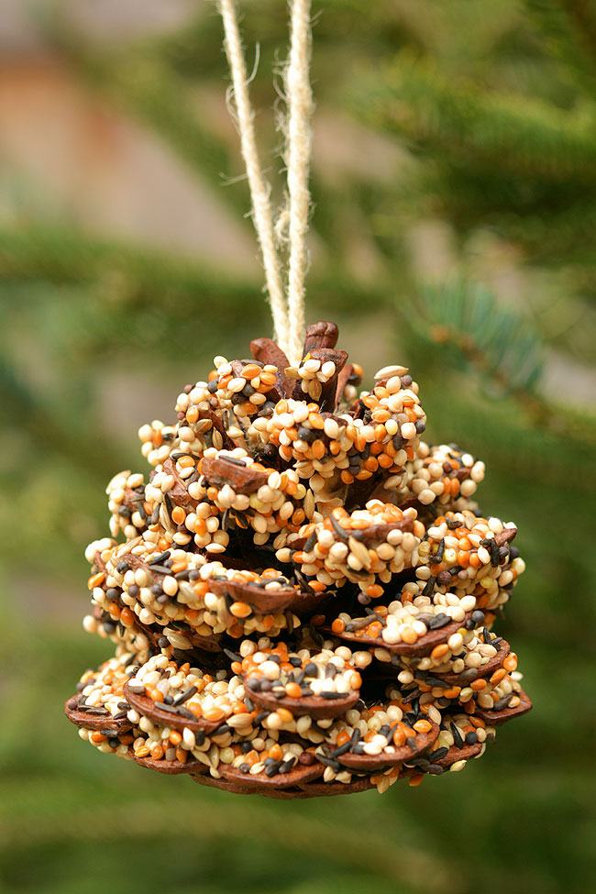
Instructions
1. Remove dirt and debris from your pine cone by lightly shaking, tapping, or brushing. This will help your shortening stick better!
2. Tie string around the center of your pine cone, making sure to leave two ends of string so that your feeder can be tied to a tree later.
3. Using the popsicle stick, spread shortening all over your pine cone. If the shortening is too hard to spread, you can microwave it for 10-20 seconds to make spreading easier.
4. Pour bird seed onto a plate or shallow bowl, then roll your pine cone in the bird seed. You can also sprinkle the bird seed onto your cone using a large spoon. You may need to press the bird seed onto the pine cone with your hands to make it stick. This step may be better done outdoors to avoid making a mess!
5. Hang your finished bird feeder. Good bird feeder locations are on the end of branches where birds can see and access them, especially in front of windows where you can watch visiting birds!

Common Cones of Oregon

Douglas fir (Pseudotsuga menziesii)
Range: Very common throughout western Oregon.
Cone Length: 2 – 4 inches
Features: “Dragon tongues” between cone scales.
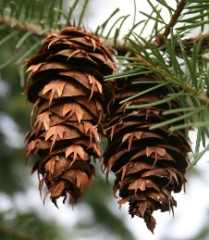

Ponderosa Pine (Pinus ponderosa)
Range: Very common in the eastern Cascades and southwestern Oregon, rare in Willamette Valley.
Cone Length: 3 – 6 inches long
Features: Woody, prickly cones.

Western Hemlock (Tsuga hetorophylla)
Range: Very common in western Oregon.
Cone Length: ½ – 1 inch
Features: Small cones with thin, round scales.
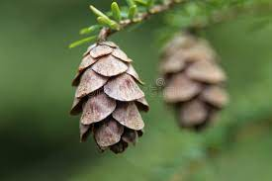

Sitka Spruce (Picea sitchensis)
Range: Very common in coastal Oregon and the Coast Range.
Cone Length: 1 – 3 inches
Features: Wavy scales on cones.
Lodgepole Pine / Shore Pine (Pinus contorta)
Range: Very common in coastal Oregon & high elevations of the Cascade Mountains.
Cone Length: 1.5 – 2.5 inches
Features: Round cone with a small prickle.

Red Alder (Alnus rubra)
Range: Common in western Oregon at low elevations.
Cone Length: ½ – 1 inch
Features: Delicate cones with no scales.
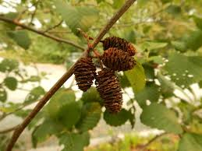

Western White Pine (Pinus monticola)
Range: Common in the Cascade Mountains and high elevations of the Coast Range
Cone Length: 8 – 10 inches
Features: Banana-shaped cone with white resin.
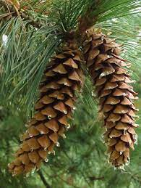

Western Redcedar (Thuja plicata)
Range: Common in mature forest of western Oregon
Cone Length: ¼ - ½ inch
Features: Tiny cones grow on ends of branches.
