Draft Compatibility Determination

Title
This document is a Draft Compatibility Determination for a right-of-way permit to be issued for the installation of a proposed utility line along the Spieker unit of the Northern Tallgrass Prairie in Clay County of Minnesota, Northern Tallgrass Prairie National Wildlife Refuge (Refuge).

Refuge Use Category
Right-of-way and Right to Access

Refuge Use Type(s)
Right-of-way (utility)

Refuge
Northern Tallgrass Prairie National Wildlife Refuge

Refuge Purpose(s) and Establishing and Acquisition Authority(ies)
The Fish and Wildlife Act of 1956 as amended by Public Law 93-271 helped pave the way for the establishment of the Northern Tallgrass Prairie NWR in 2000 to address the loss of America’s grasslands and the decline of grassland wildlife.
- 16 U.S.C. 742f(a)(4) " . . . for the development, advancement, management, conservation, and protection of fish and wildlife resources. "
- 16 U.S.C. 742f(b)(1)d “ . . . for the benefit of the United States Fish and Wildlife Service, in performing its activities and services. Such acceptance may be subject to the terms of any restrictive or affirmative covenant, or condition of servitude.”
National Wildlife Refuge System Mission: The mission of the National Wildlife Refuge System, otherwise known as Refuge System, is to administer a national network of lands and waters for the conservation, management, and where appropriate, restoration of the fish, wildlife, and plant resources and their habitats within the United States for the benefit of present and future generations of Americans (Pub. L. 105-57; 111 Stat. 1252).

Description of Use

Red River Valley Cooperative is proposing a right-of-way that would allow for the installation of an underground electric line rated at 15kV by means of plowing approximately 10-20 feet north of the southern property line of the Spieker tract of the Northern Tallgrass Prairie Refuge in northwestern Minnesota. All facilities will be buried at 4 feet below surface level. The length of the right-of-way footprint is 1,320 feet and the width is 10 feet. Construction will take 8 hours to complete. Station staff will seed the area with locally sourced native seed to bring it back to preconstruction conditions. The term of the permit will be 50 years.

Is this an existing use?
No.

What is the use?
Right-of-way (utility).

Is the use a priority public use?
No.

Where would the use be conducted?
The work for which the proposed right-of-way permit would be issued is to be conducted 10-20 feet north of the southern boundary line of the Spieker tract of the Northern Tallgrass Prairie National Wildlife Refuge along State Highway 10 in Clay County in northwestern Minnesota. The legal description of the tract is W ½ SE ¼ Section 2, T. 139 N, R. 46 W, Clay County, MN. The issuance of a permit will create a new right-of-way for a utility line that will run parallel to an existing road right-of-way. The existing habitat within the proposed right-of-way is native prairie remnant dominated by brush species that act as a buffer between the highway and the Refuge tract. The utility line will not cross any wetlands.

When would the use be conducted?
Construction of the use would be conducted during an 8-hour window as weather conditions allow during the spring, summer, or fall of 2023. Once installed, the use would remain continuous within a 50-year permit window to support public needs. Occasional future maintenance may be required within the existing right-of-way, but a special use permit outlining parameters and stipulations will be required for all maintenance activities, and all maintenance work will be completed in timelines intended to reduce impacts to wildlife, such as outside the bird nesting period, unless an urgent repair is needed for safety. All work will be coordinated with the Refuge prior to the initiation.

How would the use be conducted?
The plowing would be conducted by a single machine with one operator and other employees standing by for safety and maintenance. The machine allows for minimal disturbance. The tracks on the plow are 7-8 feet wide, and the plow trenches a narrow furrow 4 feet deep, then lays the electrical utility cable in the bottom of the trench. No access holes are needed for the portion of the utility line within the Refuge. The operator will drive over the plow scar with the tracks and compact the soil back to its existing grade. As this is not a treed area, there would not need to be any sort of site prep prior to the plowing. The use of the right-of-way for future maintenance will be coordinated closely with the Refuge in every instance. This will allow for the Refuge to monitor and potential impacts and ensure the surrounding native prairie is not negatively impacted on a large scale.

Why is this use being proposed or reevaluated?
This is being proposed to supply electric power to a large use customer to operate their aggregate business. Although the proposed right-of-way is parallel to an existing road right-of way with a utility corridor, it was requested that a new one be permitted due to the cables that are already present being at a much shallower depth than the ones that will be installed through this project.

Availability of Resources
The utility line construction will be completed by the Red River Valley Co-op using their own resources. For long-term maintenance of the right-of-way, Red River Valley Co-op will coordinate with the Refuge. A Special Use Permit from the Refuge will be required prior to maintenance being undertaken. Refuge staff time spent on this project will be minimal, including time spent on completing the permit processing procedures, reseeding the site after construction, and any future special use permits for potential maintenance or other activities associated with this project. Some staff time will be allocated for inspecting maintenance activities conducted by the applicant but would not strain the station's resources in the conceivable future. No special equipment or facilities are expected to be needed. The applicant will accrue all responsibilities to maintain the utility. Staff will monitor usage of the Refuge through current funding capacity. No additional funding is needed.

Anticipated Impacts of the Use
Short-term impacts
All impacts from the utility line installation are anticipated to be short-term and temporary in nature. The underground cable will run parallel to an existing road right-of-way that is already being maintained by the Minnesota Department of Transportation. The line would be trenched in by machine and will not require any tree clearing, thus, it has been determined that the project will not affect the habitat of any federally threatened or endangered species, including the Northern Long-eared Bat. The machine used to install the cable will open a seam, and once the cable is installed, will seal it back in place, therefore resulting in minimal disturbance to vegetation or the surrounding habitat. The machine being used is also no heavier than the tractor currently being used by Refuge staff to maintain and mow the area, so no impacts to the soil structure are anticipated beyond the temporary impacts within the narrow trench footprint. Although wildlife disturbance due to noise from construction is possible, it would be considered minimal due to the short duration of construction as well the permitted right-of-way footprint occurring parallel to an existing major highway. No historic structures are present on or near the project area - the footprint of the right-of-way has been cleared by the Midwest Regional Historic Preservation Officer, and it has been determined that there will be no effect to cultural resources as a result of issuing the utility right-of-way. Additionally, it is not likely that any visitor use will be impacted in the short term due to the small project footprint and short construction window of the project within the proposed right-of-way.

Long-term impacts
Due to the small footprint and the applicant’s intent to return the project site surface to pre-construction conditions, as well as the location of this project along an existing roadway, it is unlikely there will be any long-term impacts from the issuance of a right-of-way and the resulting utility line installation. The small utility line footprint will allow for reseeding by Refuge staff to occur quickly after construction is completed, which will promote fast revegetation, therefore mitigating any long-term impacts to habitat and wildlife near the project area. Visitor use will also not be impacted in the long term, as the surface footprint around the trenched utility line is expected to be returned to preconstruction conditions after the line is installed. No historic structures or cultural resources were noted during clearance of the project site, so it has been determined that there is no potential to effect historic properties in the long-term. Any proposed future maintenance projects will be monitored closely and mitigated for by close coordination between the Refuge and the applicant. Additional mitigating measures have been put in place to minimize any long-term impacts as indicated in the stipulations below.

Public Review and Comment
The draft compatibility determination will be available for public review and comment for 15 days from (insert date) to (insert date). The public will be made aware of this comment opportunity through newspapers, postings at local libraries and the federal register. A hard copy of this document will be posted at the Detroit Lakes Wetland Management District Headquarters at 1732 North Tower Road, Detroit Lakes, MN 56501, as this is the station nearest to the tract on which the right-of-way has been proposed. It will also be made available electronically on the Refuge website, https://www.fws.gov/refuge/northern-tallgrass-prairie. Please let us know if you need the documents in an alternative format. Concerns expressed during the public comment period will be addressed in the final Compatibility Determination.

Determination

Is the use compatible?
Yes

Stipulations Necessary to Ensure Compatibility
1. Project will comply with all state and federal environmental policies. The project must comply with other Federal, State, and local permitting requirements and regulations relating to environmental and cultural resource protection. Terms and conditions of the right-of-way permit will allow for modification to ensure compatibility (603 FW 2.11 (H)(3)).
2. All fees/requirements of the application process must be satisfied.
3. A special use permit outlining parameters and stipulations is required for all maintenance activities and will include provisions that ensure disturbance to wildlife and public use, impacts to habitat and other resources is avoided or minimized.
4. Exposed soils must be redressed with “clean” soil and excavations refilled with adequate soil for settlement to restore the original landscape. Disturbed soil will be re-seeded by the Refuge using a native seed mixture.
5. In the event that temporary use outside of right-of-way boundaries is necessary, the applicant must request and receive written approval prior to conducting any disturbance activity from the Refuge.
6. No annual or routine management activities will be permitted that disturbs or alters soils or vegetation unless written permission is obtained from the Refuge. Trees may be removed only with Refuge approval and must be disposed of off properly.
7. Use of herbicides, pesticides or solvents is prohibited unless otherwise approved by the Refuge. No storage tanks will be used or stored on the right-of-way without prior approval by the Refuge.

Justification
The stipulations outlined above would help ensure that the use is compatible at Northern Tallgrass Prairie National Wildlife Refuge. The right-of-way (utility) as outlined in this compatibility determination, would not conflict with the national policy to maintain the biological diversity, integrity, and environmental health of the Refuge. Based on available science and best professional judgement, the Service has determined that the right-of-way (utility) at Northern Tallgrass Prairie, in accordance with the stipulations provided here, would not materially interfere with or detract from the fulfillment of the National Wildlife Refuge System or the purpose of the Northern Tallgrass Prairie National Wildlife Refuge.

Signature of Determination
Refuge Manager Signature and Date

Signature of Concurrence
Assistant Regional Director Signature and Date

Mandatory Reevaluation Date
2073

Literature Cited/References

U.S. Fish and Wildlife Service. 1998. Northern Tallgrass Prairie Habitat Preservation Area: Environmental Impact Statement.

Figure(s)
​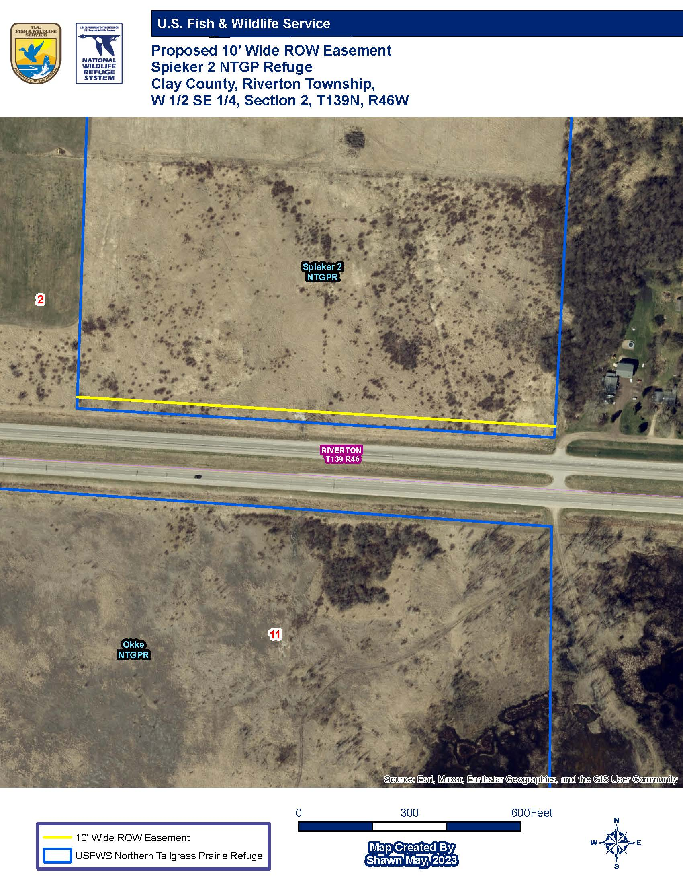
Figure 1: Location of the proposed 10' wide right of way along the southern edge of the Spieker 2 unit within the Norther Tallgrass Prairie National Wildlife Refuge.

