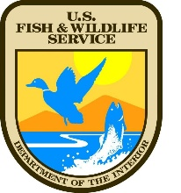
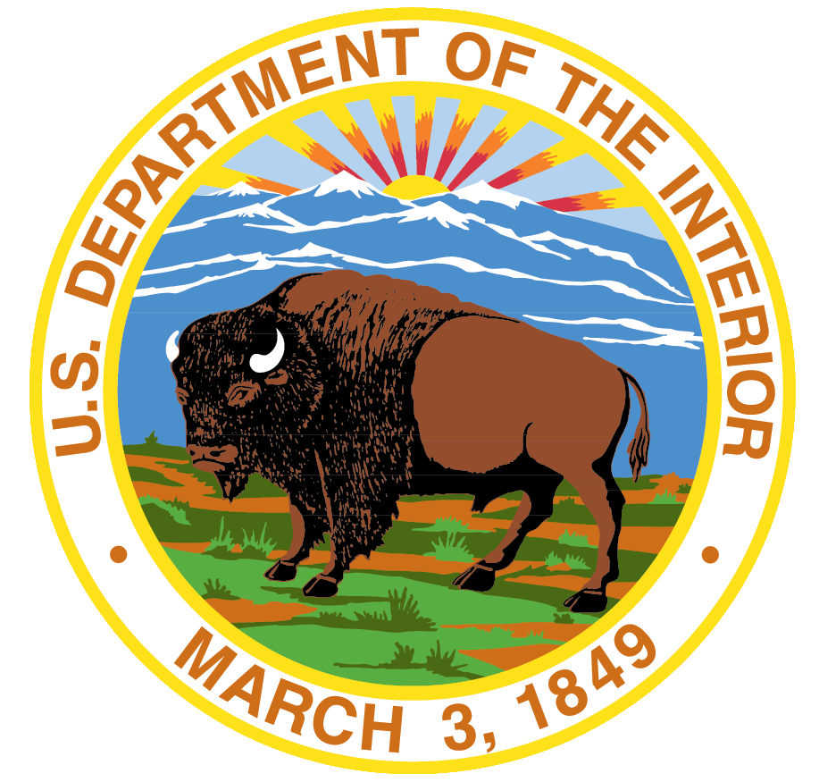

United States Department of the Interior
FISH AND WILDLIFE SERVICE
KLAMATH MARSH NATIONAL WILDLIFE REFUGE

21401 Silver Lake Road
Chiloquin, OR 97624

TELE (541) 783-3380

Date: July 7, 2022
To: Interested Hay Operators
Subject: 2022 Refuge Haying Units

The U.S. Fish and Wildlife Service – Klamath Marsh National Wildlife Refuge – is offering three haying permits in 2022. Hay units are located at T31S R8E Sections 11/12/13/14 and Sections 21/22/23/26/27/28, TS30S R9E Sections 28/33, and TS31S R9E Sections 4/8/9/17/20/29. Hay areas are divided into three units: South Silver Lake (1,674 acres), North Silver Lake (833 acres), and Wocus (562 acres).

Hay unit descriptions, special conditions, maps, and a bid application are provided below. Cooperators are responsible for following all terms and conditions identified in the requirements and regulations section of this package.

Cooperators will be selected based on receipt of a sealed bid for each of the haying units. In the event of numerous bids, the USFWS retains the right to only accept a single bid from any one family farm/ranch, or trust or cooperative agricultural business. Sealed bids are due at the Refuge Office no later than 4:30 PM PST, July 28, 2022. Bids can be submitted by phone (541) 783-3380, e-mail (michael_r_johnson@fws.gov), or mail.

Please call the Refuge Headquarters if you have any questions about the units or bidding process.

Sincerely,

Mike Johnson
Refuge Manager – Klamath Marsh National Wildlife Refuge
21401 Silver Lake Road
Chiloquin, OR 97624
541-783-3380 - office

