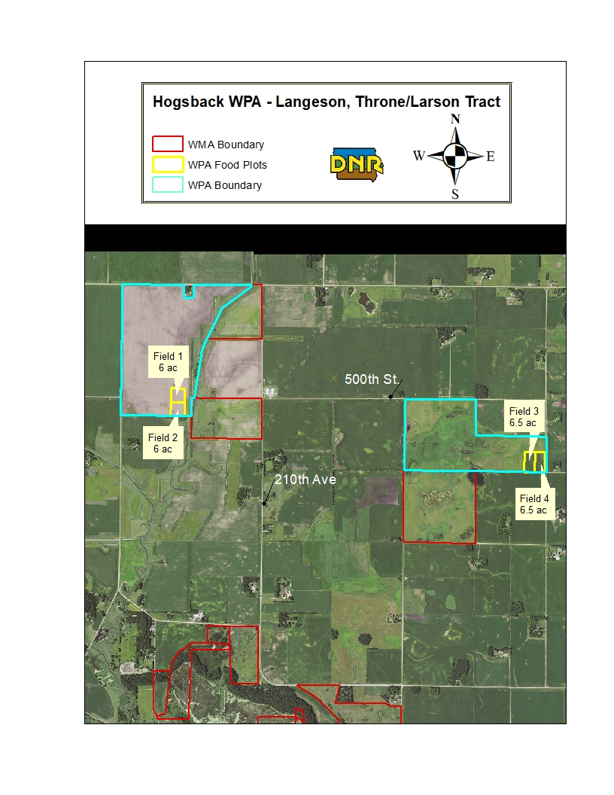
HOGSBACK WPA – LANGESON and THRONE/LARSON TRACTS
AGRICULTURAL LEASE AGREEMENT
Fields 1,2 Section 9 T100N, R23W and
Fields 3,4 Section 14, T100N, R23W, Winnebago Co., IA

LEASE AGREEMENT CROP PLAN – 25.0 ACRES

Field No. | Acres | 2022 | 2023 | 2024
1 | 6 | Beans | Corn | Beans
2 | 6 | Corn | Beans | Corn
3 | 6.5 | Beans | Corn | Beans
4 | 6.5 | Corn | Beans | Corn
TOTAL | 25.0

CROP ACREAGE SUMMARY BY CROP YEAR:
2022 – Soybeans – 12.5 ac.; Corn – 12.5 ac. all left unharvested until 3/1/23
2023 – Soybeans – 12.5 ac.; Corn – 12.5 ac. all left unharvested until 3/1/24
2024 – Soybeans – 12.5 ac.; Corn – 12.5 ac. all left unharvested until 3/1/25

LEASE AGREEMENT MANAGEMENT PLAN

- Cable gates must be closed and locked when Operator is not physically on the area.
- Permittee is required to implement or maintain site specific Best Management Practices, as designated by IA DNR.
- An approved Pesticide Use Proposal is required before pesticide application and the permittee is required to follow the associated guidelines contained in the Pesticide Use Proposal. Use of any other chemical (herbicide or pesticide) without an approved Pesticide Use Proposal will constitute a Refuge violation, and revocation of any Special Use Permit.
- Permittee may be required to post fields after pesticide application (check with DNR office or Ag. Manager).
- GMO crop use is not allowed. Only conventional crop seed may be used on fields intended for food plots.
- Neonicotinoid treated seed will not be permitted to be used on any U.S. Fish and Wildlife Service lands including Waterfowl Production Areas.

_______________________________________ _______________________
Operator’s signature Date

__________________________________________ ______________________
DNR’s Land Manager Date

Iowa Wetland Management District
Agricultural Bid Sheet

Instructions:

- Complete this bid sheet with your bid and contact information. If you are the winning bidder, you will be contacted. you will complete a Special Use Permit once the bid is accepted.
- This bid sheet needs to be mailed or turned in to Agriland Inc. 17 West 4th St. Spencer IA, 51301 by 4:00 p.m. on March 7, 2022.
- You will need to evaluate the bid solicitation for each unit and the cropping plan for the next year and place your total bid. This will be your competing bid, and highest bid will be awarded. In the event of a tie bid, the winning bidder will be randomly drawn from the tying bidders. Place NA on any crops you do not want to bid on.

Year 2022 | Field # | Acres | Unharvested Amount | Bid Amount
Row Crops | 1,2,3,4 | 25.0 | 12.5 | $/Acre
Small Grains
Grazing/Paddock
Hay

Signature of Bidder:___________________________________ Date:_____________

Name: _______________________________________________

Address: _____________________________________________
_____________________________________________________

Phone: _______________________________________________

Email Address: _______________________________________________

