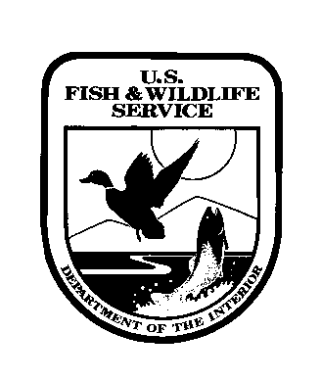
UNITED STATES DEPARTMENT OF THE INTERIOR
FISH AND WILDLIFE SERVICE
Valley City Wetland Management District
11515 River Road
Valley City, ND 58072
701-845-3466

2023 Application and Bid Form for Grazing Privileges

Name_____________________________________________________________Application Date____________
Address___________________________________________________Telephone No.______________________
City, Zip Code, and County_____________________________________________________________________
Email (optional)______________________________________________________________________________

The U.S. Fish and Wildlife Service (Service) is planning to allow approximately 213 acres of pasture to be grazed on 2 Waterfowl Production Areas (WPAs) in the Valley City Wetland Management District in 2023. Bids will be accepted immediately and opened at 1pm, Monday, March 20, 2023. You may mail your bid(s) to the address above or email them to kurt_tompkins@fws.gov.

Pre-inspection of units is encouraged. Successful bidders will be notified by telephone no later than March 21st and issued a Special Use Permit.

Please write your bid in the table on the other side of this form. If you bid on more than one unit, please rank the units in priority order by circling a number in the “Bid Priority” column for each unit, 1 being your highest priority and 5 being your lowest.

If you are the high bidder on your first priority unit, we will issue you a permit on that unit. If you are the high bidder on units that you ranked lower than your number one priority, you will be offered the opportunity on the units you ranked lower than number one if there are no other bidders for those units.

If there are other bidders on the units you ranked lower than number one, the next highest bidder on the unit will be given the opportunity to graze the unit at the price that the bidder submitted, provided that bidder has not been successful on other units. In case of a tie the parties will be drawn by chance.

We will calculate the final bill at the end of each grazing season. Please review the maps and special terms and conditions and bid accordingly.

If you have any questions, please contact Kurt Tompkins, District Manager, at 701-840-3128 or kurt_tompkins@fws.gov. Our phone number and address can be found above.

Please sign and date below the bid table on the back of this form and submit to our office at the address above by the bid opening.

Minimum Bid of $13.00

WPA Grazing Unit | Bid per AUM | Bid Priority
Rogers WPA (Steele County)  T144N. R55W. Sec 9  116 Acres |  | 1 2 3 4 5
Erickson WPA (Traill County)  T145N. R6053W. Sec 29  96 Acres |  | 1 2 3 4 5

Bidder's Signature__________________________________________Date:______________

