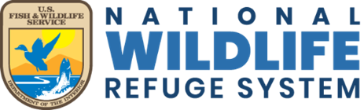
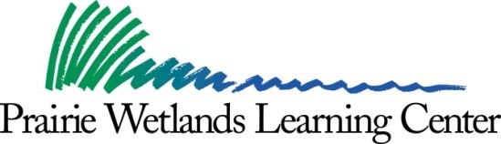
2022 Events

July 9
Date | Description
January 1 – September 15  Through August 31 | Friends of Prairie Wetlands Learning Center Photography Contest for all ages. For additional information and entry forms, stop by the visitor center or visit Facebook: @FriendsPWLC. FREE  Visitor Center Open 8:00 am – 4:00 pm Monday, Wednesday, and Friday only. Closed Tuesday, Thursday, weekends, and federal holidays. FREE
June 14 and  August 16  June 16 and  August 18  June 18  June 20  June 21-23  June 21 and 22 | Nature Tots for ages 4 and 5 years with an adult. Times: 10:00 am – 11:00 am. Outdoor activity. Topics to be announced. Call 218-998-4480 to register. FREE  Nature Programs for children entering kindergarten through 6th grades. Outdoor activity. Times: 10:00 am – 11:30 am for children entering kindergarten through 3rd grade. 1:00 pm – 3:00 pm for children entering 4th through 6th grades. Topics to be announced. Call 218-998-4480 to register. FREE  Green Gym Workout I for youth and adults. Time: 8:00 am -12:00 pm.  Work outside along the trails with the Friends of Prairie Wetlands Learning Center and PWLC staff to remove invasive species while learning about the prairie plant community. Call 218-998-4488 to register. FREE  Compass to Nature Workshop for educators. Time: 8:00 am - 4:00 pm Acquire skills for teaching in the outdoor classroom. Receive 7 hours of continuing education credit. Call 218-998-4493 or email mdavis@fergusotters.org register. Cost: $25.  Biology Camp Lite – for students entering 5th – 6th grades. Time: 9:00 am – 12:00 pm. For more information stop by the PWLC or call for a brochure. Phone 218-998-4480 to register for the waiting list. FREE  Adventure Painting with artist Katrina Case for ages 12 to adult.  All skill levels welcome. Time: 5:30 pm, Tuesday evening session, June 21; 8:30 am Wednesday morning session, June 22. Hike to a scenic location for a guided two-to-three-hour landscape painting session. (Over for more…)  Art supplies provided. For additional information call 218-998-4480. To register, call 218-998-4488 or email friendspwlc@gmail.com. Cost $25
July 1 | Firefly Walk for all ages. Time: 9:00 pm – 10:00 pm.  Experience the twinkling magic of lightning bugs in the dark prairie. Catch, examine, and release them. Find out more about how these wonder-full insects create their literally cool light. Call 218-998-4480 to register. FREE
July 16  August  7-13 | Green Gym Workout II for youth and adults. Time: 8:00 am – 12:00 pm. Work outside along the trails with the Friends of Prairie Wetlands Learning Center and PWLC staff to remove invasive species while learning about the prairie plant community. Call 218-998-4488 to register. FREE  Woodie Camp for youth 13-15 years of age.  Presented by the Fergus Falls Fish and Game Club, a week-long residential waterfowl camp. Register on Facebook at Woodie Camp Fergus Falls MN. For more information, call camp leaders: Tony Rondeau, 218-770-2025 or Brad Nylin, 763-232-2783. Cost: $50
August  15 – 31 | Monarch Butterfly Tagging for all ages. Time: 10:00 am – 3:00 pm. Mondays, Wednesdays, and Fridays.  Catch and release monarch butterflies for tagging. Citizen science that makes a difference for this amazing and declining species. FREE
August 20 | Saturday Monarch Tagging for all ages. Time: 10:00 am – 3:00 pm.  Catch and release monarch butterflies for tagging. Citizen science that makes a difference for this amazing and declining species. FREE
August 27 | CANCELLED -- Duck Banding for all ages. Time: 10:00 am – 11:30 am.  Find out what duck banding is all about, and band and release a live, wild duck! Call 218-998-4480 to register. Meet at Adams Pond. FREE
September 24 | National Public Lands Day for all ages. Time: 9:00 am – 12:00 noon.  Assist with habitat restoration projects at the PWLC. Be part of the national celebration of public lands. Register at 218-998-4480. FREE

Prairie Wetlands Learning Center
602 State Highway 210 East
Fergus Falls, Minnesota 56537

Web site
https://www.fws.gov/refuge/fergus-falls-wetland-management-district

Phone: 218/998-4480 (voice)

Deaf/Hard of Hearing individuals may reach the Fergus Falls Wetland Management District through Minnesota's State Relay System by dialing: 711
1-800-627-3529 (voice, TTY, ASCII)

Events are subject to change.

