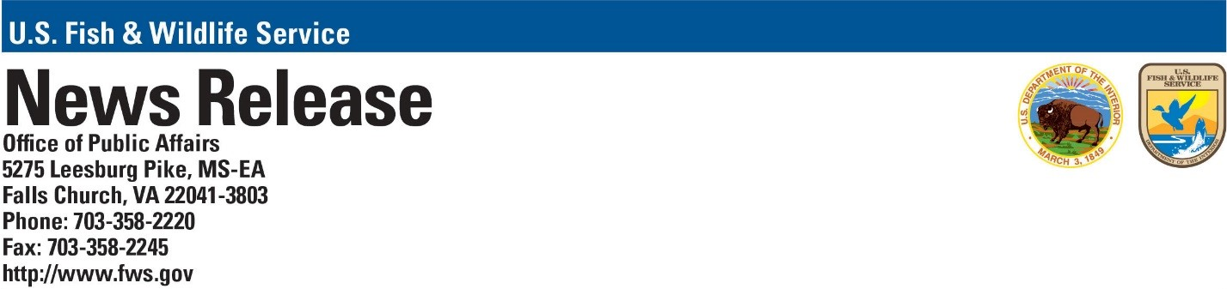

FOR IMMEDIATE RELEASE
June 6, 2022
Contact: publicaffairs@fws.gov

Department of the Interior Proposes Expanding Conservation Technique as Climate Change Threatens Greater Species Extinction

In the first Endangered Species Act (ESA) interpretive rule produced under the Biden-Harris administration, the U.S. Fish and Wildlife Service is proposing to revise section 10(j) regulations under the ESA to better facilitate recovery by allowing for the introduction of listed species to suitable habitats outside of their historical ranges. The proposed change will help improve the conservation and recovery of imperiled ESA-listed species in the coming decades, as growing impacts from climate change and invasive species cause habitats within their historical ranges to shift and become unsuitable.

Reintroducing species of plants and animals back into areas where they have disappeared has been a regularly used technique in wildlife conservation for decades, and federal agencies were authorized by Congress to create experimental populations to aid in that effort in 1982.

“Climate change and the rapid spread of invasive species pose an ever-increasing threat to native biodiversity. The time to act – and use every tool at our disposal – is now,” said Secretary of the Interior Deb Haaland. “The growing extinction crisis highlights the importance of the Endangered Species Act and efforts to conserve species before declines become irreversible. This effort to update proven conservation tools will help ensure species on the cusp of extinction can recover and thrive for generations to come.”

Foundational conservation policy must keep pace with corresponding science, which has shown that climate change and invasive species are pushing plants and animals into completely new geographic areas for the habitat needed for their continued survival. Improving the ESA’s experimental population regulations will prevent more species from becoming stranded when conditions change in their current habitat and help establish them in more suitable habitats given these rising threats.

“Recovering species and preventing their extinction will require innovative, proactive, science-based policies and conservation actions that address the growing impacts from climate change and invasive species before it is too late,” said Martha Williams, Service Director. “The Service remains committed to working with our diverse state, local and Tribal partners to meet these growing challenges, and appreciates how vital locally driven, partnership-based solutions will be in the coming years.”

The Service uses experimental populations as a recovery tool when there is a need to establish a new population of an ESA listed species outside of its current range. This tool furthers the conservation of the species by establishing more populations, while also providing fewer regulatory restrictions for affected partners. Establishment of an experimental population requires a rulemaking process, including publishing the rule in the Federal Register and providing the public an opportunity to review and submit comments. Experimental populations have been used to help advance the recovery of numerous listed species including but not limited to, California condors, whooping cranes, and Sonoran pronghorns.

Stemming this extinction crisis is a central component of the Biden-Harris administration’s America the Beautiful initiative. This locally led and voluntary effort aims to conserve, connect and restore 30 percent of lands and waters in the U.S. by 2030, while enhancing wildlife habitat and improving biodiversity.

Under today’s proposed revisions, the Service would be able to introduce an experimental population of an ESA threatened or endangered species into suitable habitat outside of its current range and probable historical range. The revised regulation will not change the rulemaking process for designating a 10(j) experimental population or require reevaluation of existing experimental populations.

Scientists have already observed wildlife responding to the effects of climate change, with some species and ecosystems losing habitat due to increased temperatures, altered rain and snow patterns, sea level rise, and greater frequency and intensity of drought and wildfires. These species include the Mt. Rainer ptarmigan in Washington state, Montana stoneflies, and the emperor penguin, found in the Antarctic. Climate change has also exacerbated existing threats to plants and wildlife, such as greater threats from disease and invasive species. In Hawaii, increased temperatures are driving the spread of avian malaria among some of the world’s most endangered birds, as mosquitoes move upslope. At Blackwater National Wildlife Refuge in Maryland, coastal wetlands are being overtaken by the invasive grass phragmites -- a problem made worse by sea level rise -- causing the loss of habitat for imperiled species such as the saltmarsh sparrow.

The Service is also proposing other minor changes to provide more clarity in the regulations. We will accept comments from all interested parties until August 8, 2022. Please note that if you are using the Federal eRulemaking Portal, the deadline for submitting an electronic comment is 11:59 p.m. Eastern Standard Time on this date (https://www.regulations.gov. In the Search box, enter FWS-HQ-ES-2021-0033).

The U.S. Fish and Wildlife Service works with others to conserve, protect and enhance fish, wildlife, plants and their habitats for the continuing benefit of the American people. For more information, visit www.fws.gov, or connect with us through any of these social media channels: Facebook, Twitter, YouTube and Flickr.
-FWS-

