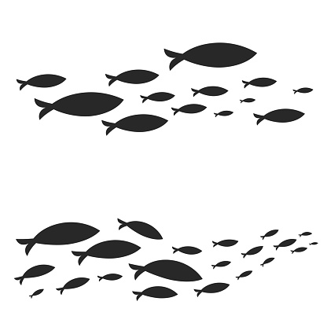

Visit Your Local Refuges
www.fws.gov/Refuge/Ridgefield

EXPLORING THE SENSES
A JOURNALING ACTIVITY
Steigerwald Lake National Wildlife Refuge

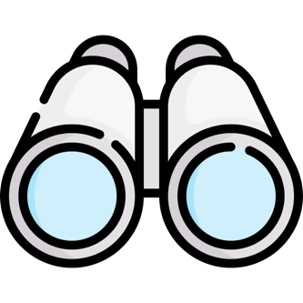

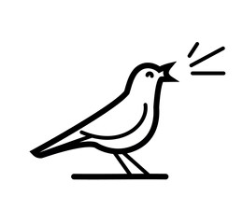

Your Name: ______________________

Instructions
1. This book is a guidebook to help you engage with nature through different activities that touch our various senses that can be used in any natural space, even your backyard!
2. At the beginning of each part, it explains how to do the activity.
3. These activities can be done in any order you wish, or not at all! This book is a guide for you during your time outside, not a quiz of nature knowledge.
4. Most importantly, enjoy your day outside and see what you notice. There is a lot to notice once you stop and look.

KEEP TRACK

Mark how many birds you see!

Mark all the animals you see
that are not birds!

Mark all the different kinds of plants, including trees, that you notice!

Mark every time you see an insect!

Mark every time you feel
a connection with nature!

TOUCH
Find each thing that feels different, then draw it!

FIND: Something smooth

FIND: Something rough

FIND: Something sharp

FIND: Something soft

FIND: Something warm

FIND: Something cold

SIGHT
What shapes can you find naturally in nature? Draw them in the box below as you find them. Try to find three different shapes!

Example

COLORS: Find different colors as you look around nature. Check off each color as you find it!
- Yellow | - Red | - Light Green
- Brown | - Grey | - Pink
- Dark Green | - Orange | - Blue
- Black | - White | - Purple
SOUND
Write down something you heard and then draw what you think that sound would look like!

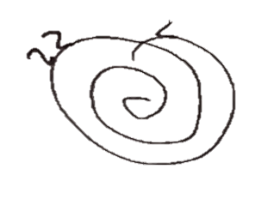
(Example): What did you hear?
A bug

_________________________

What did you hear?

_________________________

_________________________

What did you hear?

_________________________

_________________________

What did you hear?

_________________________

_________________________

SMELL
Hunt down two smells and write down what you found!

- _____________________________________

- _____________________________________

DRAWING SPACE
Use this space to draw anything else that you want that you notice around you!

