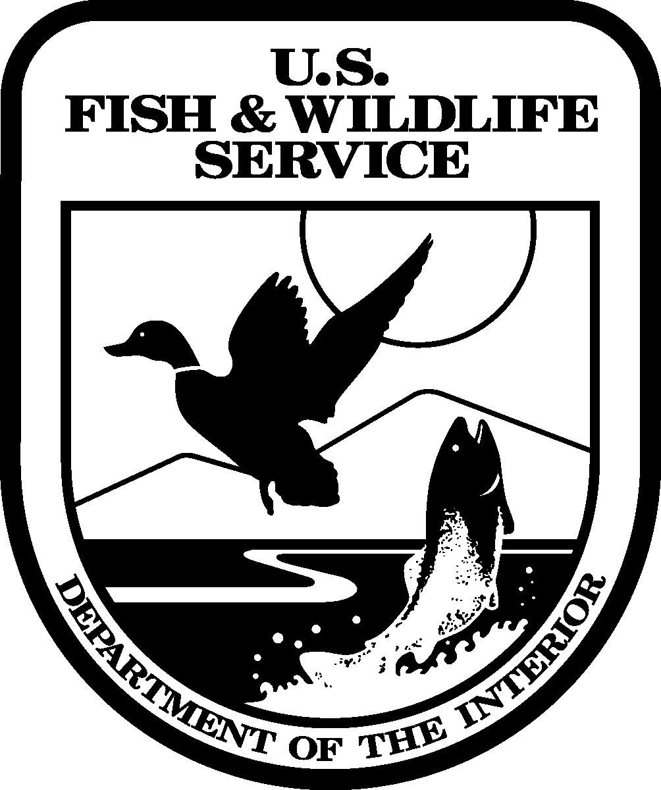
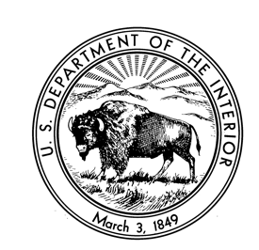
United States Department of the Interior

U.S. FISH AND WILDLIFE SERVICE
Oʻahu National Wildlife Refuge Complex
56-795 Kamehameha Hwy
P.O. Box 429
Kahuku, Hawaii 96731

Oahu National Wildlife Refuge Complex Bird Tour Rules

- Gate will be locked at 8 am. Please arrive by 7:45 am.
- Tours will be limited to 10 individuals per tour guide with a maximum of 20 people for 2 tour guides.
- Please park in the area between the gate and the office building.
- Please ensure that vehicles, clothing and gear are clean and free of seeds or pests before entering the refuge.
- Pets are not allowed on the Refuge and may not be left in cars. Service animals are allowed with a 6ft or less leash and a muzzle, but animals are discouraged from being brought to the refuge in consideration of rare, endangered wildlife.
- Some binoculars will be available, but we encourage visitors to bring their own optics if possible.
- Visitors will abide by the guidance of the tour docents, FWS staff, and/or Kupu members.
- Alcohol and drugs and their use are strictly prohibited on the refuge. Any person who is visibly intoxicated will be asked to leave the premises immediately.
- Groups must stay together during tour activities to minimize disturbance to wildlife. It is not permitted to wander outside of the authorized tour area or away from the group.
- Photography is allowed but must be conducted at an appropriate distance to avoid disturbance to wildlife.
- Drone use is not permitted on the Refuge.
- Food and beverage are not permitted on the Refuge, except for water. Please plan to stay hydrated!
- Close toed shoes are required.

Please remember that you are on closed Federal public lands. Violations of local, state, and Federal laws will be prosecuted to the full extent of the law.

We love dogs! But our endangered and native birds do not. Please help us to protect our wildlife. Mahalo.

