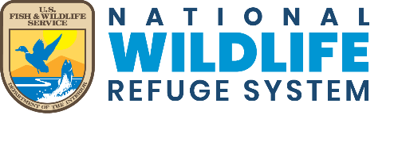

**San Luis Valley National Wildlife Refuge Complex**

***Cooperative Agriculture Program***

**Sheep Grazing Permit**

**Application Package**

**(2023-2027)**

**Attention Agricultural Operators:**

The U.S. Fish & Wildlife Service (Service) is seeking to permit selected agricultural operator(s) for a Cooperative Agricultural Program at the San Luis Valley National Wildlife Refuge Complex (Refuge Complex). The refuge complex consists of the Alamosa, Monte Vista, and Baca National Wildlife Refuges in southcentral Colorado. Under this permit agreement, selected operator(s) will fulfill prescriptions for specific intensities of sheep grazing for a period of up to 5 years (2023-2027). The acres available for grazing will vary annually based on habitat and environmental conditions, however about 5500 acres on Alamosa Refuge, about 9000 acres on Monte Vista Refuge, and about 15,000 aces on Baca Refuge are considered for these offerings,

each year for a period of up to 5 years (2023-2027).

**Background**

The Service’s Comprehensive Conservation Plan (CCP) for the Refuge Complex provides resource management objectives for each refuge. It outlines that the refuges provide resting, feeding, and breeding habitats for native fish, wildlife, and migratory bird species. Additionally, it identifies the permitting of prescribed grazing as a management tool as an appropriate, compatible, and necessary use to meet the CCP objectives. So, through the Cooperative Agricultural Program, both the selected applicants and the Service complete and sign both a Special Use Permit and a Cooperative Agricultural Agreement to permit grazing on refuge lands accordingly.

**Proposed Cooperative Agriculture Agreement**

Interested applicants should read all requirements and flexibilities outlined in this package and complete the application as thoroughly as possible. Selected sheep operators will work under a Cooperative Agriculture Agreement (CAA) as a “Cooperator” with the U.S. Fish & Wildlife Service (Service). Under this agreement, selected Cooperators will fulfill prescriptions for specific intensities of sheep grazing on the Refuge Complex for a period of up to 5 years (2023-2027).

Bids will be accepted based on cattle equivalent of Animal Unit Month (AUM) of which, a Mature Sheep/Goat is 0.2 AUM and an Ewe-lamb/nanny-kid pair is 0.3 AUM. The minimum bid accepted is $19.50/AUM. This grazing fee is based on average grazing fee rates published by USDA, National Agricultural Statistics Service (NASS) for Colorado for 2022. Grazing fees in years 2023-2027 will be adjusted accordingly based on NASS published average rates.

There will be three (3) Bid Packages available for bidding. Cooperators can submit applications for one, two, or for all three bid packages. If applying for more than one bid package, operators must be able to fulfill all required stocking rates for each refuge separately.  **\*\*\*** Potential bidders **must** attend a pre-bid onsite briefing and formal inspection tour to have their bids considered.

**Bid Package # 1 - Alamosa Refuge, Alamosa County, Colorado**

**Bid Package # 2 - Monte Vista Refuge, Rio Grande County, Colorado**

**Bid Package # 3 - Baca Refuge, Saguache County, Colorado**

Cooperator(s) will be selected through an open, transparent, and competitive process where applicants will be scored and ranked based on a combination of a competitive bids, reference checks, flexibilities, ability to provide in-kind services, and relevant experience.

Applications **must be received by 4:30 p.m. on Friday, February 24, 2023.** (Postmarked by Friday, February 24, 2023, if mailed)

Hand delivers or Mail to:

**SLVNWRC – Dean Lee**

**Attn: 2023-2027 Sheep Grazing**

**9383 El Rancho Lane**

**Alamosa, CO 81101**

OR

Email to:

Dean_Lee@fws.gov with subject line “2023-2027 Sheep Grazing”

Sealed applications will be opened starting on February 27, 2023, and selected operators will be notified starting on Monday, March 6, 2023.

For more information, please reach out to Dean Lee at 1-719-589-4021 ext. 1008 or by email at Dean_Lee@fws.gov.

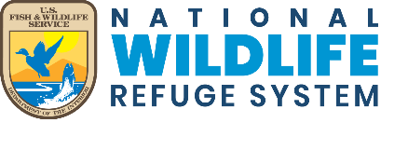

**Bid Package # 1 – Alamosa Refuge**

* The following is information pertaining to sheep grazing permits on the Alamosa Refuge. Please familiarize yourself with this information when preparing your bid. The information contains the requirements and flexibilities that the Service will be considering when evaluating your bid package.

* Potential bidders **must** attend an onsite briefing and formal inspection tour with the Refuge Manager which will occur on **Monday, February 27, 2023**, beginning at 9:00 a.m. at the **Alamosa** **Refuge Visitor Center** located at9383 El Rancho Ln., Alamosa, Colorado 81101 (no additional inspections will be accommodated).

*** **Bids will only be accepted by operators who attend the briefing/inspection.**

**Bid Package # 1 - Alamosa National Wildlife Refuge –**

**2023-2027 Prescribed Sheep Grazing Permit Bid Package**

**Attachment A – Sheep Grazing Program Description & Goals (page 1)**

**Program Description**

The Alamosa Refuge is proposing to graze up to 2 bands of sheep (1000 Ewes w/ lambs in each band) on up to approximately 5,500 acres on the Alamosa National Wildlife Refuge (Refuge) between the period May 1 and October 30 annually during the period 2023-2027. Grazing rates will vary between 0.04 AUM’s and 1.00 AUMs per acre to be adjusted by animal numbers and duration of grazing period.

Bids will be accepted based on cattle equivalent of Animal Unit Month (AUM) of which, a Mature Sheep/Goat is 0.2 AUM and an Ewe-lamb/nanny-kid pair is 0.3 AUM. The minimum bid accepted is $19.50/AUM. This grazing fee is based on average grazing fee rates published by USDA, National Agricultural Statistics Service (NASS) for Colorado for 2022. Grazing fees in years 2023-2027 will be adjusted accordingly based on NASS published average rates.

**Program Goals**

Areas to be grazed are dry meadows, grasslands, transitioning farm ground and uplands found throughout the refuge. Because of the periodic nature of irrigation and subsequent vegetative management in these habitats during past years, they have become heavily invaded by aggressively growing and prolific non-native plants such as Russian Knapweed (*Acroptilons repens*), Tall Whitetop (*Lepedium latifolium*) and Canada Thistle (*Cirsium arvense*). Recent years efforts using sheep in these areas have been effective in reducing the vigor of plant growth in both Tall Whitetop and Russian Knapweed, as well as in preventing most plants of these species from producing seed. These efforts have also showed that when sheep were able to impact the plants early in the growing season (w/in 30 days of germination), the plants were less resistant to impacts by the grazing animals on future rotations (i.e., beginning too late in the season resulted in plant vigor not being reduced and

**Bid Package # 1 - Alamosa National Wildlife Refuge –**

**2023-2027 Prescribed Sheep Grazing Permit Bid Package**

**Attachment A – Sheep Grazing Program Description & Goals (page 2)**

only prevention of seed production was gained) during the same growing season. Typically, rotation times are reduced as the growing season progresses as desired impact to invasive species occurs more quickly when sheep enter a unit for the second or third time. Actual rotation times are driven by impacts on desired native vegetation (grasses). Sheep have been tending to prefer forbs when first entering a new area. Once forbs are eaten or if sheep are allowed to stay in one area for too long then they will begin to impact grasses. To prevent sheep from “stalling” in areas, herders are required to keep constant gentle pressure on the animals while feeding. If moved too fast many target species are missed and go un-impacted. If moved too slow non-target species can be negatively impacted. Herders are educated to recognize desired effects within the units so they can alter their control (speed) to get these desired effects.

Prescribed grazing by the above proposed numbers of sheep will be used to impact infested areas on a planned rotation, with up to 4 rotations scheduled during each growing season. Success of this program is dependent on close cooperation between the cooperator, specific herders, and refuge staff. Regular evaluation of vegetation, and animals will be required of the cooperator and herders. Refuge personnel will work closely with herders providing regular observations and subsequent adjustments to scheduling and sheep movement techniques.

Changes to the duration and number of rotations used will be made based on habitat conditions.

**Bid Package # 1 - Alamosa National Wildlife Refuge**

**2023-2027 Prescribed Sheep Grazing Permit Bid Package**

**Attachment B – Sheep Graze Area Map**

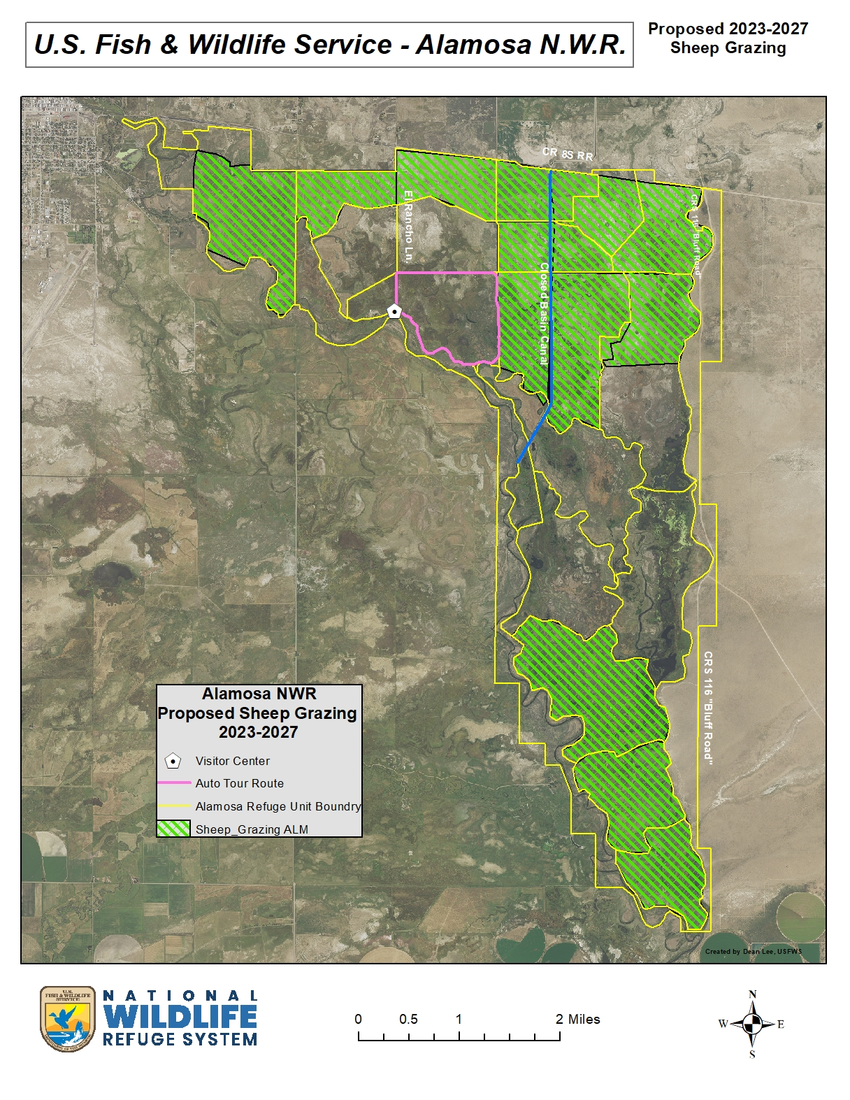

**Bid Package # 1 - Alamosa National Wildlife Refuge –**

**2023-2027 Prescribed Sheep Grazing Permit Bid Package**

**Attachment C – Special Conditions Pertaining to Permit (page 1)**

**SPECIAL CONDITIONS**

The grazing permit will be issued to support invasive plant species control efforts on the Alamosa National Wildlife Refuge using varying numbers and intensities of sheep over a 5-year period (2023-2027).

**Eligible Deductions for selected Cooperators include**:

*\* Full Time Herder w/camp* ***$3527/Month***

*\* Water Hauling* ***$0.03/gallon***

*\* In-Kind Services*

- Success of this program is dependent on close cooperation between the cooperator, specific herders, and refuge staff. Regular evaluation of vegetation and animals will be required of the Cooperator and herders. Refuge personnel will work closely with herders providing regular observations and subsequent adjustments to scheduling and sheep movement techniques.

- Cooperator will document all sheep move dates among the overall areas grazed. This documentation will then be given to the Refuge Manager at the end of the grazing season along with the dates and descriptions of any problems that occurred and were reported to the Refuge Manager.

- The Cooperator certifies that all livestock grazing under this permit comply with State Livestock Health Laws.

- If watering problems develop, the refuge staff must be contacted. Releasing water from impoundments or other water control structures by the permittee will not be allowed.

- Actual grazing is not guaranteed during each year of the permit. Grazing needs are based entirely on habitat conditions. If habitat conditions do not warrant a grazing need for a particular year, it will not be prescribed. In addition, Refuge Manager retains the right to discontinue prescribed grazing practices in the event that compatibility or any other issue/concern arises or if desirable effects are obtained prior to proposed end date.

- Dates may vary within approved range and within approved AUM’s based on impacts sheep are having on subject habitats.

- The cooperator must abide by Title VI of the Civil Rights Act of 1964 and not deny any person the right to receive any service or benefit because of race, color, creed, sex, or national origin.

- Cooperator is expected to act in a manner that is respectful of refuge habitats, wildlife, and property, and is subject to all laws pertaining to the National Wildlife Refuge System.

- All persons working on the refuge as a result of an issued permit are required to have a copy of the permit on their person/vehicle while on the refuge. Failure to do so may result in criminal penalties for trespass.

**Bid Package # 1 - Alamosa National Wildlife Refuge –**

**2023-2027 Prescribed Sheep Grazing Permit Bid Package**

**Attachment C – Special Conditions Pertaining to Permit (page 2)**

- Cooperator is not to be considered agent of the U.S. Fish and Wildlife Service and is not to represent the Service in any matters. All matters arisen or encountered should be promptly brought to the attention of Refuge Management at (719) 589-4021.

- Cooperator shall perform all work required under an issued permit in accordance with the highest standards of their profession or craft and to the satisfaction of the U.S. Fish and Wildlife Service and work in accordance with all laws and regulations and shall obtain all/any necessary permits or licenses required.

- The work performed under an issued permit shall be performed entirely at the cooperators risk. The cooperator shall indemnify and hold the U.S. Fish and Wildlife Service harmless for any and all liability and/or loss arising in any way out of the performance of this permit.

**Ownership**

-All sheep must be owned by cooperator and must have been in San Luis Valley at least 1 year or newborn in San Luis Valley. No sub-leasing or non-cooperator owned sheep are allowed.

-All animals must be identifiable as belonging to cooperator, and cooperator must provide Refuge Manager with any brand and location information, along with ear tag colors/information.

**Access and Travel Management**

-All vehicle travel is restricted to developed roads and two-track roads, and only within prescribed grazing units. Any ATV use and/or needed vehicle use deviations must be pre-approved by Refuge Manager in writing prior to any action taken.

-All equipment for grazing, including camp units, ATVs and UTVs, must be clean and free of invasive species plant material including seeds and must be inspected by refuge personnel prior to entering the Refuge.

**Sheep Herding**

- A herder is required to be with sheep. The main flock will never be left unattended for any reason.

-Sheep will be herded and distributed across the management unit in order to achieve proper grazing of key vegetation species of concern. Herders will spend as much time as necessary to move sheep from areas of high use to areas of light use to ensure proper grazing distribution.

-Sheep will be moved away from water sources after animals have finished drinking.

-All sheep must be accounted for (dead or alive) as they enter and exit each management unit. Special attention should be given to accounting for sheep as they are trailed between the management units. If sheep are unaccounted for, efforts should be made to locate them as quickly as possible. Stray or left behind sheep must be gathered within 24 hours of recognition.

-Injured or sick sheep will not be left behind but will be moved and/or dispatched and removed from refuge.

**Bid Package # 1 - Alamosa National Wildlife Refuge –**

**2023-2027 Prescribed Sheep Grazing Permit Bid Package**

**Attachment C – Special Conditions Pertaining to Permit (page 3)**

-Herders will employ gentle herding techniques based on slow movement, moving sheep constantly from early morning through early evening with period of rest for 1-3 hours during afternoon hours. Sheep are to be rested in problem invaded areas.

**Sheep Bedding**

-Sheep will be bedded on new ground every night and moved to fresh feed daily.

-Sheep bed grounds will be no closer than **200 feet** from any road, water source, riparian corridor, or active wetland.

**Salting/Supplemental Practices**

-Supplemental feeding on refuge land is prohibited without the advance approval, in writing, from Refuge Manager.

-Salting will be allowed and can be used to improve distribution of sheep into areas of light use and lessen impacts on areas of high use. However, any proposed action must be pre-approved by Refuge Manager prior to implementation.

-Approved salt blocks will be moved daily to prevent over impact on any given area within the management unit.

-Salt will be placed no closer than **300 feet** from any road, water source, riparian corridor, or active wetland.

-All salt will be removed from each management unit when sheep are moved out of the management unit.

**Disposal of Dead Sheep**

-All dead sheep must be removed promptly from the refuge.

**Herder Camps**

-Sheep herder camps will be moved every 1-7 days.

-Herders must have the ability to move camps independently and on a potentially frequent basis (daily) without assistance from the cooperator.

-Camps will be placed no closer than **300 feet** from any road, water source, riparian corridor, or active wetland.

-Camps will be kept clean and all garbage packed out a minimum of 3 times weekly.

- **No** wood burning stoves or open fires will be allowed on sheep herder camps, or anywhere on the refuge.

**Bid Package # 1 - Alamosa National Wildlife Refuge –**

**2023-2027 Prescribed Sheep Grazing Permit Bid Package**

**Attachment C – Special Conditions Pertaining to Permit (page 4)**

-Sheep herders will not be allowed to do any excavating at camp sites.

-Cooperators are required to visit sheep camps and account for all sheep a minimum of **3 times weekly**

**Sheep Herder Working Dogs**

-Working dogs will be required to be under the herder’s control and must be non-threatening to people and non-threatening wildlife (i.e., prairie dogs, rabbits etc.…) or they will not be allowed.

**Animal Damage Management**

-Random killing of non-threatening predators will not be tolerated and will result in the immediate termination of a permit.

-Predator control will be limited to coyotes and feral dogs that are **actively** threatening sheep and Refuge Management must be notified prior to taking any action.

-Any approved animal damage management activities will be conducted according to State Law and Federal Regulations

-Dust bags, oilers, or other insecticide treatment or sprays may not be used on the refuge. Treated ear tags may be used.

-Sheep herder will make every effort to prohibit or minimize interactions between sheep and wild ungulates (antelope, deer, and elk). Hazing of elk, deer, and antelope will be allowed in the immediate vicinity of the sheep herd.

**Implementation monitoring**

-Cooperator and herders are responsible for monitoring sheep numbers and adhering to all management unit entry and exit dates.

-Cooperator and herders will keep a log of all move dates as well as any improvements made to water sources, fences, etc... This log will also include a description of problems encountered and any recommendations for future activities. This log will be turned over to Refuge Manager at the end of the management season.

- Cooperator and herders will participate in management unit inspections with Refuge Manager a minimum of four times during the management season, at least one of which will take place upon completion of the first rotation through management units. However, informal unit inspections by cooperator are encouraged and may occur at any time.

**Bid Package # 1 - Alamosa National Wildlife Refuge –**

**2023-2027 Prescribed Sheep Grazing Permit Bid Package**

**Attachment C – Special Conditions Pertaining to Permit (page 5)**

**Effectiveness Monitoring**

-The U.S. Fish and Wildlife Service will be responsible for carrying out effectiveness monitoring on this management action. Cooperator is encouraged to participate and can receive the results of any monitoring upon request.

**Bid Package # 1 - Alamosa National Wildlife Refuge –**

**2023-2027 Prescribed Sheep Grazing Permit Bid Package**

**Attachment D – Sample move schedule**

**(Sample) Grazing Schedule**

Sample grazing schedule showing pastures, date-in, date-out, number of days, number of animals (AU), animal units per month (AUM), season duration over a 30 day month.



**Bid Package # 2 – Monte Vista Refuge**

* The following is information pertaining to sheep grazing permits on the Monte Vista Refuge. Please familiarize yourself with this information when preparing your bid. The information contains the requirements and flexibilities that the Service will be considering when evaluating your bid package.

* Potential bidders **Must** attend an onsite briefing and formal inspection tour with the Refuge Manager which will occur on **Tuesday, February 28, 2023**, beginning at 9:00 a.m. at the **Monte Vista Refuge Office** located at6120 S Hwy 15, Monte Vista, Colorado 81144 (no additional inspections will be accommodated).

*** **Bids will only be accepted by operators who attend the briefing/inspection.**

**Bid package # 2 - Monte Vista National Wildlife Refuge –**

**2023-2027 Prescribed Sheep Grazing Permit Bid Package**

**Attachment A – Sheep Grazing Program Description & Goals (page 1)**

**Program Description**

Propose to graze up to 2 bands of sheep (1000 Ewes w/ lambs each band) on up to approximately 9,000 acres on the Monte Vista National Wildlife Refuge (Refuge) between the period May 1 and October 30 annually during the period 2023-2027. Grazing rates will vary between 0.04 AUM’s and 1.00 AUMs per acre to be adjusted by animal numbers and duration of grazing period.

**Program Goals**

Areas to be grazed are dry meadows, grasslands, transitioning farm ground and uplands found throughout the refuge. Because of the periodic nature of irrigation and subsequent vegetative management in these habitats during past years, they have become heavily invaded by aggressively growing and prolific non-native plants such as Russian Knapweed (*Acroptilons repens*), Tall Whitetop (*Lepedium latifolium*) and Canada Thistle (*Cirsium arvense*).

Recent years efforts using sheep in these areas have been effective in reducing the vigor of plant growth in both Tall Whitetop and Russian Knapweed, as well as in preventing most plants of these species from producing seed. These efforts have also showed that when sheep were able to impact the plants early in the growing season (w/in 30 days of germination), the plants were less resistant to impacts by the grazing animals on future rotations (i.e., Beginning too late in the season resulted in plant vigor not being reduced and only prevention of seed production was gained) during the same growing season. Typically, rotation times are reduced as the growing season progresses as desired impact to invasive species occurs more quickly when sheep enter a unit for the second or third time. Actual rotation times are driven by impacts on desired native vegetation (grasses).

**Bid package # 2 - Monte Vista National Wildlife Refuge –**

**2023-2027 Prescribed Sheep Grazing Permit Bid Package**

**Attachment A – Sheep Grazing Program Description & Goals (page 2)**

Sheep have been tending to prefer forbs when first entering a new area. Once forbs are eaten or if sheep are allowed to stay in one area for too long then they will begin to impact grasses. To prevent sheep from “stalling”

in areas, **herders are required** to keep constant gentle pressure on the animals while feeding. If moved too fast many target species are missed and go un-impacted. If moved too slow non-target species can be negatively

impacted. Herders are educated to recognize desired effects within the units so they can alter their control (speed) to get these desired effects.

Prescribed grazing by the above proposed numbers of sheep will be used to impact infested areas on a planned rotation, with up to 4 rotations scheduled during each growing season. Success of this program is dependent on close cooperation between the cooperator, specific herders, and refuge staff. Regular evaluation of vegetation, and animals will be required of the cooperator and herders. Refuge personnel will work closely with herders providing regular observations and subsequent adjustments to scheduling and sheep movement techniques.

Changes to the duration and number of rotations used will be made based on habitat conditions.

**Bid package # 2 - Monte Vista National Wildlife Refuge**

**2023-2027 Prescribed Sheep Grazing Permit Bid Package**

**Attachment B – Sheep Graze Area Map**

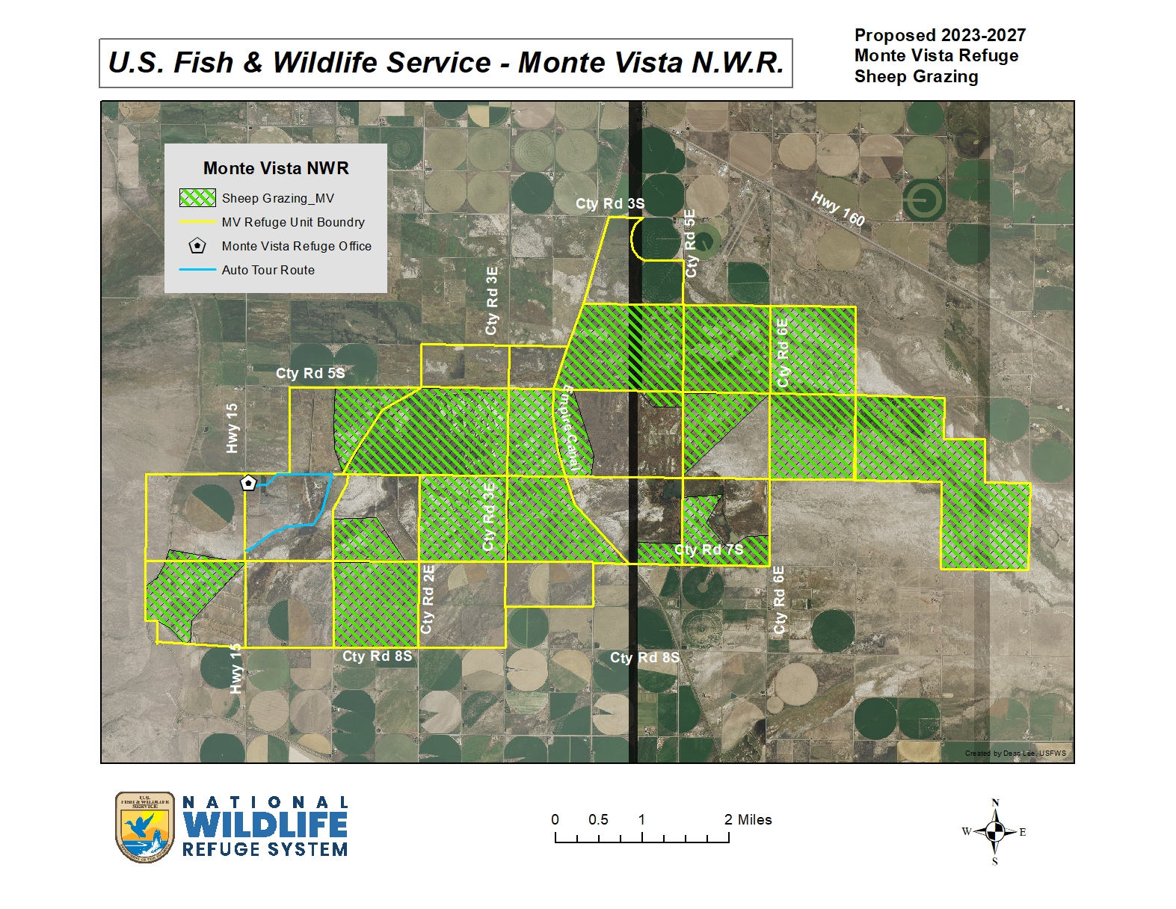

**Bid Package # 2 - Monte Vista National Wildlife Refuge –**

**2023-2027 Prescribed Sheep Grazing Permit Bid Package**

**Attachment C – Special Conditions Pertaining to Permit (page 1)**

**SPECIAL CONDITIONS**

The grazing permit will be issued to support invasive plant species control efforts on the Monte Vista National Wildlife Refuge using varying numbers and intensities of sheep over a 5-year period (2023-2027).

**Eligible Deductions for selected Cooperators include**:

*\* Full Time Herder w/camp $3527/Month*

*\* Water Hauling $0.03/gallon*

*\* In-Kind Services*

- Success of this program is dependent on close cooperation between the cooperator, specific herders, and refuge staff. Regular evaluation of vegetation and animals will be required of the Cooperator and herders. Refuge personnel will work closely with herders providing regular observations and subsequent adjustments to scheduling and sheep movement techniques.

- Cooperator will document all sheep move dates among the overall areas grazed. This documentation will then be given to the Refuge Manager at the end of the grazing season along with the dates and descriptions of any problems that occurred and were reported to the Refuge Manager.

- The Cooperator certifies that all livestock grazing under this permit comply with State Livestock Health Laws.

- If watering problems develop, the refuge staff must be contacted. Releasing water from impoundments or other water control structures by the permittee will not be allowed.

- Actual grazing is not guaranteed during each year of the permit. Grazing needs are based entirely on habitat conditions. If habitat conditions do not warrant a grazing need for a particular year, it will not be prescribed. In addition, Refuge Manager retains the right to discontinue prescribed grazing practices in the event that compatibility or any other issue/concern arises or if desirable effects are obtained prior to proposed end date.

- Dates may vary within approved range and within approved AUM’s based on impacts sheep are having on subject habitats.

- The cooperator must abide by Title VI of the Civil Rights Act of 1964 and not deny any person the right to receive any service or benefit because of race, color, creed, sex, or national origin.

- Cooperator is expected to act in a manner that is respectful of refuge habitats, wildlife, and property, and is subject to all laws pertaining to the National Wildlife Refuge System.

- All persons working on the refuge as a result of an issued permit are required to have a copy of the permit on their person/vehicle while on the refuge. Failure to do so may result in criminal penalties for trespass.

**Bid Package # 2 - Monte Vista National Wildlife Refuge –**

**2023-2027 Prescribed Sheep Grazing Permit Bid Package**

**Attachment C – Special Conditions Pertaining to Permit (page 2)**

- Cooperator is not to be considered agent of the U.S. Fish and Wildlife Service and is not to represent the Service in any matters. All matters arisen or encountered should be promptly brought to the attention of Refuge Management at (719) 589-4021.

- Cooperator shall perform all work required under an issued permit in accordance with the highest standards of their profession or craft and to the satisfaction of the U.S. Fish and Wildlife Service and work in accordance with all laws and regulations and shall obtain all/any necessary permits or licenses required.

- The work performed under an issued permit shall be performed entirely at the cooperators risk. The cooperator shall indemnify and hold the U.S. Fish and Wildlife Service harmless for any and all liability and/or loss arising in any way out of the performance of this permit.

**Ownership**

-All sheep must be owned by cooperator and must have been in San Luis Valley at least 1 year or newborn in San Luis Valley. No sub-leasing or non-cooperator owned sheep are allowed.

-All animals must be identifiable as belonging to cooperator, and cooperator must provide Refuge Manager with any brand and location information, along with ear tag colors/information.

**Access and Travel Management**

-All vehicle travel is restricted to developed roads and two-track roads, and only within prescribed grazing units. Any ATV use and/or needed vehicle use deviations must be pre-approved by Refuge Manager in writing prior to any action taken.

-All equipment for grazing, including camp units, ATVs and UTVs, must be clean and free of invasive species plant material including seeds and must be inspected by refuge personnel prior to entering the Refuge.

**Sheep Herding**

- A herder is required to be with sheep. The main flock will never be left unattended for any reason.

-Sheep will be herded and distributed across the management unit in order to achieve proper grazing of key vegetation species of concern. Herders will spend as much time as necessary to move sheep from areas of high use to areas of light use to ensure proper grazing distribution.

-Sheep will be moved away from water sources after animals have finished drinking.

-All sheep must be accounted for (dead or alive) as they enter and exit each management unit. Special attention should be given to accounting for sheep as they are trailed between the management units. If sheep are unaccounted for, efforts should be made to locate them as quickly as possible. Stray or left behind sheep must be gathered within 24 hours of recognition.

**Bid Package # 2 - Monte Vista National Wildlife Refuge –**

**2023-2027 Prescribed Sheep Grazing Permit Bid Package**

**Attachment C – Special Conditions Pertaining to Permit (page 3)**

-Injured or sick sheep will not be left behind but will be moved and/or dispatched and removed from refuge.

-Herders will employ gentle herding techniques based on slow movement, moving sheep constantly from early morning through early evening with period of rest for 1-3 hours during afternoon hours. Sheep are to be rested in problem invaded areas.

**Sheep Bedding**

-Sheep will be bedded on new ground every night and moved to fresh feed daily.

-Sheep bed grounds will be no closer than **200 feet** from any road, water source, riparian corridor, or active wetland.

**Salting/Supplemental Practices**

-Supplemental feeding on refuge land is prohibited without the advance approval, in writing, from Refuge Manager.

-Salting will be allowed and can be used to improve distribution of sheep into areas of light use and lessen impacts on areas of high use. However, any proposed action must be pre-approved by Refuge Manager prior to implementation.

-Approved salt blocks will be moved daily to prevent over impact on any given area within the management unit.

-Salt will be placed no closer than **300 feet** from any road, water source, riparian corridor, or active wetland.

-All salt will be removed from each management unit when sheep are moved out of the management unit.

**Disposal of Dead Sheep**

-All dead sheep must be removed promptly from the refuge.

**Herder Camps**

-Sheep herder camps will be moved every 1-7 days.

-Herders must have the ability to move camps independently and on a potentially frequent basis (daily) without assistance from the cooperator.

-Camps will be placed no closer than **300 feet** from any road, water source, riparian corridor, or active wetland.

-Camps will be kept clean and all garbage packed out a minimum of 3 times weekly.

**Bid Package # 2 - Monte Vista National Wildlife Refuge –**

**2023-2027 Prescribed Sheep Grazing Permit Bid Package**

**Attachment C – Special Conditions Pertaining to Permit (page 4)**

- **No** wood burning stoves or open fires will be allowed on sheep herder camps, or anywhere on the refuge.

-Sheep herders will not be allowed to do any excavating at camp sites.

-Cooperators are required to visit sheep camps and account for all sheep a minimum of **3 times weekly**

**Sheep Herder Working Dogs**

-Working dogs will be required to be under the herder’s control and must be non-threatening to people and non-threatening wildlife (i.e., prairie dogs, rabbits etc.…) or they will not be allowed.

**Animal Damage Management**

-Random killing of non-threatening predators will not be tolerated and will result in the immediate termination of a permit.

-Predator control will be limited to coyotes and feral dogs that are **actively** threatening sheep and Refuge Management must be notified prior to taking any action.

-Any approved animal damage management activities will be conducted according to State Law and Federal Regulations

-Dust bags, oilers, or other insecticide treatment or sprays may not be used on the refuge. Treated ear tags may be used.

-Sheep herder will make every effort to prohibit or minimize interactions between sheep and wild ungulates (antelope, deer, and elk). Hazing of elk, deer, and antelope will be allowed in the immediate vicinity of the sheep herd.

**Implementation monitoring**

-Cooperator and herders are responsible for monitoring sheep numbers and adhering to all management unit entry and exit dates.

-Cooperator and herders will keep a log of all move dates as well as any improvements made to water sources, fences, etc... This log will also include a description of problems encountered and any recommendations for future activities. This log will be turned over to Refuge Manager at the end of the management season.

- Cooperator and herders will participate in management unit inspections with Refuge Manager a minimum of four times during the management season, at least one of which will take place upon completion of the first rotation through management units. However, informal unit inspections by cooperator are encouraged and may occur at any time.

**Bid Package # 2 - Monte Vista National Wildlife Refuge –**

**2023-2027 Prescribed Sheep Grazing Permit Bid Package**

**Attachment C – Special Conditions Pertaining to Permit (page 5)**

**Effectiveness Monitoring**

-The U.S. Fish and Wildlife Service will be responsible for carrying out effectiveness monitoring on this management action. Cooperator is encouraged to participate and can receive the results of any monitoring upon request.

**Bid Package # 2 - Monte Vista National Wildlife Refuge –**

**2023-2027 Prescribed Sheep Grazing Permit Bid Package**

**Attachment D – Sample move schedule**

**(Sample) Grazing Schedule**

Sample grazing schedule showing pastures, date-in, date-out, number of days, number of animals (AU), animal units per month (AUM), season duration over a 30 day month.



**Bid Package # 3 – Baca Refuge**

* The following is information pertaining to sheep grazing permits on the Baca Refuge. Please familiarize yourself with this information when preparing your bid. The information contains the requirements and flexibilities that the Service will be considering when evaluating your bid package.

* Potential bidders **Must** attend an onsite briefing and formal inspection tour with the Refuge Manager which will occur on **Wednesday,** **March 1, 2023**, beginning at 9:00 a.m. at the **Baca Refuge Office** located at 69812 Saguache County Rd. T (no additional inspections will be accommodated).

*** **Bids will only be accepted by operators who attend the briefing/inspection.**

**Bid Package # 3 - Baca National Wildlife Refuge –**

**2023-2027 Prescribed Sheep Grazing Permit Bid Package**

**Attachment A – Sheep Grazing Program Description & Goals (page 1)**

**Program Description**

Propose to graze up to 2 bands of sheep (1000 Ewes w/ lambs each band) on up to approximately 15,000 acres on the Baca National Wildlife Refuge (Refuge) between the period May 1 and October 30 annually during the period 2023-2027. Grazing rates will vary between 0.04 AUM’s and 1.00 AUMs per acre to be adjusted by animal numbers and duration of grazing period.

**Program Goals**

Areas to be grazed are dry meadows, grasslands, transitioning farm ground and uplands found throughout the refuge. Because of the periodic nature of irrigation and subsequent vegetative management in these habitats during past years, they have become heavily invaded by aggressively growing and prolific non-native plants such as Russian Knapweed (*Acroptilons repens*), Tall Whitetop (*Lepedium latifolium*) and Canada Thistle (*Cirsium arvense*).

Recent years efforts using sheep in these areas have been effective in reducing the vigor of plant growth in both Tall Whitetop and Russian Knapweed, as well as in preventing most plants of these species from producing seed. These efforts have also showed that when sheep were able to impact the plants early in the growing season (w/in 30 days of germination), the plants were less resistant to impacts by the grazing animals on future rotations (i.e., Beginning too late in the season resulted in plant vigor not being reduced and only prevention of seed production was gained) during the same growing season. Typically, rotation times are reduced as the growing season progresses as desired impact to invasive species occurs more quickly when sheep enter a unit for the second or third time. Actual rotation times are driven by impacts on desired native vegetation (grasses).

**Bid Package # 3 - Baca National Wildlife Refuge –**

**2023-2027 Prescribed Sheep Grazing Permit Bid Package**

**Attachment A – Sheep Grazing Program Description & Goals (page 2)**

Sheep have been tending to prefer forbs when first entering a new area. Once forbs are eaten or if sheep are allowed to stay in one area for too long then they will begin to impact grasses. To prevent sheep from “stalling”

in areas, **herders are required** to keep constant gentle pressure on the animals while feeding. If moved too fast many target species are missed and go un-impacted. If moved too slow non-target species can be negatively impacted. Herders are educated to recognize desired effects within the units so they can alter their control (speed) to get these desired effects.

Prescribed grazing by the above proposed numbers of sheep will be used to impact infested areas on a planned rotation, with up to 4 rotations scheduled during each growing season. Success of this program is dependent on close cooperation between the cooperator, specific herders, and refuge staff. Regular evaluation of vegetation, and animals will be required of the cooperator and herders. Refuge personnel will work closely with herders providing regular observations and subsequent adjustments to scheduling and sheep movement techniques.

Changes to the duration and number of rotations used will be made based on habitat conditions.

**Bid Package # 3 - Baca National Wildlife Refuge**

**2023-2027 Prescribed Sheep Grazing Permit Bid Package**

**Attachment B – Sheep Graze Area Map** 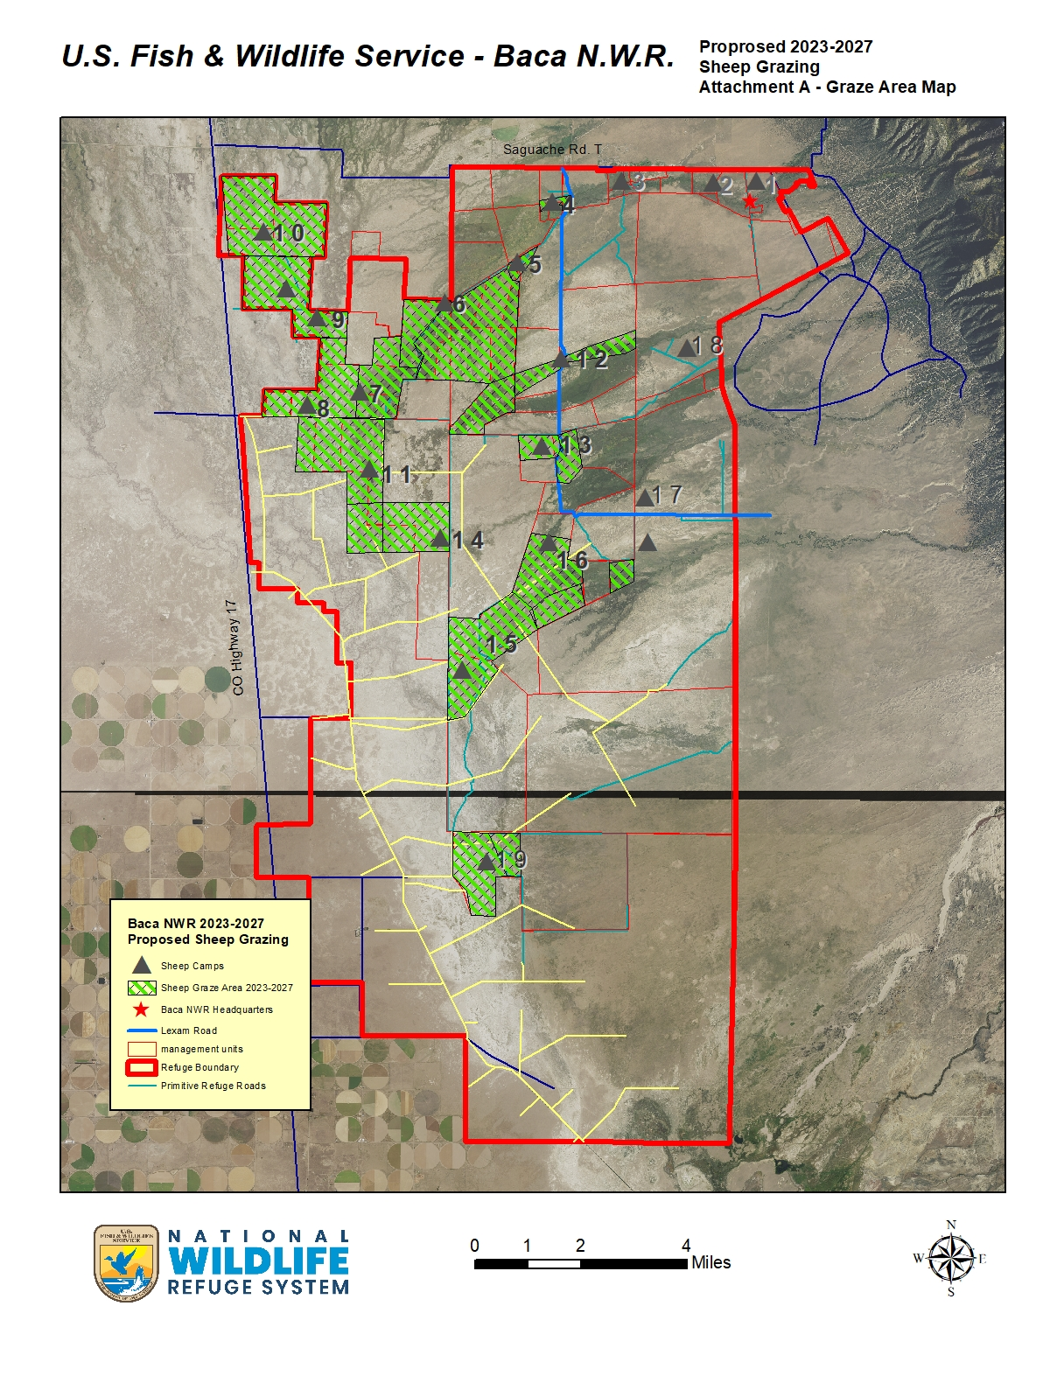

**Bid Package # 3 - Baca National Wildlife Refuge –**

**2023-2027 Prescribed Sheep Grazing Permit Bid Package**

**Attachment C – Special Conditions Pertaining to Permit (page 1)**

**SPECIAL CONDITIONS**

The grazing permit will be issued to support invasive plant species control efforts on the Baca National Wildlife Refuge using varying numbers and intensities of sheep over a 5-year period (2023-2027).

**Eligible Deductions for selected Cooperators include**:

*\* Full Time Herder w/camp $3527/Month*

*\* Water Hauling $0.03/gallon*

*\* In-Kind Services*

- Success of this program is dependent on close cooperation between the cooperator, specific herders, and refuge staff. Regular evaluation of vegetation and animals will be required of the Cooperator and herders. Refuge personnel will work closely with herders providing regular observations and subsequent adjustments to scheduling and sheep movement techniques.

- Cooperator will document all sheep move dates among the overall areas grazed. This documentation will then be given to the refuge manager at the end of the grazing season along with the dates and descriptions of any problems that occurred and were reported to the Refuge Manager.

- The Cooperator certifies that all livestock grazing under this permit comply with State Livestock Health Laws.

- If watering problems develop, the refuge staff must be contacted. Releasing water from impoundments or other water control structures by the permittee will not be allowed.

- Actual grazing is not guaranteed during each year of the permit. Grazing needs are based entirely on habitat conditions. If habitat conditions do not warrant a grazing need for a particular year, it will not be prescribed. In addition, Refuge Manager retains the right to discontinue prescribed grazing practices in the event that compatibility or any other issue/concern arises or if desirable effects are obtained prior to proposed end date.

- Dates may vary within approved range and within approved AUM’s based on impacts sheep are having on subject habitats.

- The cooperator must abide by Title VI of the Civil Rights Act of 1964 and not deny any person the right to receive any service or benefit because of race, color, creed, sex, or national origin.

- Cooperator is expected to act in a manner that is respectful of refuge habitats, wildlife, and property, and is subject to all laws pertaining to the National Wildlife Refuge System.

- All persons working on the refuge as a result of an issued permit are required to have a copy of the permit on their person/vehicle while on the refuge. Failure to do so may result in criminal penalties for trespass.

**Bid Package # 3 - Baca National Wildlife Refuge –**

**2023-2027 Prescribed Sheep Grazing Permit Bid Package**

**Attachment C – Special Conditions Pertaining to Permit (page 2)**

- Cooperator is not to be considered agent of the U.S. Fish and Wildlife Service and is not to represent the Service in any matters. All matters arisen or encountered should be promptly brought to the attention of Refuge Management at (719) 589-4021.

- Cooperator shall perform all work required under an issued permit in accordance with the highest standards of their profession or craft and to the satisfaction of the U.S. Fish and Wildlife Service and work in accordance with all laws and regulations and shall obtain all/any necessary permits or licenses required.

- The work performed under an issued permit shall be performed entirely at the cooperators risk. The cooperator shall indemnify and hold the U.S. Fish and Wildlife Service harmless for any and all liability and/or loss arising in any way out of the performance of this permit.

**Ownership**

-All sheep must be owned by cooperator and must have been in San Luis Valley at least 1 year or newborn in San Luis Valley. No sub-leasing or non-cooperator owned sheep are allowed.

-All animals must be identifiable as belonging to cooperator, and cooperator must provide Refuge Manager with any brand and location information, along with ear tag colors/information.

**Access and Travel Management**

-All vehicle travel is restricted to developed roads and two-track roads, and only within prescribed grazing units. Any ATV use and/or needed vehicle use deviations must be pre-approved by Refuge Manager in writing prior to any action taken.

-All equipment for grazing, including camp units, ATVs and UTVs, must be clean and free of invasive species plant material including seeds and must be inspected by refuge personnel prior to entering the Refuge.

**Sheep Herding**

- A herder is required to be with sheep. The main flock will never be left unattended for any reason.

-Sheep will be herded and distributed across the management unit in order to achieve proper grazing of key vegetation species of concern. Herders will spend as much time as necessary to move sheep from areas of high use to areas of light use to ensure proper grazing distribution.

-Sheep will be moved away from water sources after animals have finished drinking.

-All sheep must be accounted for (dead or alive) as they enter and exit each management unit. Special attention should be given to accounting for sheep as they are trailed between the management units. If sheep are unaccounted for, efforts should be made to locate them as quickly as possible. Stray or left behind sheep must be gathered within 24 hours of recognition.

**Bid Package # 3 - Baca National Wildlife Refuge –**

**2023-2027 Prescribed Sheep Grazing Permit Bid Package**

**Attachment C – Special Conditions Pertaining to Permit (page 3)**

-Injured or sick sheep will not be left behind but will be moved and/or dispatched and removed from refuge.

-Herders will employ gentle herding techniques based on slow movement, moving sheep constantly from early morning through early evening with period of rest for 1-3 hours during afternoon hours. Sheep are to be rested in problem invaded areas.

**Sheep Bedding**

-Sheep will be bedded on new ground every night and moved to fresh feed daily.

-Sheep bed grounds will be no closer than **200 feet** from any road, water source, riparian corridor, or active wetland.

**Salting/Supplemental Practices**

-Supplemental feeding on refuge land is prohibited without the advance approval, in writing, from Refuge Manager.

-Salting will be allowed and can be used to improve distribution of sheep into areas of light use and lessen impacts on areas of high use. However, any proposed action must be pre-approved by Refuge Manager prior to implementation.

-Approved salt blocks will be moved daily to prevent over impact on any given area within the management unit.

-Salt will be placed no closer than **300 feet** from any road, water source, riparian corridor, or active wetland.

-All salt will be removed from each management unit when sheep are moved out of the management unit.

**Disposal of Dead Sheep**

-All dead sheep must be removed promptly from the refuge.

**Herder Camps**

-Sheep herder camps will be moved every 1-7 days.

-Herders must have the ability to move camps independently and on a potentially frequent basis (daily) without assistance from the cooperator.

-Camps will be placed no closer than **300 feet** from any road, water source, riparian corridor, or active wetland.

-Camps will be kept clean and all garbage packed out a minimum of 3 times weekly.

**Bid Package # 3 - Baca National Wildlife Refuge –**

**2023-2027 Prescribed Sheep Grazing Permit Bid Package**

**Attachment C – Special Conditions Pertaining to Permit (page 4)**

- **No** wood burning stoves or open fires will be allowed on sheep herder camps, or anywhere on the refuge.

-Sheep herders will not be allowed to do any excavating at camp sites.

-Cooperators are required to visit sheep camps and account for all sheep a minimum of **3 times weekly**

**Sheep Herder Working Dogs**

-Working dogs will be required to be under the herder’s control and must be non-threatening to people and non-threatening wildlife (i.e., prairie dogs, rabbits etc.…) or they will not be allowed.

**Animal Damage Management**

-Random killing of non-threatening predators will not be tolerated and will result in the immediate termination of a permit.

-Predator control will be limited to coyotes and feral dogs that are **actively** threatening sheep and Refuge Management must be notified prior to taking any action.

-Any approved animal damage management activities will be conducted according to State Law and Federal Regulations

-Dust bags, oilers, or other insecticide treatment or sprays may not be used on the refuge. Treated ear tags may be used.

-Sheep herder will make every effort to prohibit or minimize interactions between sheep and wild ungulates (antelope, deer, and elk). Hazing of elk, deer, and antelope will be allowed in the immediate vicinity of the sheep herd.

**Implementation monitoring**

-Cooperator and herders are responsible for monitoring sheep numbers and adhering to all management unit entry and exit dates.

-Cooperator and herders will keep a log of all move dates as well as any improvements made to water sources, fences, etc... This log will also include a description of problems encountered and any recommendations for future activities. This log will be turned over to Refuge Manager at the end of the management season.

- Cooperator and herders will participate in management unit inspections with Refuge Manager a minimum of four times during the management season, at least one of which will take place upon completion of the first rotation through management units. However, informal unit inspections by cooperator are encouraged and may occur at any time.

**Bid Package # 3 - Baca National Wildlife Refuge –**

**2023-2027 Prescribed Sheep Grazing Permit Bid Package**

**Attachment C – Special Conditions Pertaining to Permit (page 5)**

**Effectiveness Monitoring**

-The U.S. Fish and Wildlife Service will be responsible for carrying out effectiveness monitoring on this management action. Cooperator is encouraged to participate and can receive the results of any monitoring upon request.

**Bid Package # 3 - Baca National Wildlife Refuge –**

**2023-2027 Prescribed Sheep Grazing Permit Bid Package**

**Attachment D – Sample move schedule**

**(Sample) Grazing Schedule**

Sample grazing schedule showing pastures, date-in, date-out, number of days, number of animals (AU), animal units per month (AUM), season duration over a 30 day month.

**San Luis Valley National Wildlife Refuge Complex–**

**2023-2027 Prescribed Sheep Grazing Permit Bid Package**

**Attachment E – Supplemental Application Information and Bid Sheet**

**SUPPLEMENTAL INSTRUCTIONS FOR USE OF FORM 3-1383-C FOR APPLICATIONS FOR COOPERATIVE AGRICULTURAL OPPORTUNITIES ON THE NATIONAL WILDLIFE REFUGE SYSTEM**

Please read the following carefully before filling out the application:

• Form 3-1383 - Commercial Special Use Permit (CSUP) is used by the U.S. Fish and Wildlife Service (Service) to permit cooperative agricultural practices on National Wildlife Refuges, as well as for formalizing Cooperative Agricultural Agreements on Refuges. ***This form will be filled out by the Refuge Manager****.*

• Form 3-1383-C - Commercial Special Use Permit Application (3-1383-C) (**Attached**) - must be completed for consideration and be submitted as part of the application package. However, at the time of the application, applicant does not need to complete all sections of the application but does need to ensure that they provide sufficient information in their proposed operations for the Service to review the application based on the objective criteria listed in the bid package. ***This form is to be filled out by the Applicant(s)****.*

* Write N/A in any sections that do not appear to be relevant.

* Both the “Plan of Operations” (section 18) and the “Logistics and Transportation Section” (sections 24a through 30) only need to be completed if/after an applicant has been selected as the Cooperator.

* Form 3-1384 - Supplemental Application Information and Bid Sheet (**Attached**) - should be submitted with the Form 3-1383-C as part of the application package. ***This form is to be filled out by the Applicant(s)****.*

- In addition to providing the Service detailed information about your proposed grazing practices on the refuge, you must also describe how your proposed activity, based on your background, knowledge, and experience, meets the objective criteria by which the Service will evaluate your application.