Scope of Work: Amphibian Injury Data Gap Study
Koppers Delaware Superfund Site
Submitted to the Department of the Interior NRDAR Program by
Fred Pinkney, USFWS, Chesapeake Bay Field Office (CBFO) March 2023
Fred_Pinkney@fws.gov

Introduction

Purpose of the Project
This Scope of Work is for an amphibian injury study to be funded by the Department of the Interior Natural Resources Damage Assessment and Restoration (NRDAR) Program. This study and proposed bird and fish studies address data gaps for the Koppers Delaware Superfund Site (Koppers) Injury Assessment. The site background and history are taken from the recently approved Preliminary Assessment Screen (PAS) which recommended proceeding with a NRDAR case (Pinkney et al. 2022).

The Koppers Site
The Koppers Co., Inc. (Newport Plant) Superfund Site (Site) is comprised of approximately 121 hectares (ha) (=300 acres (ac)), located southwest of Newport, Delaware (Figure 1a, b, 2). In 1929, three parcels comprising the Site were conveyed by Lynam and Wright to the Delaware Wood Preserving Company, which began conducting wood treatment operations on these parcels. Wood treatment operations continued at the Site, under various owners, until 1971. The Trustees are evaluating potential releases of hazardous substances and related injuries to natural resources within the Site boundary (which is defined here as the Assessment Area).
According to the U.S. Environmental Protection Agency (USEPA 2005), the major habitat types are uplands (66 ha = 163 ac), wetlands (55 ha = 136 ac) and three small freshwater ponds (total of about 0.4 ha = 1 ac). The wetlands include freshwater tidal marsh, non-tidal emergent wetlands, non-tidal forested wetlands, and non-tidal scrub/shrub wetlands. Wetland delineations were performed in 1994 by Woodward Clyde (1997) as part of the Blasland, Bouck & Lee Inc. (BBL 2003) Remedial Investigation (RI), and in 2005 as reported in the Langan (2008) Preliminary Design Report.
Hershey Run is a 4.7-kilometer (km) (2.9-mile (mi)) stream that originates in and adjacent to the town of Newport, DE and flows southward. As it crosses Newport Pike (Route 4), it becomes a tidal freshwater stream. It enters the Site after crossing the Amtrak railroad tracks through a culvert. Approximately 1.6 km (1 mi) of Hershey Run passes through the Site, where portions of the stream appear to be channelized.
The Site borders on White Clay Creek and the Christina River (Figures 1a, b). As detailed below, elevated concentrations of contaminants found at the Site are directly attributable to the onsite wood treatment operations. Other industries and hazardous waste sites (such as the DuPont Newport Superfund Site, about 1.6 km (1 mi) upstream on the Christina River) contribute contaminants to these waterbodies. By restricting the Assessment Area to the Koppers Site boundary, issues about whether contamination is site-related are avoided.

History of the Koppers Superfund Site
Wood-treatment operations were conducted at the Site from 1929 through 1971. Wood treatment used a creosote coal tar solution, which was applied to railroad ties, telephone poles, and other wood products (BBL 2003, USEPA 2005). Pentachlorophenol with number 2 fuel oil was also used, but to a much lesser extent (USEPA 2005, 2006). Creosote (also referred to as “coal tar creosote”) is an oily complex mixture, typically composed of approximately 85 percent polycyclic aromatic hydrocarbons (PAHs) and 2 to 17 percent phenolics (Agency for Toxic Substances and Disease Registry 2002). The individual PAH compounds vary from lighter molecular weight compounds (e.g., naphthalene) to heavier ones such as benzo(a)pyrene.
Koppers Company acquired the Site property in 1940 and reorganized in 1944 into the Koppers Company, Inc. (Koppers). Koppers continued wood-treatment operations at the Site until 1971, when the property was sold to DuPont. In December 2004, DuPont deeded the property to Beazer East, Inc. (Beazer), the successor corporation to Koppers and current owner of the Site (USEPA 2006). Beazer, Inc. identified by USEPA as the Responsible Party has funded the site investigations and will be conducting the remediation using contractors.
The Koppers Site was identified as a potential hazardous waste site in 1979 after the Subcommittee on Oversight and Investigations of the Interstate and Foreign Commerce Commission reviewed responses to a survey of the 53 largest domestic chemical companies on their waste disposal practices (USEPA 2006). Following investigations by USEPA and the State of Delaware in the 1980s, the Koppers Site was proposed for inclusion on the CERCLA National Priority List (NPL) in 1989, and formally listed in 1990. In 1991, Beazer and DuPont (the landowner at that time) agreed to conduct a Remedial Investigation/Feasibility Study (RI/FS) under the terms of an Administrative Consent Order with the USEPA (USEPA 2006). The RI was finalized in 2003 and showed that shallow soils, subsurface soils, groundwater, and sediment were contaminated with PAHs (USEPA 2006). The results of the Ecological Risk Assessment (ERA; USEPA 1997) conducted as part of the RI demonstrated that concentrations of PAHs in shallow soils, subsurface soils, groundwater, and sediment pose an unacceptable risk to upland, wetland, and aquatic communities at the Site (USEPA 2005). Several other contaminants present at the site were evaluated for potential risk as part of the ERA, but the predominant effects were due to the high concentrations of PAHs (USEPA 1997). Thus, the primary contaminants of concern (COCs) at the Site are PAHs.
In oil spills, PAHs are often the most toxic fraction to vertebrate receptors (King et al. 2021; Takeshita et al. 2021). According to the ROD, some areas of the Koppers Site have very high levels of contamination, including creosote, non-aqueous phase liquid (NAPL), and PAHs. This contamination is considered to be a principal threat waste since it is a continuous source for ground water contamination. USEPA (1991) defines principal threat waste as “source materials considered to be highly toxic or highly mobile that generally cannot be reliably contained or would present a significant risk to human health or the environment should exposure occur.”

The Remedy
After the Feasibility Study (FS) report was finalized in 2004, the USEPA issued a Record of Decision (ROD), in which a remedial action was selected for implementation at the Site, in 2005 (USEPA 2005, 2006). Based on results of toxicity testing conducted as part of the ERA, USEPA (2005) determined that a sediment cleanup criterion of 150 mg/kg = parts per million (ppm) total PAHs and a soil cleanup criterion of 600 ppm total PAHs were appropriate levels to protect the environment.
The Administrative Order (USEPA 2006) directed Beazer to implement the remedial action selected in the ROD. As part of the Remedial Design Investigation, Langan (2008) recommended modifications to reduce the cost and complexity of the cleanup and still achieve the ROD objectives. These included reducing the depth of excavation and not using site sediments as part of a wetland mitigation bank (Langan 2019).
Beazer submitted a request for ROD Amendment in April 2019 and the ROD Amendment was issued in August 2022 (USEPA 2022). The ROD is “a final remedy for soils, sediments, and DNAPL in the saturated zone serving as a source for groundwater contamination; and an interim remedy for groundwater that will address certain risks presented by contamination but will not restore the groundwater to beneficial use. Selection of a comprehensive (final) groundwater remedy will take place in a subsequent decision document.” Although the Amendment modifies portions of the remedy selected in the 2005 ROD; the cleanup criteria remain the same (USEPA 2022). It is likely that remedial design work will be completed within 12 to 18 months of the issuance of the ROD. Thus, cleanup activities are projected to start in 2024 and finish in 2027 (D. Taylor, USEPA Region 3, personal communication).
The ROD identified areas of the site with high levels of liquid creosote in the groundwater. The liquid creosote is found in a NAPL with a density slightly greater than water. The remedy is intended to minimize the ongoing contamination of groundwater from the presence of NAPL in the saturated zone through removal and/or containment. The remedy will include the realignment of Hershey Run to avoid high contamination areas and where the containment area extends into the wetlands area and Upper Hershey Run (Figure 3). Proposed remedial measures will affect both tidal (~ 3.2 hectares (8 acres)) and freshwater wetlands (~0.16 hectares (0.4 acres)). Surface water, sediments, and biota will be monitored to determine if risk has been reduced to acceptable levels and that the remedy continues to be effective (USEPA 2022).

NRDAR
Natural Resource Damage Assessment and Restoration (NRDAR) is a regulatory process to determine the amount and type of restoration needed to compensate the public for injuries to natural resources resulting from the release of hazardous substances into the environment. The ultimate goal of the NRDAR is to restore natural resources that have been injured by a hazardous substance(s) to baseline, which is defined as the condition of the resource that would have existed if the hazardous substances were not released (43 CFR §11.14(e)) and obtain compensation for public losses pending restoration to that baseline condition. There are two categories of injury: 1) those that occur before the remediation (dating back to 1980 for CERCLA); and 2) those that occur resulting from the remediation. Because of the schedule for cleanup activities, the Trustees—Department of the Interior (DOI) led by the U.S. Fish and Wildlife Service Chesapeake Bay Field Office (CBFO), State of Delaware Department of Natural Resources and Environmental Control (DNREC), and Department of Commerce, National Oceanic and Atmospheric Administration (NOAA)—need to conduct data gap studies at an accelerated pace to be able to calculate injury.
DOI NRDA regulations provide definitions used to assess injuries to biological resources. As defined at 43 CFR §11.62(f), an injury to a biological resource has resulted from the discharge of a hazardous substance if concentration of the substance is sufficient to: 1) Exceed action or tolerance levels established under section 402 of the Food, Drug and Cosmetic Act, 21 U.S.C. 342 in edible portions of organisms, 2) Exceed levels for which an appropriate State health agency has issued directives to limit or ban consumption of such organism pursuant to 43 CFR §11.62(f)(1)(iii), or 3) Cause the biological resource or its offspring to have undergone at least one of the following adverse changes in viability: death, disease, behavioral abnormalities, cancer, genetic mutations, physiological malfunctions (including malfunctions in reproduction), or physical deformations pursuant to 43 CFR §11.62(f)(1)(i).
The Koppers PAS (Pinkney et al. 2022) was approved by all Trustees in December 2022. Through the PAS, the Trustees made a preliminary determination that the criteria specified in the CERCLA NRDAR regulations have been met. Furthermore, the Trustees have determined that there is a reasonable probability of making a successful claim for damages with respect to natural resources over which the Trustees have trusteeship. Therefore, the Trustees have determined that a NRDAR is warranted. The schedule for the Data Gap Study is triggered by the need to complete field work before the site is altered (presumably in 2024) by the remedial action.

Rationale for the Amphibian Data Gap Study

Toxicity Tests
According to Woodward Clyde (1997), the following species of frogs and toads were detected at the Koppers Site: American bullfrog, Lithobates catesbeianus; southern leopard frog, L. sphenocephalus, spring peeper, Pseudacris crucifer; wood frog, L. sylvaticus; and American toad, Anaxyrus americanus. To assess possible effects on amphibians, Frog Embryo Teratogenesis Assay Xenopus (FETAX) were attempted as part of the Ecological Risk Assessment (ERA). These tests failed because of excessive control mortality. The ERA assumed that the cleanup criterion of 150 ppm total PAHs in the sediments and 600 ppm in the soils would be protective of amphibians. The lack of data on amphibians is a serious data gap. Thus, the sediments identified for embryo-larval fish toxicity tests will also be tested with FETAX based on American Society for Testing and Materials (ASTM 2014) guidance E1439-98, as modified for sediment exposure by Turley et al. (2003). Embryo lethality and malformations at 96-hours are the endpoints.
Data analyses will be consistent with ASTM guidance and similar to those for the embryolarval fish tests. Survival data will be arcsine square root transformed and tested by one-way analysis of variance (ANOVA) followed by the Dunnett (1955) multiple pairwise comparison test. Data not satisfying normality or homogeneity of variance requirements for parametric statistics will be tested using Kruskal-Wallis one-way ANOVA on ranks followed by Dunn’s multiple pairwise comparison. Treatment means will be compared to both in-system (Newport Marsh) and out-of- system (Wye River) reference sediments. Endpoints can be calculated using Probit analysis for effective concentrations (EC) values. Lowest Adverse EC and No Adverse EC are determined with hypothesis testing, based on sediment total PAH concentrations, with acknowledgment that concentrations of metals which will be measured, and unmeasured analytes may affect the results. If appropriate, Pearson product-moment correlation coefficients will be computed to determine strength of association between survival and measured chemical parameters. Statistical analyses will be performed using Sigma-Stat version 12.0 (Systatsoftware.com) with significance set at p < 0.05.

Sediment chemistry supporting the FETAX tests
The sediments to be sampled will be those used for the fish toxicity tests. Approximately twelve (12) sites within Hershey Run, South Pond and the adjacent wetland drainage areas will be targeted for sediment collection. Sediment will also be collected from Newport Marsh (Figure 1b), a wetland bordering the Christina River, approximately 2 km downstream from the region of contamination, to serve as an in-system reference, as was the case in Pinkney and Harshbarger (2006). The Wye River on Maryland’s Eastern Shore, with no industrial history, limited imperviousness and a modest population density, will serve as an out-of-system reference for provision of clean sediments. Sediments from this source have been used for many years by Dr. Yonkos and colleagues from UMCP (L. Yonkos, personal communication). Selection of samples at the Koppers Site will be based on several criteria including spatial coverage within and adjacent to the region planned for remediation, reflection of the concentration range and variety of contaminants based on previous chemical analyses, suitability of sediment characteristics for FETAX tests, safe accessibility of the location by boat, personal water craft (e.g., kayak, canoe) or on foot using waders. Up to 20 potential sample sites will be identified based on aerial images and results of previous sediment contaminant analysis. These sites will be reconnoitered prior to sampling to determine the subset of 12 that best satisfy other selection criteria.
Depending on location, accessibility and tidal stage, sediments will be collected by boat mounted Ponar® grab sampler, or by hand via Petit Ponar® or Ekman® grab sampler. The top five (5) cm of multiple grab samples from each location will be combined in a stainless steel bowl and homogenized before being apportioned to pre-cleaned and labeled I-Chem® certified amber glass jars for chemical analysis and to pre-cleaned 1 L stainless steel paint cans with lids for sediment toxicity testing. A sufficient number of grab samples will be taken at each location to yield a final homogenized volume of approximately 6 L, allowing preparation of five 1 L test aliquots (with minimal head space) after removal of media for chemical analysis. The number of grab samples necessary at each site will depend on sample apparatus employed (e.g., 5-6 for Ponar, 8-10 for Petit Ponar/Ekman). If wetland sediments are exposed at low tide, they may be collected directly to a depth of 5 cm using a stainless steel scoop. All samples will be placed on ice immediately after collection and during transport to the laboratory before storage at -20°C.
Sediment samples will be analyzed through the Service’s Analytical Control Facility (ACF). A metals scan (Table 1) will be run at the AWH laboratory (Mansfield, MA) and an aromatic scan (Table 1) at SGS AXYS (Sidney, British Columbia, Canada). Although PAHs are the primary constituent of concern, metals such as zinc have been detected in sediment samples at Koppers (USEPA 2005). Zinc is of particular concern, based on its frequent detection in Christina River sediments and its documented lethality to early life stages of mummichogs (Guy et al. 2006). Grain size and total organic carbon will be analyzed.

Analytical Laboratory Quality control/Quality Assurance
Quality control (QC)/quality assurance (QA) procedures included the analysis of standard reference materials, laboratory duplicates, procedural blanks, internal standards, surrogates, and matrix spikes. A QA review of the data will be performed by U.S. Fish and Wildlife Service, Analytical Control Facility (ACF) chemists, Danunetta Jones and Steve Boateng and included in the laboratory reports. For sediments, a field duplicate will be collected so that relative percent difference (RPD) can be calculated. For fish tissues, a lab-generated duplicate will serve the same function. A full data validation (USEPA Stage 4, according to USEPA 2017 guidance) will be conducted by EcoChem, Inc., Seattle, WA.
The samples will be packed with bubble wrap around the sample jars and dry ice pellets equivalent to the total sample weight. A top layer of gel packs will be placed in the cooler to maintain temperature in case of shipping delays. A signed chain of custody form will accompany the shipment. The laboratory will document sample temperature at the time of arrival and note that information on a sample receiving form. A temperature blank (plastic bottle containing tap water) will be labelled and included with each cooler.

Quantifying NRDA Amphibian Injury
Results of the amphibian toxicity tests will be used to quantify losses in habitat and ecological services. In general, toxicity test results in relation to laboratory controls and background are translated to service or habitat losses (Cacela et al. 2005).
Two common approaches to scaling in injury assessment are Habitat Equivalency Analysis (HEA) and Resource Equivalency Analysis (REA; described in Baker et al. 2020). In both approaches, a service loss is calculated based on biological data. The public is made whole through restoration of the amount of habitat (HEA) and/or biota (REA) needed to return the injured resource to baseline conditions and if necessary to compensate for any interim losses.
Recently, Baker et al. (2020) developed Habitat based Resource Equivalency Method (HaBREM) as a procedure for sites with multiple habitat types and multiple injuries. Thus, this procedure may be appropriate for the Koppers Site. According to Patrick Lee (DOI, Office of Policy Analysis, personal communication) DOI economists have used HaBREM at several NRDA sites. Mr. Lee is the economist assigned to the Koppers site and will play a critical role in determining how to apply these models to the data gap studies and existing data to scale ecological service losses, determine injury, and help identify restoration projects.

Schedule, Deliverables
Spring 2023: Site reconnaissance, collect sediment samples, send to laboratory for rapid turnaround chemistry; select samples for toxicity tests.
Summer/Fall 2023: Conduct FETAX tests
Fall/Winter 2023-24: Analyze data and submit draft final amphibian report
Spring/Summer 2024: Prepare final report with detailed response to comments. Prepare fact sheet and release to the public.
Sept. 30, 2024: Closeout

Key Personnel (Resumes available upon request)
Dr. Fred Pinkney, U.S. Fish and Wildlife Service Chesapeake Bay Field Office will serve as Principal Investigator
Dr. Lance Yonkos, University of Maryland will conduct the FETAX tests and collaborate on report writing

References

Agency for Toxic Substances and Disease Registry (ATSDR). 2002. Toxicological profile for wood creosote, coal tar creosote, coal tar, coal tar pitch, and coal tar pitch volatiles. Atlanta, GA.
American Society for Testing and Materials (2014) Standard guide for conducting frog embryo teratogenesis assay-Xenopus, Archives of Environmental Contamination and Toxicology (2021) 80:708–716 715 1 3 ASTM E1439-98: annual book of ASTM standards, vol 11.05. ASTM, Philadelphia, PA, pp 826–36
Baker, M., A. Domanski, T. Hollweg, J. Murray, D. Lane, K. Skrabis, R. Taylor, T. Moore, and
L. DiPinto. 2020. Restoration scaling approaches to addressing ecological injury: The Habitat-Based Resource Equivalency Method. Environmental Management 65:161–177.
BBL, Inc. 2003. Remedial Investigation Report. Former Koppers Co., Inc. Newport Site,
Newport, Delaware. Volume 1 of 3, Revised draft. BBL, Inc., Syracuse, NY.
Cacela, D. J. Lipton, D. Beltman, J. Hansen, and R. Wolotira. 2005. Associating ecosystem service losses with indicators of toxicity in Habitat Equivalency Analysis. Environmental Management 35:343-351.
Dunnett, C.W.1955. Multiple comparison procedure for comparing several treatments with a control. Journal of the American Statistical Association 50:1096-1121.
Guy, C.P., Pinkney, A.E. and M.H. Taylor. 2006. Effects of sediment‐bound zinc contamination on early life stages of the mummichog (Fundulus heteroclitus L.) in the Christina Watershed, Delaware, USA. Environmental Toxicology and Chemistry 25:1305-1311.
King, M.D., J.E. Elliott, and T.D. Williams. 2021. Effects of petroleum exposure on birds: A review. Science of The Total Environment 755:142834.
Langan, Inc. 2008. Preliminary Design Report —Excavation/Capping of Soils and Sediment, Hershey Run Remediation, Relocation, and Restoration. Former Koppers Company, Inc. Newport Site, Newport, Delaware. Volume I. Philadelphia, PA. 95 p.
Langan, Inc. 2019. Final Remedy Modification and Record of Decision Amendment Technical Document Remedial Design and Remedial Action Former Koppers Company, Inc. (Newport, Delaware) Site. Philadelphia, PA. 60 p.
Pinkney, A.E. and J.C. Harshbarger. 2006. Tumor prevalence in mummichogs from the Delaware Estuary watershed. Journal of Aquatic Animal Health 18:244-251.
Pinkney, A.E., S. Ciparis, O. Griffin, and R. M. Wetzel. 2022. Preliminary Assessment Screen of the Koppers Delaware Superfund Site for Natural Resource Damage Assessment.. U.S. Fish and Wildlife Service, Chesapeake Bay Field Office, Annapolis, MD.
Takeshita, R., S.J. Bursian, K.M. Colegrove, T.K. Collier, K. Deak, K.M. Dean, S. De Guise et al. 2021. A review of the toxicology of oil in vertebrates: what we have learned following the Deepwater Horizon oil spill. Journal of Toxicology and Environmental Health, Part B 24:355-394.
Turley, S.D., Eaton-Poole, L., Pinkney, A.E., Osborn, M.A. and Burton, D.T., 2003. Evaluation of the potential impact of water and sediment from National Wildlife Refuge sites using a modified frog embryo teratogenesis assay-Xenopus (FETAX) ASTM Special Technician Publication 1443, pp.79-95
U.S. Environmental Protection Agency (USEPA). 1991. A guide to principal threat and low-level threat wastes. Superfund publication 9380.3-06FS, Office of Solid Waste and Emergency Response, Washington, DC.
U.S. Environmental Protection Agency (USEPA).1997. Final Ecological Risk Assessment. Former Koppers Company Inc. Site, Newport, DE. US EPA, Environmental Response Team, Edison, NJ.
U.S. Environmental Protection Agency (USEPA). 2005. Record of Decision. Koppers Co. Inc. (Newport Plant) Superfund Site. Newport, New Castle County, Delaware. U.S. EPA Region 3, Philadelphia, PA
U.S. Environmental Protection Agency (USEPA). 2006. Administrative Order for Remedial Design/Action. In the Matter of Koppers, Co., Inc. (Newport Plant) Superfund Site. Docket No. CERC-03-2006-0266DC. https://semspub.epa.gov/work/03/2068465.pdf
U.S. Environmental Protection Agency (USEPA) 2017. National functional guidelines for organic Superfund methods data review. OLEM 9355.0-135. EPA-540-R-2017-001.
U.S. Environmental Protection Agency (USEPA). 2022. Record of Decision Amendment Koppers Co., Inc (Newport Plant) Superfund Site, Newport/New Castle County, Delaware. https://semspub.epa.gov/work/03/2330854.pdf
Woodward Clyde, Inc. 1997. Remedial Investigation Report. Former Koppers Co., Inc. Newport Site, Newport, Delaware. Volumes 2 and 3. Woodward Clyde, Inc., Blue Bell, PA.

TABLES

Table 1. Sediment samples: List of analytes, detection limits, and laboratory method citations.
Polynuclear Aromatic Hydrocarbons
Standard PAH Parents and Select Alkylated PAHs determined by linearity
Acenaphthene | 1-Methylnaphthalene | C1-Biphenyls
Acenaphthylene | C1-Naphthalenes | C2-Biphenyls
Anthracene | 1,2-Dimethylnaphthalene | C1-Acenaphthenes
Benz(a)anthracene | C2-Naphthalenes | 2-Methylfluorene
Benzo(b)fluoranthene | 2,3,6-Trimethylnaphthalene | C1-Fluorenes
Benzo(j/k)fluoranthenes | C3-Naphthalenes | 1,7-Dimethylfluorene
Benzo(a)pyrene | 1,4,6,7-Tetramethylnaphthalene | C2-Fluorenes
Benzo(e)pyrene | C4-Naphthalenes | C3-Fluorenes
Benzofluoranthenes | 2-Methylphenanthrene | 2/3-Methyldibenzothiophenes
Benzo(ghi)perylene | 3-Methylphenanthrene | C1-Dibenzothiophene
Chrysene | 9/4-Methylphenanthrenes | 2,4-Dimethyldibenzothiophene
Dibenzo(ah)anthracene | 2-Methylanthracene | C2-Dibenzothiophene
Dibenzothiophene | C1-Phenanthrenes/Anthracenes | C3-Dibenzothiophene
2,6Dimethylnaphthalene | 1,7-Dimethylphenanthrene | C4-Dibenzothiophene
Fluoranthene | 1,8-Dimethylphenanthrene | 3-Methylfluoranthene/ Benzo(a)fluorene
Fluorene | 2,6-Dimethylphenanthrene | C1-Fluoranthenes/Pyrenes
Indeno(1,2,3-cd)pyrene | 3,6-Dimethylphenanthrene | C2-Fluoranthenes/Pyrenes
2-Methylnaphthalene ¹ | C2-Phenanthrenes/Anthracenes | C3-Fluoranthenes/Pyrenes
1-Methylphenanthrene | 1,2,6-Trimethylphenanthrene | C4-Fluoranthenes/Pyrenes
Naphthalene | C3-Phenanthrenes/Anthracenes | 1-Methylchrysene
Perylene | Retene | 5/6-Methylchrysenes
Phenanthrene | C4-Phenanthrenes/Anthracenes | C1-Benz(a)anthracenes/Chrysenes
Pyrene | Biphenyl | 5,9-Dimethylchrysene
C2-Benz(a)anthracenes/Chrysenes
2,3,5- |  | C3-Benz(a)anthracenes/Chrysenes
Trimethylnaphthalene |  | C4-Benz(a)anthracenes/Chrysenes
7-Methylbenzo(a)pyrene
C1-Benzofluoranthenes/ Benzopyrenes
C2-Benzofluoranthenes/ Benzopyrenes
Metals
Aluminum, Arsenic, Barium, Beryllium, Boron, Cadmium, Chromium, Copper, Iron,
Lead, Manganese, Mercury, Molybdenum, Nickel, Selenium, Strontium, Thallium,Vanadium
Zinc
Other analyses
Total organic carbon, grain size
PAHs: detection limit: 0.1-0.2 parts per billion (µg/kg) dry weight sediment:
Laboratory: SGS AXYS, Sidney, British Columbia, Canada
SGS AXYS (2021). METHOD MLA-021 REV. 12 VER. 07: ANALYTICAL METHOD FOR THE DETERMINATION OF POLYCYCLIC AROMATIC HYDROCARBONS (PAH), ALKYLATED POLYCYCLIC AROMATIC HYDROCARBONS, AND ALKANES SGS AXYS Method MLA-021
Metals: Minimum acceptable detection limits parts per million (mg/kg) dry weight sediment:
Be, Cd – 0.10; Hg – 0.0125; As, Se, Cr, Cu, Ni, Pb, Sr, Tl, V – 0.50; Ba, Zn –1.0; B, Mo –2.0; Al, Fe – 5.0.
Laboratory: AWH, Inc. Mansfield, MA
Metals, Grain Size, Total Organic Carbon: AWH, Mansfield, MA
AWH Method 002 (Inductively Coupled Plasma-Mass Spectrometry) for all metals except for mercury by AWH Method 004 Cold Vapor Atomic Absorption Spectroscopy;
Grain size: AWH Method 052 Grain Size with Hydrometer Particle Size with hydrometer is determined according to "ASTM Method D6913-04 (re-approved 2009) and D7928-16.
Total Organic Carbon: AWH Method 005. Solid samples are dried, acidified with phosphoric acid, loaded into an aluminum tin, and introduced into a furnace for combustion in a pure oxygen environment. CO2 is produced in the combustion zone and non-target elements are removed by scrubbing
All method summaries available upon request

FIGURES

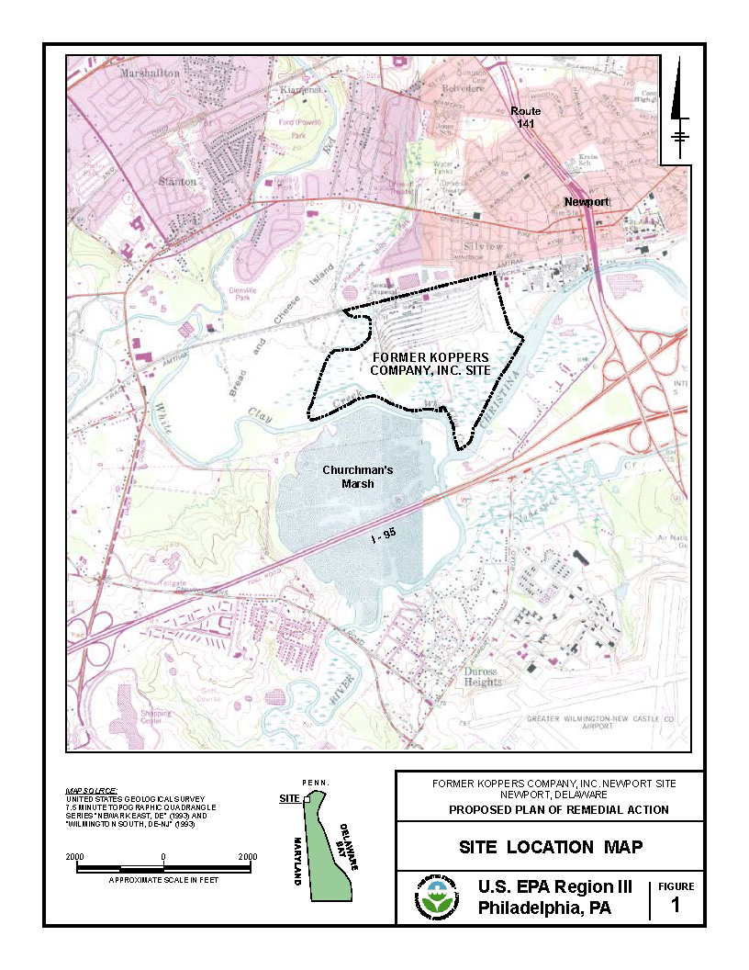
Figure 1a. Site map from U.S. Environmental Protection Agency Region III.

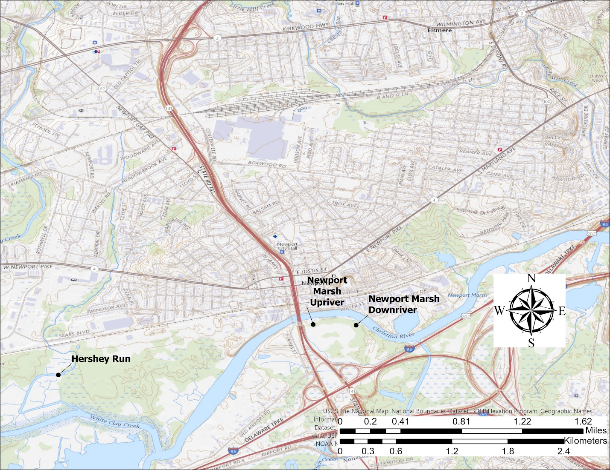
Figure 1b. Location of the Koppers Newport, DE Superfund Site showing Hershey Run and nearby Newport Marsh.

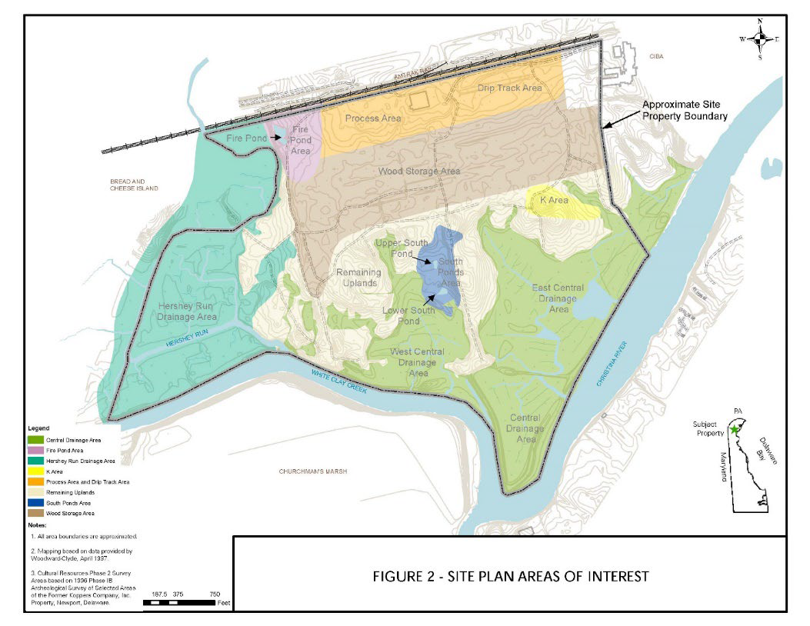
Figure 2. Site plan areas of interest (from USEPA 2022)

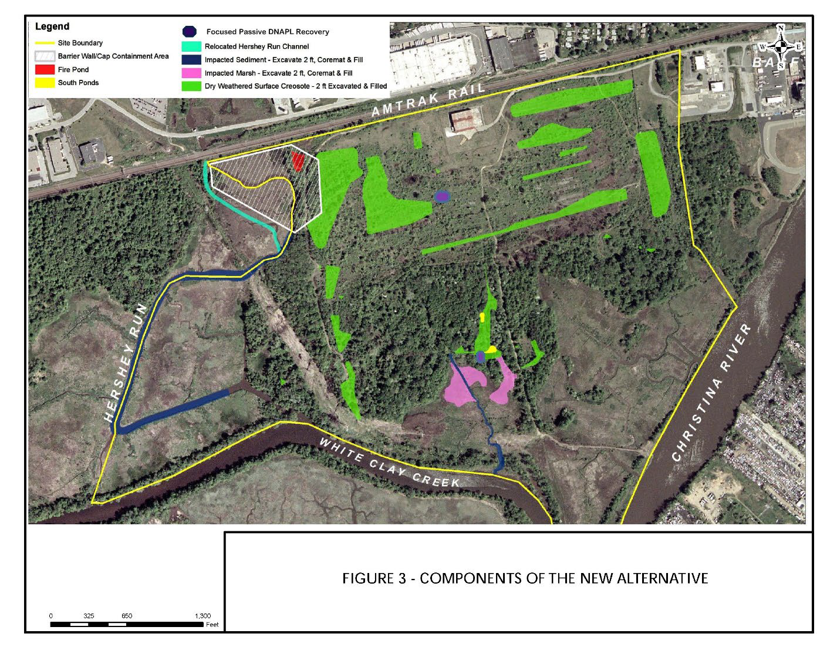Figure 3. Components of the new alternative (from USEPA 2022)

