Species Status Assessment Report for
Navasota False Foxglove (Agalinis navasotensis)

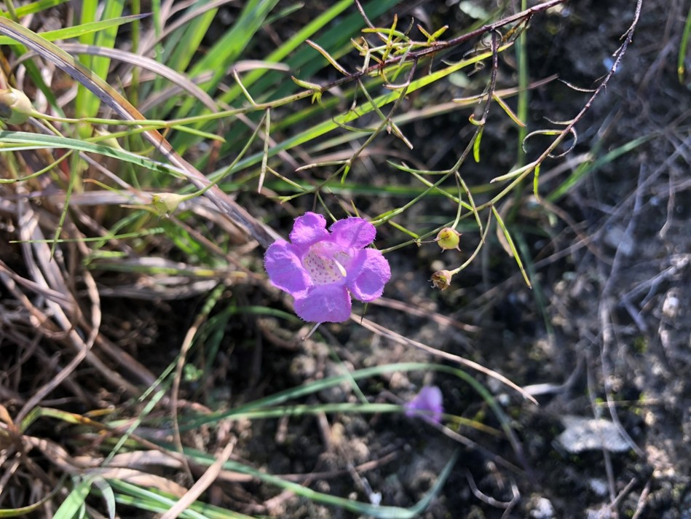

Version 1.0

U.S. Fish and Wildlife Service
Southwest Region
Texas Coastal Ecological Services Field Office
Houston, Texas
February 2022

This document was prepared by the U.S. Fish and Wildlife Service’s Navasota False Foxglove Species Status Assessment Core Team: Sheena Waters (USFWS-Clear Lake Ecological Services Office) and Michelle Shoultz (USFWS-Headquarters Office).

We would also like to recognize and thank the following individuals who provided substantive information, photographs, and insights for our Species Status Assessment: Monique Reed (Research Associate, TAES-TAMU), Anna Strong (TPWD), Jason Singhurst (TPWD), Chris Best (USFWS), Eric Keith (Raven Environmental Services), and Anita Tiller (Mercer Botanical Center).

Additionally, valuable input into the analysis and reviews of a draft of this document were provided by Nathan Allen (USFWS-Southwest Regional Office) and Monique Reed. We appreciate their input and comments, which resulted in a more robust status assessment and final report.

Suggested Reference:

U.S. Fish and Wildlife Service. 2022. Species Status Assessment Report for
Navasota False Foxglove (Agalinis navasotensis), Do Not Cite. Houston, TX.

Table of Contents
Chapter 1: Introduction 6
Chapter 2: Species Information 8
2.1 Taxonomy and Genetics 9
2.2 Species Distribution 12
2.3 Life History 14
2.3.1. Life Cycle and growth 14
2.3.2. Phenology 15
2.3.3. Reproduction 16
2.4 Habitat 16
2.4.1. Geological substrates 16
2.4.2. Microhabitats 17
2.5 Population Trends 17
2.6 Individual Requirements 18
2.6.1. Disturbance and competition reduction 20
2.6.2. Host plants 20
2.6.3. Precipitation 21
2.6.4. Laboratory Research 21
2.6.5. Uncertainties relating to individual needs 21
2.7 Population Requirements 22
2.7.1. Minimum viable population (MVP) 22
2.8 Species Requirements 23
Chapter 3: Influences on Viability 23
3.1 Potential Stressors Affecting Navasota False Foxglove and Habitat 23
3.1.1. Encroachment of woody vegetation 24
3.1.2. Land Use Changes/Private land ownership 24
3.1.3. Few known populations 24
3.1.4. Demographic consequences of small population sizes 24
3.1.5. Climate change and drought 25
3.1.6 Cattle and other ungulates 26
3.2 Summary of stressors 26
Chapter 4: Current Conditions 26
4.1 Current Conditions 26
4.2 Ranking Status 27
4.3 Population Resiliency 27
4.4 Condition Category Table 28
4.4.1. Host plant availability 28
4.4.2. Open Canopy (% of sun exposure) 28
4.4.3. Population size 29
4.4.4. Population connectivity 29
4.5 Unknowns and Assumptions 31
4.6 Current Condition Summary 31
Chapter 5: Species Future Condition and Status 31
5.1 Potential Future Viability – Scenario 1 (Continuation) 32
5.2 Potential Future Viability – Scenario 2 (Increased Effects) 33
5.3 Summary of Evaluation 33

Appendix A Literature Cited 35
Appendix B Glossary of Scientific and Technical Terms 40
Appendix C Conservation Efforts 41

List of Tables
1 Texas Counties surveyed for Navasota false foxglove between 2000-2020 14
2 Annual Life Cycle Gant Chart 15
3 Resource Needs by Life Stage 19

4 Minimum viable population guidelines applied to Navasota false foxglove

(adapted from Pavlik 1996, p. 137) 23

5 Current Condition Categories 28
6 Current Condition Site Scores 31
7 Resiliency of Navasota false foxglove source features under Scenario 1 32
8 Resiliency of Navasota false foxglove source features under Scenario 2 33
9 Comparing the resiliency of Navasota false foxglove source features for Current
Conditions, and Future Conditions under Scenario 1 and 2 33

List of Figures
1 Species Status Assessment framework 7
2 Navasota false foxglove (asergeev.com) 11
3 Navasota false foxglove (asergeev.com) 11
4 Life cycle diagram of Navasota False Foxglove (Agalinis navasotensis) 15
5 Flower Fly (Toxomerus marginatus) on Navasota false foxglove 30
6 Bee Fly (Poecilognathus punctipennis) on a Navasota false foxglove 30

List of Maps
1 Navasota False Foxglove Populations by Element Occurrence Number 13
2 Soils and habitat mapping for Navasota false foxglove 18

Executive Summary

This report summarizes the results of the species status assessment (SSA) conducted for Navasota false foxglove (Agalinis navasotensis). The Navasota false foxglove is a narrowly endemic, hemiparasitic, annual plant that can self-pollinate. The species currently is only known to occur in two counties in Texas, Grimes and Tyler counties. This species currently occupies less than 2 acres total, just outside of the Houston, Texas area. The primary threats to this species include very few populations (low redundancy), small population size, encroachment of woody vegetation, and non-native grass invasion. Potential future threats to this species include timber harvesting and land use change. Conservation actions that protect land from conversion and that foster appropriate management strategies to promote seedling establishment have the greatest influence on population status.

The U.S. Fish and Wildlife Service (Service; we) used the best available information, including survey data provided by state agencies, non-governmental organizations, and from species experts. We defined Navasota false foxglove populations based on known occurrence locations defined by the state agencies and species experts. We considered Navasota false foxglove’s ecological requirements for survival and reproduction at the individual, population, and species levels and described the factors influencing species viability. To evaluate these factors both currently and into the future, we assessed a range of conditions to allow us to consider species’ resiliency, redundancy, and representation (together, the 3Rs). Navasota false foxglove needs to improve its redundancy, resiliency, and viability currently and into the future. A number of factors influence whether Navasota false foxglove populations are resilient to stochastic events. These factors include two habitat factors 1) host plant availability and 2) open canopy (% of sun exposure), along with two demographic factors 3) population size and 4) population connectivity.

We evaluated a number of stressors that potentially influence resiliency of Navasota false foxglove populations, including encroachment of woody vegetation; land use changes/private land ownership; few known populations; demographic consequences of small populations; livestock grazing; and the consequences stemming from global climate change. Many of the previously identified influences, such as livestock trampling and global climate change, currently exert little or no influence over population resiliency or species viability.

Of the 3 extant Navasota false foxglove Element Occurrences (EO); EO# 6674 (East), EO# 6674 (West), and EO# 9000, one (33.3%) currently exhibits moderate resiliency and the other two (66%) currently exhibit low resiliency. All extant source features for Navasota false foxglove occur on private lands.

We evaluated two plausible scenarios to assess the future viability of Navasota false foxglove. Both scenarios were examined over a 30-year time period. Scenario 1 is a continuation scenario of the current conditions of Navasota false foxglove. Under scenario 1, EO# 6674 (East) will remain in a moderate resiliency and EO# 6674 (West) will remain in a low resiliency. The EO# 9000 site will see a slight decrease in resiliency to a very low condition. Scenario 2 is an increased effects scenario, where we expect to see increased woody encroachment and an increase in invasive grasses. In this scenario, EO# 6674 (East) population will see a slight decrease to a low resiliency, EO# 6674 (West) will remain at a low resiliency, and the EO# 9000 site will see a slight decrease to very low resiliency.
Chapter 1: Introduction
This report summarizes the results of the Species Status Assessment (SSA) conducted for the Navasota false foxglove (Agalinis navasotensis). The U.S. Fish and Wildlife Service (Service; we) received a petition to list the Navasota false foxglove as an endangered or threatened species under the Endangered Species Act of 1973, as amended (16 U.S.C. 1531-1543) (Act), in 2007 as a part of the Petition to List All Critically Imperiled or Imperiled Species in the Southwest United States by Forest Guardians (now called WildEarth Guardians) (Forest Guardians 2007, p.29). On December 16, 2009, the Service published a 90-day finding that the petition presented substantial scientific information indicating that listing may be warranted for 192 species, including Navasota false foxglove (74 FR 66866-66905); a review of the status of the species was initiated to determine if the petitioned action is warranted. Based on the status review, the Service will issue a 12-month finding for the Navasota false foxglove. Thus, we conducted an SSA to compile the best available data regarding the species’ biology and factors that influence the species’ viability.

This SSA report is intended to provide the biological support for determining whether or not to propose to list the species as an endangered or threatened species and if so, whether or not to propose designating critical habitat. It provides a review of the best scientific information available strictly related to the biological status of Navasota false foxglove. The Service uses a SSA Framework (USFWS 2016, entire) to review the best available scientific information about the life history and ecology of a species, assess its current viability and trends, and project its future viability under a range of scenarios. The SSA does not convey policy decisions but compiles the information and analyses that support many of the Act’s actions, including candidate conservation, listing, recovery planning, section 7 consultations, permitting, five-year reviews, and reclassification.

For this assessment, we define species viability as the ability of Navasota false foxglove to sustain resilient populations in the wild over time. We assess the viability of the species’ needs by characterizing its status in terms of its resilience, redundancy, and representation (USFWS 2016, p. 21).
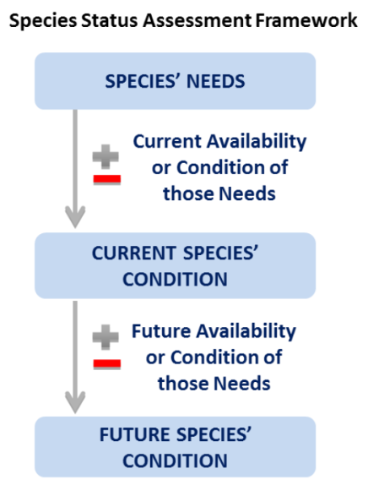
Figure 1. Species Status Assessment framework
- Resiliency is the ability of a species to withstand environmental stochasticity (normal, year-to-year variations in environmental conditions such as temperature and rainfall), periodic disturbances within the normal range of variation (fire, floods, and storms), and demographic stochasticity (normal variation in demographic rates such as mortality and fecundity) (Redford et al. 2011, p. 40). Simply stated, resiliency is the ability to sustain populations through the natural range of favorable and unfavorable conditions. We can best gauge resiliency by evaluating population level characteristics such as: demography (abundance and the components of population growth rate—survival, reproduction, and migration), genetic health (effective population size and heterozygosity), connectivity (gene flow and population rescue), and habitat quantity, quality, configuration, and heterogeneity. Also, for species prone to spatial synchrony (regionally correlated fluctuations among populations), distance between populations and degree of spatial heterogeneity (diversity of habitat types or microclimates) are also important considerations.

- Redundancy is the ability of a species to withstand catastrophes. Catastrophes are stochastic events that are expected to lead to population collapse regardless of population health and for which adaptation is unlikely (Mangel and Tier 1993, p. 1083). We can best gauge redundancy by analyzing the number and distribution of populations relative to the scale of anticipated species-relevant catastrophic events. The analysis entails assessing the cumulative risk of catastrophes occurring over time. Redundancy can be analyzed at a population or regional scale, or for narrow-ranged species, at the species level.

- Representation is the ability of a species to adapt to both near-term and long-term changes in its physical (climate conditions, habitat conditions, habitat structure, etc.) and biological (pathogens, competitors, predators, etc.) environments. This ability to adapt to new environments—referred to as adaptive capacity—is essential for viability, as species need to continually adapt to their continuously changing environments (Nicotra et al. 2015, p. 1269). Species adapt to novel changes in their environment by either [1] moving to new, suitable environments or [2] by altering their physical or behavioral traits (phenotypes) to match the new environmental conditions through either plasticity or genetic change (Beever et al. 2016, p. 132; Nicotra et al. 2015, p. 1270). The latter (evolution) occurs via the evolutionary processes of natural selection, gene flow, mutations, and genetic drift (Crandall et al. 2000, p. 290-291; Zackay 2007, p. 1). We can best gauge representation by examining the breadth of genetic, phenotypic, and ecological diversity found within a species and its ability to disperse and colonize new areas. In assessing the breadth of variation, it is important to consider both larger-scale variation (such as morphological, behavioral, or life history differences which might exist across the range and environmental or ecological variation across the range), and smaller-scale variation (which might include measures of interpopulation genetic diversity). In assessing the dispersal ability, it is important to evaluate the ability and likelihood of the species to track suitable habitat and climate over time. Lastly, to evaluate the evolutionary processes that contribute to and maintain adaptive capacity, it is important to assess [1] natural levels and patterns of gene flow, [2] degree of ecological diversity occupied, and [3] effective population size. In our species status assessments, we assess all three facets to the best of our ability based on available data.
To evaluate the biological status of Navasota false foxglove into the future, we assessed a range of possible future conditions to allow us to consider the species’ resiliency, redundancy, and representation. This SSA Report provides a thorough assessment of biology and natural history and assesses demographic risks, stressors, and limiting factors in the context of determining the viability and risks of extinction for the species going forward.

Chapter 2: Species Information
In this chapter, we provide basic biological information about Navasota false foxglove, including physical environment, taxonomic history and relationships, morphological description, along with reproductive and other life history traits. We then outline the resource needs of individuals, populations, and the species as a whole. Here we report those aspects of the life history of the Navasota false foxglove that are important to our analysis. Data on this species was obtained by the Texas Parks and Wildlife Department (TPWD), Texas Natural Diversity Database (TXNDD), Texas A&M University, TPWD botanists, Mercer Botanical Center – Mercer Botanic Gardens botanists, other relevant species specialist (federal botanists, private consultants, academicians, and others). For further information regarding this species please refer to Canne-Hilliker and Dubrule (1993, entire) and Reed et al (2005, entire).
2.1 Taxonomy and Genetics
Agalinis (false foxglove) is a genus of about 70 species in North, Central, and South America that until 2008 was aligned with members of the family Scrophulariaceae (figwort family). In 2008, it was shown to be more closely related to Orobanchaceae (Broomrape family), which consists mostly of hemiparasitic plants (Pettengill and Neel 2008, pg. 15).
Navasota false foxglove is a narrowly endemic, hemiparasitic, annual plant known in only two counties in southeast Texas, Grimes and Tyler counties. Navasota false foxglove flowering begins in mid-September and is triggered by short days when there are fewer hours of sunlight (Reed et al 2005, pg. 7). Navasota false foxglove blooms from mid-September to October, and seeds mature from October to early November. Fruit maturation and seed dispersal occurs by November, with other Agalinis fruit typically containing between 50 and 180 seeds (Cunningham and Parr 1990, pg. 269). Plants are essentially dead by December. This species is relatively hard to see when the plants are not in flower, and even during flowering times they can be hard to see across the landscape. They bloom every day, and flowers often drop by mid-afternoon of the same day. Navasota false foxglove will not grow in a solid stand of very dense vegetation due to the requirement of full sunlight (Strong and Williamson 2015, pg. 6).
The currently accepted taxonomic classification of Agalinis navasotensis (Navasota false foxglove) is as follows:

Order: Scrophulariales
Family: Orobanchaceae (broomrape) (Pettengill and Neel 2008 & Flora of North America (c))
Genus: Agalinis Raf. (false foxglove) (Flora of North America (b)
Species: Agalinis navasotensis (Canne-Hilliker & Dubrule 1993 & Flora of
North America (a))

The description provided by Canne-Hilliker & Dubrule 1993 (pg. 426-431) is as follows:
Navasota false foxglove is an annual herb from a few fibrous roots, 2.8-9.0 decimeter (dm) tall, often tinged with purple, maroon, or bronze. Stem erect or sometimes declined, single from the base, divaricately branched above, terete to slightly angled below the branches. Leaves opposite, spreading to ascending or often recurved filiform, 0.5-1 millimeters (mm) broad, 1.2-3 centimeters (cm) long, acute to acuminate. Pedicels slender, terete, spreading or ascending, glabrous to minutely scabridulous and always longer than the calyx. Calyx somewhat campanulate or funnelform, straight sided. Tube 2.2-3.7 mm long, 3-4 mm broad, unribbed, exterior glabrous, interior with a narrow band of capitate hairs below the sinuses and lobes; lobes triangular-subulate, 0.5-1.5 mm long, sinuses broad and straight to slightly concave. Corolla including lobes 16 – 25 millimeters (mm) long, lavender to rose-purple. Corolla paler in the larger blossoms and darker in the smaller, throat paler than lobes, with darker spots and two pale yellow lines abaxially. Tube 2-3 mm long, narrow, glabrous. Stamens didynamous, abaxial filaments 9-11 mm long, villous; adaxial filaments 5-6 mm long; sparingly villous. Anthers of abaxial stamens usually coherent by entangled hairs; thecae villous, 2- 3.2 mm long. Style 1.5 cm long, pubescent; stigma 2 - 4.5 mm long, densely yellow-papillate. Capsule 4-7 mm long, conspicuously longer than the calyx, 4- 4.5 mm broad, ovoid-or obovoid-oblong. Seeds 0.8-2.3 mm long, dark brown, irregularly trapezoidal, testa reticulate, radial walls of reticulae densely thickened, inner tangential walls with an irregular pattern of spinulose thickenings.
The leaves and general appearance of Navasota false foxglove resemble several of other common false foxgloves that all have thin thread-like leaves. Navasota false foxglove is most similar to Caddo false foxglove (Agalinis caddoensis), a species from Louisiana that has not been seen since the original collection in 1913 by F.W. Pennell. Navasota false foxglove can be distinguished from Caddo false foxglove because Navasota false foxgloves are more delicate, the primary stem leaves are often longer and recurved, and the inflorescences differ in structure, being racemose-paniculate and not solely racemose (Canne-Hilliker & Dubrule 1993, pg. 433). The original Caddo false foxglove collection from Pennell in 1921 does not have fruit or seeds and the area described has been developed since collection. The site description for Caddo false foxglove does not resemble the habitat of the Grimes or EO# 9000 sites. Greenhouse study efforts to propagate Navasota false foxglove by the Mercer Botanic Gardens proved that the sculpting on the surface of the seeds did not match that of any other species (Reed, pers. comm. 2019). These studies also determined, based on the size of the Navasota false foxglove chromosomes, that it was probably not a hybrid between Prairie false foxglove (Agalinis heterophylla) and other common Agalinis spp. in the area. Plant chromosomes vary in size; Navasota false foxglove chromosomes differs from all other members of this section (Canne-Hilliker & Dubrule 1993, pg. 432). The status of Navasota false foxglove as a distinct species was supported by DNA barcoding research (Pettengill and Neel 2010, entire) but the distinction and population genetics between the current sites in Grimes and Tyler counties have not been analyzed.

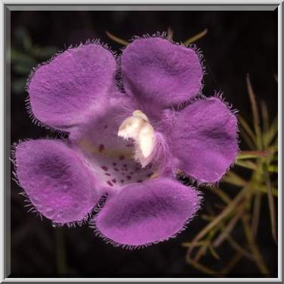
Figure 2. Navasota false foxglove (asergeev.com)
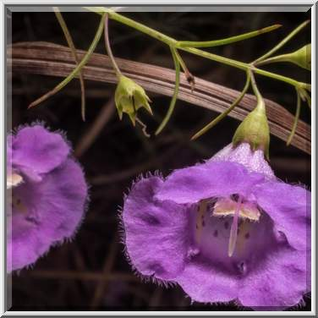
Figure 3. Navasota false foxglove (asergeev.com)
2.2 Species Distribution
Navasota false foxglove is only known in two counties in Texas: Grimes and Tyler. It was thought to occur in Jasper and Newton counties (Strong and Williamson 2015, p. 3), but no voucher specimens or literature exist to support historical or current populations of Navasota false foxglove in those counties (Strong, pers. comm. 2020). Therefore, this SSA recognizes populations in the Grimes and Tyler County sites only. For further information about the Navasota false foxglove distribution, refer to Canne-Hilliker & Dubrule (1993, entire) and Strong and Williamson (2015, entire).

Information obtained from the TXNDD uses an Element Occurrence data standard for recording data. The Element Occurrence (EO) is an area of land or water where a species or species habitat is, or was, present. Source features are mapped representation of one or more observations that includes Locational Uncertainty to ensure that the actual location on the ground is captured within that source feature. Source features are the components from which Element Occurrences are developed (Nature Serve 2004 pg. 2). The Grimes County EO consists of two source features (east and west) within one mile of each other. The two sites are referenced as the “EO# 6674 (East)” and the “EO# 6674 (West)” and both are on private properties (See Map 1). The EO# 6674 (East) population is the main source feature on a sand-limestone outcrop (Oakville Formation) southeast facing, full sun, thin soils, and well drained soils. The EO# 6674 (West) population was discovered in the fall of 1992 and is located on an eroded hillside which is essentially the northern face of the same outcrop as the EO# 6674 (East) site. The two locations are linked to the same element occurrence record in TXNDD. Genetics on these populations have not been analyzed. In this document the Grimes County sites are separated into two source features, due to the difference in habitat, stressors, and management. The EO# 9000 site (See Map 1) in Tyler County consists of only one source feature more than 100 miles from the Grimes County sites. This site is found along the roadside and is in an old pine plantation area.

Map 1. Navasota False Foxglove Populations by Element Occurrence Number
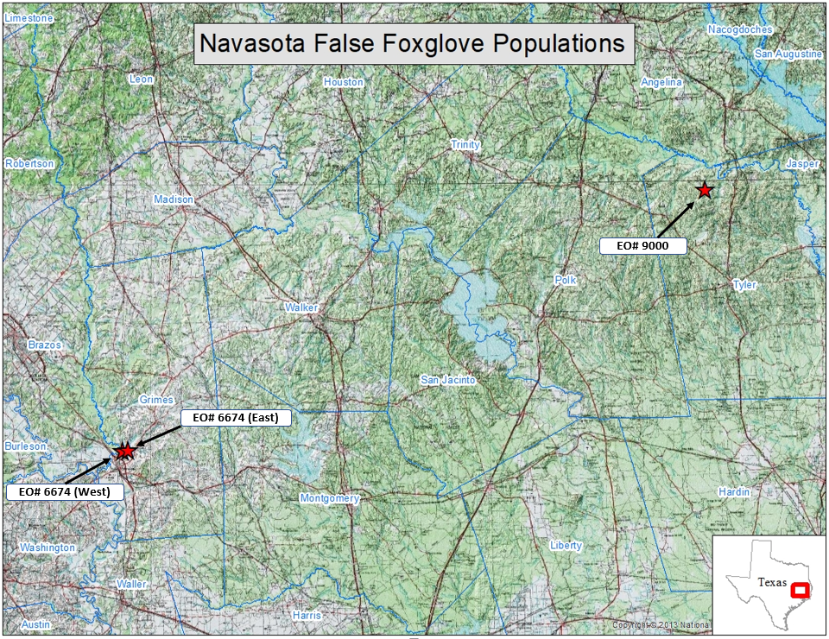

Botanists have searched for Navasota false foxglove on other Oakville formation outcrops in Grimes County and on similar outcrops in Washington and Fayette counties, but no individuals have been found (Reed et al. 2005, pg. 2). Most of the Oakville formation is buried except for rare areas where it is exposed to the surface and these areas are where EO6674 of Navasota false foxglove has been recorded. A calcareous outcrop near St. Matthew’s Parish in Washington County was surveyed for the presence of Navasota false foxglove but was found to support only Prairie false foxglove (Canne-Hilliker & Dubrule 1993, pg. 437). Plants surveyed in Fayette County were originally thought to be Navasota false foxglove based on fruit alone. However, in fall 2020, the Fayette County site was surveyed during blooming season, and it was identified as Agalinis homalantha.

Table 1. Texas Counties surveyed for Navasota false foxglove between 2000-2020
The first record identified of an Agalinis species in Grimes County comes from the Keeney (1967) thesis where he identified an Agalinis species while researching the flora and ecological relationships on the EO# 6674 (East) site (Canne-Hilliker & Dubrule 1993, pg. 436). Navasota false foxglove specialists believe Keeney’s record of Agalinis was probably Navasota false foxglove at the time of Keeney’s research, even though Navasota false foxglove had not been discovered yet (Reed, pers. comm. 2021). The first Navasota false foxglove specimen was collected in 1983 in Grimes County but was initially identified as green false foxglove (Agalinis viridis). Specialists noted that the specimen appeared to be inconsistent with other known Agalinis species. In 1993, the specimen was confirmed to be a new species, Agalinis navasotensis (Canne-Hilliker & Dubrule 1993, pg. 436; Reed, pers. comm 2020). The species was not officially identified in Tyler County until 1993 when it was recognized by Canne-Hillier and Dubrule as Navasota false foxglove (Agalinis navasotensis). When specialists discovered this new Agalinis species, they reviewed old herbarium specimens. In 2003, an herbarium specimen that was collected in 1967, identified as St. Mark’s false foxglove (Agalinis pulchella), was re-evaluated, and identified as Navasota false foxglove (Agalinis navasotensis), which led to the rediscovery of the Tyler County site in 2003 (Reed et al 2005, pg. 2).

2.3 Life History
2.3.1. Life Cycle and Growth
Figure 4. Life cycle diagram of Navasota False Foxglove (Agalinis navasotensis)
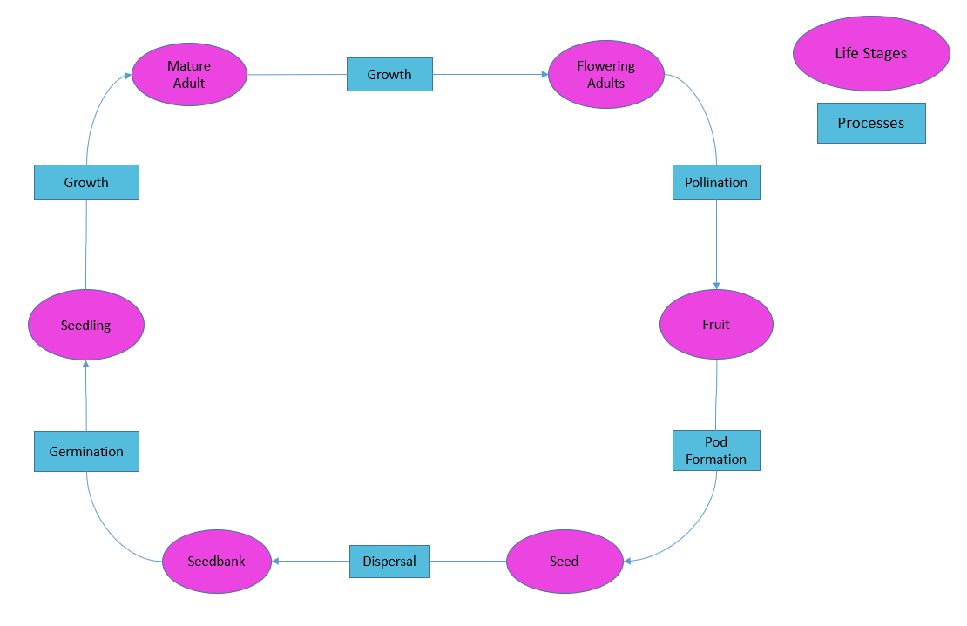

Table 2. Annual Life Cycle Gant Chart
Life stage | Jan | Feb | Mar | Apr | May | Jun | Jul | Aug | Sep | Oct | Nov | Dec
Flower
Capsule/Seeds
Dead Plant
Germination (varies)
Seedling Growth
Mature Adults

2.3.2. Phenology
We reviewed data on the species’ phenology included in EO records of Navasota false foxglove, provided by the TXNDD. This database provides EO records of Navasota false foxglove from multiple sources. Surveys of Navasota false foxglove usually include only reproductive individuals due to only being able to see them during the flowering season. The life cycle is well known for the genus Agalinis. Positive identification is only available for Navasota false foxglove during the flowering season in late September to early October of each year, and it closely resembles several other Agalinis species when not in flower. The life cycle stages for Navasota false foxglove have not been fully researched, therefore surrogate species are used for those stages not yet studied, the surrogates include Prairie false foxglove (A. heterophylla), Ridgestem false foxglove (A. oligophylla), and Beach false foxglove (A. fasciculata).

2.3.3. Reproduction
Little is known about specific reproductive biology for Navasota false foxglove, but inferences can be made from other Agalinis species. The reproductive age of false foxgloves is less than 1 year. False foxgloves need pollinators and are structured like typical bee-pollinated flowers with nectar guides and an open throat, but they can also self-pollinate. Corollas are present for one day only and drop by the end of the day. As a corolla falls, it drags the anthers and stigma together, effecting pollination (Pennell 1921, pgs. 515-525). Numerous dark brown seeds (0.8-2.3mm) are encapsulated within a 6-7 mm long (Canne-Hilliker & Dubrule 1993 p. 430), ovoid to obovoid-oblong fruit; not all seeds will germinate in a single year and not all seeds in a capsule are viable (Strong and Williamson 2015 p. 4).

2.4 Habitat
2.4.1. Geological substrates
The EO# 6674 (East) site is a remnant prairie on a rocky sandstone outcrop representing the easternmost escarpment of the Oakville formation. The soils consist of rock outcrop and sandy loam over sandstone. Plants occupy open areas of the outcrops where sun exposure is nearly constant. In 1967, Keeney presented his thesis on the “Flora and Ecological Relationships of the Easternmost Extension of the Oakville Formation of Texas.” Keeney’s study on the soil-plant relationships on the outcrop areas of the Oakville sandstones revealed several interesting findings, including that the soils are a major factor in determining flora distribution and that segregation of species exists when limiting factors (plant structure, soil types, adequate water, base rock material, etc.) within a particular area are complex. Plants inhabit soil types specific to their individual needs, therefore soil mapping can identify flora distribution based on specific soil types. Mapping these specific soils can provide information for species distribution, which can help narrow down survey areas specific to certain rare plant species. Isolation of species in the case of the Navasota false foxglove is limiting due to exposed rocky outcrops and well drained soils being a need for this species. Keeney described ten different factors in his thesis where soil-plane relationships can be used (Kenney 1967, pg. 5-6). At the EO# 6674 (East) site, most of the plants occur on exposed rock formations, similar to the habitat at EO# 6674 (West) site. The EO# 9000 site is an outcrop of the Catahoula Formation within a pine plantation and surrounding pine savannah. Soils consist of fine sandy loams and clay. The Catahoula formations are similar to the Oakville formations found in Grimes County, but many of the plants at this site were not near exposed rock like the ones in Grimes County. Soils at the EO# 9000 site tend to be hard when dry, and when wet the thick clay becomes sticky and slick (Reed et al 2005, pg. 3).

2.4.2. Microhabitats
The soils were analyzed at the current Navasota false foxglove locations to determine the habitat features of areas that are currently occupied. The Grimes County sites (EO# 6674 East and West) are within a formation described as renish-rock outcrop complex. Plants are located on 8 to 20 percent slope and Brenham clay loam. Grimes County is within the Catahoula formation that extends across most of the eastern and southern parts of Texas (Map 2 below). The EO# 9000 site has soils that are described as Colita fine sandy loam and are within the Browndell-Kittrell complex, stony. Individual plants occur on slopes of 1 to 3 percent in the former soil and 5 to 15 percent slopes on the latter soils. Navasota false foxglove has only been found in areas where these formations are exposed to the surface, producing shallow, well drained soils. Map 2 illustrates soil types that were selected for projecting soils and potential habitat features that are like currently occupied habitat conditions based on description and knowledge of soils in the areas of occupied sites. The description of these soil types varies across databases and counties, so it is difficult to determine which soil types are closely related across county lines. While developing and evaluating the soil and rock layers, it was determined that there is a lot of uncertainty between county boundaries and soil mapping. The soil mapping was helpful as a visual representation of the areas that could potentially be Navasota false foxglove habitat, but it was not ground-truthed and did not provide any increased probability that could be used to determine potential survey areas or critical habitat mapping.

2.5 Population Trends
It is challenging to interpret the size and demographic trends of Navasota false foxglove populations due to the varying number of plants flowering at each location annually. For example, in a “good year” there may be more than three hundred individuals in flower at the EO# 6674 (East) site, while in a “bad year,” as few as thirty may be observed. The Bracted twistflower Species Status Assessment states:
“Bracted twistflower, like other annual plants, persists through its soil seed reserve, which is the quantity of viable seeds that are present in the soil. Hence, the most realistic measure of its population sizes is the abundance and extent of the soil seed reserve, rather than the highly variable numbers of individuals that emerge from year to year. Unfortunately, it is extremely difficult to quantify seed bank for this species. The established methods require extracting seeds from soil samples or allowing seeds present in soil samples to germinate; however, these methods do not give comparable results, and each has flaws (Gonzalez and Ghermandi 2012, pg. 241). Consequently, we do not know how many viable, dormant seeds reside in the soil seed bank of this species, nor how long its seeds remain viable in the soil. Bracted twistflower replenishes its seed bank during the relatively few years when large numbers of individuals emerge, flower, and set seed. The soil seed reserve loses seeds through germination and the incremental loss of viability over time” (USFWS 2019, pg. 22).

The largest of the three sites (EO# 6674 (East)) has been periodically visited since 1993, but more frequently since 2000. Surveys at this site between 2000 and 2010 identified between 24 (2006) and 570 individual plants (2001). In 2007, after a winter prescribed burn, the records stated “too many to count” indicating that a survey of individuals was not done but plants were extremely abundant (TXNDD 2020). Surveys done on this same site between 2011 and 2021 ranged between 52 (2020) and 389 individuals (2012). In 2015 there is another record stating “too many to count – post burn” indicating that the survey showed an abundance of individuals following a winter burn in 2014. The EO# 6674 (West) site was initially counted in 1992 with 30 individuals. Only three surveys were done after 1992 and were 70 individuals (2001), 20 (2002), and 30 (2004). The site has been visited but not surveyed since 2004. The EO# 9000 site was surveyed only between 2003 and 2005 and the number of individual plants ranged from 200 (2003), 30 (2004), and 200 (2005). This site has not been surveyed since 2005.

Map 2. Soils and habitat mapping for Navasota false foxglove
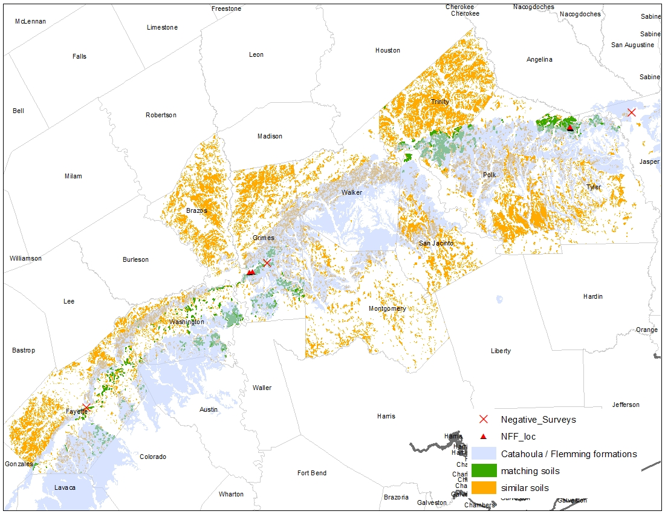

2.6 Individual Requirements
We evaluated the individual needs of Navasota false foxglove in terms of the resource needs and/or the circumstances that are necessary to complete each stage of the life cycle. The life history of Navasota false foxglove is closely tied to its specific habitat requirements for all stages of the species’ life cycle. Table 3 summarizes the resources that are needed by life stage.

Table 3. Resource Needs by Life Stage
Life Stage | Resources and/or circumstances needed for INDIVIDUALS to complete each life stage | Resource Function | References
Seeds  (little known) | - Calcareous sandy to clay loam soils that are ungrazed, unplowed, shallow thin soils. No woody encroachment, open prairie habitat. Full sun and adequate precipitation. | Habitat  Nutrition  Seed dispersal | Strong and Williamson, 2015 pg. 5 & 9.  Canne-Hilliker & Dubrule 1993 pg. 433
Germination (little known) | - Uses a host plant to aid in germination  - Can and will germinate with adequate precipitation years and soil nutrients  - Drought years – will parasitize a host in order to gather more nutrients and water  - Chemicals from prairie fires can break open seeds for germination.  - Host plants (growing root tips that produce exudate for development).  - Calcareous, shallow, sandy to clay loam soils that are ungrazed and unplowed. No woody encroachment, open prairie habitat. Full sun and adequate precipitation. | Habitat  Nutrition | Strong and Williamson, 2015 pg. 5 & 9.  Canne-Hilliker & Dubrule 1993 pg. 433.  Yatskievych, pers comm. 2021.
Seedlings | - Calcareous, shallow, sandy to clay loam soils that are ungrazed and unplowed. No woody encroachment, open prairie habitat. Full sun and adequate precipitation. | Habitat  Nutrition | Strong and Williamson, 2015 pg. 5, 8 & 9. Canne-Hilliker & Dubrule 1993 pg. 433.
Mature  and  Reproductive  Adults | - Short sun hour days to trigger flowering  - Full sun exposure, can maintain with shade up to 10-15%  - Pollinators  - Adversely affected if surrounding vegetation is too thick  - Calcareous, shallow, sandy to clay loam soils that are ungrazed and unplowed. No woody encroachment, open prairie habitat. Full sun and adequate precipitation. | Habitat  Nutrition  Reproduction | Strong and Williamson, 2015 pg. 5 & 9. Canne-Hilliker & Dubrule 1993 pg. 433. Reed, pers. comm 2020.
Fruit/Capsule | - Pollination (selfing or pollinators)  - Calcareous, shallow, sandy to clay loam soils that are ungrazed and unplowed. No woody encroachment, open prairie habitat. Full sun and adequate precipitation. | Habitat  Nutrition  Reproduction | Canne-Hilliker & Dubrule 1993 pg. 433. Strong and Williamson, 2015 pg. 5 & 9.

2.6.1. Disturbance and competition reduction
Fire is an integral part of the prairie ecosystems and thus the growth pattern of the Navasota false foxglove. Historically, prairie fires were part of the normal cycling of these habitats. Since settlement times, these variations in natural fire cycling have been suppressed. These areas are not currently prone to wildfire from lightning-caused fires but could use a rotation of prescribed burning to manage woody plant encroachment and shading of Navasota false foxglove habitat (Strong and Williamson, 2015, pg. 9). Two prescribed burns were conducted at the EO# 6674 (East) in December 2006 and December 2014, which resulted in a noticeable increase in individuals the following flowering season (Reed, pers. comm. 2021). Prescribed fire has been a resource management tool for pyrophytes for many years, especially in these prairie grass, thin-soiled communities (Keeney 1967, pg. 2). Agalinis species have seen declining trends due to conditions where development or a lack of natural disturbance have taken place (Pettengill and Neel 2008, pg. 2). This lack of disturbance causes Agalinis to be restricted to very narrow areas of habitat like forest edges, roadsides, and utility corridors. Additionally, this makes the Agalinis species more susceptible to mowing during the reproductive season, disturbance from removal of woody vegetation, and invasion of aggressively competitive non-native species. Exotic invasive plants that impact the habitat of Navasota false foxglove at the EO# 6674 (East) site include King Ranch bluestem (Bothriochloa ischaemum var. songarica), Japanese honeysuckle (Lonicera japonica), and privet (Ligustrum spp.). In addition, native juniper (Juniperus virginiana) at the site shades out Navasota false foxglove and can reduce its reproduction which decreases the likelihood of seed germination (Keeney 1967, pg. 35). Prescribed burning at the EO# 6674 (East) site has potential to continue in the future years, but the owners like having the junipers as a sound and visual privacy barrier between the highway and their house. The site has a beautiful view over Grimes County and is a popular area for trespassers.

2.6.2. Host Plants
Navasota false foxglove parasitizes neighboring plants, and a lack of hosts could stunt or prevent growth of the hemiparasite plant (Strong and Williamson 2015, pg. 6). The host plant requirements for Navasota false foxglove have not been researched, but specialists hypothesize that little bluestem (Schizachyrium scoparium) is one of the main plants that it parasitizes (Reed, pers. comm. 2020). Little bluestem occurs in all three current source features for Navasota false foxglove. Also, the co-occurring King Ranch bluestem (Bothriochloa ischaemum var. songarica), a non-native, invasive grass, could serve as a potential beneficial host but could also out-compete it for sunlight, if not managed (Strong and Williamson 2015, pg. 6). Currently, both species of host plants inhabit areas where Navasota false foxglove are found. These host plants provided needed nutrients for survival and reproduction of Navasota false foxglove, especially in drought years.

2.6.3. Precipitation
The climate of Navasota false foxglove habitat features hot, often dry summers and mild to cold winters, with two annual peaks of average precipitation: May–June and September–October. The eastern part of Texas (the area where the populations are located) receives close to 60 inches of rainfall annually and lies within the humid subtropical zone. Severe thunderstorms and tornadoes are frequent in this area during the spring season. Summers are hot and humid, and tropical storms often occur in the late summer/fall. Hurricanes Rita (2005), Ike (2008), and Harvey (2017) all affected the Navasota false foxglove habitat areas. Species here must be able to withstand or rebound from the high winds, heavy rainfall, saturated soils, and flooding that accompany these storms. These storms can, however, mitigate drought conditions by the large amounts of rainfall that they bring (Nielsen-Gammon 2011, p. 10). January is usually the coldest month of the year and August is the hottest month of the year. There are 244 frost-free days on average in this area, from early March through mid-December (Larkin and Bomar 1983).

2.6.4. Laboratory Research
Seeds were collected from the EO# 6674 (East) site and stored at Mercer Arboretum and Botanic Gardens in Humble, TX. This seed bank has been maintained since 1999. The seeds that were collected in October 1999 were germinated in the same year by Dr. Valerie Pence’s lab at the Cincinnati Zoo and Botanic Gardens. Dr. Pence maintains Navasota false foxglove in tissue cultures produced from the germinated seeds. The plants produced by tissue culture bloom but are much smaller than wild plants (Tiller pers. comm. 2020). The seed germination rate of Navasota false foxglove on 1% agar reported by Kew Botanic Garden Seed Information Database was much lower than rates of other Agalinis species at 1-12% (Tiller pers. comm. 2020). The most recent germination work has been by Jeff Glitz, U.S. Forest Service Seed Lab in Macon, Georgia. He collected capsules from the EO# 6674 (East) site in 2017. He placed these seeds under cold moist stratification for 1 month and then transferred them to a germination chamber calibrated for spring temperatures. There was no germination after one month. He had ~100 seeds remaining after this trial which he placed in a standard plug tray with soil (Glitz, pers. comm. 2021). After 2 years, only one germinated. It died after it was transferred to a pot with potential host grasses. Future work would consider trying germination with both grasses and Navasota false foxglove at the same time. Overall, laboratory efforts have been unsuccessful and germination in labs may not be a viable option unless further research is done in these areas.
2.6.5. Uncertainties relating to Individual Needs
It is unclear how long Navasota false foxglove seeds remain viable in the seed bank and what the seed germination requirements are. It is important to understand the germination requirements and seed bank dynamics in order to determine resiliency over time. The two main populations in Grimes and Tyler Counties have different habitat types and it is very difficult to determine the best areas to survey for this species. Mapping of the current habitats and where they overlap did not help narrow the areas for future surveys or potential habitats. We do not fully understand how climatic and biotic factors influence seed production and growth. Furthermore, we do not fully understand the factors that define and constrain this species to its relatively small range.

2.7 Population Requirements
The population requirements of Navasota false foxglove in terms of resiliency were evaluated. The measure of resiliency is based on a population’s ability to withstand or recover from environmental or demographic stochastic events, such as changes in precipitation or decreased plant densities, for example.

The following conditions are needed to support resilient Navasota false foxglove populations:
- Population Size – the necessary abundance or minimum viable population size for Navasota false foxglove is unknown; however, estimations can be attained from literature. Pavlik (1996, p.137 Figure 6-3) recommends Minimum Viable Population (MVP) for the conservation of rare plants, depending on various life-history characteristics of the taxon.
- Population Connectivity – in order for Navasota false foxglove source features to be resilient, they need to be connected such that gene flow is occurring between source features. The areas between the source features should have habitat to support pollinator species for Navasota false foxglove. Pollinator species are discussed in Chapter 4 below.

2.7.1. Minimum Viable Population (MVP)
Populations of Navasota false foxglove must be large enough to have a high probability of surviving a prescribed period of time. For example, Mace and Lande (1991, p. 151) propose that species or populations be classified as vulnerable when the probability of persisting 100 years is less than 90 percent. This metric of population resilience is called minimum viable population (MVP).

Table 5 is an adaptation of a method for estimating plant MVPs published in Pavlik (1996, p. 137). The Clear Lake and Austin Ecological Services Field Office along with species specialists discussed revisions and standardization of our use of Pavlik’s table to estimate MVPs. By consensus, we agreed to add an intermediate column (B) of 1,275 individuals to Pavlik’s table to account for species with intermediate traits. The species is an annual, with herbaceous growth form, no ramets, and environmental variation is high (wide variation in annual rainfall and sunlight); hence, 4 factors call for larger populations. The breeding system is mixed, and successional status is intermediate, so two factors are ranked in the intermediate column. Fecundity, individual survivorship, and the longevity of seed viability are all unknown; these 3 factors are excluded from the estimate. The MVP calculations have been revised according to this consensus agreement. Therefore, our estimate of MVP is the weighted average of these factors:

(0 x 50) + (2 x 1,275) + (4 x 2,500) = 2,092 (or about 2,100 individuals).
6

Table 4. Minimum viable population guidelines applied to Navasota false foxglove (adapted from Pavlik 1996, p. 137).

Factor | A. MVP of 50 individuals for species with these traits. | B. Intermediate MVP of 1,275 individuals for species with intermediate or unknown traits. | C. MVP of 2,500 individuals for species with these traits.
Longevity | Perennial |  | Annual
Breeding System | Selfing | Mixed | Outcrossing
Growth Form | Woody |  | Herbaceous
Fecundity | High | Unknown | Low
Ramet Production | Common |  | Rare or None
Survivorship | High | Unknown | Low
Longevity of Seed Viability | Long | Unknown | Short
Environmental Variation | Low |  | High
Successional Status | Climax | Mixed | Seral or Ruderal

2.8 Species Requirements

We identify the species’ needs in terms of redundancy and representation of the species. We evaluate the redundancy of this species by the number and distribution of Navasota false foxglove populations. Having multiple populations distributed across a larger area reduces the risk of catastrophic events that may affect one or more populations simultaneously, affecting the whole species. Fewer populations distributed narrowly across its range would increase catastrophic risk and lower redundancy. Representation of Navasota false foxglove is based on the presence of multiple, self-sustaining populations across the range of the species and their contributions to providing adaptive capacity to the species in the face of changing conditions. Navasota false foxglove requires a level of genetic diversity that enables the species to adapt to environmental change. We do not know if there is occupied habitat elsewhere within Grimes County, Tyler County, or other areas of Texas. Therefore, we do not know how many populations are necessary to provide sufficient redundancy and representation to the species.

Chapter 3: Influences on Viability
3.1 Potential Stressors Affecting Navasota False Foxglove and Habitat
3.1.1. Encroachment of woody vegetation
Although Navasota false foxglove populations occur in different habitats, the soils are sandy loam over sandstone (EO# 6674 East and West) and clay loam (EO# 9000). Navasota false foxglove thrives in full sun along with its potential host plant, little bluestem. The larger source feature, EO# 6674 (East), occurs in relatively open vegetation with edges of juniper trees and low shrubs. Even though some individual plants were found in shaded areas during high sun hours, they have morning or afternoon sun exposure that would allow completion of the life cycle. In the summer of 2007, habitat improvement projects to remove some of the woody vegetation along the habitat edges were successful. With the prescribed burn in December 2006, combined with the woody vegetation removal in 2007, the fall 2007 surveys had high numbers of individuals.

3.1.2. Land use changes/Private land ownership
There are no known land use changes since initial surveys at the EO# 6674 (East) location. The private landowners have been open to the Service and other individuals from Texas A&M visiting their property for surveys and implementing habitat management projects as well. The EO# 6674 (West) and EO# 9000 populations have changed owners or lessees within the last decade. The known EO records occur entirely on privately owned lands. Private ownership does not itself constitute a threat. We are unsure at this time if grazing causes impacts; none of the known occurrences are in areas that have been grazed or had any previous disturbance. If at any point grazing was introduced in these areas; it would need to be managed for this species. It is not occurring in any populations of Navasota false foxglove at this time; therefore, it is not a current threat.

3.1.3. Few known populations
The EO records of Navasota false foxglove have been documented with a combined area of less than 2 acres. The Grimes County and Tyler County populations are separated by more than 100 miles. A single event, such as a prolonged drought, or a single development project could easily destroy a large portion of the species’ remaining resources. Based on the species information it is concluded that the small number of Navasota false foxglove individuals and populations is a current and continued threat to this species.

3.1.4. Demographic consequences of small population sizes
Small, isolated populations are more vulnerable to catastrophic losses caused by random fluctuations in recruitment (demographic stochasticity) or variations in rainfall or other environmental factors (environmental stochasticity) (USFWS 2016, p. 20). In addition to population size, it is likely that population density also influences population viability, since reproduction requires genetically compatible individuals to be clustered within the forage ranges of the species’ pollinators. The known EOs of Navasota false foxglove had reported population sizes of “too many to count”; however, on other occasions, surveyors found as few as 20 individuals. It is unknown if these low numbers represent actual population fluctuations, or if the surveyors were unable to detect live, vegetative individuals. Due to the infrequency of censuses, the current population sizes or trends cannot be assessed. In conclusion, the demographic consequences of small population sizes present a potential threat of unknown immediacy, severity, and extent.

3.1.5. Climate change and Drought
Climate change has already begun, and continued greenhouse gas emissions at or above current rates will cause further warming (Intergovernmental Panel on Climate Change (IPCC) 2013, pp. 11–12). Warming in the Southwest is expected to be greatest in the summer and annual mean precipitation is very likely to decrease in the Southwest (IPCC 2013, pp. 11–12). In Texas, the number of extreme hot days (high temperatures exceeding 95º Fahrenheit) are expected to double by around 2050 (Kinniburgh et al. 2015, p. 83).

The Fifth Assessment Report of the IPCC (2013, p. 23) projects the following changes by the end of the 21st century, relative to the 1986 to 2005 averages:
- It is virtually certain that most land areas will experience warmer and/or fewer cold days and nights;
- it is virtually certain that most land areas will experience warmer and/or more frequent hot days and nights;
- it is very likely that the frequency and/or duration of warm spells and heat waves will increase in most land areas;
- it is very likely that the frequency, intensity, and/or amount of heavy precipitation events will increase in mid-latitude land masses; and
- it is likely that the intensity and/or duration of droughts will increase on a regional to global scale.
Representation Concentration Pathways (RCPs) provide a framework for modelling in the next stages of scenario-based research for greenhouse gas emissions. These are plausible pathways toward reaching each target of time-evolving emissions or concentrations of radiatively active constituents (Moss et al. 2010). RCPs provide scenarios that include time series of emissions and concentrations of greenhouse gases, aerosols, and chemically active gases. Within RCP, the word representative signifies that each RCP provides only one of many possible scenarios that would lead to the specific radiative forcing characteristics. The term pathway in RCPs emphasizes that not only are the long-term concentration levels something to consider, but the possible outcomes of these trajectories overtime (Moss et al. 2010). RCP models provides one of many possible scenarios for future conditions based on specific radiative forcing characteristics, for example, change in the concentration of carbon dioxide or the output of the sun. Two RCP scenarios were used in this SSA. One pathway was evaluated at RCP 4.5 where the radiative forces are stabilized at 4.5 watts per square meter by year 2100 and concentrations are constant after year 2150. The second pathway evaluated was the RCP 8.5 where the radiative forces are greater than 8.5 watts per square meter by year 2100 and continue to rise. These RCP scenarios provides research for future conditions of climate change (i.e. drought).

Drought-adapted plant species may experience lower mortality during severe droughts (Gitlin et
al. 2006, pp. 1477, 1484). Depending on timing and intensity of drought events, Navasota false foxglove could be adversely affected by increased mortality rates, reduced reproductive output due to loss or reduced vigor of mature plants, and reduced rates of seed germination and seedling recruitment. Increases in soil temperatures and soil moisture evaporation in response to predicted ambient warming could increase rates of soil seed bank depletion by increasing the seedling mortality rates (Ooi 2012, pp. S54–S55) and diminish the resilience of Navasota false foxglove populations by reducing the species’ ability to maintain soil seed banks. While climate has changed in recent decades in regions where Navasota false foxglove occurs, the rate of change likely will continue to increase into the future. Data is not available to accurately determine how the Navasota false foxglove or the habitats it occupies will respond to these changes.

3.1.6. Cattle and other ungulates
The EO# 6674 (East) site has not been mowed or grazed for as long as there are written records for the site (Reed pers. comm. 2021). In 1967, Keeney reported it had not been grazed for decades, at least. There are no known records whether grazing or mowing took place in the EO# 6674 (West) or EO# 9000 sites.

  - Summary of stressors
Small populations of Navasota false foxglove leave them vulnerable to stochastic events and can cause these populations to fluctuate randomly in size. In general, the smaller the population, the greater the probability that fluctuations will lead to extirpation. Also, low redundancy, having small individual numbers and being a small, isolated population can reduce species richness and genetic variability. Unknown timber activities at the EO# 9000 site pose a potential threat in the future. Urban and residential developments are not currently a threat to this species. Climate change could become a threat in the future, but the net effect of positive and negative interactions for this species cannot be projected specifically. Conservation for this species in the EO# 6674 (East) population has been beneficial to its annual abundance post treatments like prescribed burning and manual removal of woody encroachment. It is unknown if there are any efforts to conserve the species or its habitats in the EO# 6674 (West) and EO# 9000 populations. Essentially all of the species’ known populations, as well as undocumented populations that may exist in potential habitats, occur on privately owned lands. Landowners are not obligated to allow rare plant surveys on their lands. Consequently, there is insufficient knowledge of the species’ actual distribution, abundance, and status throughout the range of its potential habitats.

Chapter 4: Current Conditions
4.1 Current Conditions
In this chapter the current conditions of the Navasota false foxglove in terms of population resiliency, redundancy, and representation are considered. It is very difficult to determine the population sizes and demographic trends of an annual plant with wide annual variation in the numbers of individuals that germinate from the seed bank, flower, and set seed. In the case of EOs that have multiple source features, seed germination pulses may not be synchronous at all source features; since the maximum numbers observed at different areas may occur in different years, the potential population size may be much greater than the numbers observed in an entire EO in any single year.
4.2 Ranking Status
- Global Conservation Status Rank (G)1 – Critically Imperiled at a very high risk of extinction due to extreme rarity, very steep declines, or other factors (Nature Serve Explorer 2020).
- Subnational or State Conservation Status Rank (S)1 – Critically Imperiled in the nation or state/province because of extreme rarity or other factors.
- Other ranks include Texas Parks and Wildlife Department (TPWD) 2020 list as a Species of Greatest Conservation Need (SGCN), and U.S. Forest Service (USFS) Sensitive Species.
4.3 Population Resiliency
Population resilience for the current conditions of Navasota false foxglove was derived from two habitat factors (host plant availability, open canopy) and two demographic factors (population size and connectivity). To rank these four factors, we described conditions that were assumed to contribute to “high”, “moderate”, “low”, or “very low” levels of population resilience and provided each with a quantified rank of “3”, “2”, “1”, or “0”, respectively (Table 6)
Condition category ranking is based on a subjective assessment of the following characteristics:
High. Large to moderately large stable populations relative to other Navasota false foxglove populations. Source Features have intact habitats and occur on properties that are protected from development; populations are monitored annually, and population pulses have been observed in the last decade; habitats are suitable for the species, and management actions, such as juniper thinning, or prescribed burning are conducted as needed. Smaller populations are ranked high if they are close to larger populations within the same protected, contiguous habitat.
Moderate. Formerly large or moderately large potential populations that have declined due to habitat loss, juniper encroachment, or other impacts; large population pulses (large population - >500 individuals compared to the other Navasota false foxglove sites) have not been observed in the last decade; and management actions, such as juniper thinning, are difficult or unlikely to be conducted on a regular basis. Medium-ranked populations are likely to continue to decline but could also recover if managed appropriately. Source features may also be ranked medium if their size and habitat have not yet been adequately surveyed.
Low. Relatively small populations: source features are not protected from development, or if protected, cannot be managed for Navasota false foxglove conservation; few or no individuals have been observed in the last decade.
Very Low. Known habitats or areas of occurrence have been completely altered by soil disturbance, construction, or conversion to non-native vegetation. No conservation management taking place. However, we acknowledge that dormant, viable seeds could persist for an unknown length of time in sites considered extirpated if the soils remain intact.
4.4 Condition Category Table
Table 5. Current Condition Categories

4.4.1. Host Plant Availability
Please see Section 2.6.2. for individual needs of the host plant. In the current conditions, Little blue stem (LBS), assumed to be the host plant, is abundant across all sites for Navasota false foxglove. In the very low condition category, the presence of LBS is completely absent and the habitat would not support the production of LBS. The low condition category would support a few LBS but is in very low occurrence. When an area has presence of some LBS (more than a few individuals) then this would be considered a moderate condition category. In the high condition category, LBS is abundant and flourishing in these areas.

4.4.2. Open Canopy (% of sun exposure)
The Navasota false foxglove is not a shade tolerant species. Manual removal of branches and understory would reduce a dense canopy cover therefore increasing sunlight and increasing the species survival. The EO# 6674 (East) site has been surveyed the most over the years and these plants thrive where there is full sun or only a few hours of shade from the junipers per day. There is no Navasota false foxglove under the canopy of the large junipers, only in the open habitat between them. Navasota false foxglove would rank as having high resiliency if the amount of open canopy is greater than 75%, moderate resiliency between 50-75%, low resiliency between 25-50%, and very low resiliency if it is less than 25%.

4.4.3. Population Size
True viable population sizes for Navasota false foxglove are currently unknown. However, based on our adaptation of Pavlik’s Minimum Viable Population table, we estimated the MVP to be greater than or equal to 2,100 individuals. There is not quantitative rationale for setting these boundaries. The approach taken, which is a provisional guideline, is: ≥ 100% MVP = high resilience; 50–100% MVP = Medium resilience; <50% MVP = low resilience. 0 = very low resilience (since Navasota false foxglove is an annual, it is possible that viable, dormant seeds remain in the soil seed reserve even when no plants have emerged in a given year). Again, population sizes are currently unknown but preliminary criteria for viable population sizes and the condition category ranking is provided in Table 6 above.

4.4.4. Population Connectivity
The source features have been delineated based on distance between sites where the species is present on the landscape. Since population connectivity is closely related to pollinator forage ranges, pollinator foraging distance was analyzed to determine if it should be considered in these criteria. Although there is anecdotal evidence that suggests what pollinator species would use Navasota false foxglove, it is not known if these species are effective in pollination. A definitive conclusion cannot be made about the needed foraging distances for some pollinators, but research done by Zurbchen et al. 2010 evaluated several southeast Texas pollinators foraging distances (Table 7). However, even though the Navasota false foxglove is presumed capable of self-pollination, having healthy populations of pollinators are likely essential to maintain genetic diversity. It is assumed that healthy (high) ranking populations allow for genetic and pollinator connectivity within and between populations, and therefore populations that are within 0 - 0.25 km range are ranked as healthy (high).

While population connectivity may be an important aspect to geneflow between EOs, we do not currently have the information to support the needed proximity of populations for cross pollination to occur. In recent visits to the EO# 6674 (East) site, two potential pollinators have been identified. In 2014, the Flower fly was seen visiting a Navasota false foxglove (Figure 5) and in 2021 a Bee fly was seen visiting the plant as well (Figure 6). Not much research has been done on these two species of flies nor can we determine pollination distances for genetic flow between the Grimes County sites.
Figure 5. Flower Fly (Toxomerus marginatus) on Navasota false foxglove
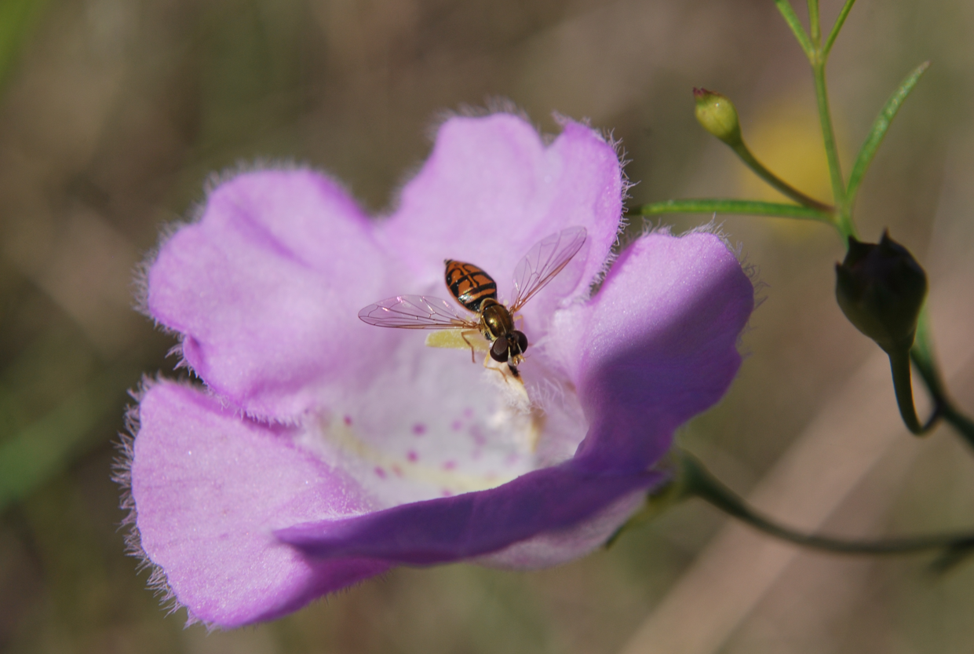

Figure 6. Bee Fly (Poecilognathus punctipennis) on a Navasota false foxglove
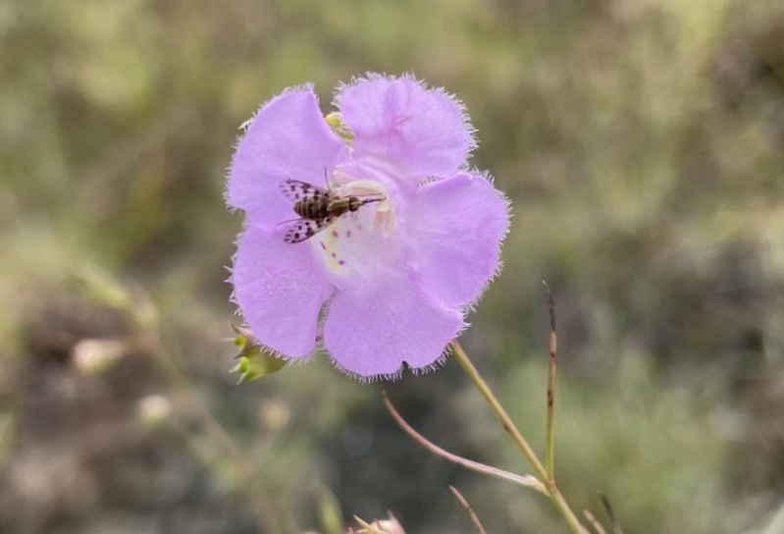
4.5 Unknowns and Assumptions
Navasota false foxglove plant numbers can fluctuate widely year-to-year and survey data are generally sparse; therefore, there is uncertainty regarding the species’ status, population size, or trends across all source features. Additionally, there are no scientific studies documenting the magnitude or significance of the stressor effects to the species.

The best available information is not sufficient for determining potential trends in Navasota false foxglove abundance. The available survey data is limited to “presence/absence,” and where population estimates are provided, the data are infrequent and generally incomparable because survey methodologies were not documented and changed over time. Therefore, it is unknown if Navasota false foxglove population numbers are changing over time across the source features. In the absence of current survey data for some populations (EO# 9000), it was assumed that if a historically known population site maintains habitat conditions conducive to the species, the population is presumed extant. If this assumption is incorrect, the current condition of the species may be overestimated.

4.6 Current Condition Summary
The conservation 3Rs—resiliency, redundancy, and representation—were used to summarize the current condition site scores for Navasota false foxglove (Table 8). The resiliency of each source feature was based on the survey data and condition of the individual source features. Specifically, the site scores for the extant populations within each source feature considered the total number and size of extant populations in each area (i.e., redundancy within the source feature), and other factors such as observed population size, specific local stressors, and available survey data. The species’ redundancy and representation were assessed based on the distribution of the species.
Table 6. Current Condition Site Scores
* based on numeric value where 3 is high resiliency, 2 is moderate resiliency, 1 is low resiliency, and 0 is very low resiliency based on the Current Conditions Scoring table of High, Moderate, Low, and Very Low resiliency categories.

Chapter 5: Species Future Conditions and Status
This section of the SSA forecasts the species’ response to probable future scenarios of environmental conditions. The future scenarios project the threats into the future and consider the impacts those threats would potentially have on Navasota false foxglove viability. The concepts of resiliency, redundancy, and representation are applied to the future scenarios to describe the future viability of Navasota false foxglove. Two future scenarios are described and future resiliency for each Navasota false foxglove source feature was assessed. The “continuation” scenario assesses the viability of the species if conditions were to continue at the current trajectory into the future with current conditions and management practices. The “worse than expected” scenario assesses Navasota false foxglove future viability by considering where conditions could deteriorate in the future. While we considered a third scenario in which conditions would improve for this species, we determined that this scenario would not be plausible as it relies heavily on the involvement of private landowners. Table 9 and 10 provide a comparison of the assumptions made for each scenario. By using these two scenarios, it allows the Service to consider two future possibilities for predicting the future viability of the species. For this SSA, the future was assessed at 30 years. This range represents our best professional judgment of the conditions that will likely affect the species in the future.
  - Potential Future Viability – Scenario 1 (Continuation)
In this scenario, where the Representative Concentration Pathways (RCP) is evaluated at 4.5 (see Section 3.1.5), it is projected that there will be no significant changes in the activities currently affecting the extant Navasota false foxglove sites. Under this scenario, it is assumed there is some management of woody vegetation encroachment to increase open canopy – percentage of sun exposure. The nonnative invasive grasses increase by 50% or less over a 30-year period. In EO# 9000, there is no road development or timber activities taking place. Managed grazing takes place on active sites, if applicable and prescribed fires are done when weather and time permit. Extant population sites currently with moderate site condition scores are considered to have a moderate resiliency and be at low risk of extirpation within the next 30 years. Populations currently with low to very low condition scores are considered to be at risk of decline because of continued disturbances, unknown environmental or demographic stochasticity. Therefore, the resiliency of the two Grimes County sites is not predicted to change significantly under this scenario. The resiliency for the EO# 9000 site moves from low resiliency to very low resiliency.
Table 7. Resiliency of Navasota false foxglove source features under Scenario 1.

  - Potential Future Viability – Scenario 2 (Increased Effects)
In this scenario, where the RCP is evaluated at 8.5 (see Section 3.1.5), woody vegetation encroachment continues to increase and open canopy (full sun) habitat is minimal. The nonnative invasive grasses increase between 50 - 100% over a 30-year period. In EO# 9000, roads are developed for timber planting or harvest and habitat is fragmented and seedbank is destroyed. The open canopy factor for the EO# 9000 site changes from very low in scenario 1 to moderate in scenario 2 due to the potential timber activities taking place at this site; it has potential to open the canopy to more sunlight and overall sun exposure for the Navasota false foxglove seedbank. Open grazing takes place on any/all active sites, if applicable and there are no prescribed burns for habitat management being done.
Table 8. Resiliency of Navasota false foxglove source features under Scenario 2.
  - Summary of Evaluation
Table 9. Comparing the resiliency of Navasota false foxglove source features for Current Conditions, and Future Conditions under Scenario 1 and 2.
To evaluate species’ viability, the known source features of Navasota false foxglove were analyzed for future conditions. Results of the current conditions analyses indicates that none of the populations are in high condition, one in moderate condition, and two are in low condition. Under the two future scenarios, it is predicted various plausible changes in the stressors, habitat condition, and conservation measures affecting Navasota false foxglove will have impacts to the resiliency of these populations. These changes in turn are predicted to affect the resiliency of the species at the population and source feature scale. Under scenario 1, by 2050, the Grimes County sites stay consistent at moderate and low resiliencies while the EO# 9000 site is predicted to have a lower resiliency then the current condition. Under scenario 2, it is predicted that two of the populations will be in low condition and one in very low condition.

APPENDIX A – Literature Cited
Beever, E.A., J. O’Leary, C. Mengelt, J.M. West, S. Julius, N. Green, D. Magness, L. Petes, B. Stein,
A.B. Nicotra, and J.J. Hellmann. 2016. Improving conservation outcomes with a new paradigm
for understanding species’ fundamental and realized adaptive capacity. Conservation Letters 9:131-137.Canne-Hilliker, J., and M. Dubrule. 1993. A new species of Agalinis (Scrophulariaceae) from Grimes County, Texas. Sida 15(3): 425-440.

Canne-Hilliker, J., and M. Dubrule. 1993. A new species of Agalinis (Scrophulariaceae) from
Grimes County, Texas. Sida 15(3): 425-440.

Crandall, K.A., O.R. Bininda-Emonds, G.M. Mace, and R.K. Wayne. 2000. Considering evolutionary
processes in conservation biology. Trends in Ecology and Evolution 15:290-295.

Cunningham, M., and P. Parr. 1990. Successful culture of the rare annual hemiparasite
Tomanthera auriculata (Michx.) Raf. (Scrophulariaceae). Castanea 55(4): 266-271.

Flora of North America (a). 1993+. Genus Agalinis. http://floranorthamerica.org/Agalinis. Accessed
19 January 2022.

Flora of North America (b). 1993+. Species Agalinis navasotensis.
http://floranorthamerica.org/Agalinis_navasotensis. Accessed 19 January 2022.

Flora of North America (c). 1993+. Family Orobanchaceae.
http://floranorthamerica.org/Orobanchaceae. Accessed 19 January 2022.

Forest Guardians. 2007. A Petition to List All Critically Imperiled or Imperiled Species in the
Southwest United States as Threatened or Endangered Under the Endangered Species Act, 16
U.S.C. §§ 1531 et seq. Page 29.

Intergovernmental Panel on Climate Change (IPCC). 2013. Summary for Policymakers. In:
Climate Change 2013: The Physical Science Basis. Contribution of Working Group I to the Fifth Assessment Report of the Intergovernmental Panel on Climate Change. Stocker, T.F., D.
Quin, G.K. Plattner, M. Tignor, S.K. Allen, J. Boschung, A. Nauels, Y. Xia, V. Bex and P.M.
Midgley (eds.). Cambridge University Press, Cambridge, United Kingdom and New York, NY, USA.

Gitlin, A., Stuhultz, M., Bowker, M., Stumpf, S., Paxton, K., Kennedy, K., Munoz, A., Bailey, J., and
Whitham, T. 2006. Mortality Gradients within and among Dominant Plant Populations as Barometers of Ecosystem Change During Extreme Drought. pp. 1477, 1484

Gonzalez, S. L., and Ghermandi, L. 2012. Comparison of methods to estimate soil seed banks: the role
of seed size and mass. Community Ecology 13(2): 238-242.

Keeney, T. 1967. Flora and ecological relationships of the easternmost extension of the Oakville
Formation of Texas. M.A. Thesis: Sam Houston State College, Huntsville, TX.

Kinniburgh, F., M.G. Simonton, C. Allouch. 2015. Come heat or high water: climate risk in the
southeastern U.S. and Texas. 114 pp.

Larkin, T. J. and Bomar, G. W. 1983. Climatic Atlas of Texas. Texas Department of Water Resources,
Austin, pp. 151.

Mace, G.M. and R. Lande. 1991. Assessing extinction threats: Toward re-evaluation of IUCN
Threatened Species Categories. Conservation Biology 5:148-157.

Mangel, M., and C. Tier. 1993. A simple direct method for finding persistence times of populations
and application to conservation problems. Proceedings of the National Academy of Sciences of the USA 90:1803-1086.

Moss, R. H., Edmonds, J. A., Hibbard, K. A., Manning, M. R., Rose, S. K., Van Vuuren, D. P., Carter,
T. R.,Emori, S., Kainuma, M., Kram, T., Meehl, G. A., Mitchell, J. F. B., Nakicenovic, N.,
Riahi, K., Smith, S. J., Stouffer, R. J., Thomson, A. M., Weyant, J. P., & Wilbanks, T. J. 2010. The next generation of scenarios for climate change research and assessment. Nature. Volume 463, pp. 747-756.

NatureServe. 2002. NatureServe Element Occurrence Standard.
http://www.natureserve.org/explorer/glossary/gloss_e.htm. Accessed: February 10, 2022.

NatureServe 2004. Habitat-based plant Element Occurrence delimitation guidance, 1 October 2004.
http://explorer.natureserve.org/decision_tree.htm. Accessed: February 10, 2022.

Nature Serve Explorer. 2020. G1 Critically Imperiled Status for Navasota false foxglove.
(Pinus palustris) / Schizachyrium scoparium - Bigelowia nuttallii /Cladonia spp. Grassland | NatureServe Explorer. Accessed: February 25, 2021.

Nicotra, A.B., E.A. Beever, A.L. Robertson, G.E. Hofmann, and J. O’Leary. 2015. Assessing the
components of adaptive capacity to improve conservation and management efforts under global change. Conservation Biology 29:1268-1278.

Nielson-Gammon, J. 2011. The 2011 Texas Drought: A Briefing Packet for the Texas Legislature.
October 31, 2011. 43 pp.

Pavlik, B.M. 1996. Defining and measuring success. Pp 127-155 in: Falk, D.A., C.I. Millar, and M.
Olwell, (eds.), Restoring Diversity: Strategies for reintroduction of endangered plants. Island Press, Washington, D.C. 505 pp.

Pennell, F. W. 1921. Scrophulariaceae of the west gulf states. Academy of Natural Sciences. Vol 73,
No. 3, pp. 459-536.

Pettengill, J., and M. Neel. 2008. Phylogenetic patterns and conservation among North American
members of the genus Agalinis (Orobanchaceae). BMC Evolutionary Biology 8: 263-264

Pettengill, J., and M. Neel. 2010. An evaluation of candidate plant DNA barcodes and assignment
methods in diagnosing 29 species in the genus Agalinis (Orobanchaceae). American Journal of
Botany 97(8): 1391–1406

Ooi, M. K. J. 2012. Seed bank persistence and climate change. Seed Science Research 22: S53-S60.
Reed, M., J. Hays, J. Canne-Hilliker, D. Price, J. Singhurst, and E. Keith. 2005. A second population
of Agalinis navasotensis (Scrophulariaceae) confirmed from Tyler County, Texas. Sida 21(3): 1927-1929.

Reed, M. 2014. Report on Agalinis navasotensis at Moore’s Hill outcrop. Grimes County, Texas.

Reed, M. 2019. Personal Communication to C. Best. Species Specialist & Retired Technical
Laboratory Coordinator, Texas A&M University. College Station, TX.

Reed, M. 2020. Personal Communication to S. Waters. Species Specialist & Retired Technical
Laboratory Coordinator, Texas A&M University. College Station, TX.

Reed, M. 2021. Personal Communication to S. Waters. Species Specialist & Retired Technical
Laboratory Coordinator, Texas A&M University. College Station, TX.

Redford, K.H., G. Amato, J. Baillie, P. Beldomenico, E.L. Bennett, N. Clum, R. Cook, G. Fonseca, S.
Hedges, F. Launay, S. Liberman, G.M. Mace, A. Murayama, A. Putnam, J.G. Robinson, H. Rosenbaum, E.W. Sanderson, S.N. Stuart, P. Thomas, and J. Thorbjarnarson. 2011. What does it mean to conserve (a vertebrate) species? Bio Science 61:39-48.

Strong, A. W., and Williamson, P. S. 2015. Data synthesis and species assessments to aid in
determining future candidate or listed status for plants from the USFWS lawsuit settlements. Final Performance Report. Texas Parks and Wildlife Department pp. 3-15.

Strong, A. W. 2020. Personal Communication to S. Waters. Botanist, Texas Parks and Wildlife
Department. Austin, TX.

Texas Natural Diversity Database (TXNDD). 2015. Agalinis navasotensis element occurrence records.
Texas Parks and Wildlife Department, Austin.

Tiller, A. 2020. Personal Communication to M. Shoultz. Botanist, Mercer Botanical Center – Mercer
Botanic Gardens. Spring, TX.

U.S. Department of Agriculture. 2014. Agalinis Navasotensis M. Dubrule & J. Canne-Hilliker.
https://plants.sc.egov.usda.gov/home/plantProfile?symbol=AGNA. Accessed 19 January 2022.

U.S. Fish and Wildlife Service. 2009. Endangered and Threatened Wildlife and Plants; Partial 90-Day
Finding on a Petition to List 475 Species in the Southwestern United States as Threatened or Endangered with Critical Habitat. Federal Register Vol. 74: 66866-66905

U.S. Fish and Wildlife Service. 2016. USFWS Species Status Assessment Framework: and
integrated analytical framework for conservation. Version 3.4 dated August 2016. Pg. 21.

U.S. Fish and Wildlife Service. 2019. Species status assessment of Bracted Twistflower
(Streptanthus bracteatus A. Gray). September 2019 (Version 1.0). U.S. Fish and Wildlife Service Southwest Region, Albuquerque, New Mexico. iv + 76 pp. + 2 appendices.

Zackay, A. 2007. Random genetic drift and gene fixation. https://www.metabolic-
economics.de/pages/semianr_theoretische_biologie_2007/ausarbeitungen/zackay.pdf . Accessed 21 June 2018. 7 pp.

Zurbchen, A., Landert, L., Klaiber, J., Muller, A., Hein, S., Dorn, S. 2010. Maximum foraging ranges
in solitary bees: only few individuals have the capability to cover long foraging distances. Biological Conservation 143:669-676.

APPENDIX B - Glossary of Scientific and Technical Terms.
Term Definition
Calcareous Containing relatively high levels of calcium carbonate or other calcium compounds
Element Occurrence An area of land and/or water in which a species or natural community is, or was, present
Hemiparasitic a plant that carries out photosynthesis but is partially parasitic on the roots or shoots of a plant host
Population Pulse a large increase of individuals during years of adequate precipitation and environmental conditions allowing an increase in production
Pyrophyte a plant adapted to tolerate fire
Radiative Forcing the change in energy flux in the atmosphere caused by natural or anthropogenic factors of climate change
Stratification placing seeds in moist planting medium in a cold environment for a period of time
Tissue Culture the use of small pieces of plant tissue which are cultured in a nutrient medium under sterile conditions

APPENDIX C - Conservation Efforts
Of the three source features for Navasota false foxglove, all three EOs occur entirely on privately owned land. The EO# 6674 (East) population owners voluntarily allow researchers and scientists on their property to do surveys and protect the habitat on their property for conservation purposes. The EO# 6674 (West) population has been visited a few times by TPWD and Service employees and researchers from Texas A&M. This population has varied surveys, is not currently being managed for Navasota false foxglove, and has new electric fencing for cattle during the fall 2020 site visit. The EO# 9000 source feature is currently owned by a timber company and has not been visited by specialists in several years. Private ownership doesn’t necessarily mean that there is a threat to a population. However, private ownership can make conservation in these areas more challenging. Based on the other reported sightings of Navasota false foxglove (none verified), populations are likely to occur on other private lands, but access to survey potential habitats is subject to permission of numerous individual landowners. Establishing and maintaining working relationships with private landowners is time-consuming, and these relationships may lapse over periods of time due to Service personnel pursuing other career choices. Also, private land ownership changes hands over time, and future landowners may choose to not continue conservation efforts that were supported by previous owners. Being able to assess long-term conservation efforts on private land is difficult.

