Enhanced Delta Smelt Monitoring
  - 2026 Phase 3 Preliminary Analysis
  - U.S. Fish and Wildlife Service
  - October 19, 2026
DRAFT

Overview
The Enhanced Delta Smelt Monitoring (EDSM) program started its 2026 Phase 3 sampling program for juvenile and sub-adult Delta Smelt on June 29, 2026. Sampling effort is focused on geographic areas where Delta Smelt are likely to be caught based on historical data. Sampling locations are generated using a generalized random-tessellation stratified (GRTS) design (Stevens and Olsen 2004) with stratification and equal probability sampling. Kodiak trawls are used to conduct multiple tows per site.
Everything presented here is preliminary and subject to correction, revision, and improvement. The following points should be taken into consideration when interpreting the results:
- Abundance indices incorporate Delta Smelt regardless of origin, i.e. wild or hatchery.
- Delta Smelt captured outside of the live box or cod end of the net could not be assigned to a specific tow and were excluded from this analysis (see exception in Note section below). These fish are included in the daily catch summary and are indicated by a Gear Condition Code of 9. Delta Smelt captured in highly impaired samples, e.g., samples with large net blockages of debris or vegetation, were also excluded from this analysis. These fish are included in the daily catch summary and are indicated by a Gear Condition Code of 3.
- The ‘Week’ designations used here were defined out of convenience and are subject to change.
- Current sampling is limited to areas of the Bay-Delta that can be safely navigated by EDSM vessels, which means areas with a minimum depth of approximately 8 feet. The abundance estimation method used here assumes that the density of fish in unsampled areas (i.e., those with depth less than 8 feet) is the same as in sampled areas (i.e., those with depth greater than or equal to 8 feet).
- The methods of analysis used here remain in development.

Methods
Delta Smelt abundance indices were derived from a negative binomial generalized linear mixed model with tow-level resolution containing (1) fixed effects for each week-stratum combination, (2) first and second order polynomial terms for the environmental variables Secchi depth, specific conductance, and water temperature, (3) site random effect, and (4) volume of water sampled in a tow as an offset (Mitchell et al. 2024). The model was fit with EDSM Kodiak trawl data collected between December 2016 and the present. Results presented here are limited to the current phase.

Results
Table 1: Delta Smelt catch summary and abundance indices by week. The total number of Delta Smelt, the number of marked Delta Smelt, and the number of code-9 Delta Smelt are indicated in separate columns. Lower Bound and Upper Bound represent a 95% confidence interval on the index point estimate. An asterisk (*) is used to emphasize weeks when no code-9 Delta Smelt were caught and NA is used to indicate that sampling did not occur or that a quantity could not be calculated. Weekly totals are only calculated when sampling has occurred in every stratum. Sample volumes are in cubic meters. See Table 2 for the dates corresponding to each week number.
Week | Stratum | Number of Sites | Number of Tows | Total Number Caught | Number Marked | Number of Code 9's | Total Sample Volume | Abundance Index | Lower Bound | Upper Bound
1 | Suisun Bay | 6 | 24 | 0 | 0 | 0 | 116,137 | 0* | NA | NA
1 | Suisun Marsh | 6 | 24 | 0 | 0 | 0 | 95,561 | 0* | NA | NA
1 | Lower Sacramento | 6 | 24 | 0 | 0 | 0 | 91,238 | 0* | NA | NA
1 | Cache Slough LI | 6 | 24 | 0 | 0 | 0 | 85,428 | 0* | NA | NA
1 | Sac DW Ship Channel | 6 | 24 | 0 | 0 | 0 | 90,937 | 0* | NA | NA
1 | Lower San Joaquin | 6 | 24 | 0 | 0 | 0 | 97,013 | 0* | NA | NA
1 | All Strata | 36 | 144 | 0 | 0 | 0 | 576,314 | 0* | NA | NA
2 | Suisun Bay | 6 | 24 | 0 | 0 | 0 | 94,927 | 0* | NA | NA
2 | Suisun Marsh | 6 | 24 | 0 | 0 | 0 | 95,569 | 0* | NA | NA
2 | Lower Sacramento | 6 | 24 | 0 | 0 | 0 | 86,051 | 0* | NA | NA
2 | Cache Slough LI | 6 | 24 | 0 | 0 | 0 | 90,645 | 0* | NA | NA
2 | Sac DW Ship Channel | 6 | 24 | 0 | 0 | 0 | 84,717 | 0* | NA | NA
2 | Lower San Joaquin | 6 | 24 | 0 | 0 | 0 | 88,131 | 0* | NA | NA
2 | All Strata | 36 | 144 | 0 | 0 | 0 | 540,039 | 0* | NA | NA
3 | Suisun Bay | 6 | 24 | 0 | 0 | 0 | 97,424 | 0* | NA | NA
3 | Suisun Marsh | 6 | 24 | 0 | 0 | 0 | 105,750 | 0* | NA | NA
3 | Lower Sacramento | 6 | 24 | 0 | 0 | 0 | 96,006 | 0* | NA | NA
3 | Cache Slough LI | 6 | 24 | 0 | 0 | 0 | 81,755 | 0* | NA | NA
3 | Sac DW Ship Channel | 6 | 22 | 0 | 0 | 0 | 77,668 | 0* | NA | NA
3 | Lower San Joaquin | 6 | 24 | 0 | 0 | 0 | 96,118 | 0* | NA | NA
3 | All Strata | 36 | 142 | 0 | 0 | 0 | 554,721 | 0* | NA | NA
4 | Suisun Bay | 6 | 24 | 0 | 0 | 0 | 95,588 | 0* | NA | NA
4 | Suisun Marsh | 6 | 24 | 0 | 0 | 0 | 96,097 | 0* | NA | NA
4 | Lower Sacramento | 6 | 24 | 0 | 0 | 0 | 91,975 | 0* | NA | NA
4 | Cache Slough LI | 5 | 20 | 0 | 0 | 0 | 74,372 | 0* | NA | NA
4 | Sac DW Ship Channel | 6 | 24 | 0 | 0 | 0 | 90,162 | 0* | NA | NA
4 | Lower San Joaquin | 6 | 24 | 0 | 0 | 0 | 96,024 | 0* | NA | NA
4 | All Strata | 35 | 140 | 0 | 0 | 0 | 544,218 | 0* | NA | NA
5 | Suisun Bay | 5 | 20 | 0 | 0 | 0 | 86,738 | 0* | NA | NA
5 | Suisun Marsh | 6 | 24 | 0 | 0 | 0 | 94,309 | 0* | NA | NA
5 | Lower Sacramento | 6 | 24 | 0 | 0 | 0 | 100,580 | 0* | NA | NA
5 | Cache Slough LI | 6 | 20 | 0 | 0 | 0 | 70,838 | 0* | NA | NA
5 | Sac DW Ship Channel | 6 | 24 | 0 | 0 | 0 | 90,403 | 0* | NA | NA
5 | Lower San Joaquin | 6 | 24 | 0 | 0 | 0 | 92,733 | 0* | NA | NA
5 | All Strata | 35 | 136 | 0 | 0 | 0 | 535,601 | 0* | NA | NA
6 | Suisun Bay | 3 | 12 | 0 | 0 | 0 | 43,758 | 0* | NA | NA
6 | Suisun Marsh | 4 | 16 | 0 | 0 | 0 | 63,502 | 0* | NA | NA
6 | Lower Sacramento | 6 | 24 | 0 | 0 | 0 | 90,156 | 0* | NA | NA
6 | Cache Slough LI | 6 | 24 | 0 | 0 | 0 | 75,450 | 0* | NA | NA
6 | Sac DW Ship Channel | 6 | 23 | 0 | 0 | 0 | 83,425 | 0* | NA | NA
6 | Lower San Joaquin | 6 | 24 | 0 | 0 | 0 | 87,146 | 0* | NA | NA
6 | All Strata | 31 | 123 | 0 | 0 | 0 | 443,437 | 0* | NA | NA
7 | Suisun Bay | 4 | 14 | 0 | 0 | 0 | 62,064 | 0* | NA | NA
7 | Suisun Marsh | 6 | 24 | 0 | 0 | 0 | 96,576 | 0* | NA | NA
7 | Lower Sacramento | 6 | 24 | 0 | 0 | 0 | 86,656 | 0* | NA | NA
7 | Cache Slough LI | 6 | 24 | 0 | 0 | 0 | 90,830 | 0* | NA | NA
7 | Sac DW Ship Channel | 6 | 24 | 0 | 0 | 0 | 88,591 | 0* | NA | NA
7 | Lower San Joaquin | 6 | 24 | 0 | 0 | 0 | 88,028 | 0* | NA | NA
7 | All Strata | 34 | 134 | 0 | 0 | 0 | 512,743 | 0* | NA | NA
8 | Suisun Bay | 4 | 16 | 0 | 0 | 0 | 61,084 | 0* | NA | NA
8 | Suisun Marsh | 6 | 24 | 0 | 0 | 0 | 97,645 | 0* | NA | NA
8 | Lower Sacramento | 6 | 24 | 0 | 0 | 0 | 90,486 | 0* | NA | NA
8 | Cache Slough LI | 6 | 21 | 0 | 0 | 0 | 73,972 | 0* | NA | NA
8 | Sac DW Ship Channel | 6 | 24 | 0 | 0 | 0 | 83,820 | 0* | NA | NA
8 | Lower San Joaquin | 6 | 24 | 0 | 0 | 0 | 89,190 | 0* | NA | NA
8 | All Strata | 34 | 133 | 0 | 0 | 0 | 496,197 | 0* | NA | NA
9 | Suisun Bay | 5 | 20 | 0 | 0 | 0 | 84,824 | 0* | NA | NA
9 | Suisun Marsh | 6 | 24 | 0 | 0 | 0 | 94,778 | 0* | NA | NA
9 | Lower Sacramento | 6 | 23 | 0 | 0 | 0 | 88,171 | 0* | NA | NA
9 | Cache Slough LI | 6 | 24 | 0 | 0 | 0 | 87,792 | 0* | NA | NA
9 | Sac DW Ship Channel | 6 | 24 | 0 | 0 | 0 | 92,025 | 0* | NA | NA
9 | Lower San Joaquin | 6 | 24 | 0 | 0 | 0 | 89,766 | 0* | NA | NA
9 | All Strata | 35 | 139 | 0 | 0 | 0 | 537,356 | 0* | NA | NA
10 | Suisun Bay | 6 | 22 | 0 | 0 | 0 | 89,266 | 0* | NA | NA
10 | Suisun Marsh | 6 | 22 | 0 | 0 | 0 | 89,557 | 0* | NA | NA
10 | Lower Sacramento | 6 | 24 | 0 | 0 | 0 | 88,760 | 0* | NA | NA
10 | Cache Slough LI | 6 | 24 | 0 | 0 | 0 | 72,033 | 0* | NA | NA
10 | Sac DW Ship Channel | 6 | 24 | 0 | 0 | 0 | 83,649 | 0* | NA | NA
10 | Lower San Joaquin | 6 | 24 | 0 | 0 | 0 | 89,117 | 0* | NA | NA
10 | All Strata | 36 | 140 | 0 | 0 | 0 | 512,382 | 0* | NA | NA
11 | Suisun Bay | 4 | 16 | 0 | 0 | 0 | 63,759 | 0* | NA | NA
11 | Suisun Marsh | 6 | 20 | 1 | 0 | 0 | 74,520 | 1,378 | 143 | 5,552
11 | Lower Sacramento | 6 | 22 | 0 | 0 | 0 | 85,053 | 0* | NA | NA
11 | Cache Slough LI | 6 | 24 | 0 | 0 | 0 | 91,137 | 0* | NA | NA
11 | Sac DW Ship Channel | 6 | 24 | 0 | 0 | 0 | 89,476 | 0* | NA | NA
11 | Lower San Joaquin | 6 | 24 | 0 | 0 | 0 | 91,091 | 0* | NA | NA
11 | All Strata | 34 | 130 | 1 | 0 | 0 | 495,036 | 1,378 | 143 | 5,552
12 | Suisun Bay | 6 | 24 | 0 | 0 | 0 | 91,068 | 0* | NA | NA
12 | Suisun Marsh | 6 | 24 | 0 | 0 | 0 | 97,257 | 0* | NA | NA
12 | Lower Sacramento | 6 | 24 | 0 | 0 | 0 | 91,408 | 0* | NA | NA
12 | Cache Slough LI | 6 | 24 | 0 | 0 | 0 | 80,587 | 0* | NA | NA
12 | Sac DW Ship Channel | 6 | 24 | 0 | 0 | 0 | 88,978 | 0* | NA | NA
12 | Lower San Joaquin | 6 | 24 | 0 | 0 | 0 | 85,806 | 0* | NA | NA
12 | All Strata | 36 | 144 | 0 | 0 | 0 | 535,105 | 0* | NA | NA
13 | Suisun Bay | 6 | 24 | 0 | 0 | 0 | 93,931 | 0* | NA | NA
13 | Suisun Marsh | 6 | 24 | 0 | 0 | 0 | 85,581 | 0* | NA | NA
13 | Lower Sacramento | 6 | 24 | 0 | 0 | 0 | 91,417 | 0* | NA | NA
13 | Cache Slough LI | 6 | 24 | 0 | 0 | 0 | 81,491 | 0* | NA | NA
13 | Sac DW Ship Channel | 6 | 24 | 0 | 0 | 0 | 91,588 | 0* | NA | NA
13 | Lower San Joaquin | 6 | 24 | 0 | 0 | 0 | 94,224 | 0* | NA | NA
13 | All Strata | 36 | 144 | 0 | 0 | 0 | 538,231 | 0* | NA | NA
14 | Suisun Bay | 6 | 24 | 0 | 0 | 0 | 101,205 | 0* | NA | NA
14 | Suisun Marsh | 6 | 22 | 0 | 0 | 0 | 93,071 | 0* | NA | NA
14 | Lower Sacramento | 6 | 24 | 0 | 0 | 0 | 96,057 | 0* | NA | NA
14 | Cache Slough LI | 6 | 22 | 0 | 0 | 0 | 83,574 | 0* | NA | NA
14 | Sac DW Ship Channel | 6 | 24 | 0 | 0 | 0 | 86,976 | 0* | NA | NA
14 | Lower San Joaquin | 6 | 24 | 0 | 0 | 0 | 94,108 | 0* | NA | NA
14 | All Strata | 36 | 140 | 0 | 0 | 0 | 554,991 | 0* | NA | NA
15 | Suisun Bay | 6 | 24 | 0 | 0 | 0 | 95,629 | 0* | NA | NA
15 | Suisun Marsh | 5 | 18 | 0 | 0 | 0 | 72,998 | 0* | NA | NA
15 | Lower Sacramento | 6 | 22 | 0 | 0 | 0 | 83,263 | 0* | NA | NA
15 | Cache Slough LI | 6 | 20 | 0 | 0 | 0 | 70,951 | 0* | NA | NA
15 | Sac DW Ship Channel | 6 | 22 | 0 | 0 | 0 | 80,708 | 0* | NA | NA
15 | Lower San Joaquin | 6 | 21 | 0 | 0 | 0 | 71,734 | 0* | NA | NA
15 | All Strata | 35 | 127 | 0 | 0 | 0 | 475,283 | 0* | NA | NA
16 | Suisun Bay | 6 | 24 | 0 | 0 | 0 | 88,684 | 0* | NA | NA
16 | Suisun Marsh | 6 | 23 | 0 | 0 | 0 | 89,654 | 0* | NA | NA
16 | Lower Sacramento | 7 | 25 | 0 | 0 | 0 | 96,006 | 0* | NA | NA
16 | Cache Slough LI | 6 | 24 | 0 | 0 | 0 | 76,826 | 0* | NA | NA
16 | Sac DW Ship Channel | 6 | 24 | 0 | 0 | 0 | 79,513 | 0* | NA | NA
16 | Lower San Joaquin | 6 | 22 | 0 | 0 | 0 | 75,472 | 0* | NA | NA
16 | All Strata | 37 | 142 | 0 | 0 | 0 | 506,155 | 0* | NA | NA

Table 2: Week numbers and corresponding dates used in Table 1.
Week | Dates
1 | June 29–July 3, 2026
2 | July 6–10, 2026
3 | July 13–17, 2026
4 | July 20–24, 2026
5 | July 27–31, 2026
6 | August 3–7, 2026
7 | August 10–14, 2026
8 | August 17–21, 2026
9 | August 24–28, 2026
10 | August 31–September 4, 2026
11 | September 7–11, 2026
12 | September 14–18, 2026
13 | September 21–25, 2026
14 | September 28–October 2, 2026
15 | October 5–9, 2026
16 | October 12–16, 2026

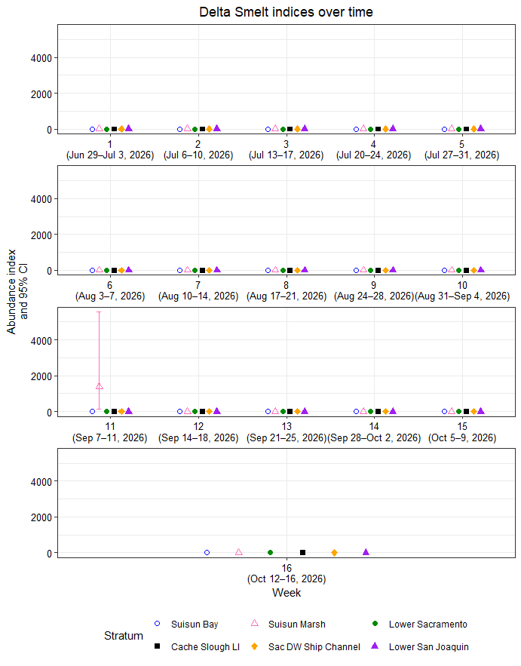
Figure 1: Delta Smelt abundance indices and 95% confidence intervals by week and stratum.

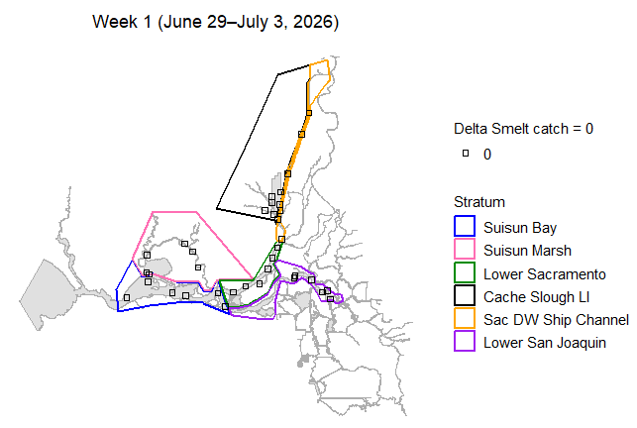
Figure 2: Map of total Delta Smelt catch by site in week 1.
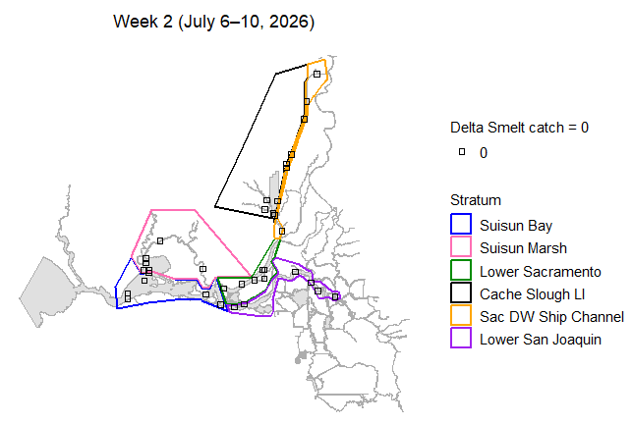
Figure 3: Map of total Delta Smelt catch by site in week 2.
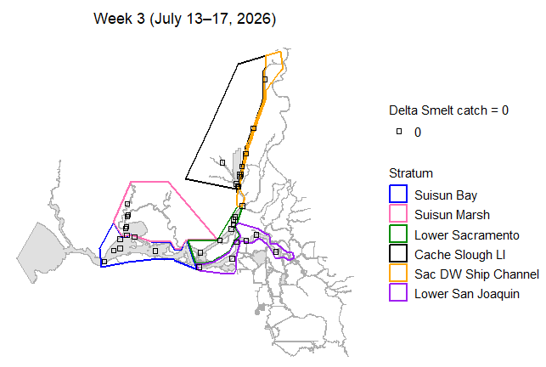
Figure 4: Map of total Delta Smelt catch by site in week 3.
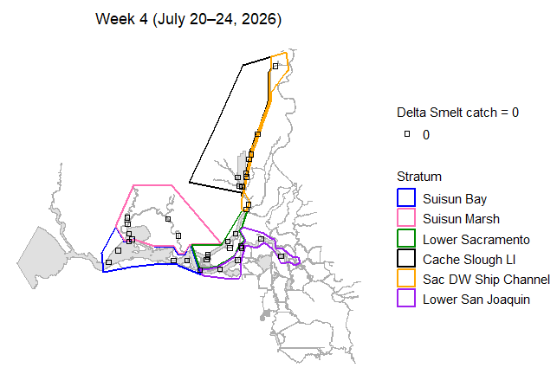
Figure 5: Map of total Delta Smelt catch by site in week 4.
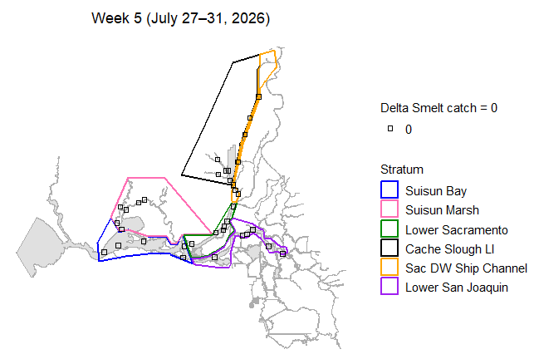
Figure 6: Map of total Delta Smelt catch by site in week 5.
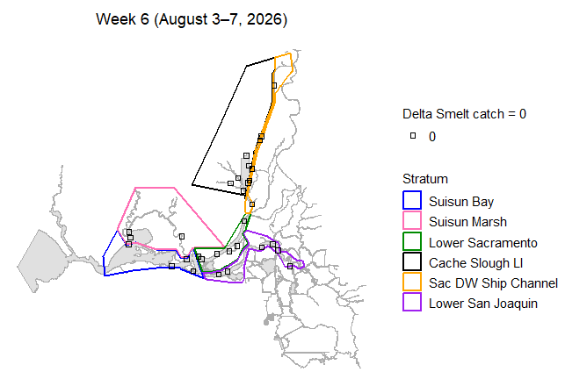
Figure 7: Map of total Delta Smelt catch by site in week 6.
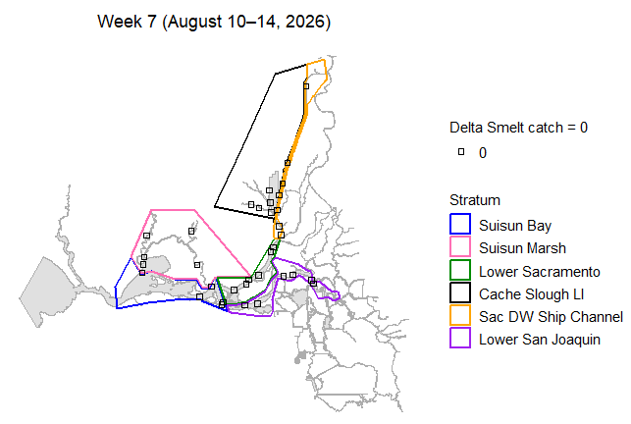
Figure 8: Map of total Delta Smelt catch by site in week 7.
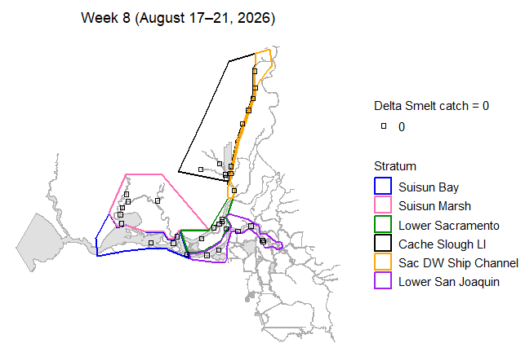
Figure 9: Map of total Delta Smelt catch by site in week 8.
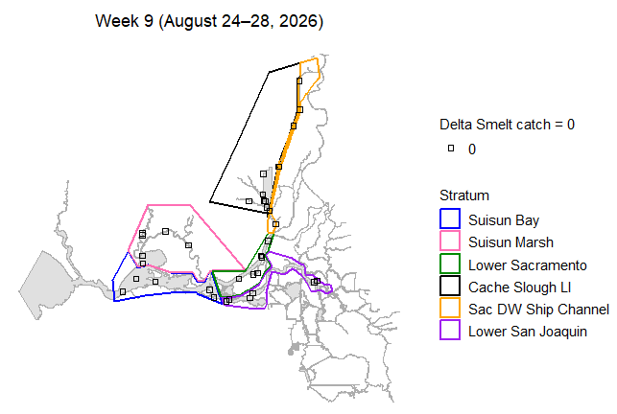
Figure 10: Map of total Delta Smelt catch by site in week 9.
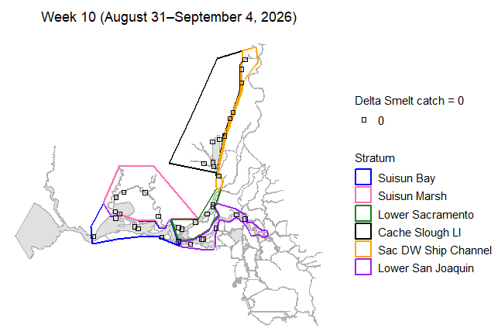
Figure 11: Map of total Delta Smelt catch by site in week 10.
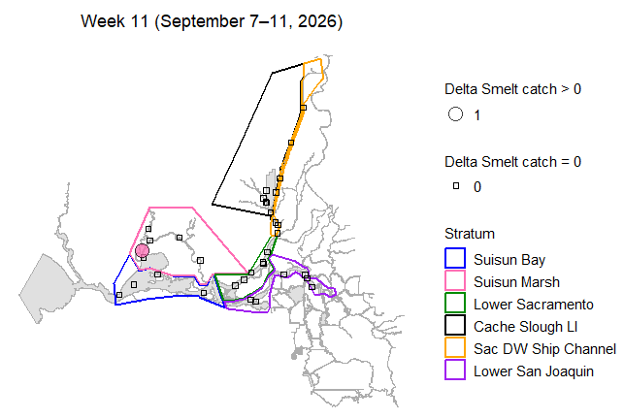
Figure 12: Map of total Delta Smelt catch by site in week 11.
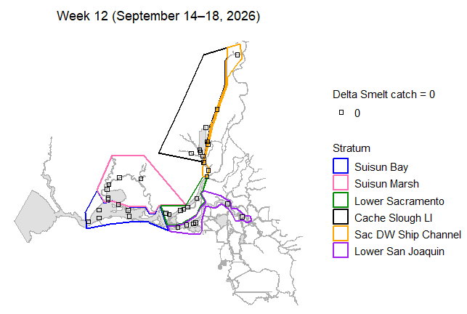
Figure 13: Map of total Delta Smelt catch by site in week 12.
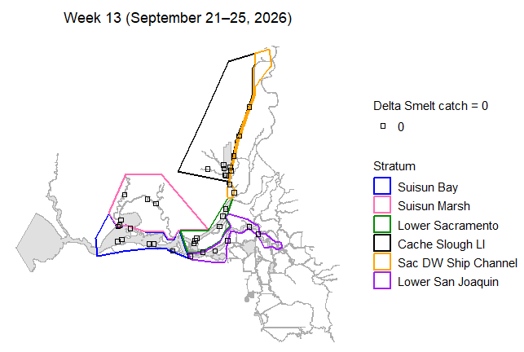
Figure 14: Map of total Delta Smelt catch by site in week 13.
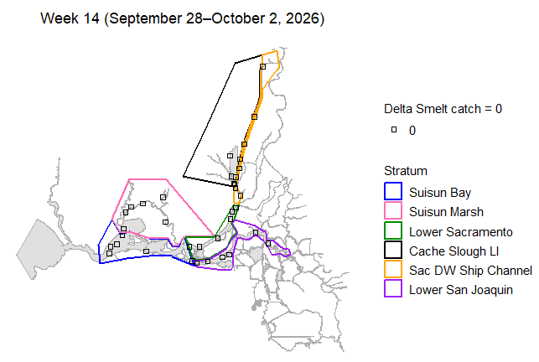
Figure 15: Map of total Delta Smelt catch by site in week 14.
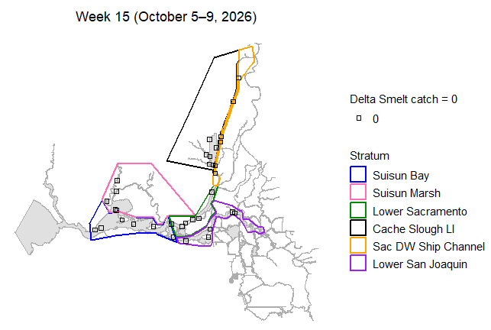
Figure 16: Map of total Delta Smelt catch by site in week 15.
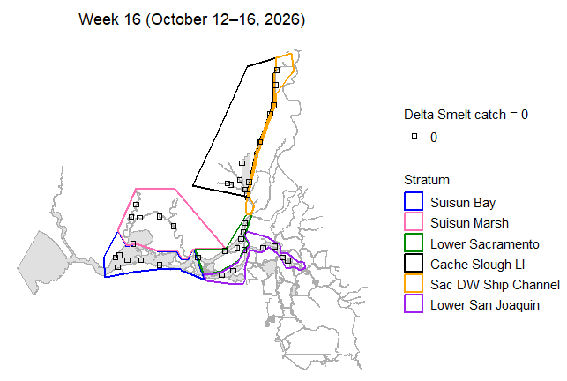
Figure 17: Map of total Delta Smelt catch by site in week 16.
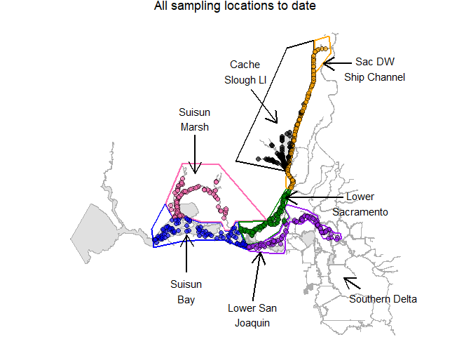
Figure 18: Map of all sampling sites in this phase.

Habitat Volume Estimates
Table 3: Estimates of water volume (cubic meters) between 0.5-m and 4.5-m depth, by stratum.
Stratum | Volume
Suisun Bay | 285,840,678
Suisun Marsh | 76,278,718
Lower Sacramento | 88,162,170
Cache Slough LI | 33,420,492
Sac DW Ship Channel | 30,411,491
Lower San Joaquin | 122,096,565

References
Stevens D.L. and Olsen A.R. 2004. Spatially balanced sampling of natural resources. Journal of the American Statistical Association, 99(465):262–278.
Mitchell L., Polansky L., Newman K.B. 2024. Stopping rule sampling to monitor and protect endangered species. Journal of Agricultural, Biological, and Environmental Statistics. https://doi.org/10.1007/s13253-024-00649-3

