Enhanced Delta Smelt Monitoring
  - 2025 Phase 3 Preliminary Analysis
  - U.S. Fish and Wildlife Service
  - November 24, 2025
DRAFT

Overview
The Enhanced Delta Smelt Monitoring (EDSM) program started its 2025 Phase 3 sampling program for juvenile and sub-adult Delta Smelt on June 2, 2025. Sampling effort is focused on geographic areas where Delta Smelt are likely to be caught based on historical data. Sampling locations are generated using a generalized random-tessellation stratified (GRTS) design (Stevens and Olsen 2004) with stratification and equal probability sampling. Trawling gear similar to that used in the California Department of Fish and Wildlife’s Spring Kodiak Trawl Survey (https://www.wildlife.ca.gov/Conservation/Delta/Spring-Kodiak-Trawl) is used to conduct multiple tows per site.
Everything presented here is preliminary and subject to correction, revision, and improvement. The following points should be taken into consideration when interpreting the results:
- Abundance indices incorporate Delta Smelt regardless of origin, i.e. wild or hatchery.
- Delta Smelt captured outside of the live box or cod end of the net could not be assigned to a specific tow and were excluded from this analysis (see exception in Note section below). These fish are included in the daily catch summary and are indicated by a Gear Condition Code of 9. Delta Smelt captured in highly impaired samples, e.g., samples with large net blockages of debris or vegetation, were also excluded from this analysis. These fish are included in the daily catch summary and are indicated by a Gear Condition Code of 3.
- The ‘Week’ designations used here were defined out of convenience and are subject to change.
- Current sampling is limited to areas of the Bay-Delta that can be safely navigated by EDSM vessels, which means areas with a minimum depth of approximately 8 feet. The abundance estimation method used here assumes that the density of fish in unsampled areas (i.e., those with depth less than 8 feet) is the same as in sampled areas (i.e., those with depth greater than or equal to 8 feet).
- The methods of analysis used here remain in development.

Summary of Delta Smelt Releases
Further release information will be available on the SacPAS Delta Smelt Release page (http://www.cbr.washington.edu/sacramento/workgroups/delta_smelt).
Table 1: Summary of Delta Smelt experimental releases for winter 2025–2026.
Release | Site | Date | Total Released
1a | Belden's Landing | November 4, 2025 | 33,032
1b | Belden's Landing | November 5, 2025 | 34,551

Methods
Delta Smelt abundance indices were derived from a negative binomial generalized linear mixed model with tow-level resolution containing (1) fixed effects for each week-stratum combination, (2) first and second order polynomial terms for the environmental variables Secchi depth, specific conductance, and water temperature, (3) site random effect, and (4) volume of water sampled in a tow as an offset (Mitchell et al. 2024). The model was fit with EDSM Kodiak trawl data collected between December 2016 and the present. Results presented here are limited to the current phase.

Results
Table 2: Delta Smelt catch summary and abundance indices by week. The total number of Delta Smelt, the number of marked Delta Smelt, and the number of code-9 Delta Smelt are indicated in separate columns. Lower Bound and Upper Bound represent a 95% confidence interval on the index point estimate. An asterisk (*) is used to emphasize weeks when no code-9 Delta Smelt were caught and NA is used to indicate that sampling did not occur or that a quantity could not be calculated. Weekly totals are only calculated when sampling has occurred in every stratum. Sample volumes are in cubic meters. See Table 3 for the dates corresponding to each week number.
Week | Stratum | Number of Sites | Number of Tows | Total Number Caught | Number Marked | Number of Code 9's | Total Sample Volume | Abundance Index | Lower Bound | Upper Bound
1 | Suisun Bay | 5 | 20 | 0 | 0 | 0 | 103,018 | 0* | NA | NA
1 | Suisun Marsh | 6 | 24 | 0 | 0 | 0 | 117,435 | 0* | NA | NA
1 | Lower Sacramento | 6 | 22 | 0 | 0 | 0 | 80,886 | 0* | NA | NA
1 | Cache Slough LI | 7 | 25 | 0 | 0 | 0 | 95,635 | 0* | NA | NA
1 | Sac DW Ship Channel | 6 | 24 | 0 | 0 | 0 | 77,127 | 0* | NA | NA
1 | Lower San Joaquin | 6 | 24 | 0 | 0 | 0 | 96,208 | 0* | NA | NA
1 | All Strata | 36 | 139 | 0 | 0 | 0 | 570,310 | 0* | NA | NA
2 | Suisun Bay | 2 | 8 | 0 | 0 | 0 | 40,957 | 0* | NA | NA
2 | Suisun Marsh | 6 | 22 | 0 | 0 | 0 | 107,367 | 0* | NA | NA
2 | Lower Sacramento | 3 | 12 | 0 | 0 | 0 | 53,079 | 0* | NA | NA
2 | Cache Slough LI | 5 | 20 | 0 | 0 | 0 | 64,668 | 0* | NA | NA
2 | Sac DW Ship Channel | 6 | 24 | 0 | 0 | 0 | 89,304 | 0* | NA | NA
2 | Lower San Joaquin | 6 | 24 | 0 | 0 | 0 | 102,125 | 0* | NA | NA
2 | All Strata | 28 | 110 | 0 | 0 | 0 | 457,500 | 0* | NA | NA
3 | Suisun Bay | 6 | 22 | 0 | 0 | 0 | 128,403 | 0* | NA | NA
3 | Suisun Marsh | 6 | 22 | 1 | 0 | 0 | 115,314 | 872 | 91 | 3,509
3 | Lower Sacramento | 6 | 24 | 0 | 0 | 0 | 90,774 | 0* | NA | NA
3 | Cache Slough LI | 6 | 20 | 0 | 0 | 0 | 70,280 | 0* | NA | NA
3 | Sac DW Ship Channel | 6 | 22 | 0 | 0 | 0 | 79,389 | 0* | NA | NA
3 | Lower San Joaquin | 6 | 24 | 0 | 0 | 0 | 93,740 | 0* | NA | NA
3 | All Strata | 36 | 134 | 1 | 0 | 0 | 577,900 | 872 | 91 | 3,509
4 | Suisun Bay | 6 | 22 | 0 | 0 | 0 | 95,038 | 0* | NA | NA
4 | Suisun Marsh | 7 | 23 | 0 | 0 | 0 | 103,397 | 0* | NA | NA
4 | Lower Sacramento | 6 | 24 | 0 | 0 | 0 | 97,622 | 0* | NA | NA
4 | Cache Slough LI | 6 | 24 | 0 | 0 | 0 | 77,714 | 0* | NA | NA
4 | Sac DW Ship Channel | 6 | 24 | 0 | 0 | 0 | 96,615 | 0* | NA | NA
4 | Lower San Joaquin | 6 | 24 | 0 | 0 | 0 | 95,972 | 0* | NA | NA
4 | All Strata | 37 | 141 | 0 | 0 | 0 | 566,359 | 0* | NA | NA
5 | Suisun Bay | 4 | 14 | 0 | 0 | 0 | 61,004 | 0* | NA | NA
5 | Suisun Marsh | 5 | 20 | 0 | 0 | 0 | 92,824 | 0* | NA | NA
5 | Lower Sacramento | 6 | 24 | 0 | 0 | 0 | 97,191 | 0* | NA | NA
5 | Cache Slough LI | 6 | 24 | 0 | 0 | 0 | 80,122 | 0* | NA | NA
5 | Sac DW Ship Channel | 6 | 24 | 0 | 0 | 0 | 88,275 | 0* | NA | NA
5 | Lower San Joaquin | 6 | 24 | 0 | 0 | 0 | 89,580 | 0* | NA | NA
5 | All Strata | 33 | 130 | 0 | 0 | 0 | 508,995 | 0* | NA | NA
6 | Suisun Bay | 3 | 12 | 0 | 0 | 0 | 54,431 | 0* | NA | NA
6 | Suisun Marsh | 6 | 24 | 0 | 0 | 0 | 112,022 | 0* | NA | NA
6 | Lower Sacramento | 6 | 22 | 0 | 0 | 0 | 96,137 | 0* | NA | NA
6 | Cache Slough LI | 6 | 22 | 0 | 0 | 0 | 80,874 | 0* | NA | NA
6 | Sac DW Ship Channel | 6 | 22 | 0 | 0 | 0 | 79,342 | 0* | NA | NA
6 | Lower San Joaquin | 6 | 24 | 0 | 0 | 0 | 98,809 | 0* | NA | NA
6 | All Strata | 33 | 126 | 0 | 0 | 0 | 521,615 | 0* | NA | NA
7 | Suisun Bay | 3 | 12 | 0 | 0 | 0 | 50,847 | 0* | NA | NA
7 | Suisun Marsh | 6 | 24 | 1 | 0 | 0 | 113,446 | 791 | 77 | 3,260
7 | Lower Sacramento | 6 | 24 | 0 | 0 | 0 | 105,427 | 0* | NA | NA
7 | Cache Slough LI | 6 | 24 | 0 | 0 | 0 | 87,841 | 0* | NA | NA
7 | Sac DW Ship Channel | 5 | 20 | 0 | 0 | 0 | 75,247 | 0* | NA | NA
7 | Lower San Joaquin | 4 | 14 | 0 | 0 | 0 | 52,343 | 0* | NA | NA
7 | All Strata | 30 | 118 | 1 | 0 | 0 | 485,151 | 791 | 77 | 3,260
8 | Suisun Bay | 6 | 24 | 0 | 0 | 0 | 101,839 | 0* | NA | NA
8 | Suisun Marsh | 6 | 24 | 0 | 0 | 0 | 102,728 | 0* | NA | NA
8 | Lower Sacramento | 6 | 23 | 0 | 0 | 0 | 89,180 | 0* | NA | NA
8 | Cache Slough LI | 5 | 20 | 0 | 0 | 0 | 67,031 | 0* | NA | NA
8 | Sac DW Ship Channel | 6 | 24 | 0 | 0 | 0 | 79,693 | 0* | NA | NA
8 | Lower San Joaquin | 6 | 24 | 0 | 0 | 0 | 102,654 | 0* | NA | NA
8 | All Strata | 35 | 139 | 0 | 0 | 0 | 543,125 | 0* | NA | NA
9 | Suisun Bay | 6 | 24 | 0 | 0 | 0 | 107,589 | 0* | NA | NA
9 | Suisun Marsh | 6 | 22 | 0 | 0 | 0 | 98,370 | 0* | NA | NA
9 | Lower Sacramento | 6 | 24 | 0 | 0 | 0 | 92,153 | 0* | NA | NA
9 | Cache Slough LI | 6 | 24 | 0 | 0 | 0 | 95,410 | 0* | NA | NA
9 | Sac DW Ship Channel | 6 | 24 | 0 | 0 | 0 | 90,960 | 0* | NA | NA
9 | Lower San Joaquin | 6 | 24 | 0 | 0 | 0 | 92,394 | 0* | NA | NA
9 | All Strata | 36 | 142 | 0 | 0 | 0 | 576,875 | 0* | NA | NA
10 | Suisun Bay | 6 | 24 | 0 | 0 | 0 | 97,471 | 0* | NA | NA
10 | Suisun Marsh | 6 | 24 | 0 | 0 | 0 | 92,712 | 0* | NA | NA
10 | Lower Sacramento | 6 | 24 | 0 | 0 | 0 | 101,878 | 0* | NA | NA
10 | Cache Slough LI | 6 | 24 | 0 | 0 | 0 | 77,622 | 0* | NA | NA
10 | Sac DW Ship Channel | 6 | 24 | 0 | 0 | 0 | 87,098 | 0* | NA | NA
10 | Lower San Joaquin | 6 | 24 | 0 | 0 | 0 | 90,827 | 0* | NA | NA
10 | All Strata | 36 | 144 | 0 | 0 | 0 | 547,608 | 0* | NA | NA
11 | Suisun Bay | 6 | 22 | 0 | 0 | 0 | 115,424 | 0* | NA | NA
11 | Suisun Marsh | 6 | 24 | 0 | 0 | 0 | 118,002 | 0* | NA | NA
11 | Lower Sacramento | 6 | 24 | 0 | 0 | 0 | 98,124 | 0* | NA | NA
11 | Cache Slough LI | 6 | 24 | 0 | 0 | 0 | 87,661 | 0* | NA | NA
11 | Sac DW Ship Channel | 6 | 24 | 0 | 0 | 0 | 92,284 | 0* | NA | NA
11 | Lower San Joaquin | 6 | 24 | 0 | 0 | 0 | 95,548 | 0* | NA | NA
11 | All Strata | 36 | 142 | 0 | 0 | 0 | 607,041 | 0* | NA | NA
12 | Suisun Bay | 4 | 16 | 0 | 0 | 0 | 66,832 | 0* | NA | NA
12 | Suisun Marsh | 6 | 24 | 0 | 0 | 0 | 94,827 | 0* | NA | NA
12 | Lower Sacramento | 6 | 23 | 0 | 0 | 0 | 93,204 | 0* | NA | NA
12 | Cache Slough LI | 6 | 22 | 0 | 0 | 0 | 77,480 | 0* | NA | NA
12 | Sac DW Ship Channel | 6 | 24 | 0 | 0 | 0 | 97,101 | 0* | NA | NA
12 | Lower San Joaquin | 6 | 24 | 0 | 0 | 0 | 88,645 | 0* | NA | NA
12 | All Strata | 34 | 133 | 0 | 0 | 0 | 518,088 | 0* | NA | NA
13 | Suisun Bay | 4 | 16 | 0 | 0 | 0 | 69,238 | 0* | NA | NA
13 | Suisun Marsh | 6 | 24 | 1 | 0 | 0 | 98,810 | 796 | 75 | 3,327
13 | Lower Sacramento | 6 | 24 | 0 | 0 | 0 | 90,966 | 0* | NA | NA
13 | Cache Slough LI | 6 | 24 | 0 | 0 | 0 | 89,945 | 0* | NA | NA
13 | Sac DW Ship Channel | 6 | 24 | 0 | 0 | 0 | 95,673 | 0* | NA | NA
13 | Lower San Joaquin | 6 | 24 | 0 | 0 | 0 | 87,528 | 0* | NA | NA
13 | All Strata | 34 | 136 | 1 | 0 | 0 | 532,159 | 796 | 75 | 3,327
14 | Suisun Bay | 6 | 24 | 0 | 0 | 0 | 110,395 | 0* | NA | NA
14 | Suisun Marsh | 6 | 24 | 0 | 0 | 0 | 103,386 | 0* | NA | NA
14 | Lower Sacramento | 6 | 22 | 0 | 0 | 0 | 78,614 | 0* | NA | NA
14 | Cache Slough LI | 6 | 24 | 0 | 0 | 0 | 80,636 | 0* | NA | NA
14 | Sac DW Ship Channel | 6 | 24 | 0 | 0 | 0 | 87,181 | 0* | NA | NA
14 | Lower San Joaquin | 4 | 13 | 0 | 0 | 0 | 44,727 | 0* | NA | NA
14 | All Strata | 34 | 131 | 0 | 0 | 0 | 504,938 | 0* | NA | NA
15 | Suisun Marsh | 6 | 24 | 0 | 0 | 0 | 103,829 | 0* | NA | NA
15 | All Strata | 6 | 24 | 0 | 0 | 0 | 103,829 | 0* | NA | NA
16 | Suisun Bay | 6 | 24 | 0 | 0 | 0 | 95,444 | 0* | NA | NA
16 | Suisun Marsh | 6 | 24 | 0 | 0 | 0 | 93,428 | 0* | NA | NA
16 | Lower Sacramento | 6 | 24 | 0 | 0 | 0 | 90,985 | 0* | NA | NA
16 | Cache Slough LI | 6 | 24 | 0 | 0 | 0 | 82,116 | 0* | NA | NA
16 | Sac DW Ship Channel | 6 | 24 | 0 | 0 | 0 | 87,670 | 0* | NA | NA
16 | Lower San Joaquin | 6 | 24 | 0 | 0 | 0 | 90,457 | 0* | NA | NA
16 | All Strata | 36 | 144 | 0 | 0 | 0 | 540,100 | 0* | NA | NA
17 | Suisun Bay | 6 | 24 | 0 | 0 | 0 | 96,337 | 0* | NA | NA
17 | Suisun Marsh | 6 | 24 | 0 | 0 | 0 | 84,561 | 0* | NA | NA
17 | Lower Sacramento | 6 | 24 | 0 | 0 | 0 | 96,191 | 0* | NA | NA
17 | Cache Slough LI | 6 | 24 | 0 | 0 | 0 | 84,678 | 0* | NA | NA
17 | Sac DW Ship Channel | 6 | 24 | 0 | 0 | 0 | 88,389 | 0* | NA | NA
17 | Lower San Joaquin | 6 | 24 | 0 | 0 | 0 | 92,333 | 0* | NA | NA
17 | All Strata | 36 | 144 | 0 | 0 | 0 | 542,489 | 0* | NA | NA
18 | Suisun Bay | 6 | 24 | 0 | 0 | 0 | 101,612 | 0* | NA | NA
18 | Suisun Marsh | 6 | 24 | 0 | 0 | 0 | 115,630 | 0* | NA | NA
18 | Lower Sacramento | 6 | 24 | 0 | 0 | 0 | 88,325 | 0* | NA | NA
18 | Cache Slough LI | 6 | 24 | 0 | 0 | 0 | 89,415 | 0* | NA | NA
18 | Sac DW Ship Channel | 6 | 24 | 0 | 0 | 0 | 84,418 | 0* | NA | NA
18 | Lower San Joaquin | 6 | 24 | 0 | 0 | 0 | 91,846 | 0* | NA | NA
18 | All Strata | 36 | 144 | 0 | 0 | 0 | 571,246 | 0* | NA | NA
19 | Suisun Bay | 6 | 24 | 0 | 0 | 0 | 115,585 | 0* | NA | NA
19 | Suisun Marsh | 6 | 24 | 1 | 0 | 0 | 113,833 | 756 | 74 | 3,107
19 | Lower Sacramento | 6 | 24 | 1 | 0 | 0 | 97,872 | 376 | 33 | 1,607
19 | Cache Slough LI | 5 | 20 | 0 | 0 | 0 | 70,931 | 0* | NA | NA
19 | Sac DW Ship Channel | 6 | 24 | 0 | 0 | 0 | 84,693 | 0* | NA | NA
19 | Lower San Joaquin | 4 | 16 | 0 | 0 | 0 | 63,512 | 0* | NA | NA
19 | All Strata | 33 | 132 | 2 | 0 | 0 | 546,427 | 1,132 | 180 | 3,862
20 | Suisun Bay | 6 | 24 | 0 | 0 | 0 | 115,859 | 0* | NA | NA
20 | Suisun Marsh | 6 | 22 | 1 | 0 | 0 | 102,403 | 812 | 78 | 3,357
20 | Lower Sacramento | 6 | 24 | 0 | 0 | 0 | 94,714 | 0* | NA | NA
20 | Cache Slough LI | 6 | 23 | 0 | 0 | 0 | 84,701 | 0* | NA | NA
20 | Sac DW Ship Channel | 5 | 20 | 0 | 0 | 0 | 72,976 | 0* | NA | NA
20 | Lower San Joaquin | 6 | 24 | 0 | 0 | 0 | 95,140 | 0* | NA | NA
20 | All Strata | 35 | 137 | 1 | 0 | 0 | 565,794 | 812 | 78 | 3,357
21 | Suisun Bay | 6 | 24 | 0 | 0 | 0 | 111,321 | 0* | NA | NA
21 | Suisun Marsh | 6 | 22 | 0 | 0 | 0 | 115,261 | 0* | NA | NA
21 | Lower Sacramento | 5 | 19 | 0 | 0 | 0 | 77,035 | 0* | NA | NA
21 | Cache Slough LI | 6 | 22 | 0 | 0 | 0 | 71,683 | 0* | NA | NA
21 | Sac DW Ship Channel | 6 | 24 | 0 | 0 | 0 | 92,880 | 0* | NA | NA
21 | Lower San Joaquin | 6 | 24 | 0 | 0 | 0 | 94,594 | 0* | NA | NA
21 | All Strata | 35 | 135 | 0 | 0 | 0 | 562,775 | 0* | NA | NA
22 | Suisun Bay | 6 | 24 | 0 | 0 | 0 | 93,524 | 0* | NA | NA
22 | Suisun Marsh | 6 | 24 | 0 | 0 | 0 | 95,286 | 0* | NA | NA
22 | Lower Sacramento | 6 | 24 | 0 | 0 | 0 | 94,754 | 0* | NA | NA
22 | Cache Slough LI | 6 | 24 | 0 | 0 | 0 | 78,565 | 0* | NA | NA
22 | Sac DW Ship Channel | 6 | 24 | 0 | 0 | 0 | 80,976 | 0* | NA | NA
22 | Lower San Joaquin | 6 | 24 | 0 | 0 | 0 | 92,989 | 0* | NA | NA
22 | All Strata | 36 | 144 | 0 | 0 | 0 | 536,095 | 0* | NA | NA
23 | Suisun Bay | 3 | 12 | 0 | 0 | 0 | 50,456 | 0* | NA | NA
23 | Suisun Marsh | 6 | 20 | 19 | 0 | 0 | 89,408 | 7,116 | 1,504 | 21,311
23 | Lower Sacramento | 6 | 24 | 0 | 0 | 0 | 93,981 | 0* | NA | NA
23 | Cache Slough LI | 3 | 12 | 0 | 0 | 0 | 40,272 | 0* | NA | NA
23 | Sac DW Ship Channel | 6 | 24 | 0 | 0 | 0 | 87,009 | 0* | NA | NA
23 | Lower San Joaquin | 6 | 24 | 0 | 0 | 0 | 91,437 | 0* | NA | NA
23 | All Strata | 30 | 116 | 19 | 0 | 0 | 452,562 | 7,116 | 1,504 | 21,311
24 | Suisun Bay | 6 | 24 | 0 | 0 | 0 | 105,412 | 0* | NA | NA
24 | Suisun Marsh | 5 | 16 | 5 | 0 | 2 | 66,441 | 3,385 | 503 | 11,887
24 | Lower Sacramento | 6 | 24 | 0 | 0 | 0 | 94,953 | 0* | NA | NA
24 | Cache Slough LI | 3 | 12 | 0 | 0 | 0 | 36,871 | 0* | NA | NA
24 | Sac DW Ship Channel | 6 | 24 | 0 | 0 | 0 | 73,983 | 0* | NA | NA
24 | Lower San Joaquin | 4 | 14 | 0 | 0 | 0 | 60,361 | 0* | NA | NA
24 | All Strata | 30 | 114 | 5 | 0 | 2 | 438,022 | 3,385 | 503 | 11,887
25 | Suisun Bay | 5 | 20 | 0 | 0 | 0 | 89,814 | 0* | NA | NA
25 | Suisun Marsh | 4 | 12 | 4 | 0 | 0 | 59,529 | 6,550 | 1,037 | 22,385
25 | Lower Sacramento | 6 | 24 | 0 | 0 | 0 | 90,014 | 0* | NA | NA
25 | Cache Slough LI | 6 | 24 | 0 | 0 | 0 | 78,675 | 0* | NA | NA
25 | Sac DW Ship Channel | 6 | 24 | 0 | 0 | 0 | 89,853 | 0* | NA | NA
25 | Lower San Joaquin | 6 | 24 | 0 | 0 | 0 | 81,796 | 0* | NA | NA
25 | All Strata | 33 | 128 | 4 | 0 | 0 | 489,681 | 6,550 | 1,037 | 22,385
Table 3: Week numbers and corresponding dates used in Table 2.
Week | Dates
1 | June 2–6, 2025
2 | June 9–13, 2025
3 | June 16–20, 2025
4 | June 23–27, 2025
5 | June 30–July 4, 2025
6 | July 7–11, 2025
7 | July 14–18, 2025
8 | July 21–25, 2025
9 | July 28–August 1, 2025
10 | August 4–8, 2025
11 | August 11–15, 2025
12 | August 18–22, 2025
13 | August 25–29, 2025
14 | September 1–5, 2025
15 | September 8–12, 2025
16 | September 15–19, 2025
17 | September 22–26, 2025
18 | September 29–October 3, 2025
19 | October 6–10, 2025
20 | October 13–17, 2025
21 | October 20–24, 2025
22 | October 27–31, 2025
23 | November 3–7, 2025
24 | November 10–14, 2025
25 | November 17–21, 2025

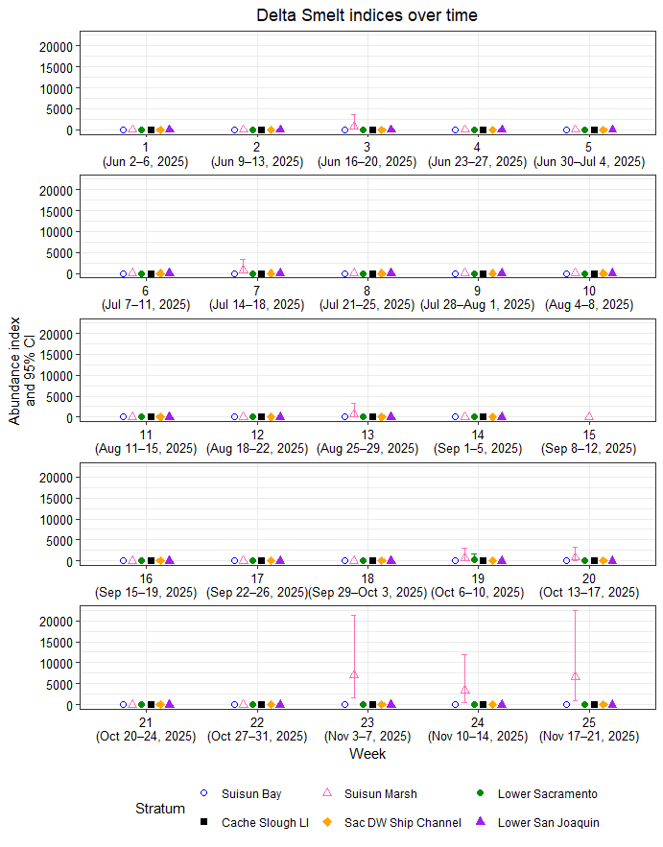
Figure 1: Delta Smelt abundance indices and 95% confidence intervals by week and stratum.

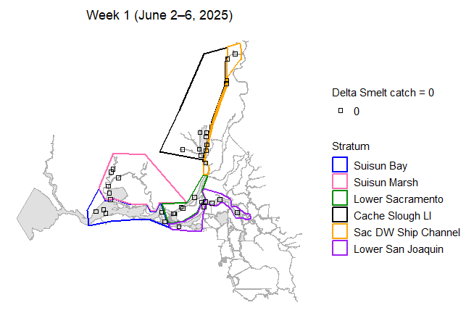
Figure 2: Map of total Delta Smelt catch by site in week 1.
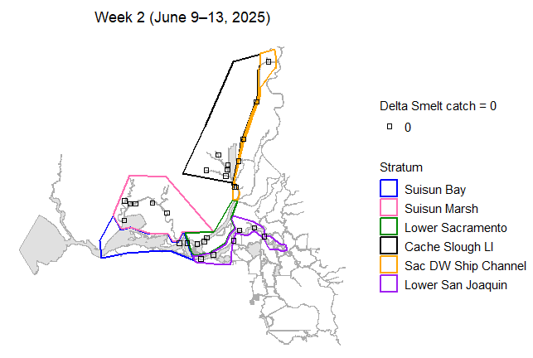
Figure 3: Map of total Delta Smelt catch by site in week 2.
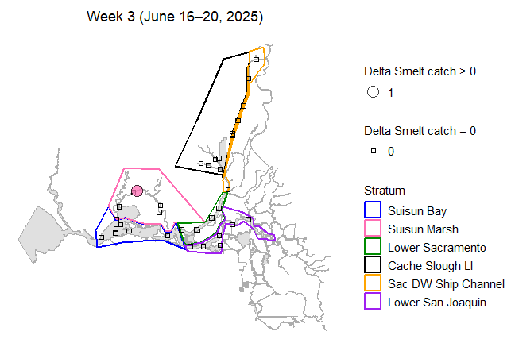
Figure 4: Map of total Delta Smelt catch by site in week 3.
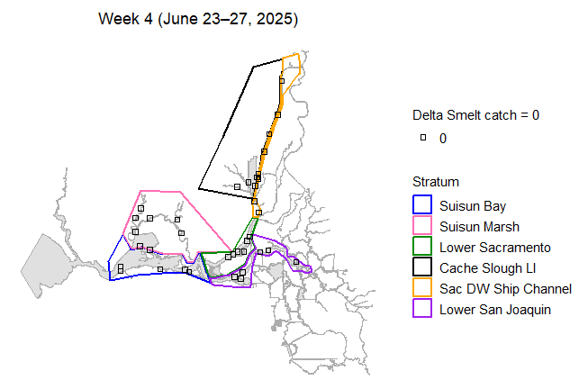
Figure 5: Map of total Delta Smelt catch by site in week 4.
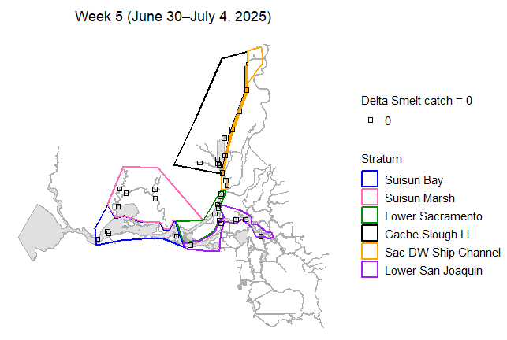
Figure 6: Map of total Delta Smelt catch by site in week 5.
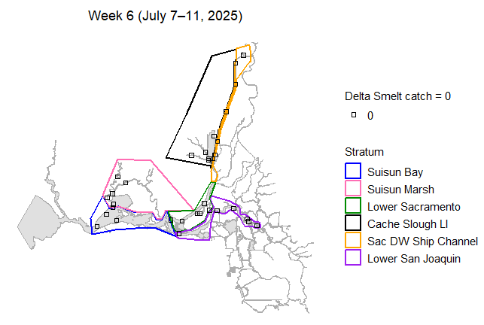
Figure 7: Map of total Delta Smelt catch by site in week 6.
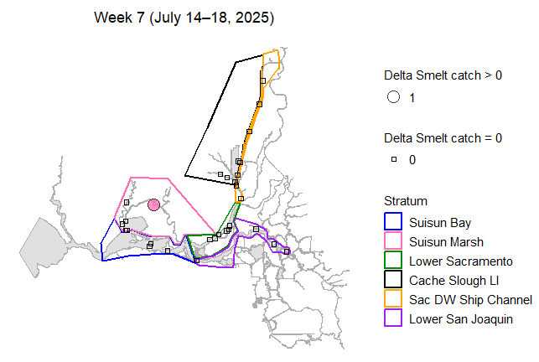
Figure 8: Map of total Delta Smelt catch by site in week 7.
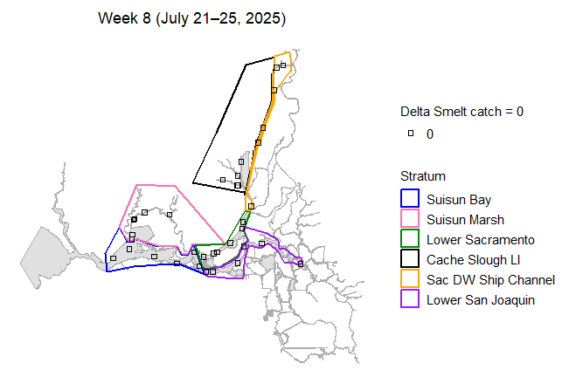
Figure 9: Map of total Delta Smelt catch by site in week 8.
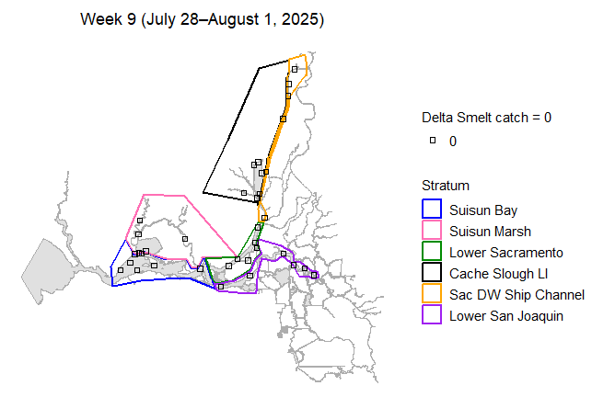
Figure 10: Map of total Delta Smelt catch by site in week 9.
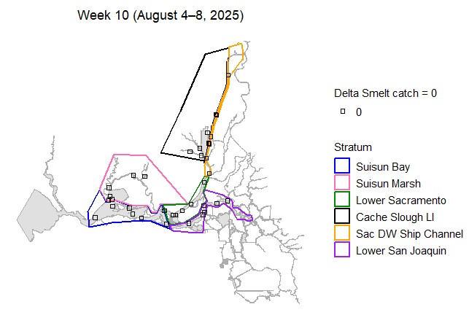
Figure 11: Map of total Delta Smelt catch by site in week 10.
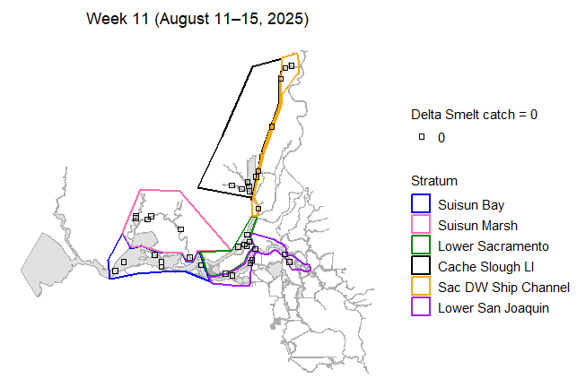
Figure 12: Map of total Delta Smelt catch by site in week 11.
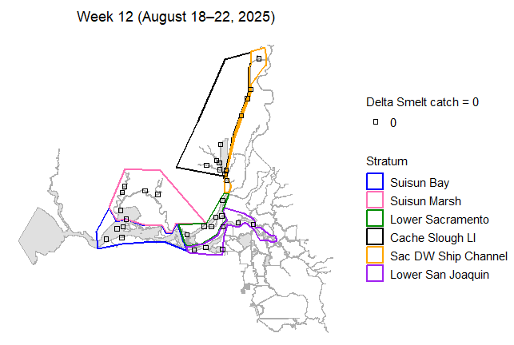
Figure 13: Map of total Delta Smelt catch by site in week 12.
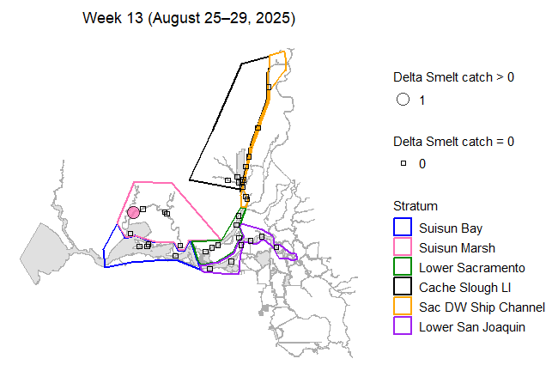
Figure 14: Map of total Delta Smelt catch by site in week 13.
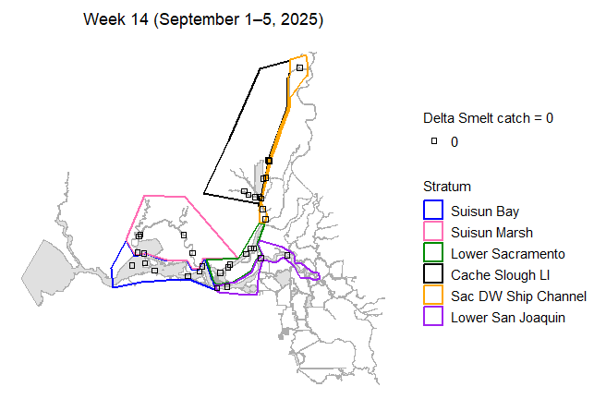
Figure 15: Map of total Delta Smelt catch by site in week 14.
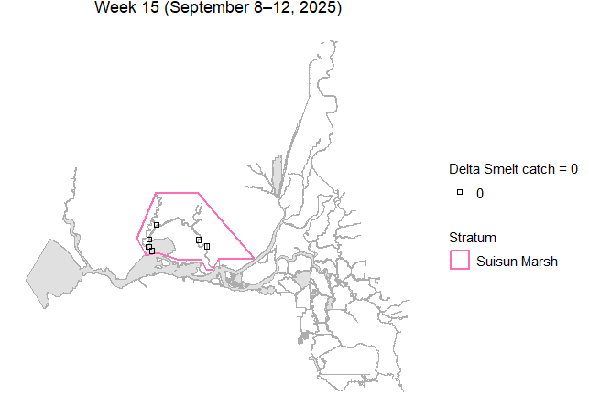
Figure 16: Map of total Delta Smelt catch by site in week 15.
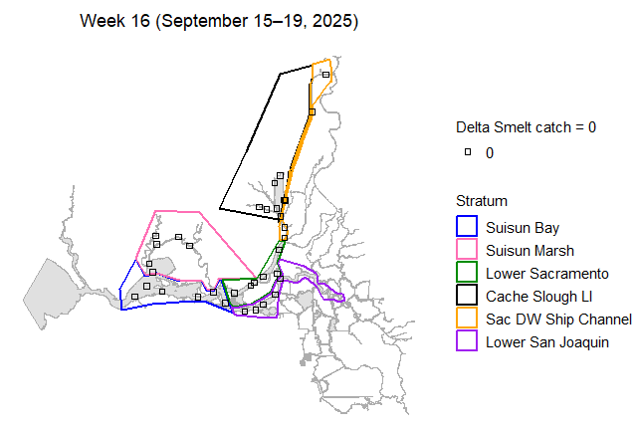
Figure 17: Map of total Delta Smelt catch by site in week 16.
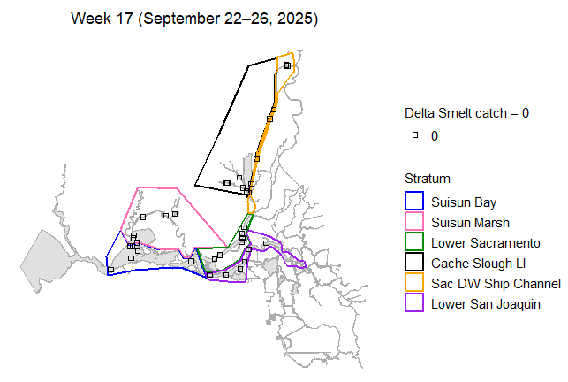
Figure 18: Map of total Delta Smelt catch by site in week 17.
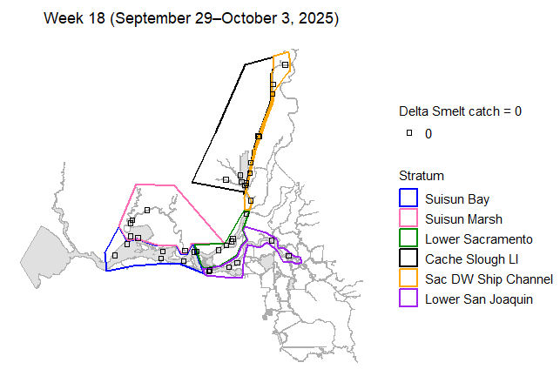
Figure 19: Map of total Delta Smelt catch by site in week 18.
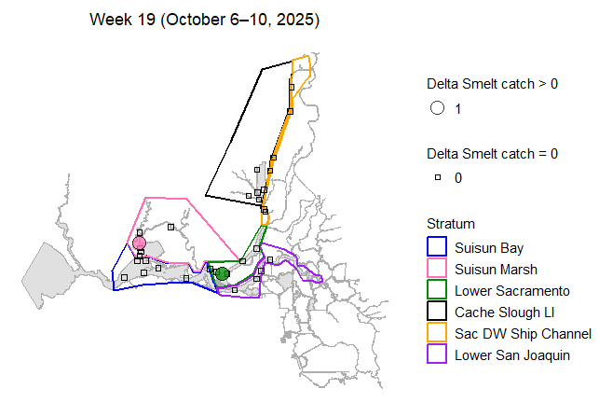
Figure 20: Map of total Delta Smelt catch by site in week 19.
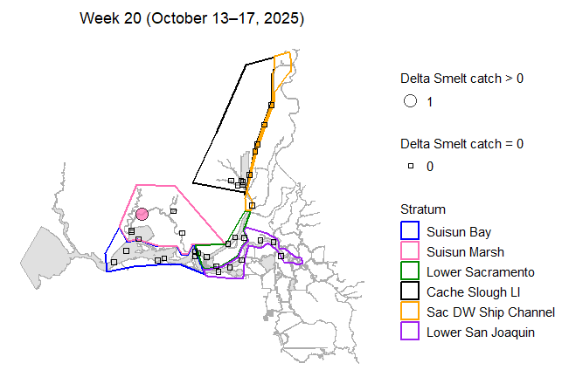
Figure 21: Map of total Delta Smelt catch by site in week 20.
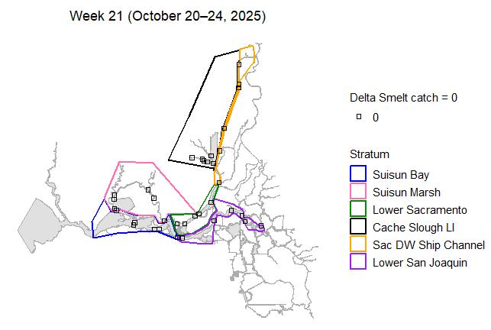
Figure 22: Map of total Delta Smelt catch by site in week 21.
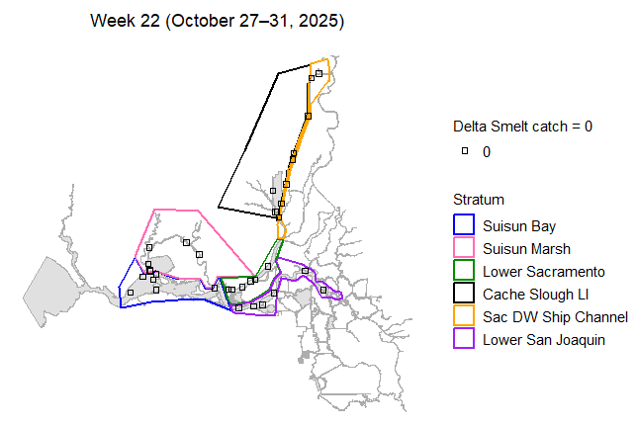
Figure 23: Map of total Delta Smelt catch by site in week 22.
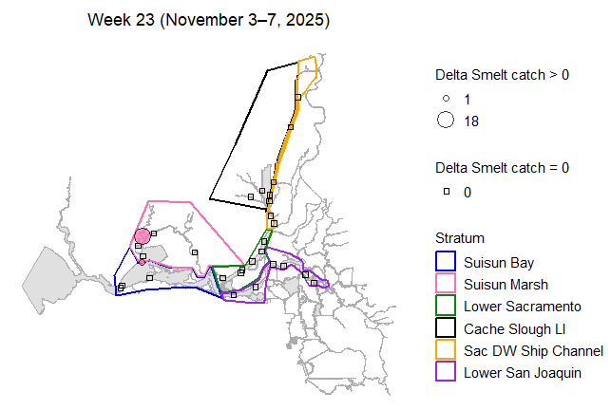
Figure 24: Map of total Delta Smelt catch by site in week 23.
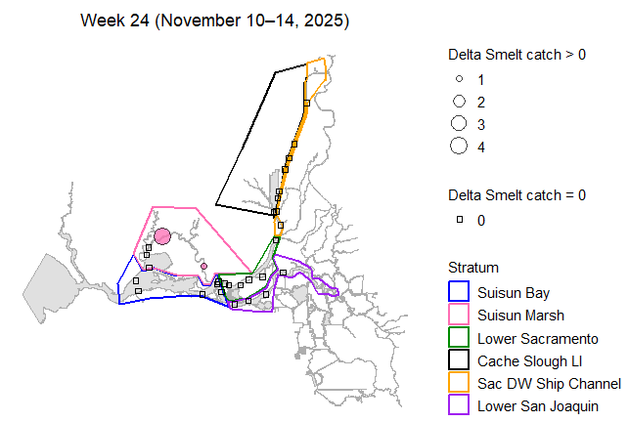
Figure 25: Map of total Delta Smelt catch by site in week 24.
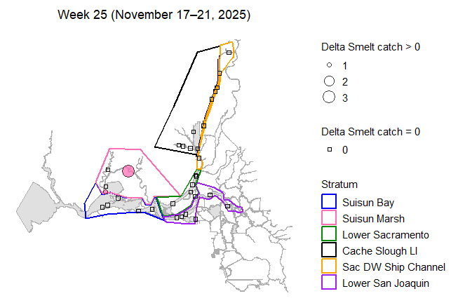
Figure 26: Map of total Delta Smelt catch by site in week 25.
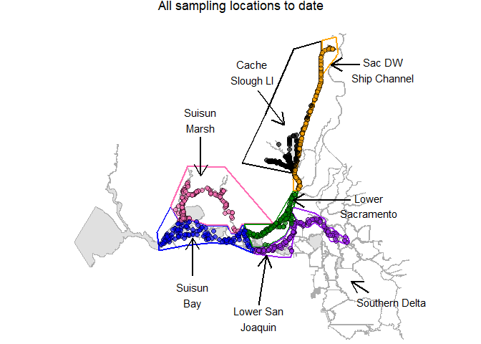
Figure 27: Map of all sampling sites in this phase.

Habitat Volume Estimates
Table 4: Estimates of water volume (cubic meters) between 0.5-m and 4.5-m depth, by stratum.
Stratum | Volume
Suisun Bay | 285,840,678
Suisun Marsh | 76,278,718
Lower Sacramento | 88,162,170
Cache Slough LI | 33,420,492
Sac DW Ship Channel | 30,411,491
Lower San Joaquin | 122,096,565

References
Stevens D.L. and Olsen A.R. 2004. Spatially balanced sampling of natural resources. Journal of the American Statistical Association, 99(465):262–278.
Mitchell L., Polansky L., Newman K.B. 2024. Stopping rule sampling to monitor and protect endangered species. Journal of Agricultural, Biological, and Environmental Statistics. https://doi.org/10.1007/s13253-024-00649-3

