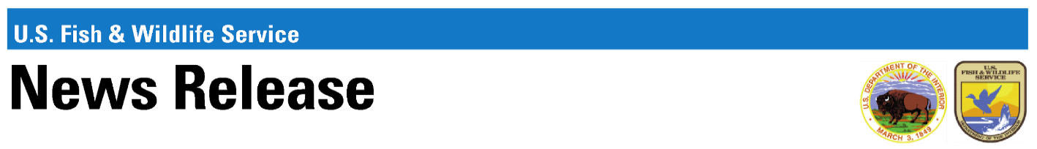
Patuxent Research Refuge
10901 Scarlet Tanager Loop,
Laurel, MD 20708
Phone: 301-497-5817
Email: Tarik_Adams@fws.gov
https://www.fws.gov/refuge/patuxent-research

For immediate release
09/02/2025
Contact: Tarik Adams
Phone Number: 301-497-5817
Email: Tarik_Adams@fws.gov

Patuxent Research Refuge Seeks Public Comment
on Draft Compatibility Determinations
The Patuxent Research Refuge is seeking public review and comment on Draft Compatibility Determinations for research. The refuge proposes opening to this activity, where it does not compromise the mission and operations of the national wildlife refuge. Also, only research that has low- or no-adverse impacts is proposed for this opening, which includes projects that have minimal potential to adversely affect cultural resources, populations of plants, wildlife, or their habitats, or ecosystems. The U.S. Fish and Wildlife Service (Service) will accept comments received or postmarked on or before September 16, 2025.
The Service prepares Compatibility Determinations to ensure that public and economic uses of national wildlife refuges do not interfere with or detract from the purposes for which each refuge was established. Compatibility Determinations also describe how these uses would contribute towards achieving refuge purposes and the mission of the National Wildlife Refuge System.
Copies of the Draft Compatibility Determinations can be found at the refuge’s website https://www.fws.gov/refuge/patuxent-research and hard copies are available at the Visitor Center.
Comments or requests for additional information may be made by email to PRR_Refuge_Admin@fws.gov or U.S. Mail to 10901 Scarlet Tanager Loop, Laurel, MD 20708, Attn: Refuge Manager.
All comments received from individuals become part of the official public record. The Service’s practice is to make comments, including names and home addresses of respondents, available for public review during regular business hours. Individual respondents can request that we withhold their home address from the record, which we will honor to the extent allowable by law. If you wish to have your name and/or address withheld, you must state this prominently at the beginning of your comments.
-Attachments-
Draft Compatibility Determination for research, Patuxent Research Refuge
The U.S. Fish and Wildlife Service works with others to conserve, protect and enhance fish, wildlife, plants and their habitats for the continuing benefit of the American people. For more information, visit www.fws.gov, or connect with us through any of these social media channels: Facebook, Twitter, YouTube and Flickr.
-FWS-

