 | United States Department of the Interior  FISH AND WILDLIFE SERVICE  Lacreek National Wildlife Refuge  29746 Bird Road  Martin, SD 57551 |  | 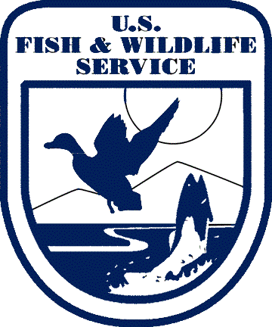
In Reply Refer to:
FWS/R6

For immediate release

Lacreek National Wildlife Refuge to Hold Annual Grazing Auction

The Lacreek National Wildlife Refuge, Bennett County South Dakota, has cooperative agriculture opportunities for grazing on 7 units totaling nearly 3,600 acres. A live auction will be held at the refuge Headquarters on February 20, 2025 at 11:00 AM MST. Grazing has proven to be one of the best management practices at the Refuge to benefit native grasses, forbs, and grassland dependent migratory birds. For more information call the office at 605-910-7086 or Refuge Manager Todd Schmidt 308-760-6268. todd_schmidt@fws.gov

