U.S. Fish & Wildlife Service

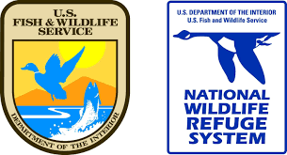
Parker River National Wildlife Refuge
2022 Biological Technician Positions

Looking for a challenging and fulfilling career in Coastal Conservation? Parker River is hiring Biological Technicians to join a dynamic and innovative team. This is a great opportunity for applicants seeking a challenging environment to advance their scientific and communications skills while conducting cutting edge conservation in a highly imperiled ecosystem. Direct inquiries to nancy_pau@fws.gov

Salt Marsh Restoration Coordinator:
16 months (April/May 2022– July 2023)
$17 per hr + benefits & free housing
Accepting applications now.
https://www.massaudubon.org/jobs/great-marsh-biological-technician

This incumbent will be a Mass Audubon employee, but will primarily be working with the Refuge Biological program, under the direction of the Refuge Biologist.

The Marsh Coordinator will have the lead on coordinating a community-based perennial pepperweed eradication project in the Great Marsh. Duties include coordinating with volunteers, partners, and contractors; mapping, hand-pulling, applying herbicides, and extensive GIS database management. The Coordinator will be involved in recruiting, training, and leading a pepperweed team of 5 technicians.

The Coordinator will assist in the planning and implementation of multifaceted wildlife studies, habitat management and restoration projects by contributing ideas, determining research and survey methods, establishing practical procedures for accomplishing and reporting the work and determine other needs, such as costs, equipment and personnel.

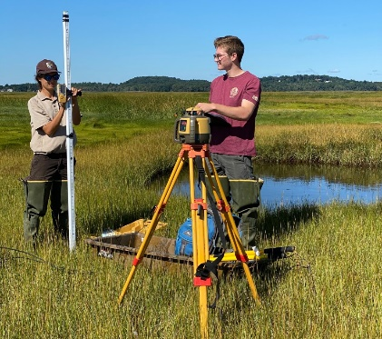

Perennial Pepperweed Technicians:
12-14 weeks (May– August, 2022)
$14.25 per hr + benefits, local commute
Announcement pending; Apply at: https://www.massaudubon.org/jobs

In collaboration with FWS, Mass Audubon is hiring a team of pepperweed technicians to assist with the control of perennial pepperweed in the Great Marsh (Salisbury to Essex). The technicians will work as a team, under the direction of the Salt Marsh Coordinator and Mass Audubon staff.
Duties include mapping and hand-pulling invasive plants, community engagement, and outreach. Opportunities to learn field research and habitat management techniques and development of leadership skills will be incorporated into the position.

With funding providing through the Friends of Parker River National Wildlife Refuge, we are providing opportunities for two early career candidates. Candidates from under-represented communities are encouraged to apply.

Technicians must possess valid driver’s license, have good communication and organizational skills, ability to work well with others and independently with minimal supervision, and be an enthusiastic field worker.
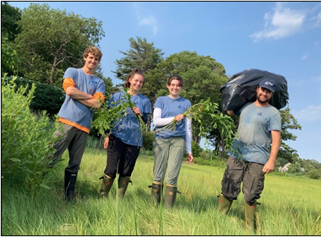

Avian Technician
4 years, starting April 2022
$40-45k per year, gov’t housing available
Apply through USAJobs (announcement pending)

The is a GS 5/7 Term FWS position. The technician will have the lead on the piping plover recovery program, conducting nest surveys, assessing predation risks, and managing public disturbance on 6-miles of pristine barrier beach on Plum Island, MA.

S/he will also assist with cutting edge salt marsh restoration techniques being implemented on Refuge and partner lands. The technician will lead the salt marsh sparrow demographics study, including point count, vegetation surveys, mistnetting and banding, to evaluate the effectiveness of restoration techniques to restore sparrow nesting populations.

The technician will assist in the planning and implementation of multifaceted wildlife studies and practices by contributing ideas, determining research and survey methods, establishing practical procedures for accomplishing and reporting the work and determine other needs, such as costs, equipment and personnel. Other duties include maintaining survey and management records in GIS, analyzing data using standard statistical methods, and developing project reports.

