Species Status Assessment Report for the
Florida Keys Mole Skink
(Plestiodon egregius egregius)

Version 2.0

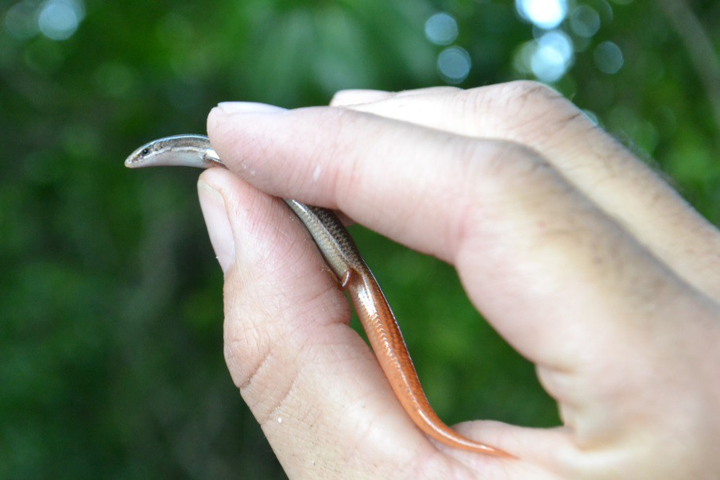
Florida Keys mole skink from Long Beach, Big Pine Key, Florida.
Photo by Adam Emerick, U.S. Fish and Wildlife Service

April 2022

U.S. Fish and Wildlife Service Region 4
Atlanta, GA

ACKNOWLEDGEMENTS

This document was originally prepared by Layne Bolen (USFWS – South Florida Ecological Services Field Office) with assistance from Billy Brooks (USFWS – North Florida Ecological Services Field Office), Erin Rivenbark (USFWS – Region 4), Nicole Rankin (USFWS – Region 4), Colleen Fahey (USFWS – HQ), Heather Bell (USFWS – HQ), Emily Bauer (South Florida Ecological Services Field Office), Nikki Lamp (South Florida Ecological Services Field Office), and the Florida Keys and Cedar Key Mole Skinks Technical Team Working Group (Shana DiPalma – USFWS South Florida Ecological Services Field Office; Adam Emerick – USFWS Florida Keys Refuge Complex; Kevin Enge – Florida Fish and Wildlife Conservation Commission; Andrew Gude – USFWS Cedar Key National Wildlife Refuge; Jonathan Mays – Florida Fish and Wildlife Conservation Commission; Katie Mercier – University of Central Florida; Lori Miller – USFWS South Florida Ecological Services Field Office; Paul Moler – Retired Florida Fish and Wildlife Conservation Commission; Dr. Henry Mushinsky – Retired University of South Florida; Lindsay Nester – USFWS South Florida Ecological Services Field Office; and Dr. Christopher Parkinson – University of Central Florida).

Updates to this SSA were provided in 2021–2022 by Tiffany McFarland (Texas A&M University), Billy Brooks (USFWS – North Florida Ecological Services Field Office), and Leah Kenney (USFWS – Alaska Region).

Valuable peer reviews of a draft of this document were provided by Dr. Dale Jackson (Florida State University), Jeannette Parker (Florida Fish and Wildlife Conservation Commission), Dr. Carol Rizkalla (Florida Fish and Wildlife Conservation Commission), Dr. Coleman Sheehy (Florida Museum of Natural History), and additional review was provided by staff from the Florida Fish and Wildlife Conservation Commission. We appreciate the time and effort of those dedicated to learning and implementing the Species Status Assessment Framework, which resulted in a more robust assessment and report.

Suggested reference:

U.S. Fish and Wildlife Service. 2022. Species status assessment report for the Florida Keys mole skink (Plestiodon egregius egregius). Version 2.0. April 2022. Atlanta, GA.

Summary of Version Updates

The change from version 1.0 (October 2017) to 2.0 (April 2022) was to incorporate new data (Sweet et al. 2017 and Sweet et al. 2018) available for sea-level rise and high tide flooding. We incorporated these new data into our current condition and future condition analyses. We also updated all known survey and occurrence records since 2017 and up until 2021. We made changes to tables and figures based on these additional survey data. In addition to new analyses and updated survey data, minor updates were made to the entire SSA including updated references, re-wording, and new hurricane information. Additional minor changes were made to address 508 compliance.

EXECUTIVE SUMMARY

The Florida Keys mole skink (Plestiodon egregius egregius) is a small lizard known to occur only on islands in the Florida Keys. This species is semi-fossorial (adapted to digging and living underground) and cryptic in nature. While it can run, it more often utilizes “swimming” as a method to move through loose substrate. Soil and moisture conditions help define habitat, as skinks are seldom encountered where the soil is not well drained and friable. The Florida Keys mole skink has been found in wave-washed wrack above the intertidal zone of beaches, in debris, and in piles of rocks, as well as in other inland areas of suitable soils within other habitat types. It is unknown how much habitat exists within the interior of the islands, what these presumably small pockets of habitat contribute to the overall species population sizes, and whether or not these interior habitats could serve to repopulate more coastal habitats following strong storms. The vast majority of detections exist within the beach berm habitat type and adjacent dunes. Beach formation is not common in the Florida Keys, and little quartz sand exists in the region. The sand of the Florida Keys beaches is of carbonate origin derived from the erosion of limestone, from aragonite particles precipitated from seawater, and from the fragmented remains of corals, cast-off shells, and calcareous algae. There are no naturally occurring beaches in the Upper Keys.
The predominant threats currently affecting the Florida Keys mole skink and its habitat are sea level rise (SLR), more numerous high tide flooding events (the very highest tides), increased storm surges, and shifts in seasonal patterns of rainfall and temperature, all of which are predicted by climate change models. Because the Florida Keys mole skink inhabits and utilizes the transitional zone (50 centimeters [cm] to 80 cm [20 inches [in] to 31 in] above sea level) beach berm habitat and the coastal hammock habitat during all of its life stages, the species is especially vulnerable to SLR across its entire range. The Florida Keys are low-lying (average elevation is less than 1 meter [m] or 3.2 feet [ft]) the area is highly susceptible to flooding, and land further inland is at risk of inundation and saltwater intrusion from high tide flooding. Florida Keys mole skink habitat is also at risk of loss and degradation due to land uses and human activities, such as land development, human population increase and the resulting habitat disturbance, and beach erosion.
The Florida Keys mole skink has been found in small numbers across the range of the Florida Keys (including the Distal Sand Keys region, consisting of the islands west of Key Wet to the Dry Tortugas). The majority of islands with any past or current detections occur within the Lower Keys, with the largest numbers of detections from Long Beach on Big Pine Key. Using individual islands as our potential populations (or analysis units, as these may not be biologically meaningful populations), we define 15 current, 5 recent, and 4 historical populations of the Florida Keys mole skink. “Current” populations represent those with detections from 2000 to present, “recent” populations have detections since 1970, and populations with detections only prior to 1970 are considered “historical.”
We assessed current population resiliency only for islands with documented populations (both current and historical). Resiliency for each population is comparative among populations and is based on a series of factors: 1) time passed since the last detection; 2) the number of current detections recorded within the population, and; 3) the number of distinct locations where current detections were recorded within the population (Table A). Historical populations are considered “likely extirpated,” while recent populations are considered “possibly extirpated.” However, the lack of detections does not necessarily imply extirpation and could be a product of a lack of surveys.

Table A. Metrics used for current population resiliency classifications. For current populations (detections since 2000), the number of total detections and the number of locations (greater than a 100 m apart) factor into whether the population is considered to have a low, moderate, high, or very high current resiliency.

Using our analysis of comparative population resiliency (Table A), we determined that four historical populations are likely extirpated, and five recent populations are possibly extirpated. Of the 15 current populations, only 3 can be confirmed to have high (2 populations) or very high (1 population) resiliency, all of which are in the Lower Keys. Five populations were determined to be moderately resilient, and seven are considered to have low resiliency (Table C).
Due to its small endemic range, it is likely that the species has inherently low redundancy (historically and currently) and that low numbers of individuals exist across its range. Despite some redundancy provided by the fact that discrete populations exist on multiple islands, large scale impacts from catastrophic events (e.g, hurricanes or storm surges) could affect the entire Florida Keys archipelago, leaving the entire species vulnerable to the timing and intensity of impacts. Similarly, this species occurs across a narrow geographic and ecological range; there is little variation in habitat types across distance or elevation as occurs in wider-ranging and more abundant species. Thus, representation for this species is thought to be inherently low. However, genetic evidence suggests that there is little interbreeding among populations; thus, some diversity could be lost when a population is lost, meaning that some representation may have been lost compared to historical levels.
To model the future condition of the species, we accounted for SLR, modeled using several National Oceanic Atmospheric Association (NOAA) projections and also considered the effects of high tide flooding. We modeled both of these threats for 2040 and 2060 (20 years and 40 years) into the future, to estimate the condition of the Florida Keys mole skink. Given the Florida Keys mole skink’s estimated short generation time (approximately 3 or 4 years), we chose 20 and 40 years to capture approximately 5 to 15 generations as well as capturing the SLR estimates before the SLR scenarios begin to diverge significantly due to uncertainty of the future of human carbon emissions. While human population increase and habitat disturbance is a stressor on the natural habitats needed by the Florida Keys mole skink, the most immediate threat is the impact of SLR and subsequent loss of habitat across the species range.
Our possible future predictions of SLR include three scenarios for 2040: 2 ft, 3 ft, and 4 ft, and four scenarios for 2060: 3 ft, 4 ft, 5 ft, and 6 ft. These represent the range of likely habitat loss above current Mean High High Water (MHHW), and are aligned with emissions-based, conditional probabilistic and global model projections of global mean SLR plus an additional 0.3 m (1.0 ft) and 0.5 m (1.7 ft) to account for increased frequency of high tide flooding (HTF), which is projected to degrade, if not remove, Florida Keys mole skink habitat. We then rounded the SLR plus HTF values using one foot increments in order to easily project the areas where inundation is projected to occur using available GIS mapping data.
To assess the amount of habitat that would be lost or degraded due to SLR and high tide flooding for each scenario, we looked at three metrics for potential habitat: 1) the total potential habitat which we calculated as the entire island area subtracting habitats defined as “freshwater,” “water,” and “impervious cover”; 2) defined preferred habitats, which only include habitat types defined as Florida Keys mole skink habitat, or Beach Berm and Hammock; and 3) defined preferred soils, which only include soils defined as Florida Keys mole skink habitat, or Bahiahonda fine sands and beach sands.
For each scenario, we calculated the area of each of the three habitat metrics (above) that would be inundated or degraded by SLR and high tide flooding. To account for potential populations on islands without previous or current detections, we calculated the amount of potential habitat and soils that would be impacted by population (individual islands), as well as within each generalized region and within the range overall.
Due to a lack of clarity regarding the true distribution of the Florida Keys mole skink on individual islands of the Florida Keys, we did not manipulate the current resiliency categories to reflect the impacts of SLR and high tide flooding (for instance, deciding whether to change a population’s resiliency from “moderate” to “low”). Instead, we quantified the magnitude of the impact of SLR and high tide flooding on the resiliency of the population. If a population currently is estimated to have moderate resiliency but the impact of SLR and high tide flooding will be high, that population has a better chance of persisting compared to a population that will sustain the same impacts but is currently estimated to have low resiliency.
Thus, we quantified the magnitude of resiliency change as described in Table B. We represented the likelihood and magnitude of a predicted change in resiliency using arrows, where ↓ represents a slight decrease, ↓↓ is a moderate decrease, ↓↓↓ is large decrease, as well as the possibility of the population being extirpated (X) as little to no unaltered habitat remains.

Table B. Portion of potential habitats impacted (degraded by high tide flooding or removed by SLR) and the corresponding magnitude of resiliency change, where ↓ represents a slight decrease, ↓↓ is a moderate decrease, ↓↓↓ is large decrease. If >90 percent of the potential habitat is impacted, we expect the population resiliency to impacted significantly and the population potentially extirpated (X), regardless of the current population resiliency. Resiliency is projected to decline more when more habitat is inundated or degraded.

Even under the lowest rise scenario (2 ft) by 2040, the islands in the Florida Keys lose or degrade over 72 percent of their total potential habitat for the Florida Keys mole skink. Only seven individual islands with Florida Keys mole skink populations have projected impacts to less than half of their total potential habitat area under this best-case scenario. Under the highest scenario (6 ft) by 2060, over 95 percent of the total potential habitat for all the Lower Keys and Middle Keys is lost. Overall, over 94% of the total potential habitat for the Florida Keys mole skink is lost rangewide under this highest scenario. The majority of the impacts are projected to occur in the more western regions (Distal Sand Keys, Lower Keys, and Middle Keys).
The impacts to individual islands due to SLR is projected to be of greater magnitude in the Lower Keys, where the current known populations of Florida Keys mole skinks are highest and where most of the current and resilient populations occur. In the Upper Keys, the impacts of SLR are projected to be more moderate; however, only two current populations are known from this region.
Three of the 5 populations with moderate resiliency and one population with high resiliency currently could possibly be extirpated even under the lowest SLR scenarios by 2040. Extensive impacts are projected for the Sawyer Key, Content Keys, Big Munson Island, and Boot Key, even under the 2 ft (0.6 m) scenario by 2040. In the Distal Sand Keys, Loggerhead Key has the highest elevations that may withstand SLR. However, this island is relatively small, and no current population exists there. The Marquesas Islands and Boca Grande, like much of the Lower Keys, are likely to see large impacts of SLR.

Table C. Projected magnitude of change in resiliency of each population for each scenario in both 2040 and 2060, where ↓ represents a slight decrease, ↓↓ is a moderate decrease, ↓↓↓ is large decrease. If 100 percent of the potential habitat is impacted, we expect the population to be potentially extirpated, regardless of the current population resiliency. Resiliency is projected to decline more when more habitat is removed due to sea level rise. The status of the population (current [2000-2021], recent [1970-1999], or historical [pre-1970]) and current estimated population resiliency is also provided.

Based on our future condition results, targeted management and conservation efforts are best focused on the islands or areas where impacts of SLR are projected to be the least severe. However, areas where SLR will have the lowest impacts are also more likely to continue to see increasing human impacts. The SLR projections predict inundation only and do not model the complex set of shifts that are anticipated to be triggered over time as the effects of SLR are experienced. Vegetation is expected to convert more towards tidal and salt-tolerant species with fewer hammock and buttonwood species. Human relocation upland and inland and by elevating new structures is projected as rising sea levels restrict development and human activities away from a receding shoreline.
Beaches above wrack lines are thought to be the most populous habitat for the Florida Keys mole skink. These beaches are already at risk of erosion, and their ability to persist given SLR and future storm events is unknown. In the Lower, Middle, and Upper Keys, where natural beach renourishment is slow and unlikely, beaches are likely to disappear from many locations as SLR. In the Distal Sand Keys, where sands are more common, both the Marquesas Islands and Boca Grande are low-lying and at threat of inundation under a 3 ft (0.9 m) scenario. Loggerhead Key has no current population of Florida Keys mole skink, and while it is small, its higher elevations indicate that some beaches may persist.
While the Upper Keys are projected to fare better given our SLR scenarios, few individuals have been detected on those islands. However, there are still many unknowns regarding Florida Keys mole skink movement, dispersal, and specific habitat requirements. The species is semi-fossorial and cryptic, and the efforts to survey for the species have not covered all potential habitat. Therefore, there may be more individuals or more populations in places that have not been discovered yet.

TABLE OF CONTENTS

CHAPTER 1 – INTRODUCTION 6
CHAPTER 2 – SPECIES BIOLOGY 8
2.1 Taxonomy 8
2.2 Description 9
2.3 Genetics 10
2.4 Life History 11
Range, Habitat, and Detections 11
Generations and reproduction 17
Diet 19
Dispersal and Home Range 19
Distribution and Density 20
CHAPTER 3 – POPULATION AND SPECIES NEEDS 20
Individual needs 21
Population Needs 21
Species Needs 21
Uncertainties and Unknowns 22
CHAPTER 4 – FACTORS AFFECTING VIABILITY 23
4.1 Climate Change 23
Sea Level Rise 24
Temperature and Precipitation 26
High Tide Flooding 29
Storm Events 30
4.2 Habitat Loss and Degradation 33
Land Development and Conversion 33
Habitat Disturbance 34
Beach erosion 35
Oil spills 36
4.3 Other Human Influences 37
Collection 37
Pesticides 37
4.4 Predation, Competition, and Disease 37
Predators 38
Invasive species 38
Disease 39
4.5 Stochastic events 39
4.6 Conservation 39
Conservation Actions 39
Conservation Lands 41
4.7 Cumulative Cause and Effect 43
Chapter 5 – CURRENT CONDITION 43
Populations and Geographic Regions 44
Methods 44
Population Resiliency 46
Species Redundancy and Representation 47
Redundancy 48
Representation 49
Habitat Condition 50
CHAPTER 6 – FUTURE CONDITIONS 52
6.1 Introduction 52
6.2 Methods 53
Sea Level Rise 53
Assessing Habitat Impacts 55
6.3 Results 56
2040 56
2060 57
6.4 Future Population Resiliency 57
6.5 Future Species Redundancy and Representation 63
Redundancy 63
Representation 63
Case study: Big Pine Key 64
6.6 Conclusions and Recommendations 66
LITERATURE CITED 68
Appendix A. Opportunistic search data 81
Appendix B. Technical Team members 82
Appendix C. Current Condition Exposure Table 83
Appendix D. Additional sea level rise (SLR) data 86
SLR Tables 86
Tutorial: How to use these data 90

Table of Figures

Figure 1. Species Status Assessment Framework. 8
Figure 2. Mole skink species and species range (credit: Kathryn Mercier, University of Central Florida 2017). 9
Figure 3. Principal component (PC) analyses using single nucleotide polymorphism data; PCs 1 and 2 of Florida Keys mole skink individuals explained 21.6 percent (%) of the variation in the data. From Mercier 2018, p. 21. 11
Figure 4. Range of the Florida Keys mole skink, including current (2000–2021), recent (1970–1999) and historical (pre–1970) detections. Exact locations may be approximated (USFWS 2021, entire). Error! Bookmark not defined.
Figure 5. General location of Florida Keys mole skink found in a developed area of Key Vaca in 2020 (Turner 2021, pers. comm.). 16
Figure 6. Influence diagram: factors influencing Florida Keys mole skink habitat and demographics. 23
Figure 7. Key Vaca (1970 to 2015) and Key West (1913 to 2015) NOAA tidal gauges (NOAA et al. 2017a) showing the increasing linear mean sea level trend for the Florida Keys. 25
Figure 8. Six representative Global Median Sea Level (GMSL) rise scenarios for 2100 (6 colored lines) relative to historical geological, tide gauge and satellite altimeter GMSL reconstructions from 1800–2015 (black and magenta lines) and central 90 percent conditional probability ranges (colored boxes) of RCP-based GMSL projections of recent studies (Church et al., 2013; Kopp et al., 2014; 2016; Slangen et al., 2014; Grinsted et al., 2015; Mengel et al., 2016 in Sweet et al. 2017, p. 22). Scenarios are as follows: red = Extreme, orange = High, Green = Intermediate-High, aqua = Intermediate, blue = Intermediate-Low, and navy = Low. The probability of exceeding the Intermediate-Low and Low scenarios is 96 percent and 100 percent, respectively. Figure from Sweet et al. 2017, p. 22. 26
Figure 9. Projected average number of days/year with temperatures above 95 F for 2041–2070 compared to 1971–2000. (Carter et al. 2014, Figure 17.4, p. 399). 29
Figure 10. Habitat photos of Long Beach site on Big Pine Key. Left side (A,C) is pre–hurricane Irma photos of maritime hammock and foredune habitats, respectively. Right side photos (B,D) show these habitats one month post Irma. Taken from Emerick 2017a (p. 30). 32
Figure 11. Critically eroded shoreline within Monroe County, Florida Keys. Taken from Clark 1990, p. 48. 36
Figure 12. Protected lands and conservation lands within the range of the Florida Keys mole skink. Lands include federal, state, and private ownership. Land uses vary among these lands. 43
Figure 13. Southern peninsula on Big Pine Key where the majority of current observations of Florida Keys mole skink were detected during cover board surveys (green dots). Even given just one foot of SLR, much of the exposed land is inundated by seawater, leaving only a narrow strip of beach where the current detections exist. 64

Table of Tables

Table 1. Length and of existing beaches (1990) in the Florida Keys, taken from Clark 1990 (p. 12). 13
Table 2. Florida Keys mole skink observations, both prior to 2000 and current (2000–2021). Values in parentheses indicate the number of individuals observed. Regions and islands are presented from west to east. We separate out everything north of U.S. Route 1, where it connects the Florida Keys to the mainland, as North Key Largo. 15
Table 3. NOAA-defined minor flooding thresholds and updated derived thresholds for minor, moderate, and major flood events for Vaca Key and Key West. From Sweet et al. 2018, p. 42. 30
Table 4. Metrics used for current population resiliency classifications. For current populations (detections since 2000), the number of total detections and the number of locations (greater than a 100 m apart) factor into whether the population is considered to have a low, moderate, high, or very high current resiliency. 46
Table 5. Resiliency classifications for current populations of the 24 defined potential populations (recent and historical populations were not evaluated for resiliency). In addition to the resiliency metrics, we provide notes on whether females (F) or juveniles (J) were detected during recent Service surveys. 46
Table 6. Current habitat metrics for defined Florida Keys mole skink populations and regions. Habitat types identified as potential habitat include “beach berm” and “hammock,” and soil types identified as potential habitat include “Bahiahonda fine sand” and “beaches,” although skinks have been found in small numbers in other habitats and soils. Island width is estimated and given as a range for areas around (within approximately 1 km) of detections. Critical beach erosion is from FDEP 2021 (pp. 7, 19). Current estimated population resiliency is provided to compare with the habitat metrics. 50
Table 7. NOAA SLR projections (Sweet et al. 2017, associated data) for the four mote likely projections at both 2040 and 2060. To account for the land degraded by high tide flooding (HTF), we added an extra 0.52 m (1.71 ft) to each value. Thus, this provides the likely range of elevations above current MHHW that will be impacted to the point of no longer providing habitat for the Florida Keys mole skink in 2040 and 2060. 55
Table 8. Current hectares and percent lost by 2040 for each scenario (2 ft, 3 ft, and 4 ft) for 1) the total potential habitat (island area minus freshwater, water, and impervious cover), 2) the defined preferred habitats (beach berm and hammock), and 3) the defined preferred soils (Bahiahonda fine sand and beach sands). These metrics are provided for individual populations (islands), the other islands within each region not recognized as populations, and for all islands within each region; however, information for additional islands was unavailable for the Distal Sand Keys. Total percent (%) lost includes habitat lost due to SLR and high tide flooding. Highlighting is for visualization of percentages: less than 10 percent no highlight, 10 to 50 percent light pink, 50 to 75 percent medium pink, 75 to 90 percent dark pink, and greater than 90 percent red. 59
Table 9. Current hectares and percent lost by 2060 for each scenario (3 ft, 4 ft, 5 ft and 6 ft) for 1) the total potential habitat (island area minus freshwater, water, and impervious cover), 2) the defined preferred habitats (beach berm and hammock), and 3) the defined preferred soils (Bahiahonda fine sand and beach sands). These metrics are provided for individual populations (islands), the other islands within each region not recognized as populations, and for all islands within each region; however, information for additional islands was unavailable for the Distal Sand Keys. Total percent (%) lost includes habitat lost due to SLR and high tide flooding. Highlighting is for visualization of percentages: less than 10 percent no highlight, 10 to 50 percent light pink, 50 to 75 percent medium pink, 75 to 90 percent dark pink, and greater than 90 percent red. 60
Table 10. Portion of potential habitats impacted (degraded by high tide flooding or removed by SLR) and the corresponding magnitude of resiliency change, where ↓ represents a slight decrease, ↓↓ is a moderate decrease, ↓↓↓ is large decrease. If >90 percent of the potential habitat is impacted, we expect the population resiliency to impacted significantly and the population potentially extirpated, regardless of the current population resiliency. Resiliency is projected to decline more when more habitat is removed due to SLR. 61
Table 11. Projected magnitude of change in resiliency of each population for each scenario in both 2040 and 2060, where ↓ represents a slight decrease, ↓↓ is a moderate decrease, ↓↓↓ is large decrease. If >90 percent of the potential habitat is impacted, we expect the population to be potentially extirpated (X), regardless of the current population resiliency. Resiliency is projected to decline more when more habitat is removed due to sea level rise. The status of the population (current [since 2000], recent [since 1970], or historical [pre-1970]) and current estimated population resiliency is also provided. 61
Table 12. Projected magnitude of change in resiliency of only the current populations of Florida Keys mole skinks for each scenario in both 2040 and 2060, where ↓ represents a slight decrease, ↓↓ is a moderate decrease, ↓↓↓ is large decrease. If >90 percent of the potential habitat is impacted, we expect the population to be potentially extirpated (X), regardless of the current population resiliency. Resiliency is projected to decline more when more habitat is removed due to sea level rise. 62
Table 13. NOAA (2017b) Sea Level Rise estimates (in feet) for Vaca Key for the four scenarios used in this assessment at each 10-year interval until 2100. We analyze future condition for 2040 and 2060 (yellow highlight). 86
Table 14. Percent of potential habitat (total island area minus water, freshwater, and impervious cover habitat types [Monroe 2016, entire]) that would be lost to inundation given each foot of Sea Level Rise (Sweet et al. 2017, entire). 87
Table 15. Percent of preferred habitat types (Beach Berm and Hammock [Monroe 2016, entire]) that would be lost to inundation given each foot of Sea Level Rise (Sweet et al. 2017, entire). 88
Table 16. Percent of preferred soil types (Bahiahonda fine sands and beach sands [Monroe 2016, entire]) that would be lost to inundation given each foot of Sea Level Rise (Sweet et al. 2017, entire). 89

CHAPTER 1 – INTRODUCTION
The Florida Keys mole skink (Plestiodon egregius egregius) is a small lizard known to occur only on islands in the Florida Keys. We, the U.S. Fish and Wildlife Service (Service), were petitioned to list the Florida Keys mole skink as endangered or threatened under the Endangered Species Act of 1973, as amended (Act), as a part of the 2010 Petition to List 404 Aquatic, Riparian, and Wetland Species from the Southeastern United States by the Center for Biological Diversity (CBD 2010, p.462). In September of 2011, the Service found that the petition presented substantial scientific or commercial information indicating that listing may be warranted for 374 species, including the Florida Keys mole skink. In 2017, a first draft of the Species Status Assessment (SSA) was completed (Version 1.1). In 2021, we updated the SSA to include additional data for current condition and future condition analyses.
The SSA framework (Service 2016, entire) (Figure 1) is intended to be an in-depth review of the species’ biology and threats, an evaluation of its biological status, and an assessment of the resources and conditions needed to maintain long-term viability. The intent is for the SSA Report to be easily updated as new information becomes available and to support all functions of the Endangered Species Program from Candidate Assessment to Listing to Consultations to Recovery. As such, the SSA Report will be a living document that may be used to inform Endangered Species Act decision making, such as listing, recovery, Section 7, Section 10, and reclassification decisions (the former four decision types are only relevant should the species warrant listing under the Act).
Importantly, the SSA Report is not a decisional document by the Service; rather it provides a review of available information strictly related to the biological status of the Florida Keys mole skink. The listing decision will be made by the Service after reviewing this document and all relevant laws, regulations, and policies, and the results of a proposed decision will be announced in the Federal Register, with appropriate opportunities for public input.
For the purpose of this assessment, we generally define viability as the ability of the Florida Keys mole skink to sustain resilient populations in the natural coastal ecosystems within the Florida Keys over time. Using the SSA framework (Figure 1), we consider what the species needs to maintain viability by characterizing the status of the species in terms of its resiliency, redundancy, and representation (Service 2016, entire; Wolf et al. 2015, entire).
Resiliency is the ability of a species to withstand environmental stochasticity or normal, year–to–year variations in environmental conditions such as temperature and rainfall; periodic disturbances within the normal range of variation such as fire, floods, and storms; and demographic stochasticity or normal variation in demographic rates such as mortality and fecundity (Redford et al. 2011, p. 40). Therefore, resiliency is the ability to sustain populations through the natural range of favorable and unfavorable conditions. We can best gauge resiliency by evaluating population level characteristics such as demography, genetic health, connectivity, and habitat factors such as quantity, quality, configuration, and heterogeneity. Also, for species prone to spatial synchrony, or regionally correlated fluctuations among populations, distance between populations and degree of spatial heterogeneity, or diversity of habitat types and microclimates, are also important considerations.

Redundancy is the ability of a species to withstand catastrophes. Catastrophes are stochastic events that are expected to lead to population collapse regardless of population health and for which adaptation is unlikely (Mangal and Tier 1993, p. 1083). We can best gauge redundancy by analyzing the number and distribution of populations relative to the scale of anticipated species–relevant catastrophic events. The analysis entails assessing the cumulative risk of catastrophes occurring over time. Redundancy can be analyzed at a population or regional scale, or for narrow–ranged species, at the species level.

Representation is the ability of a species to adapt to both near-term and long-term changes in its physical (climate conditions, habitat conditions, habitat structure, etc.) and biological (pathogens, competitors, predators, etc.) environments. This ability to adapt to new environments—referred to as adaptive capacity—is essential for viability, as species need to continually adapt to their continuously changing environments (Nicotra et al. 2015, p. 1269). Species adapt to novel changes in their environment by either [1] moving to new, suitable environments or [2] by altering their physical or behavioral traits (phenotypes) to match the new environmental conditions through either plasticity or genetic change (Beever et al. 2016, p. 132; Nicotra et al. 2015, p. 1270). The latter (evolution) occurs via the evolutionary processes of natural selection, gene flow, mutations, and genetic drift (Crandall et al. 2000, pp. 290–291; Sgro et al. 2011, p. 327; Zackay 2007, p. 1). We can best gauge representation by examining the breadth of genetic, phenotypic, and ecological diversity found within a species and its ability to disperse and colonize new areas. In assessing the breadth of variation, it is important to consider both larger-scale variation (such as morphological, behavioral, or life history differences which might exist across the range and environmental or ecological variation across the range), and smaller-scale variation (which might include measures of interpopulation genetic diversity). In assessing the dispersal ability, it is important to evaluate the ability and likelihood of the species to track suitable habitat and climate over time. Lastly, to evaluate the evolutionary processes that contribute to and maintain adaptive capacity, it is important to assess [1] natural levels and patterns of gene flow, [2] degree of ecological diversity occupied, and [3] effective population size. In our species status assessments, we assess all three facets to the best of our ability based on available data.
To evaluate the current and future viability of the Florida Keys mole skink, we assessed a range of conditions to characterize the species’ resiliency, representation, and redundancy (together, the 3Rs). This SSA Report provides a thorough account of known biology and natural history and assesses the risk of threats and limiting factors affecting the future viability of the species.
This SSA Report includes: (1) a description of Florida Keys mole skink ecology (Chapter 2); (2) a description of needs at both population and species levels (Chapter 3); (4) an assessment of the factors that contributed to the current condition of the species and the degree to which various factors influenced viability (Chapter 4); (3) an assessment of the current and potential populations and their current resiliency (Chapter 5); and (4) an assessment of the future biological status of the species based on the factors most likely to affect future viability (Chapter 6). This document is a compilation of the best available scientific information (and associated uncertainties regarding that information) used to assess the viability of the Florida Keys mole skink.

Figure 1. Species Status Assessment Framework.

CHAPTER 2 – SPECIES BIOLOGY
In this chapter, we briefly describe basic biological information about the Florida Keys mole skink, including its taxonomy, morphological description, genetics, and life history traits such as reproduction, diet, habitat, and distribution. These life history characteristics provide an understanding of the individual needs for the Florida Keys mole skink.

2.1 Taxonomy
The Florida Keys mole skink (Plestiodon egregius egregius) is one of five distinct species of mole skinks in Florida, all in the Genus Plestiodon (previously referred to as Eumeces) (Brandley et al. 2005, pp. 387–388). The other four species of mole skinks are the northern (P. egregius similis), peninsular (P. egregius onocrepis), blue-tailed (P. egregius lividus), and Cedar Key (P. egregius insularis) mole skinks. The northern mole skink is the most wide-ranging and has been documented in Florida, Alabama, and Georgia. The peninsular mole skink occurs throughout Florida. The blue-tailed mole skink is restricted to the Lake Wales Ridge in central Florida, and the Cedar Key mole skink is restricted to the Cedar Key islands in the Gulf of Mexico (Mount 1968, pp.1–2) (Figure 2). Branch et al. (2003, pp. 202–205) reported that the Florida Keys mole skink is more closely related genetically to the blue-tailed mole skink than the peninsular mole skink. However, those Florida Keys mole skinks in the Upper Keys show morphological characteristics between the Florida Keys mole skink and the peninsular (mainland) mole skink (Christman 1992, p. 178). Recent genetic evidence supports a lack of interbreeding between the Florida Keys mole skink and the other mole skink species (Parkinson et al. 2016, entire).

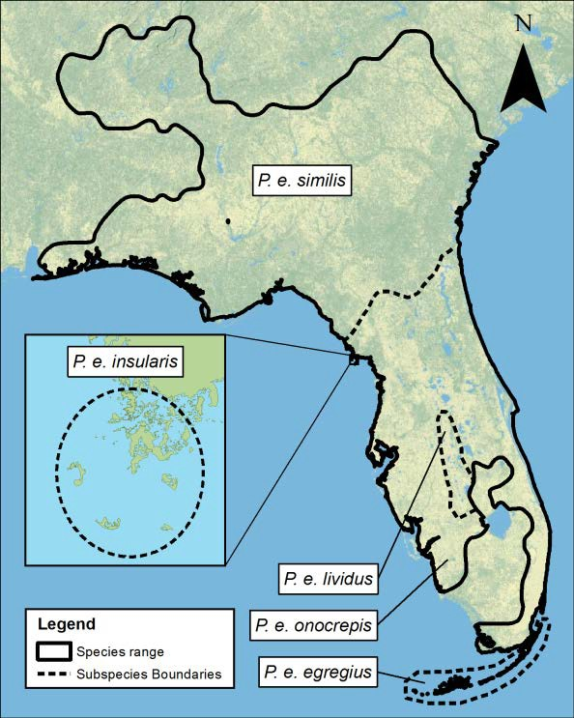
Figure 2. Mole skink species and species range (credit: Kathryn Mercier, University of Central Florida).

2.2 Description
The Florida Keys mole skink is a small lizard species isolated from the mainland and limited to islands of the Florida Keys (Figure 2). This species represents a unique genetic lineage, genetically distinct from the other Florida mole skink species (Brandley et al. 2005, pp. 387–388; Parkinson et al. 2016, entire). This skink is a slender, small brownish lizard with a brown, tan, or grey color, smooth, scales and two to four more pairs of light stripes extending from the head and neck that may reach the base of the tail. The tail, as in other species of mole skink, is brilliantly colored; individuals of the Florida Keys mole skink captured thus far have shown variations in tail color from orange and red to faded pink. This variation is likely due to age of the animal, as smaller individuals are observed with much more vibrant tails, transitioning to more subdued coloration as they grow. The small legs have five toes on each foot. Males display ventral and submental (under the chin) patches of pink and orange during the breeding season, although hints of these patches can be apparent throughout the year. Adults reach a total length of approximately 12.7 centimeters (cm) (5 inches (in)) (FNAI 2001, p. 1).
This species is semi-fossorial (adapted to digging and living underground) and cryptic in nature but has also been seen running along the substrate surface when exposed (such as when ground cover is disturbed during searches for skinks). The Florida Keys mole skink can run but more often utilizes “swimming” as a method to move through loose substrate. According to Christman (1992, p. 178), “The Florida Keys mole skinks seems to occupy intermediate evolutionary position between generalized cursorial (running) skinks and highly specialized fossorial ‘sand swimming’.” The Florida Keys mole skinks rely on ground cover over loose substrate as cover and the insects existing in this ground cover as a food source. In this case, “ground cover” as a resource for the Florida Keys mole skink, refers to, “leaf litter, debris, and tidal wrack” rather than a strictly vegetative ground cover such as grass. These ground cover and substrate conditions also provide reproductive and thermoregulatory refugia.
As a reptile, the Florida Keys mole skink is a cold-blooded (ectothermic) animal and therefore highly dependent on the air and soil temperature to thermoregulate (maintain body core temperature) (Mount 1963, p. 362). Ground cover moderates soil temperatures and provides shade to assist in the skinks’ thermoregulation in hot climates. Based on field studies by Mount (1963, p. 363), the optimum temperature range for the mole skink species (P. egregius) is 26°Celsius (C) to 34°C (78.8°Fahrenheit (F) to 93.2°F) with a mean of 29.5°C (85.1°F). The Florida Keys mole skink is specialized to live within this stable and relatively narrow thermal tropical environment. It is a thermoconformer, lacking the capacity to adjust or regulate to changes in temperature outside of this stable and relatively narrow thermal range in which it occurs (Gallagher et al 2015, p. 62).

2.3 Genetics
The Florida Keys mole skink species is a unique genetic lineage and is genetically distinct from the other mole skink species. Evidence indicates that it is an isolated species and not a population of the mainland species (Parkinson et. al. 2016, pp. 12–13; Branch et al. 2003, pp. 202–205). There are no genetic signs of interbreeding between the other species of mole skinks (Florida mole skinks Technical Team Working Group [Technical Team Working Group] 2016, pers. comm.; Mercier 2017b, pers. comm.). Nucleotide diversity and haplotype diversity is low in the Florida Keys mole skink compared to populations of other species (Branch 2003 (pp. 202–205).
Genetics research suggests that individual islands contain genetically distinct lineages of the Florida Keys mole skink species (Mercier 2018, pp. 18–21). Florida Keys mole skinks were sampled for genetics research on Boca Chica, Big Pine Key, Bahia Honda Key, Boot Key, and Long Key. Distinct genetic groups that clustered independently in a Principal Component Analysis were found at all the samples sites. Further, the study indicated that there are distinct genetic clusters between the upper and lower portions of Big Pine Key, along two sections of a 2 kilometer (km) (1.2 miles [mi]) stretch of beach separated by less than a 820 ft (250 m) stretch of mangroves (Figure 3) (Mercier 2018, pp. 21–23). This evidence indicates that there is minimal to no interbreeding or connectivity between these four populations, and that the wetland on Big Pine Key serves as a barrier to dispersal (Mercier 2018, p. 23).
Figure 3. Principal component (PC) analyses using single nucleotide polymorphism data; PCs 1 and 2 of Florida Keys mole skink individuals explained 21.6 percent (%) of the variation in the data. From Mercier 2018, p. 21.

2.4 Life History
The Florida Keys mole skink is under-surveyed and information about its life history is limited.

Range, Habitat, and Detections
The Florida Keys mole skink has been found in small numbers across the range of the Florida Keys (including the Distal Sand Keys region, including islands west of Key West to the Dry Tortugas) (Error! Reference source not found.; Table 2). The Florida Keys is a low-lying chain of small ancient coral reef islands (an archipelago) extending 201 km (125 mi) southwest from the southeastern tip of the Florida peninsula. The Florida Keys are primarily mangrove islands comprised of predominantly limestone substrate (ancient coral reef), with Key Largo limestone in the Upper Keys and Miami Limestone in the Lower Keys. The Florida Keys consist of approximately 1,700 islands connected by the Overseas Highway and many smaller outlying islands. The area covers approximately 360 square kilometers (km²) (139 square miles [mi²]) (Zhang et al. 2011, p. 3). The Marquesas Islands and Dry Tortugas are located approximately 35 km and 113 km (25 mi and 70 mi) west of Key West, Florida, respectively. The small islands of the Marquesas consist of an approximate 6.5 km² (2.5 mi²) land area. The Dry Tortugas islands cover an area of approximately 259 km² (100 mi²). The average elevation of the Florida Keys is less than one meter (3.2 ft.) above sea level. Windley Key in the Upper Keys is identified as having the highest elevation at approximately 5.5 m (18 ft.) above sea level (USGS 2017, n.p.; FEDP 2012a, p. 12).

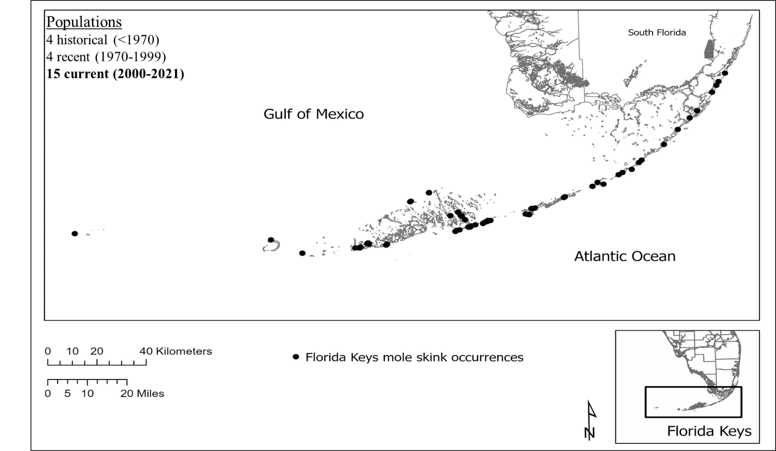Figure 4. Range of the Florida Keys mole skink, including current (2000–2021), recent (1970–1999) and historical (pre–1970) detections. Exact locations may be approximated (Service 2021, entire).
For the purposes of this SSA, the Florida Keys have been geographically divided into the Distal Sand Keys, Upper Keys, Middle Keys, and Lower Keys. The Lower Keys comprise everything from Key West to Bahia Honda Key. The Middle Keys are Boot Key east to Long Key, and the Upper Keys are everything east of Long Key up to Key Largo and northward (Error! Reference source not found.). Additionally, the Distal Sand Keys include everything west of Key West, including Boca Grande, the Marquesas Keys, and Loggerhead Key in the Dry Tortugas.
Loose soils that allow for “swimming” mobility through substrate are conducive to burrowing and nesting, and so the species requires, or highly prefers, loose soils (Christman 1992, p. 179). Mount (1963, p. 359) identified the two key ecological factors affecting mole skink distribution as soil and moisture conditions and seldom encountered mole skinks where the soil was not well drained and friable.
The Florida Keys mole skink has been found in wave-washed wrack, debris, and piles of rocks. They have also been found among rocks a few feet above the water on railroad embankments in the Upper Keys (Carr 1940, p. 75). Individual skinks have also been observed in shaded areas beneath stones in sandy areas of Key West and Stock Island (Duellman and Schwartz 1958, p. 289). The Florida Keys mole skink is documented in the beach berm zones and coastal hammocks in the Upper and Middle Keys (Monroe County 2016a, n.p.; Service 2021, n.p.). However, evidence suggests that the species can live in small areas of habitat or microhabitats within other mapped habitat types, including developed areas; individuals have been detected in developed areas of Key West (a backyard garden), Big Pine Key (along a road), and Key Vaca (in a landscaped area) and within pine rockland habitat on Big Pine Key (Emerick 2017a, pp. 4–5; iNaturalist 2020, entire). However, the vast majority of detections are within the beach berm habitat type and adjacent dunes (Emerick 2017a, p. 5). It is unknown how much of these small interior habitats exists, what they contribute to the overall species population sizes, and whether or not these interior microhabitats could serve to repopulate more coastal habitats following strong storms. It is possible that these storm events are what push the species into the more interior parts of the island.
The total land mass of the islands of the Florida Keys is approximately 37,859 ha (93,553 acres). This includes the lands of Monroe County, Florida, the main islands connected by the Overseas Highway, the Dry Tortugas, Marquesas Islands (approximately 36,006 ha [88,973 ac]) as well as the Florida Keys above Key Largo (in Miami-Dade County, Florida) (1,853.5 ha [4,580 ac]) (Monroe County 2016a, n.p.; FWC and FNAI 2016, n.p.). The smaller backwater islands (only accessible by boat) consist approximately of an additional 2,596 ha (6,416 ac). This total land mass value for the backwater islands is only an estimate; these islands are mainly mangrove, tidal islets. It is a dynamic system with changes in land cover based on conditions, and therefore, mapping is difficult.
Beach berm and coastal hammock are identified as potential Florida Keys mole skink habitat in, although these habitat classifications do not represent all of the potential habitat, as skinks have been located in other areas, as described above. The area comprised of these habitat types in the Florida Keys (Key West to Key Largo) is approximately 3,697 ha (9,134 ac). The current mapped area of suitable soils (identified as Bahia Fine Sand, Beach and unconsolidated soils) for this same range total approximately 137 ha to 191 ha (340 ac to 472 ac) (U.S. Department of Agriculture 1955, p. 55; Monroe County 2016a, n.p.); however, skinks have also been located in areas mapped as other soil types. Based on the Monroe County Soil maps, unconsolidated (or sandy) soils range in parcel sizes from 1.6 ha to 29.0 ha (4.0 ac to 72.0 ac) (average 7.8 ha; 19.2 ac) and occur on six of the main islands in Monroe County: Lower Matecumbe, Long Key, Boot Key, Bahia Honda, Big Pine, and Key West (Monroe County 2016a, n.p.).
Beaches, specifically the area above mean higher high water (MHHW) where wrack is deposited and sand dunes occur, are thought to be the primary habitat for the Florida Keys mole skink; the species has been most often found above high tide line along beaches in the Lower Keys (Emerick 2017a, p. 5). However, beach formation is not common in the Florida Keys, and little quartz sand exists in the region (Clark 1990, p. 13). Beaches are composed mostly of carbonate sand and generally increase in frequency towards the southwest. There are no naturally occurring beaches in the Upper Keys, yet the Florida Keys mole skink is still found in this region (above the Matecumbe Keys) (Error! Reference source not found.) (Clark 1990, p. 6). In the Lower Keys, Bahia Honda has the largest land mass composed of beach. In the Distal Sand Keys, beaches are common and occur almost ubiquitously on all of the islands, including Loggerhead Key of the Dry Tortugas, the Marquesas Islands, and Boca Grande (Clark 1990, p. 6).
Beaches occur both on the Atlantic side of the islands as well as on the backside of the islands, facing the Gulf of Mexico. The topography of the sea floor influences wave height and strength, and the geological conditions influence the sediment transport through tidal channels between these islands (Clark 1990, entire). These forces presumably create different environmental conditions depending on beach location. The Florida Keys are generally protected from the Atlantic swells, and wave action is mild. However, when beach sands erode due to storms or increasing sea levels, there is little material available for natural beach renourishment (Clark 1990, p. 13).
Table 1. Length and of existing beaches (1990) in the Florida Keys, taken from Clark 1990 (p. 12).
Due to a lack of available geographic information for habitat types and specific soils, the areas of the backwater islands and north of Key Largo are not included in the acreages for these potential habitat type. Information provided from a separate State of Florida land cover map was used to estimate areas of suitable habitat and soil for these areas. In the Florida Keys above Key Largo, approximately 739.4 ha (1,827 ac) is identified as coastal hammock habitat and unconsolidated soils (combined). The backwater islands of the Florida Keys consist of approximately 334.3 ha (826 ac) of unconsolidated soils (FWC and FNAI 2016, n.p.).
Pockets of unconsolidated soils occur occasionally across the islands as small patches of sand within upland areas and as augmented soils (home gardens). The total amount of these soils is not quantified but account for only a small percentage of the total soil in the species’ range. Information is lacking on their use by skinks, particularly for nesting but it is likely these areas are used opportunistically by skinks as adult habitat, and possibly for nesting (Technical Team Working Group 2016, pers. comm.). There is one verified observation of an adult skink found within a private citizen’s back yard in a completely developed area of Key West. In 2021, a skink was found on Vaca Key in an area with private residences inland, within a pocket of sandy soil and rocks (Turner 2021, pers. comm.). These areas are classified as urban in the habitat map from Monroe County (Monroe County 2016a, n.p.).
Observations of the Florida Keys mole skink are documented on 23 islands, 15 of which have had detections in the last 20 years (since 2000) (FLMNH 2011, n.p.; FNAI 2011, entire; Mays and Enge 2016, entire; Mount 1965, p. 208) (Table 2; Error! Reference source not found.). These observations are mostly independent and opportunistic reports; formal surveys have been conducted only recently, as follows.

Table 2. Florida Keys mole skink observations, both prior to 2000 and current (2000–2021). Values in parentheses indicate the number of individuals observed. Regions and islands are presented from west to east. We separate out everything north of U.S. Route 1, where it connects the Florida Keys to the mainland, as North Key Largo.
 |  | Year detected (count)
Region | Island | Pre-2000 | 2000 to 2021
Distal Sand Keys | Dry Tortugas | 1862 (1)*
Distal Sand Keys | Marquesas | unknown | 2015 (1)
Distal Sand Keys | Boca Grande |  | 2017 (3)
Lower | Key West (including Stock Island) | 1879 (1); 1919-1932 (8); 1938-1939 (4); 1944 (6); 1954-55 (5); 1960 (10); 1970 (1); 1979 (1); 1983-1988 (4); unknown (1) | 2016 (1)
Lower | Boca Chica Key | 1993 (1) | 2015 (2); 2016 (2)
Lower | Sawyer Key |  | 2008 (1); 2015 (1); 2016 (2); 2018-2021 (8)
Lower | Content Keys |  | 2017 (3); 2019-2021 (6)
Lower | Big Munson Island |  | 2016 (3); 2017 (2)
Lower | Cooks Island |  | 2017 (1)
Lower | Middle Torch Key | 1977-1985 (unknown)
Lower | Big Pine Key | 1947 (1) | 2012(1); 2014 (6); 2015 (10); 2015-2016 (39); 2016-2017 (85); 2018-2020 (3)
Lower | Scout Key | mid-80s (unknown)
Lower | Bahia Honda | 1972 (2); 1980-85 (unknown) | 2014 (1); 2015 (6); 2016 (7)
Middle | Boot Key | 1988 (1); 1997 (1) | 2013 (1); 2015 (1); 2016 (2)
Middle | Key Vaca | 1954 (1); 1980 (2); 1983(2) | 2020 (1)
Middle | Grassy Key | 1960 (1); 1968 (1); 1985 (1)
Middle | Long Key | 1990 (1) | 2017 (1); 2018-2019 (1)**
Upper | Lower Matecumbe Key |  | 2013 (1)
Upper | Indian Key | unknown (2)
Upper | Upper Matecumbe Key | 1934-35 (2); 1951 (1)
Upper | Plantation Key | 1982 (1); 1991 (1)
Upper | Key Largo | unknown | 2013 (1); 2021 (2)
Upper | North Key Largo | 1951 (1); 1954 (4); 1959 (1); 1960 (2); 1978 (2); 1979 (1)
*Museum of Comparative Zoology specimen; Harvard University; unverified.
** Unverified.

Recent Surveys
A 2015 to 2016 Florida Wildlife Commission (FWC) study found individual Florida Keys mole skinks under coverboards at Bahia Honda Key (Mays and Enge 2016, entire). Observations were made on Big Pine Key, Boca Chica, Sawyer Key, and Boot Key using raking methods. The Sawyer Key and Boca Chica observations are new records for these islands (Mays and Enge 2016, p. 11; Table 2; Error! Reference source not found.). The same survey efforts by FWC during this time failed to record any sightings on the Marquesas Keys and the Dry Tortugas, Boca Grande Key, Woman Key, Key West, Content Keys, Upper Sugarloaf Key, Scout Key (once West Summerland), Little Crawl Key, Lower Matecumbe Key, and Tavernier (Mays and Enge 2016, p.11). In June 2015, Key West National Wildlife Refuge (Refuge) staff documented a skink adjacent to a sea turtle nest on Mooney Island in the Marquesas Islands. Following Hurricane Irma (2017), FWC coverboard surveys 2018-2021 included observations on Long Beach, Long Key, Content Key, and Sawyer Key. Other recent observations of the Florida Keys mole skink are of a single skink on Key Vaca in 2020; the individual was documented in a residential area in some landscaping consisting of plants, rocks, and sand (Figure 5) (iNaturalist 2020, entire; Turner 2021, pers. comm.), as well as two skinks found in 2021, in the leaf litter of a forested area of Key Largo in John Pennekamp State Park (Zambrano 2021, pers. comm).
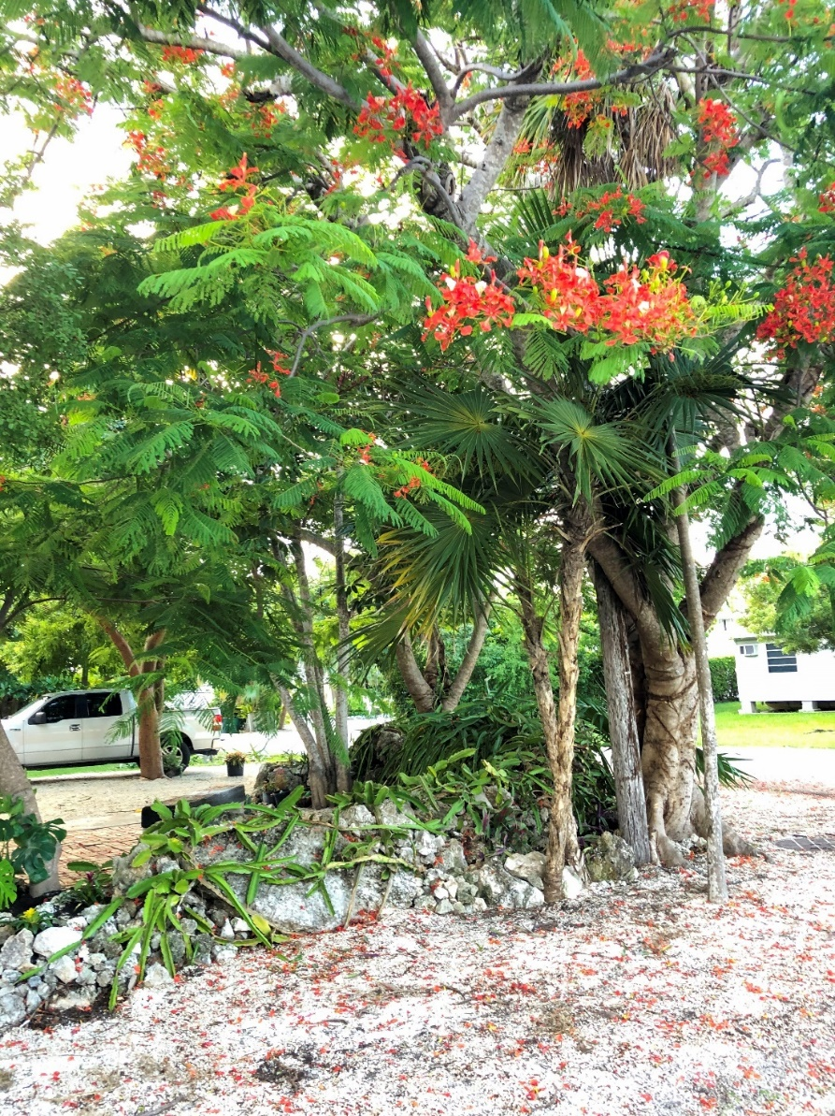
Figure 5. General location of Florida Keys mole skink found in a developed area of Key Vaca in 2020 (Turner 2021, pers. comm.).
Surveys were conducted in 2016 and 2017 on selected areas of the Key Deer National Wildlife Refuge property including Long Beach on Big Pine Key and Ohio Key where suitable beach and coastal habitat occur. Skinks have been historically documented on Long Beach. The predominant capture methods being used are via the use of coverboards or hand search (uncovering them with hand searching or gentle raking of ground cover or debris). The Key Deer National Wildlife Refuge project focuses on better defining the habitat being used by the skinks as well as collecting life history data on size classes and sex ratio throughout the year.
During surveys, 120 observations or captures have been documented at the Long Beach site on Big Pine Key (Service 2021, entire). Approximately 26 percent were recaptures, which provides some indication of site fidelity and limited dispersal range at this site; however, many were not able to be verified as either first time captures or recaptures (Emerick and FWC 2017, pers. comm.). An approximate 1:1 ratio of male to female was observed, although the sex was undeterminable for 40 percent of the Long Beach captures (Service 2021, entire).
The second site specifically targeted by searches for the Florida Keys mole skink was Ohio Key. Ohio Key is a small island immediately adjacent to Bahia Honda to the northeast. Although this site was selected because of the existing suitable habitat, there have been zero observations or captures of Florida Keys mole skinks at this location.
In addition to the monitoring, surveys taking place at the Big Pine Key and Ohio Key suitable habitat sites, opportunistic searches for the Florida Keys mole skink also occur by Key Deer National Wildlife Refuge staff at the numerous coverboards in place across the archipelago. These coverboards are used in locating various reptile species occurring in the Florida Keys, including the Florida Keys mole skink.
Herpetologists believe that skinks are likely to still occur as far north as Key Largo in the vicinity of the historical documentations (Technical Team Working Group 2016, pers. comm.; Appendix B). However, recent checks of coverboards placed within the Crocodile Lake National Wildlife Refuge on Key Largo have failed to observe or capture skinks within well-developed tropical hardwood hammocks (Emerick 2017b, pers. comm.). Additionally, an effort in February 2017 (three weeks of daily searching) to collect specimens for genetic samples in Key Largo, a historically documented skink location in the Upper Keys, has failed to observe any skinks (Mercier 2017a, pers. comm.). It is important to note that locating and capturing skinks is difficult because of their small size and cryptic nature, and even those persons with experience in locating and capturing skinks have varied success.
Species experts have not formally searched for the species in the additional barrier islands north of Key Largo (in Miami-Dade County) or in the numerous smaller and remote “backwater” islands to the north in Florida Bay. No historical records exist for these locations. Species experts agree that while the amount of suitable habitat in these areas is minimal (most of the islets are tidal mangrove), they will not discount the possibility that individuals of the species could currently exist there (Emerick 2017c, pers. comm.; Moler 2017, pers. comm.).

Generations and reproduction
The Florida Keys mole skink has three life stages: eggs, immature (juvenile), and adult. The immature stage lasts approximately one year from hatching to reproductively mature adult. Immature skinks have been found only in beach habitats. It is unknown if this life stage is limited to the beach habitat and these observations may reflect survey bias of the coastal system. The home range of individual skinks is limited (see below, Dispersal and Home Range); therefore, where adults are found in areas further inland from the beach habitat, there is a strong likelihood that juveniles are also present (Technical Team Working Group 2016, pers. comm.; Appendix B).
The generation time for the Florida Keys mole skink has not yet been documented. McCoy et al. (2010; pp. 641–642) used mark-recapture data with a similar species, the Florida sand skink (P. reynoldsi), to determine that 60 years represented 15 to 20 generations. These data illustrated that the previous estimate, based on the age at first reproduction, of generation length (30 to 37 generations in 60 years) for the Florida sand skink was underestimated (McCoy et al. 2010, pp. 642–643). The age at first reproduction for the Florida Keys mole skink and the Florida sand skink are similar (24 months compared to 19 to 22 months [McCoy 2010, p. 641], respectively) and may suggest a comparable generation time of approximately one generation every 3 to 4 years.
Due to a lack of species-specific information, the following description of life history is based primarily on a closely related species, the red-tailed skink (Eumeces [now Plestiodon] egregius) work conducted in a laboratory setting (Mount 1963, entire). Scent is the most important factor in finding and selecting mates (Mount 1963, p.367). Mating of the Florida Keys mole skink typically takes place in fall or winter. Florida Keys mole skink has been observed mating during this time by field biologists surveying for the species (Technical Team Working Group 2016, pers. comm.). After mating the female enters a period of inactivity that last approximately one month (Mount 1963, p. 372). Eggs are laid under debris and usually in nest cavities. Female mole skinks den and attend their nests annually between April and June. The females lick, turn, and protect the eggs from predators. Research has shown that when any of these activities are prevented, the eggs are at risk of not developing normally (Mount 1963, pp. 376–377).
Soils used for nesting are generally dry and unconsolidated to allow for the digging of nest cavities and their swimming movement through substrate. Nest depth is probably dependent upon substrate depth and is documented to vary greatly from 0.33 centimeters (cm) (0.13 in) to 1.83 meters (m) (6 ft) (Hamilton and Pollack 1958, p. 27; Neill 1940, p. 266). Based on laboratory research, an individual skink lays a clutch of 2 to 11 eggs with an average of 3 to 5 eggs (Bartlett and Bartlett 1999, p. 195; Mount 1963, p. 376). Eggs incubate for 31 to 51 days (Mount 1963, p. 376). No in-situ nests have been identified for the Florida Keys mole skink. Because of the predominantly limestone, prehistoric coral reef and rocky makeup of the archipelago, only a few areas provide the unconsolidated soils considered preferred by the Florida Keys mole skink for nesting. In the Florida Keys, the unconsolidated soil types are predominantly “Beach” and “Bahia Fine sand” and total only approximately 137.6 ha to 191 ha (340 ac to 472 ac) of soils in the archipelago (additional information on the distribution of these soil types in the Florida Keys is provided under “Habitat” below).
In a central Florida sandhill scrub habitat, Mount (1965, pp. 372–373) captured more P. egregius female skinks with greater regularity than males during February and March and more males than females in November-January. The spring months coincide with a period of heavy foraging by the females (Mount 1963, p. 373). The sex ratio of the Florida Keys mole skink is uncertain at this time. The sex ratio for the sand skink is 1:1 (Gianopulos, 2001, pp. 23–24; Sutton 1996, p. 36). Recent collections of Florida Keys mole skink have indicated a near 1:1 female to male ratio although this sample size is small and sex was not determined for approximately 40 percent of those skinks collected.

Diet
The Florida Keys mole skink preys on a variety of small insects (Hamilton and Pollack 1958, p. 26; Mount 1963, p. 364; Technical Team Working Group 2016, pers. comm.). Hamilton and Pollack (1958, p. 26) examined digestive tracts of 36 Plestiodon species including one sample from Key West and found ants, spiders, crickets, beetles, termites, small bugs, mites, butterfly larva, pseudoscorpion, and fungus. The make-up of diets has been shown to shift seasonally with prey relative to abundance. Prey is also thought to be caught and eaten underground (Mount 1963, p. 365). The recent surveys and field work by species experts indicate generalist and opportunistic (preying on those insects that are present and are of a size that the skink can ingest) feeding behavior by the Florida Keys mole skinks within their ground cover habitat (Technical Team Working Group 2016, pers. comm.; Appendix B).

Dispersal and Home Range
There is a high confidence level among the herpetological experts that juvenile skinks establish a territory or home range away from their parents (Appendix B). Direct evidence is lacking on the Florida Keys mole skink home range distance. Schrey et al. (2011, p. 64) showed that sand skinks (P. reynoldsi) that were captured within 25 m (82 ft) of each other were genetically more similar (statistically significant) than other individuals who were beyond that distance. Because genetic differentiation requires time to develop, it shows a pattern of behavior in which individuals interbreed within 25 m (82 ft) of each other. In this study, the maximum distance used for captures in this study was limited to 25 m (82 ft) (Schrey et al. 2011, p. 60). Mushinsky et al. 2001 (p. 55) found that adult female sand skinks had an average dispersal distance of 23 m (75 ft).
Maximum dispersal distances for sand skinks in Florida scrub habitat have been documented at 35 m (115 ft) upwards to 140 m (460 ft) although just a few adults were recorded at distances greater than 100 m (328 ft) (Gianopulus 2001, p.81; Mushinsky et al., 2001, p. 54). The larger home range distances of a few individual sand skinks beyond 100 m (328 ft) could be attributed to localized resource limitations or adult “floaters”.
As previously mentioned, the dispersal distance or typical home range for Florida Keys mole skink individuals has not been yet been studied but it is expected that the dispersal and home ranges are similar to that documented for the Florida sand skink. In general, male sand skinks have a slightly longer dispersal range than females to search for mates. Female sand skink dispersal distances are lower as they need to have soils for nesting and remain with the nest. Home range and maximum dispersal distances have been based on the findings of individual sand skinks. Dispersal distances ranged from 4.28 to 90 m (14.5 to 295.2 ft) (McCoy et al. 2020, p. 8). Capture-recapture data indicated an average home range of 219 +/- 80 m2, (radius of 44 to 95 ft) while the genetic analysis suggested a home range radius of 15 to 25 m (47 – 78 ft.) (McCoy et al. 2020. P. 17). The total size of an area needed to support a population of of Florida mole skinks has not been defined. Also, the species structure of the Florida mole skink (five species) suggests limited dispersal for individuals of these species (Branch et al. 2003, p. 2007; Adler et. al. 1995, p. 535).
There is a high likelihood that some level of stochastic passive dispersal of individuals, primarily via rafting (carried by floating debris and seaweed wrack) is occurring (Adler et al. 1995, pp. 535–537; Branch et al. p. 2003 p. 207; Losos and Ricklefs 2010, p. 360). Possible stochastic events leading to rafting or passive movement of skinks include: a) inundation and flooding of low-lying areas from strong seasonal storms and hurricanes that move debris or soils; and b) high tides and coastal storm surge that collect and carry wrack and vegetative mats. Distances between several islands with identified populations are relatively close: a) approximately 14.5 km (9 mi) from Boot Key, located on the northern end of the Overseas Highway, to Bahia Honda, the next nearest identified population; b) approximately 9.7 km (6 mi) from Bahia Honda to Big Pine Key; and approximately 25 km (15.5 mi) from Big Pine Key to Boca Chica, the most southern-identified population. Individuals may be dispersing (rafting) from one island to another often enough to maintain some interaction among the populations but still at levels low enough that the populations remain distinct (Cronin, 2003, p.1186; Smith and Green 2005, pp. 111–113). There are also small islets which lay between these mentioned islands.
Based on genetic evidence, the species population structure is a set of multiple, non-interacting populations on separate islands. Additional information may find that its structure is some form of a classic metapopulation, with population extinctions and recolonization of new immigrants, to the degree that there are interactions (immigration and emigration of individuals) between islands.

Distribution and Density
Gianopulos (2001, p. 26) found no statistically significant differences in the size distribution of sand skinks (adult versus juvenile) among sites in any given time of the year. However, three to five times more adult than juvenile sand skinks were captured during spring surveys (February-March; using pitfall traps) (Gianopulos (2001, p. 24). This result may be a reflection of differences in seasonal reproduction and abundance rather than or in addition to the motility and distribution between the two life stages. It is uncertain if size distributions exist for the Florida Keys mole skink.
Density values for the Florida Keys mole skink across the landscape are unknown; however the distribution of individuals is not expected to be uniform across the range or even within a localized area of suitable habitat. Also, as an island endemic species and based on the historical and current observations the Florida Keys mole skink is an uncommon species and its total overall abundance compared to that of the mainland skinks is low.
For the peninsular mole skink (P. egregius onocrepis), one of the mainland species, density values have been documented as high as 62.5 adults per ha (25 per ac) (Christman 1992, p. 120). Notably, however, that even in what was apparently suitable habitat, the mole skink showed limited dispersal and individuals were “concentrated in more localized pockets” (Christman 1992, p. 120; Schrey et al. 2012, pp. 243–246). A similar clumped distribution is expected to exist for the Florida Keys mole skink. The presumed limited range of individual skinks and the patchy distribution of the suitable habitat across the archipelago suggest that there is also a clumped distribution for the Florida Keys mole skink species (although in low abundance).
In a comparison of density values, the more common sand skink has an average density of 163 per ha (per 2.5 ac), and individual sand skinks were located 20 times more frequently in field collections than blue tail mole skinks (P. egregius lividus), a rare and related species to the Florida Keys mole skink (Christman 2005, p. 12; Christman (1992, p. 120).

CHAPTER 3 – POPULATION AND SPECIES NEEDS
In this chapter, we evaluate population and species’ ecological needs to consider their relevant influence on Florida Keys mole skink resiliency, representation, and redundancy. As part of the population needs assessment, we first identified and described the most influential factors representing the individual and population needs for the species. The methods used to identify population needs included convening a Technical Team Working Group Workshop in 2016 (Appendix B), the use of published literature, unpublished reports, and preliminary (unpublished) data from current survey and taxonomy research projects.

Individual needs
The Technical Team Working Group identified the individual needs of Florida Keys mole skink as: 1) Coastal beach and hammock habitat (as identified in Monroe County mapping, although additional pockets of habitat are known to exist but cannot be mapped); 2) unconsolidated, dry soils (loose soil substrate as identified in Monroe County mapping as Beach sand and Bahia Honda Fine Sand, although additional pockets of suitable substrate are known to exist, but cannot be mapped); 3) ground cover/leaf litter, debris, or wrack; and 4) arthropods/insects food source (found within the ground cover of the habitat).
Suitable coastal hammock and coastal dune habitat provides ground cover in the form of leaf litter and wrack material that skinks need for nesting, insect food sources, and cover. Mole skink abundance, distribution and life history behaviors (nesting, breeding) are limited to (and defined by) the availability of these resources in the remaining areas of beach berm and coastal hammock. While ground cover and insect food sources are apparently sufficient and occur in adequate amounts, there have been no quantitative studies completed on these factors. Valuable characteristics that contribute to population resilience are their generalist behavior in use of various ground covers and insect food sources.

Population Needs
Specific information on population carrying capacity, birth rates, and nesting success is lacking for this species. Previously cited work on the mole skink species has indicated the importance of suitable habitat, ground cover, insect food sources, and unconsolidated dry soils for meeting life history needs (breeding, feeding, cover, movement) of the mole skink (Christman 1992, p. 179; Hamilton and Pollack 1958, p. 26; Mount 1963, p. 359; Monroe County 2016a, p. 364).
Genetic evidence indicates that little to no breeding is taking place between the four genetically differentiated populations, suggesting that the population structure of the species is that of discrete, minimally to non-interbreeding populations (Parkinson et al. 2016, entire; Appendix B; Mercier 2017b. pers. comm.). This population structure is supported by the relatively limited dispersal and small home ranges assumed for the Florida Keys mole skink.

Species Needs
The species’ needs are similar to those that are identified at a population level: available suitable habitat, soils, ground cover, and food source. As well, at the species level, there needs to be multiple healthy populations or a single abundant population occurring across the species’ range. There may be a distinct, minimally to non-interbreeding populations on each island or some level of dispersal from rafting between some islands providing at least a small level of connectivity between individuals of populations. Preliminary genetic sampling has identified at least four discrete (non-interbreeding) populations as described above but sampling on other islands between or adjacent to these four islands has not been completed and may show some mixing or variation of genetics. The minimum number of viable (resilient) populations necessary to sustain the species is unknown. As an island species, the relatively small, patchily distributed islands can each support only small numbers of individuals (or separate populations). The distribution of suitable habitat and soils across the species’ range are necessary to support skink populations. The level of redundancy (distribution) operating within a species is determined by the resiliency (abundance and health) of its populations.

Uncertainties and Unknowns
The following is a list of uncertainties for the Florida Keys mole skink population distribution and needs:
      - Areas of occurrence in the Upper Keys. Surveys are focused on the Lower Keys’ public lands and recent documentation has confirmed skinks in historical areas of occurrence, however, many locations remain unsurveyed. Surveys in the Upper Keys locations have failed to document skinks. It is also unknown if skinks occur on the keys/islands north of Key Largo in Miami-Dade County.
      - Population demographics. There is little to no information regarding abundance and minimum viable populations, population trends, sex ratio, fecundity, nesting success, nest success, survival rates, and carrying capacity.
      - Connectivity between islands. Genetic evidence suggests minimally to no interbreeding despite the likelihood that stochastic dispersal takes place from rafting between keys.
      - Distribution and amounts of potential habitat. While the species is linked to two habitat types and specific soils that have been mapped throughout most of the range, skinks have been found in other areas, presumably microhabitats that do not correspond to these habitats or soils. This is likely a factor due to the mapping scale or additional habitat preferences. How commonly skinks occupy these microhabitats outside of beach berm and hammock habitat types is unknown. While the species is most often detected near the shorelines, it has also been found more inland, although in seemingly small areas of potential habitat (sandy landscaping, etc.). It is unknown how common or numerous these inland individuals are.
      - Home range size. Individual dispersal occurs but is considered limited. Distances, timing and patterns of movement are uncertain. Males are expected to have a slightly higher dispersal range than females to search for mates during the breeding season. Female dispersal distances are likely lower than those of males’ as they need to have sandy, dry soil available to them for nesting and remain with the nest.
      - Juvenile dispersal distances. Juvenile dispersal is believed to occur for the purpose of establishing their own home ranges away from those of adults, but distances are unknown. There is a lack of information on resource sharing or if any level of overlapping ranges take place on the landscape.
      - Connectivity between interior and shoreline habitats. Storm surge and high water events likely translocate individuals from the beach habitat to inland habitats. These translocated individuals and/or individuals from inland extensions of the population likely repopulate the coastal beach habitat after stochastic storm events. However, there is no documentation to confirm this pathway of a population rescue, except that locations that appear to have been extirpated are years later documented to have skinks.
      - Quantity or quality of cover needed to maintain optimum temperature range and other microhabitat conditions are undefined.
      - Quantity or metric for insects (food source) needed in the landscape is undefined.

CHAPTER 4 – FACTORS AFFECTING VIABILITY
In this chapter, we describe the stressors on the needs and viability of the Florida Keys mole skink (Figure 6). We then discuss positive influences on the viability of the species.
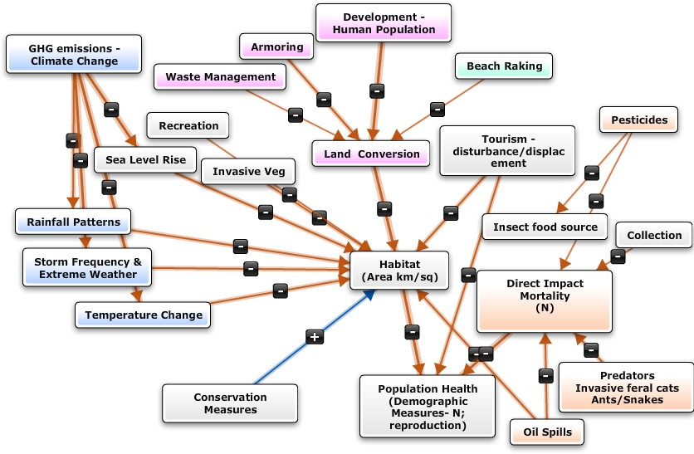

Figure 6. Influence diagram: factors influencing Florida Keys mole skink habitat and demographics.

4.1 Climate Change
The predominant environmental stressors affecting the Florida Keys mole skink and its habitat are the shifts in climate occurring as a result of increasing greenhouse gas emissions (GHG). The Florida Keys archipelago is being inundated by a rise in sea level and changing seasonal climate patterns. The main stressors affecting the Florida Keys mole skink and its habitat are SLR, more frequent tidal flooding (the highest tides of the monthly and annual lunar cycle), increased storm surges, and shifts in seasonal patterns of rainfall and temperature.

Sea Level Rise
Climatic changes, including SLR and shifts in seasonal precipitation, temperature, and tropical cyclone intensities, are major threats to south Florida and to the Florida Keys.
Since 1880, global sea level has increased by 0.20 m to 0.23 m (8 in to 9 in), and the rate of increase over the past 20 years has doubled (Service 2017, p. 5). An average 0.08 m (3 in) increase in overall global SLR has occurred between 1992 and 2015 (NASA 2015, p. 2). This rise is equivalent to the Florida coastline subsiding at a rate of 0.001 m (0.04 in) a year (Service 2017, p. 6). The long-term trend in SLR at the NOAA Key West Station shows a 0.0024 m (0.09 in) increase of the mean high water line (MHWL) per year from 1913 to 2015 (NOAA 2017a, p. 1) (Figure 7). The NOAA Vaca Key Station (City of Marathon) shows a 0.0035 m (0.14 in) per year SLR between 1971 (start of data collection) to 2015 (NOAA 2017a, p. 1) (Figure 4–2). Mean high water line is defined as, “The line on a chart or map which represents the intersection of the land with the water surface at the elevation of mean high water” (NOS 2017, p. 13).
While the SLR rate for Florida has been equivalent to that experienced globally, recent analysis is now indicating an accelerated rate for the eastern United States above that of the global rate (Sweet et al. 2017, p. 25; Carter et al. 2014, pp. 401–403; Park and Sweet 2015, entire). Various studies have developed scenarios that range from less than 0.3 m to 3.2 m (1.0 ft to 10.4 ft) of SLR in South Florida and the Florida Keys by 2100 (University of Florida Geoplan 2015, p. 13; The Nature Conservancy 2011, pp. 4–6; Zhang et al. 2011, p. 136; Vargas-Moreno and Flaxman 2010, pp. 1–6; Sweet et al. 2017, p. 25). Tidal gauges around Florida have shown 25.4 cm (10 in) of SLR since 1920. However, in the last 18 years there has been 12.7 cm (5 in) of SLR in southeast Florida (Sweet et al. 2017, p. 41). This recent acceleration suggests that, of the NOAA SLR scenarios based on different GHG emission scenarios (Sweet et al. 2017, pp. 21–22), the intermediate to extreme SLR scenarios are more likely to occur than the low and intermediate-low scenarios (scenarios), and NOAA is recommending the use of the higher end estimates for future projections (Sweet et al. 2017, p. 33-35). Also, according to statistical analyses from Church et al., 2013; Kopp et al., 2014; 2016; Slangen et al., 2014; Grinsted et al., 2015; Mengel et al., 2016 cited in the NOAA (2017) report, the probability of exceeding the lowest scenario that considers an immediate reduction in GHG (1 ft. SLR by 2100) is 100 percent. The probability of exceeding the scenario of decreasing GHG in 2040 (1.6 ft. SLR by 2100) is 96 percent. Thus, these two scenarios, along with the 2000 extrapolation scenario, are not included in the current range of SLR scenarios.
The accelerated SLR in south Florida is being attributed to shifts in the Florida Current due to: a) added ocean mass brought on by the melting Antarctic and Greenland ice packs, and; b) thermal expansion from the warming ocean (Park and Sweet 2015, entire; Rahmstorf et al 2015, entire; Sweet et al. 2017, p. 14; Deconto and Pollard, 2016, p. 596).
Because the Florida Keys mole skink inhabits and utilizes the transitional zone/beach berm (50 cm to 80 cm [20 in to 31 in] above sea level) and the coastal hammock habitat during all of its life stages, the species is especially vulnerable to SLR across its entire range. The Florida Keys are so low-lying (average elevation less than 1 m [3.2 ft]) the area is highly susceptible to flooding, and land further upland is at risk of inundation and saltwater intrusion (USGS 2017, n.p.; FDEP 2012, p. 12). Sea-level rise has been attributed to the conversion and loss of pine forest habitat in the Florida Keys to more halophilic (salt-loving) vegetation (Ross et al. 1994, pp. 152–154). These effects-higher tidal surges, coastal and inland flooding, and saltwater intrusion- of increasing sea levels are currently being experienced in the south Florida and the Florida Keys (Carter et.al 2014, pp. 398–400, 403; Wadlow 2016, entire). Thus, even prior to the sea rising to cover the land, Florida Keys mole skink habitats will likely undergo vegetation shifts triggered by changes to hydrology (wetter), salinity (higher), and more frequent storm surge and tidal flooding (i.e., pulse events causing increasing beach erosion and salinization of soils), even if high tide or surge flooding is infrequent (Saha et al. 2011a, pp. 181–182; Saha et al. 2011b, pp. 82–84; Sweet et al. 2020, pp. 1–4). If high tide or surge flooding occurs frequently, habitat could be highly degraded or eliminated prior to SLR inundation and is evidenced by ongoing beach renourishment efforts (Saha et al. 2011, p. 1).
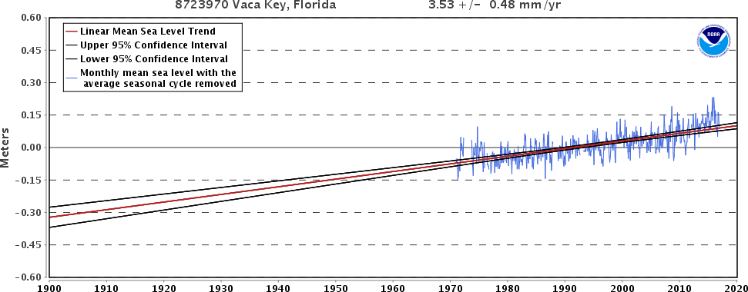

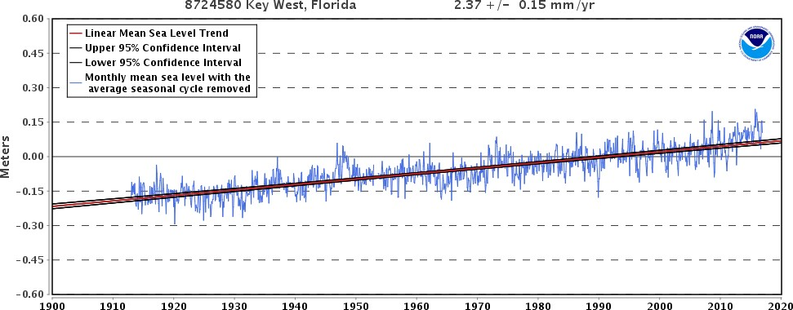

Figure 7. Key Vaca (1970 to 2015) and Key West (1913 to 2015) NOAA tidal gauges (NOAA 2017a) showing the increasing linear mean sea level trend for the Florida Keys.

NOAA (2017b, entire) recently reviewed past projections compared to current levels of SLR, and the updated comparison indicates that the actual SLR taking place is trending on the high end of 2009 projections. Therefore, NOAA (2017b, entire) has modified the Low, Medium, and High bounds to the global SLR projections. The projected lower bound for global SLR by 2100 is now 0.3 m (0.98 ft ) (was 0.1 m [0.32 ft]) and the upper bound is now a projected 2.5 m (8.2 ft) by 2100 (was 2.0 m [6.6 ft]) (Sweet et al. 2017, p. 14; Appendix D).
The SLR scenarios are based on IPCC greenhouse gas (GHG) emission scenarios (IPCC 2013, entire); however, specific scenarios are subdivisions of the bounding scenarios of Parris et al. (2012, entire), where the intermediates are 0.5 m (1.6 ft) increments of the 90 percent Representative Concentration Pathway (RCP)-based Global Mean Sea Level (GMSL) projections of recent studies (Church et al., 2013; Kopp et al., 2014; 2016; Slangen et al., 2014; Grinsted et al., 2015; Mengel et al., 2016 cited in Sweet et al. 2017, p. 22), incorporating regional updates (Sweet et al. 2017, entire) (Figure 8). Thus, the six representative GMSL rise scenarios range from a low-end (Low) scenario of 0.3 m (0.98 ft) to a worst-case (Extreme) scenario of 2.5 m (8.2 ft) by 2100. Intermediate-Low represents 0.5 m (1.6 ft) by 2100, Intermediate is1.0 m (3.28 ft), Intermediate-High 1.5 m (4.92 ft), and High is 2.0 m (6.6 ft) (Hall et al. 2016, p. 2-9). However, according to statistical analyses (Church et al., 2013; Kopp et al., 2014; 2016; Slangen et al., 2014; Grinsted et al., 2015; Mengel et al., 2016 cited in Sweet et al. 2017, p. 22), the probability of exceeding the Low scenario is 100 percent, and the probability of exceeding the Intermediate Low scenario is 96 percent. Due to the likelihood of exceeding these scenarios, we do not consider Intermediate Low and Low in our analyses.
Figure 8. Six representative Global Median Sea Level (GMSL) rise scenarios for 2100 (6 colored lines) relative to historical geological, tide gauge and satellite altimeter GMSL reconstructions from 1800–2015 (black and magenta lines) and central 90 percent conditional probability ranges (colored boxes) of RCP-based GMSL projections of recent studies (Church et al., 2013; Kopp et al., 2014; 2016; Slangen et al., 2014; Grinsted et al., 2015; Mengel et al., 2016 in Sweet et al. 2017, p. 22). Scenarios are as follows: red = Extreme, orange = High, Green = Intermediate-High, aqua = Intermediate, blue = Intermediate-Low, and navy = Low. The probability of exceeding the Intermediate-Low and Low scenarios is 96 percent and 100 percent, respectively. Figure from Sweet et al. 2017, p. 22.

Temperature and Precipitation
In the United States, the average temperatures have increased by 0.77 C to 1.1 C (1.3 F to 1.9 F) since record keeping began in 1895 (Service 2017, p.2). The decade from 2000 to 2009 is documented as the warmest on record (since record keeping began in 1895) (Service 2017, p. 2). The average temperatures in south Florida have increased 0.83 degrees C (1.5 degrees F) or more since 1991 (Service 2017, page 2). Because of the current condition of human–induced emissions (that is, the pattern of continued release of GHGs added to those already occurring in the atmosphere), increases in surface air temperature continue to rise. Even if there was an immediate and aggressive reduction to all GHGs caused by humans, there would still be expected continued increases in surface air temperature due to the lag in response to GHGs by the Earth’s system (IPCC 2013, pp. 19–20).
The Florida Keys mole skink is specialized for existing within a stable and relatively narrow thermal environment of the tropics and may lack the capacity to adjust or regulate to changes in temperature outside of the thermal range in which it occurs (Gallagher et al 2015, p. 62). This limiting coping ability to adjust to thermal stress outside of its temperature range increases the species susceptibility to the local and regional increases in temperature occurring with global warming (Gallagher et al. 2015, pp.61–63). As mentioned in Chapter 2.2 Description, the optimum temperature range for the mole skink species (P. egregius), is from 26 C (78.8 F to 93.2 F) with a mean of 29.5 C (85.1 F) (Mount 1963, p. 363). Any continuously higher average number of hot days out of the skink’s optimum range or a permanent shift in average air temperature out of this range, even by 0.28 C (0.5 F), can stress them physiologically or shift reproductive cues (Adolph and Porter 1993, p.276). Increases in sand temperature (their surrounding habitat) would likely alter their movements and time spent under cover within the sands (Adolph and Porter 1993, pp. 275–278, 290). It is unknown what thermal range the Florida Keys mole skink can tolerate. Large changes outside of the skink’s optimal temperature range can lead to decreased fitness and mortality of individuals. The impacts from this stressor are based on the level and duration of thermal changes and the capacity for individual skinks to physiological or behaviorally accommodate to these changes.
Temperature-dependent sex determination (TSD) has been documented for most reptilian species but not all (a few reptiles have shown to not exhibit TSD or an environmentally determined sex ratio) (Bull 1980 p.7). Recent work has indicated that both genetic and TSD mechanisms co-occur and function interrelatedly in the lizard species Pogona vitticeps (Holleley et al. 2015, entire). The plasticity of this dual system implies a potential for this species to rapidly shift from what is a temperature-sensitive genetic mechanism to a TSD mechanism under high incubation temperatures (Holleley et al 2015, pp. 79–80). This transition or temperature override was found to evolve rapidly in response to high temperatures and resulted in the development of more females and the loss of mixed chromosomal offspring (Holleley 2015, pp. 80–81). How prevalent this rapid transition-response is in other reptilian species is uncertain. While no direct study of TSD or the transitioning of sex-determinant mechanisms in the Florida Keys mole skink exists, TSD has been identified in skink species in the same Family (Scicinidae) (Robert and Thompson 2009, entire; Ji et al. 2006, entire). Sarre et al. (2004, pp. 640,642–643) proposed that the genetic and environmental sex determination mechanisms commonly co-occur and function as a continuum in reptile species. How the fluidity between these two mechanisms ultimately affects the fitness and genetic representation of a species is still unclear, but this mechanism is expected to be influenced by increasing temperatures from climate change (Holleley et al 2015, p. 81; Bull 2015, p.44).
Temperatures and moisture content of sandy soils (a nesting substrate), influence the nesting environment of the Florida Key mole skink. Shifts would modify incubation periods, incubation temperatures, egg survival, hatching times, and possibly sex ratios of the Florida Keys mole skink (Packard et al. 1977, pp.75–82; Bull 1980, pp. 16–17; Warner and Shine 2008, pp.566–567; Van Damme et al. 1992, pp. 224, 226).
Precipitation patterns are also changing. The National Climate Assessment reports that average precipitation has increased by 5 to 10 percent since 1900 in south Florida (Walsh et al. 2014, pp. 32–35). Shifts in seasonal rainfall events as well as increases in average precipitation are currently being documented (Service 2017, p. 405). The south Florida dry season (November-April) has become wetter, and the rainy season (May-October) has become drier. Current projections show this trend to continue.
Heavy downpours in south Florida are currently increasing and have especially increased over the last 30 to 50 years. Since the 1970s, there is a 27 percent increase in the frequency and intensity of heavy downpours (Service 2017, p. 4). Increased inland flooding is predicted during heavy rain events in low-lying areas. With worsening storms, storm surges along coastlines become stronger and push inland further. Inundation of soils from storm surges can cause saltwater intrusion, compaction of sand, and the inability or difficulty for Florida Keys mole skinks to dig nests and burrow. More powerful storm surges exacerbate effects of the increased sea level along shorelines. Increased incidences of inland flooding and of low-lying areas are being documented regionally and locally (Staletovich 2016, p. 2; Sheridan 2015, entire).
The projected changes in temperature and precipitation resulting from climate change in the south Florida regionincrease in average annual temperature by the late 21st century compared to the late 20th century; these estimates vary from 3F (-16C) to 7F (-13C ), respectively (statewide depending on location and the emissions scenario used). Extreme heat events in Florida are projected to increase relative to 1986–2005. By the late 21st century, the average temperatures on the hottest days will be 3 F to 8 F hotter. Due to the already released, human-induced emissions of GHGs present in the environment, another 0.5 F increase in surface air temperature would be expected, even if there was a sudden end to all human-induced GHG emissions (Carter et al. 2014, p. 25). From 2041 to 2070, the Florida coastal area is projected to experience approximately 30 to 40 more days per year with temperatures above (35 C) 95 F compared to recent historical levels (1971–2000) (Figure 9).

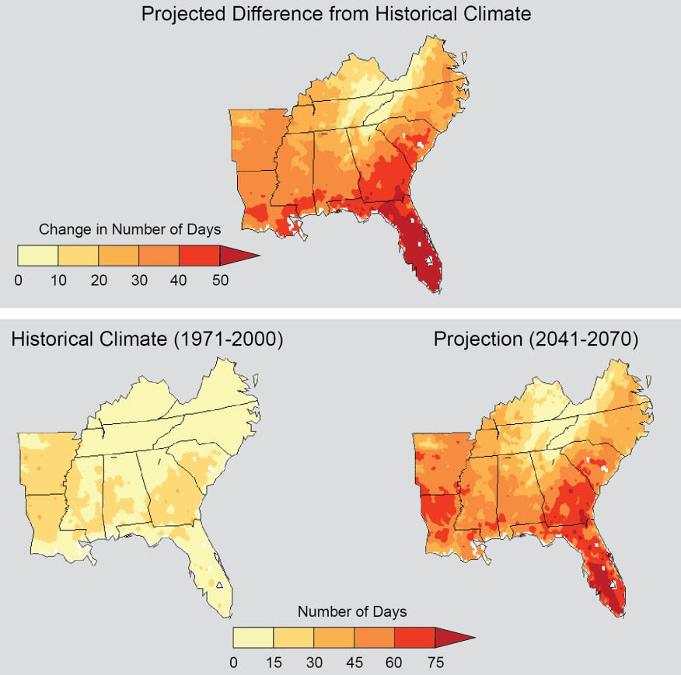
Figure 9. Projected average number of days/year with temperatures above 95 F for 2041–2070 compared to 1971–2000. (Carter et al. 2014, Figure 17.4, p. 399).

Precipitation projections are less certain, but many models project increases in precipitation during the Wet Season (rainy season) across southern Florida and the Caribbean (Service 2017, pp. 2–5). Projections of future changes in precipitation show substantial shifts in where and how precipitation will fall. Rainfall in the Florida Keys is expected to increase by approximately 20 percent in the fall, 10 percent in the winter, and 30 percent in the summer. Spring precipitation is projected to decrease by 10 percent (Walsh et al. 2014, pp. 32–34).
Dry consecutive days are expected to increase up to 30 percent in south Florida by 2100. While dry conditions are preferred for the Florida Keys mole skink, extreme conditions (lack of rainfall and increased temperatures) are detrimental. For example, prolonged periods of drought or decreased precipitation across a tropical ecosystem create losses in vegetative cover and an increased risk to the species due to desiccation.

High Tide Flooding
Coastal flood risk is increasing along U.S. coastlines due to SLR (Sweet et al. 2020, p. v). One of the most noticeable impacts from SLR is the increasing frequency of high tide flooding, and that projecting out into the future provides vital information for addressing coastal flooding impacts (Sweet et al. 2020, p. v). Based on the Sweet et al. (2017, p. 21-22) SLR scenarios, the current national high tide flooding frequency of 5 days (national median) is likely to increase to 7 to 15 days by 2030 and 25 to 75 days by 2050 in many coastal locations including much of coastal Florida and the Florida Keys (Sweet et al. 2021, p. 9-10). Vaca Key did not have a high tide flooding event in 2020; by 2030 projections are for 1-3 annually and 9-65 annually by 2050 (Sweet et al. 2021, p. 16). Key West did not have any high tide flooding events in 2020; by 2030, projections are to have 0-3 and 8-60 events per year by 2050 (Sweet et al. 2021, p. 16).

Because frequent flooding above the high tide line is likely to cause these flooded areas to become unusable to the Florida Keys mole skink (individuals cannot easily move through wet sand; individuals or nests will be washed away, etc.), high tide flooding is likely to result in additional removal of habitat. Previous estimates by NOAA and USGS indicated that tidal influences were 0.33 m (1.08 ft) above sea level (Sweet and Marra 2016, p. 4). The NOAA defined threshold for nuisance flooding at a Key West tide gauge is 0.33 m, while a similar tide gauge at Vaca Key estimates nuisance flooding at 0.59 (Sweet et al. 2018, p. 42). To estimate a more consistent tidal influence for minor, flooding events that is not gauge-specific, Sweet et al. (2018, p. 42) updated these minor flood levels as 0.52 m for Key West and 0.51 m for Vaca Key. Moderate and major flooding thresholds are also provided, although these floods will be less frequent and are unknown to contribute to removal of Florida Keys mole skink habitat (Sweet et al. 2018, p. 42) (Table 3).

Table 3. NOAA-defined minor flooding thresholds and updated derived thresholds for minor, moderate, and major flood events for Vaca Key and Key West. From Sweet et al. 2018, p. 42.

Storm Events
There has been a substantial increase in most measures of Atlantic hurricane activity since the early 1980s, the period during which high-quality satellite data are available. These include measures of intensity, frequency, and duration as well as the number of strongest (Category 4 and 5) storms (Walsh et.al. 2014, p. 20). Strong rainstorms, tropical storms, and hurricanes are natural parts of a tropical ecosystem. However, even though they are common occurrences, they are not harmless. The health of the Florida Keys mole skink species becomes vulnerable when the quantity and quality of their resources (food, cover, nesting beach) are compromised. This can particularly happen in the case of storm surges and with an increase in the number of incidences (being impacted repeatedly without time to recover).
Habitat for the Florida Keys mole skink can be degraded or removed due to impacts by extreme events such as floods or storms. Saltwater storm surge and flood would likely result in displacement landward and the loss of individual mole skinks. These same events could trigger opportunities for skinks to become passively dispersed if carried on rafting debris.
Hurricane activity has been above normal since the Atlantic Multi-Decadal Oscillation (AMO) (the natural variability of the sea surface temperature in the Atlantic Ocean) went into its warm phase around 1992. Currently, while the incidence of tropical storms in southeast Florida (including the Florida Keys) is above normal, this frequency is expected to decrease with climate change but the intensity of the storms is expected to increase by approximately 10 percent (See Future Conditions, Chapter 6) (Service 2017, p. 7). This increased intensity results in larger tidal storm surge and greater destruction than historically documented. Ecosystem resiliency is reduced when impacts by extreme events such as floods or storms occur (Service 2017, p. 7). Saltwater intrusion from storm surge and floods result in displacement landward to less suitable habitat and the loss of individual mole skinks. The unconsolidated dry soils become wet and compacted.
The recent increases in storm strength are linked, in part, to higher sea surface temperatures occurring in the equatorial regions of the Atlantic Ocean where hurricanes form and move. Numerous factors have been shown to influence these local sea surface temperatures, including natural variability of the AMO, human-induced emissions of heat-trapping gases, and particulate pollution.
Sufficient long-term monitoring of the Florida Keys mole skink species and information on strong storm impacts to this species are lacking. However, information does exist on the impacts to habitat from hurricanes and other strong storms that have occurred in the region that can provide some insight of the potential damage and loss to the Florida Keys mole skink from such storms. These events very likely disturb and reduce the quantity and quality of their resources (food, cover, nesting beach) and may do so significantly depending upon the severity and proximity of the storm center. This is particularly the case of storm surges which bring in nutrient-rich sediment that exacerbate soil accretion, deposit salt, and damage vegetation (Dingler al. 1995, p. 296; Jackson et al. 1995, p. 321; Enge et al. 2017). If in cases when storms are not too destructive, vegetative material can be deposited in localized areas high on the beach and ultimately provide habitat and increased insect food sources for the skinks.
Saltwater surges and short-term flooding of upland habitats from strong storms and hurricanes in the Florida Keys likely have and will continue to kill mole skinks (FWC 2013, p. 4). In 2005, Hurricane Wilma (Category 3) passed just north of the Florida Keys causing maximum storm tides 1.5 m to 1.8 m (5 ft to 6 ft) above mean sea level in Key West and flooding approximately 60 percent of the city. On Boca Chica and Big Pine Keys, Hurricane Wilma caused a storm surge of 1.5 m to 2.4 m (5 ft to 8 ft) (Kasper 2007, n.p.). According to Lopez et al. (2004, p. 284), a storm surge of 4 m (13 ft) would result in the complete submersion of Big Pine Key, where the largest documented population of the Florida Keys mole skink occurs.
In September of 2017, Hurricane Irma made landfall in Cudjoe Key as a 130 mile per hour (mph) Category 4 hurricane, approaching the island from the south (NOAA 2018, pp. 3–4). A storm surge of up to 2.4 m (8 ft) impacted areas in the Lower and Middle Keys, although some were harder hit than others due to the linearity of the island chain. Big Pine Key saw high water marks between 2.1 m to 2.7 m (7 ft to 8 ft) MHHW, 0.79 m (2.6 ft) MHHW at Vaca Key, and 0.83 m (2.7 ft) above MHHW on Key West (NOAA 2018, pp. 8–9).
Hurricane Irma altered whole dune ecosystems, removing the sand, vegetation, and litter from these areas via wind and storm surge forces and uprooting many of the maritime hammock ecosystem (Emerick 2017a, p. 6). Post-Irma Florida Keys mole skink surveys found small numbers of skinks persisting on Sawyer Key, Content Key, Big Pine Key, and Long Key (Zambrano 2021, pers. comm.).
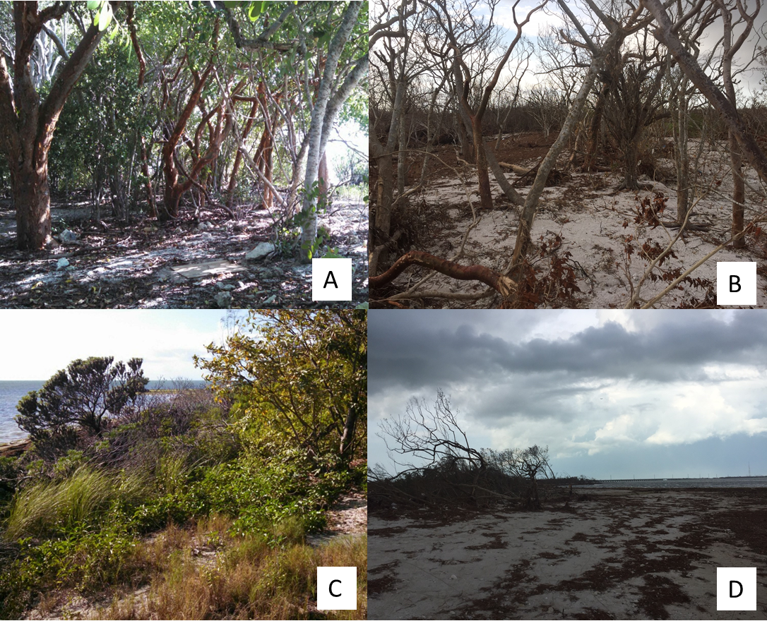
Figure 10. Habitat photos of Long Beach site on Big Pine Key. Left side (A,C) is pre–hurricane Irma photos of maritime hammock and foredune habitats, respectively. Right side photos (B,D) show these habitats one month post Irma. Taken from Emerick 2017a (p. 30).
The severity and duration of hurricane impacts to the Florida Keys mole skink and its habitat, vary based on the intensity and scale of these storm events. Localized impacts can vary greatly depending upon not only the strength of the storm, but the direction of its approach and how quickly it moves through the area. Storm surges and their intensity can also vary depending on location.
The heavy inundation and even complete overwash of some islands during hurricanes may provide some explanation for the lack of skinks being observed, even when the island has recovered and again contains high quality suitable skink habitat. Ohio Key in the Florida Keys is regularly surveyed by Service Refuge staff and despite available high-quality suitable habitat and numerous searches, no Florida Keys mole skinks have been located there. As mentioned, impacts from heavy rainstorms, tropical storms, and hurricanes are part of this tropical island system. Over time, this process may be a factor towards reducing the persistence of skink populations and thereby reducing the redundancy available in the species. Storm events are likely a contributing factor to the low abundance (historical and current) observed for this species. Individual skinks may colonize and occupy smaller islands only temporarily until storm events impact that island. Eventual recolonization of impacted islands by skinks is uncertain.

4.2 Habitat Loss and Degradation
The habitat for the Florida Keys mole skink occurs as fragmented parcels across the islands of the Florida Keys. The current amount of land mass, suitable habitat, and suitable soils for the Florida Keys mole skink was identified earlier in Chapter 2.4, Habitat. The main islands of the Florida Keys (including Key West, Big Pine Key, and Marathon), are highly impacted by human development, but there are also areas of native habitat within the National Key Deer Refuge, Dry Tortugas National Park, State Parks (Long Key, Bahia Honda, Curry Hammock), and other undeveloped parcels that occur intermittently across the species range. These areas provide suitable habitat and soils for the Florida Keys mole skink (see Conservation Actions). While it is a small and highly impacted island-system, parcels of suitable habitat and soils remain which support the current distribution of this species.
There is high uncertainty in the current and potential occupancy of the backwater islands by the Florida Keys mole skink. Current surveys on two relatively remote islands, Sawyer Key and Content Key, have recorded a few skinks (Error! Reference source not found.). Two skinks were documented on Sawyer Key in 2015, and one in 2016. Three skinks were documented on the same day in 2017 on Content Key. For this reason, these small islands also need to be considered as potential habitat under current condition.

Land Development and Conversion
The July 2016 estimated human population of Monroe County, Florida was 79,077 individuals, an 8.2 percent increase from the April 2010 population estimate of 73,090 (U.S. Census Bureau 2017, n.p.). The estimated density from the most recent census in 2010 was 28.7 people per km² (approximately 74.3 people per mi²) (U.S. Census Bureau 2017, n.p.). The 2016 estimated human population is already above the 2060 population estimate of 77,038 people made by Carr and Zwick (2016, p.28). Monroe County slightly exceeded this 2060 projection in 2015.
Within the Florida Keys, human population growth and development has occurred at a high rate and is predicted to continue until all suitable land has been developed or is lost due to sea level rise. The April 2020 human population census of Monroe County, Florida was 82,874 individuals (U.S. Census Bureau 2021, n.p.), which is already higher than the 2060 population estimate of 77,038 individuals (Carr and Zwick 2016, p. 28). An assessment of climate change on the Florida Keys assumed that the human population is directly related to remaining land area (Hoegh-Guldberg 2010, p. 14). Consequently, as land area is reduced, the number of persons in the Florida Keys would be expected to decline. There are projections that all vacant land in the Florida Keys could be consumed by development by 2060 (Zwick and Carr 2006, p.15). However, other projections indicate that little additional development is likely to occur by 2070 (Carr and Zwick 2016, entire), although some areas may be redeveloped to accommodate higher-density hotels or apartments that were previously single-family homes (Monroe County 2016b, p. 3).
Zwick and Carr (2006, p. 15) predicted with a population of approximately 92,200 people that no vacant land in the Florida Keys would remain. This information does not consider the millions of people who visit the Florida Keys as tourists and temporary visitors each year. At some point, the population could be expected to decline in order to accommodate the loss of land mass and consequential negative effects on property values and the economy (Hino et al. 2017, entire; Zhang et al. 2011, pp. 9–17).
The Florida Keys mole skink inhabits the same coastal beach berm and hammock habitat that is desirable for residential and commercial human-made development. Individual skinks do show some tolerance of habitat alteration and are occasionally documented in cemeteries, vacant lots, backyards and golf courses (Emerick 2017d pers. comm.; FNAI 2011, n.p.; Mays and Enge 2016, p. 10). However, development and conversion of beach and coastal hammock habitat are capable of impacting all of the skink life stages. In addition to direct impacts from loss of soils for nesting and movement, ground cover and availability of the insect food sources found in the ground cover can be reduced. Loss of habitat reduces shelter and shade for adult skinks. Additionally, loss of habitat connectivity can impact their ability to find mates and disperse to new locations.
In areas with networks of roads such as Big Pine Key, Key West, and Boca Chica, and along the Overseas Highway, direct mortality from vehicle strikes may be taking young and adult skink individuals. This is expected to be a minor impact to species populations based on the relatively limited home ranges of skinks within their habitat. Roads and human-made structures can fragment habitat and populations leading to a reduction in population health and genetic diversity (Jochimsen et al. 2004, p. 40). An additional conversion and degradation of habitat that is associated with development and increased human populations is the use of land for refuse. Waste management is a huge challenge on the limited amount of land.
As beach front and coastal systems in the Florida Keys are developed, displacement to higher elevations for the Florida Keys mole skink is an extremely limited option given the current level of build-out and conversion of these low-lying islands. As mentioned, the ease and likelihood of skinks to colonize new habitat on other islands is limited given the island geography and their limited dispersal mechanisms.

Habitat Disturbance
The Florida Keys are heavily visited by tourists and seasonal visitors. The increased density of people places pressure on the habitat. The Florida Keys are well-known for their outdoor recreational activities, particularly waterfront and beachfront activities which directly overlap with the habitats used by the skinks. All life stages of the Florida mole skink are being impacted by these activities and the infrastructure needed to support the tourism industry.
Approximately 2 million non-Monroe County residents visited the Florida Keys from December 2007 to November 2008 (Leeworthy 2010, p. 2). The Bahia Honda State Park, Dry Tortugas National Park, Long Key State Park, Curry Hammock State Park, and several other private sites all allow camping (Florida Rambler 2017, entire). Hiking, beach combing, and other activities (sunbathing, picnics) along the beachfront and in the coastal hammock can cause direct disturbances to the skink’s behavior and habitat. Beach cleaning directly removes wrack and vegetative material that act as cover and food sources for the skink. The behaviors (feeding, movement, and nesting) of individual skinks are very likely being disturbed by beach and upland activities. These disturbances could certainly rise to the population level depending on their intensity and duration.
There are very clear increases in both winter (generally considered to be October to April) inhabitants and tourists that place pressure on the Florida Keys’ resources during these months; however, the islands receive visitors, tourists, and recreationalists year-round. A few of the locations that experience high impacts from visitors include Islamorada, Big Pine, Bahia Honda and Key West. Increased road traffic is a direct consequence of visitors and tourists as is the need for parking.
Off-road parking sites, gravel lots and boat trailer parking can disturb the dry soils and areas used by skinks. Smaller off-road vehicles (ORVs) and golf carts are also sometimes used in communities to get around locally. These small vehicles use non-paved areas and off-road areas that can displace, disturb, or cause direct mortality of individual skinks.
An additional source of potential disturbance of skinks is via specific land management activities. Florida State rule 68A–27.007(2) (c), F.A.C. authorizes land management activities such as prescribed fire and herbicide application and do not require a FWC permit authorizing incidental take (FWC 2016a p. 5). These activities may be beneficial to the long-term quality of the natural habitats for the Florida Keys mole skink but result in local disturbance and direct mortality of individual skinks.

Beach erosion
There are an estimated 24.1 km (15.0 mi) of critically eroded beaches (approximately 41 percent of the total beach length) in the Florida Keys (FDEP 2021, p. 20). While beach erosion can be attributed to tropical storms, hurricanes, and the natural patterns of sediment transport in the Florida Keys that cause natural shoreline fluctuations, erosion has been exacerbated by the development of seawalls other coastal protection structures (FDEP 2020, p. 2). The sediment supply for these beaches is also affected by the chemical and biological processes of adjacent waters, although these environmental influences are not well understood (Clark 1990, p. 45). Beaches with identified erosion problems on islands where Florida Keys mole skinks have been detected include Long Key State Recreation Area, Sombrero Beach on Key Vaca, Bahia Honda State Recreation Area, Long Beach on Big Pine Key, Boca Chica Key, and Key West (Figure 11) (Clark 1990, pp. 45–46).
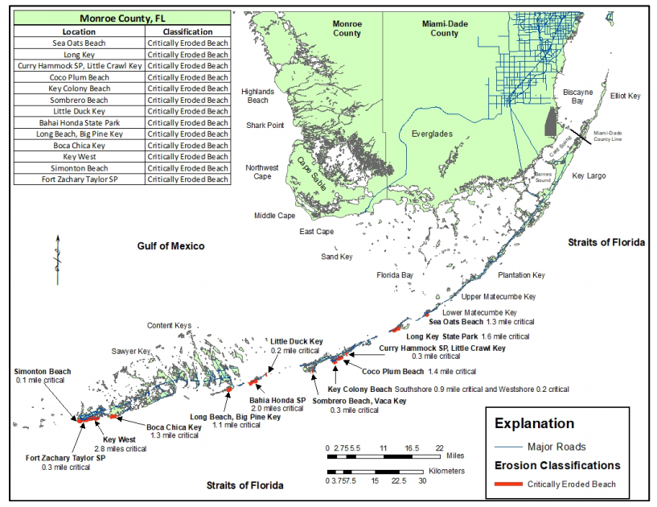
Figure 11. Critically eroded shoreline within Monroe County, Florida Keys. Taken from Clark 1990, p. 48.
When beach sands erode, there is little material available for natural beach renourishment, and efforts to address erosion problems typically involve bringing in sand from elsewhere (Clark 1990, p. 13). During storm events, the path, direction of approach, and strength of the system can influence whether sand is washed ashore where it covers inland vegetation or is washed out to sea and lost (Clark 1998, entire). Thus, as sea levels rise, while some beaches with ideal conditions may migrate (with their sand dunes) uphill, it is likely that others will be lost. Similarly, if storm events become more intense as predicted (see Chapter 4.1), beach sands may be lost at a greater rate, although which beaches are affected and to what extent will depend on the direction of the storm’s approach and the location of impact.

Oil spills
Every year, thousands of oil spills occur in the United States, but most involve the spilling of less than one barrel of oil (NOAA 2017b, p. 1). Since 1969, there have been at least 44 oil spills greater than 10,000 barrels (42,000 gallons) in U. S. waters including the largest to date, the 2010 Deepwater Horizon spill in the Gulf of Mexico NOAA 2017b, p. 1). There have been 16 oil spills recorded in the Gulf of Mexico responsible for the spilling of at least 0.05 million gallons NOAA 2017b, p. 1). There have been eight spills in the Caribbean Seas with at least 0.05 million gallons spilled (NOAA 2017b, p. 1). Any large spill has the potential to reach the shore of the Florida Keys.
Offshore oil tanker spills pose the same threat. Following the Deepwater Horizon spill, a study of contaminants in diamondback terrapins (Malaclemys terrapin) in Louisiana showed that turtles in areas with higher exposure to crude oil had higher levels of contaminants in their systems. Drabeck et al. (2014, pp. 132–133) found higher levels of toxic contaminants (2–ring aromatic hydrocarbon biphenyl, alkylated PAH dimethylnapthalene, and Biphenyl) in the reptiles’ tissues sampled. These substances are most commonly associated with crude oil and gasoline (Drabeck et al., 2014, pp. 132–33). Depending on the location and severity of the incident, oil spills could affect all life stages of the Florida Keys mole skink.

4.3 Other Human Influences

Collection
The collection of Florida Keys mole skinks is considered low and an insignificant stressor on the species. A four year study on the commercial harvest of amphibians and reptiles in Florida documented the capture and sale of four Florida Keys mole skinks (two in 1990–1991 and two in 1993–1994) (Enge 2005, p. 211). Small skinks such as the Florida Keys mole skink are more often sold as snake food or captured incidentally during hunts for snakes (Enge 2005, pp. 198–211). A 2017 internet search for the sale of any Plestiodon skinks did not find any skinks for sale. Internet searches found two records of previously independent searches from 2013 and 2008 of consumers looking to purchase “mole skinks” (Fauna Classifieds 2017, n.p.; Yahoo answers 2017, n.p.). No responses to these inquiries were found. The collection of mole skinks would primarily target the adult and juvenile life stage. Adult female skinks are expected to be particularly vulnerable when attending a nest.

Pesticides
Current broad use of pesticides for mosquito control occurs in the Florida Keys. The Florida Keys Mosquito Control District includes centers in Key Largo, Marathon (Key Vaca), and Key West. Methods used include truck spraying, aerial adulticide and aerial liquid larvicide spray missions, and local community manual spraying (Florida Keys Mosquito Control District 2017, entire). The most common pesticides used for mosquito control in the Keys include Vectobac GS and WDG, Dibrom, Permanone 30–30 and Fyfanon ULV. There are specific “No–Spraying” zones throughout the Florida Keys that primarily consist of Refuge, Sanctuary, and state park properties as well as other tracts of undeveloped lands. Spray treatments appear to be concentrated in the larger populated cities and communities. This targeted method of mosquito control treatment affords some reduced exposure to the Florida Keys mole skink. The region-wide range of the mosquito control program could possibly be having an unidentified direct impact to the Florida Keys mole skink. Indirect effects could be occurring via impacts to their insect food sources, ground cover, and through soil absorption. Because of its widespread nature, the impact of mosquito spraying would be at the population and species level. At this time, no evidence exists to indicate that this activity is a negative stressor on the Florida Keys mole skink at the population or species levels.

4.4 Predation, Competition, and Disease

Predators
Native snakes have been documented as natural predators on mole skinks (Hamilton and Pollack 1958, p. 28, Mount 1963, p. 356). The red cornsnake (Pantherophis guttatus) is known to be abundant in the Florida Keys and to frequently prey on lizards (Enge 2017, pers. comm.). There is no evidence of impacts to the Florida Keys mole skink by this snake. This predator-prey process has probably remained unchanged over time and currently presents no significant threat at the population or species level for the Florida Keys mole skink.
Free-ranging feral cats (Felis catus) are actively managed via TNR in the Florida Keys where they co-occur with several endemic small mammals (Cove et al. 2018. p. 334). Feral cats are instinctively natural predators and have been documented killing a variety of lizard species including: eastern fence lizard (Sceloporus undulates), five-lined skinks (P. fasciatus), broad-headed skinks (P. laticeps), and ground skinks (Scincella lateralis) (Mitchell and Beck 1992, p. 200). Feral and all free-roaming cats present a significant threat to all life stages of the Florida Keys mole skink where they are present in skink habitat (Calver et al. 2011, entire). Direct evidence is lacking on the current level of impacts that feral and free roaming cats have on the Florida Keys mole skink. Given the limited dispersal and possibly clumped distribution, cat predation could negatively reduce or eliminate a skink population (FWC 2013, p.5).

Invasive species
The semi-fossorial nature and small size of the Florida Keys mole skink makes all life stages, particularly the eggs, susceptible to the red imported fire ant (Solenopsis invicta). Fire ants have been documented killing numerous reptile species eggs and hatchings. Fire ants may also indirectly impact adults by affecting survival and weight gain, behavioral changes, changes in foraging patterns and habitat use, and reduced food availability (Allen et al. 2004, pp. 90–91). A study conducted in the Lower Keys, showed that transects closest to roads and which had the largest amount of development within a 150 m (492 ft) radius of a road had the highest probability of the presence of fire ants (Forys et al. 2002, p. 31). Fire ants could also be a food source for this insect–eating generalist, but this has not been documented and is not expected to be a preferred food source given the stinging capability of the ants.
The brown anole (Anoles sagrei) and tropical house gecko (Hemidactylus mabouria) are non-native lizards that may be potential predators to the Florida Keys mole skink hatchlings. The northern curly-tailed lizard (Leiocephalus carinatus, Peter's rock agama (Agama picticauda), giant ameiva (Ameiva ameiva), and Black spiny-tailed iguanas juveniles (Ctenosaura similis) are known to eat other lizards and are growing in numbers where they have been introduced (FWC 2016a; Enge 2021, pers. com.). The nonnative ashy geckos (Sphaerodactylus elegans) and the Florida reef gecko (S. notatus notatus) forage in leaf litter and may compete with the Florida Keys mole skink for food resources (Enge 2017, pers. comm.). The level of predation or resource competition that the Florida Keys mole skink species is experiencing from these invasive lizard species is unknown but not believed to be stressors to the population or species level.
Nonnative plants have significantly impacted native habitats in south Florida (Bradley and Gann 1999, pp. 15, 72). Nonnative, invasive plants compete with native plants for space, light, water, and nutrients, and make habitat conditions unsuitable for mole skinks by changing or reducing leaf ground cover, increasing root masses in friable soils as well as loss of shade, and protective cover. If nonnative vegetation cover is not as dense as native vegetation, changes in soil temperature could result and negatively impact the Florida Keys mole skink.

Disease
There is no sign or documentation of parasites or disease acting as stressors on the species.

4.5 Stochastic events
Demographic stochasticity refers to random variability in survival or reproduction among individuals within a population (Shaffer 1981, p. 131). Demographic stochasticity can have a significant impact on population health, particularly for populations that are small, have low fecundity, and are short-lived. In small populations, reduced reproduction or temporary die-offs of a certain age-class will have a significant effect on the whole population. Although such impacts may have less of a consequence to a large population or to a (sub) species with many populations (high redundancy), this randomly occurring variation in individuals becomes an important issue for small populations.
Environmental stochasticity is the variation in birth and death rates from one season to the next in response to weather, disease, competition, predation, or other factors external to the population (Shaffer 1981, p. 131). For example, drought or predation, in combination with a low population year, could result in extirpation. The origin of the environmental stochastic event can be natural or human-caused. Extreme events are expected to increase in strength and frequency with accelerated climate change.

4.6 Conservation

Conservation Actions
The Florida Keys mole skink species was state listed as threatened by Florida in 1974 but was changed to a State of Florida species of concern in 1978. In 2010, after a species status review by the FWC, the Florida Keys mole skink was again found warranted for listing as a state threatened species. The FWC justified the state threatened listing for the Florida Keys mole skink based on the species’ very restricted area of occupancy (estimated at 20.3 km² [7.8 mi²]) and the current threat of loss or degradation of habitat (FWC 2011, p. 10).
A Florida Keys mole skink State Action Plan (SAP) was developed in 2013 (FWC 2013, entire). The goal of the plan is to improve the conservation status of the Florida Keys mole skink to the point in which the species is secure within its historical range (FWC 2013, pp. 8–19). Fifteen action items in eight categories were identified for accomplishing this goal.
The categories include (FWC 2013 pp. 17–18):
    - Habitat conservation and management;
    - Population management,
    - Monitoring and research,
    - Rule and permitting intent,
    - Law enforcement,
    - Incentives and influencing,
    - Education and outreach, and
    - Coordination with other entities.

The SAP also classifies the Florida Keys mole skink as a State of Florida cryptic species. The term “cryptic species” is defined by the State of Florida as “a species that may not be easily observed, tracked, or surveyed due to camouflage or behavior rather than rarity” (FWC 2016b, entire) and their policy on cryptic species states that any permitting of cryptic species will focus on cooperation and collection information instead of regulation. Information on distribution and habitat use of Florida Keys mole skinks that provide scientific benefit for species conservation may be justification for permitting a restricted activity (FWC 2016b, p. 34).
The state threatened listing of the Florida Keys mole skink prohibits the intentional take, and some forms of incidental take, of the species. Florida state rule 68A–27.001, F.A.C., defines incidental take as, “take that is incidental to, and not the purpose of, carrying out an otherwise lawful activity” (FWC 2016b, p.15). Take of a species includes harass, harm, pursue, hunt, shoot, wound, and kill, trap, capture, or collect. The definition of harm may include such acts that significantly modify habitat to result in killing or injuring the species by impairing the animal’s ability to breed, feed, or shelter (FWC 2016b, p. 15). Incidental take may require a permit from the FWC and permits will only be issued if the activity will not have a negative impact on the survival potential of the species. The FWC lists several avoidance measures including: avoiding impacts to coastal strand, coastal dune, pine rockland, and tropical hardwood hammock habitats within the range of the Florida Keys mole skink (FWC 2016a, p. 5). Specifically, these measures recommend: a) avoiding the removal of microhabitat features; b) the prevention of activities that cause soil compaction. State rule 68A–27.007(2); and c), F.A.C. authorizes land management actives such as prescribed fire and herbicide application without an incidental take permit (FWC 2016a p. 5). As mentioned, some of these land management activities may be beneficial to the long-term quality of the natural habitats for the Florida Keys mole skink but can result in local disturbance or direct mortality of individual skinks.
The Florida Coastal Management Plan designates the Florida Keys as an Area of Critical Concern due to the Keys’ environmental sensitivity and the development pressures currently underway on the islands (FDEP 2014, p. 25). Through the Florida Forever program (and the previous State of Florida Conservation and Recreation Lands and Preservation 2000 Programs), the Monroe County Land Authority and the State of Florida has purchased 4,249.6 ha (10,501 ac) of Florida Keys land for the protection of natural resources (Florida Department of Economic Opportunity 2015 p. 12).
The Monroe County Land Authority was created in 1986 to acquire property for conservation, recreation, and affordable housing. The 2017 fiscal budget appropriates $6,749,360 of funds for land purchase in the Florida Keys (MMCCP Land Authority 2016c, p. 2). While these lands were not acquired specifically for the Florida Keys mole skink, conservation of imperiled species is an objective. The Florida Keys mole skink will indirectly benefit through these land conservation and management actions (Florida Department of Economic Opportunity 2015, p. 12).
The Monroe County Comprehensive Plan (MCCP) addresses the protection of native habitat and land development in the Florida Keys (Keith and Schnars 2016, p. 31). The MCCP limits the density and size of residential and what the authors define as “non-residential” development. Monroe County Planning and Environmental Resources Department also uses a minimum open space ratio that varies by land use category (Keith and Schnars 2016, entire). These actions aid in minimizing loss of natural habitat (Keith and Schnars 2016, p. 97). It should be noted that while limiting density can keep population numbers down and reduce pressure on a system, it can lead to urban sprawl.
Several local government plans provide conservation actions or can provide indirect conservation benefits to the Florida Keys mole skink. The Village of Islamorada, the City of Marathon, and the City of Key West also have comprehensive plans that incorporate protecting native habitats and species (Village of Islamorada 2001, entire; City of Marathon 2005, entire; City of Key West, 2013, entire).
The USFWS Coastal Program is a conservation tool in the Florida Keys. This program provides valuable technical and financial assistance to public and privately owned coastal lands by supporting habitat conservation projects (Service 2012, entire).
The NOAA Coastal Zone Management (CZM) Program addresses’ the issues of climate change, ocean planning, and planning for energy facilities and development. The program was established by the CZM Act of 1972. This is a voluntary partnership between the federal government and the coastal states. This program funds coastal improvement projects in both aquatic and terrestrial habitats which can improve and restore skink habitat and soils (NOAA 2017c, entire).
Most recently, a $700,000 grant was awarded to FWC to restore and enhance 152 ac(61.5 ha) of freshwater and estuarine habitats within the National Key Deer Refuge on Big Pine Key (Warren 2021, entire), which could help improve skink habitat.

Conservation Lands
There are numerous federal, state, county, city, and private organizations that manage conservation lands throughout the Florida Keys and provide conservation benefits and protections to the Florida Keys mole skink. The largest of these areas include The National Key Deer Refuge, primarily on Big Pine and No Name Key, but encompassing many smaller islands in the region (3,635 ha (8,983 ac)), and Crocodile Lake NWR in the Upper Keys (2,448 ha (6,050 ac)) (Figure 12).
Some sites, particularly the county and city beach parks, do allow for heavy recreational use and manipulation of the natural beach habitat which can be disruptive to the species. However, these areas also provide protection from heavy development and urbanization and allow for the persistence of sandy soil habitats. These areas provide all or some of the following conservation benefits to the Florida Keys mole skink:
      - Management of natural habitat including the maintenance and restoration of functioning beach berm and coastal hammock systems.
      - “Leave no trace” practices and principles which are designed to reduce or eliminate impacts by humans visiting or using the lands.
      - Prevention or minimization of the collection/removal of mole skinks.
      - Prohibition or limited–use of activities aimed at preventing disruptions, impacts or losses to natural habitats and the species. These include such things as: no motorized vehicles, no ORVs or bicycles allowed or only allowed on some trails (limited to foot traffic only); human exclusion of sensitive environmental sites, reduction of noise and light pollution; No dumping, no searching for antiquities, no release of exotic species.
      - Provide environmental education and interpretive services to the public on natural habitat and species: “Good stewardship” practices.
      - Aquatic sanctuary and preserve lands provide buffers on coastal habitat by minimizing high impact coastal recreational use and development of these areas.
      - “Conservation in perpetuity”. Commitment of the conservation land owner to the long–term conservation and management of native habitat and species.

The collection of Florida Keys mole skinks on any state, Federal, or public land is currently prohibited by state statue Rule 68A‐27‐.001 (4), F.A.C. (FWC 2016b, p. 15). The Florida State Parks also have specific rules prohibiting the collection, destruction, or disturbance of all plants and animals within state park properties (Florida State Parks 2017, n.p.).
Also, the Department of Defense Naval Air Station Key West on Boca Chica Key has existing beach and upland habitat occurring around the airstrip that is undeveloped and while not designated as conservation lands, does currently provide suitable habitat (FWC 2004, p. 7).
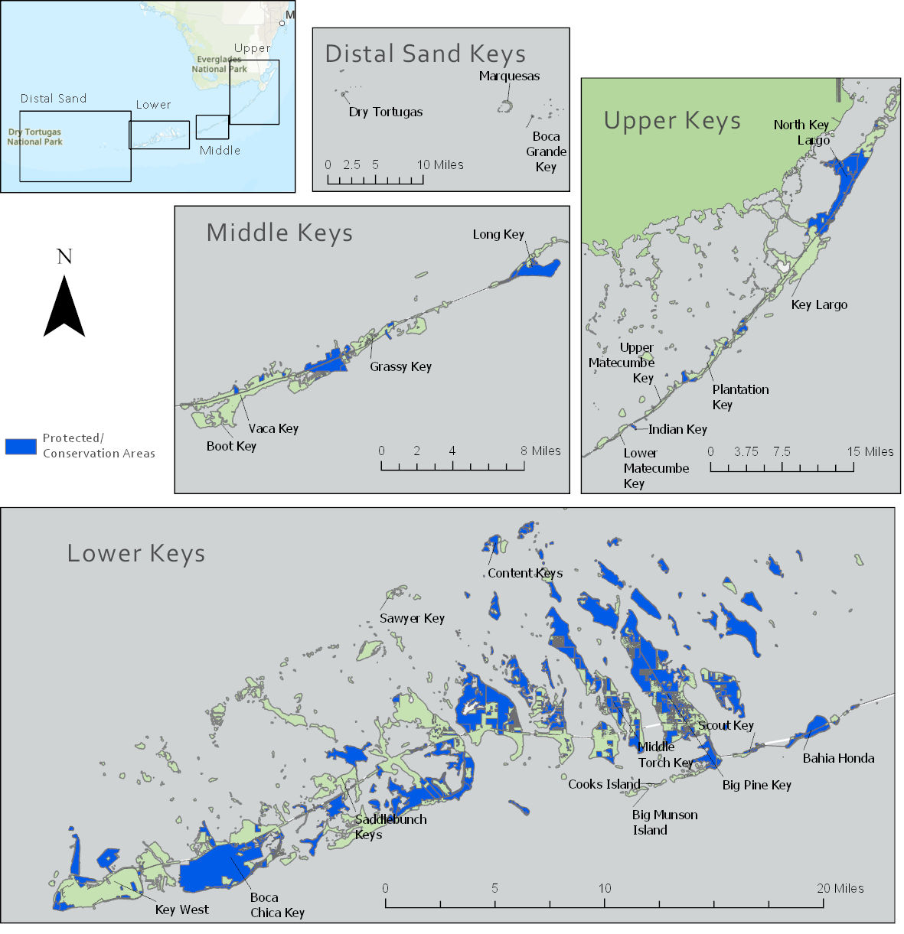
Figure 12. Protected lands and conservation lands within the range of the Florida Keys mole skink. Lands include federal, state, and private ownership. Land uses vary among these lands.

4.7 Cumulative Cause and Effect
Rarely do stressors act alone in the environment and therefore their cumulative effects to the species and habitat also need to be considered. Even minor stressors that impact just a few individuals in a population need to be considered for their additive effects. For example, the effects from invasive species, pesticide impacts, and collections may each be a low risk to individual skinks but cumulatively can become a moderate or severe stressor to the population abundance. Stressors were considered cumulatively for their effects on the Florida Keys mole skink and were currently found to not impose negative effects at the population or species level.

Various stressors can originate from a similar cause but produce a set of interdependent effects on the Florida Keys mole skink. Global greenhouse gas emissions increase the rate and severity of climactic changes which act in combination as stressors on the species. These include SLR, seasonal shifts in timing and amounts of precipitation, shifts in temperature patterns, and increased storm intensities which affect the species. Increased mean (average) high water line resulting from SLR reduces available suitable habitat for the Florida Keys mole skink. Because the average high water line is now higher than historical levels, areas not typically flooded are now flooded on a more regular basis.

Increased incidence and intensity of storm surge is another stressor produced by the occurrence of more severe storms. This surge exacerbates the level of flooding and inundation. Increased rainfall, along with the stressors of SLR and higher than average storm surges, further reduces habitat quality through soil compaction and increased durations of wet soils. This negatively affects nesting ability, skink movement, and availability of insect food sources that rely on dry ground cover. Each of these stressors alone affects the overall viability of the species and its habitat but combined produce synergistic or worsening impacts on the species.

Additional detailed descriptions of some of the stressors can also be found in FWC 2011 (p. 5) and FWC 2013 (pp. 3–5).

The identification of stressors and assessment of the current effect level of each stressor on the Florida Keys mole skink was accomplished through a specific Technical Team Workshop on life history and current conditions of the Florida Keys and Cedar Key mole skinks, and through continued discussions with Technical Team Working Group members. The individual expertise of Technical Team Working Group members included herpetology, ecosystems of the Florida Keys, reptilian genetics, south Florida meteorology and climate change, and ecosystem mapping and contributed to identifying and addressing the current effects of these stressors on the Florida Keys mole skink. An exposure table was also produced to further examine the exposure of each stressor (or activity) on the Florida Keys mole skink’s biology and habitat and the consequences (or effect) upon the skinks (Appendix C).

Chapter 5 – CURRENT CONDITION
In this section, we first define populations for the species. Then, using the Florida Keys mole skink’s historical distribution, its current distribution, and the species needs for viability, we estimate the current condition of the Florida Keys mole skink by characterizing the 3Rs in terms of the species population and habitat metrics.

Populations and Geographic Regions
Populations are the basic analytical unit on which resiliency is assessed. We delineated populations of Florida Keys mole skink by islands, where all detections on the same island represent one population. However, for Key Largo, we split the island into two populations. Due to the length of the island and given the natural break between detection locations, we considered everything north of U.S. Route 1 as its own population, North Key Largo.
Because we do not know whether dispersal is more common over land or by rafting, these populations may not be biologically meaningful and may more adequately represent analysis units. While there may be regular gene flow among some of these populations, there also may be a lack of regular gene flow among individuals within a population.
For each island population (Table 2 and Figure 4), we considered the population “current” if Florida Keys mole skinks were detected there since 2000; however, no detection data exists between 2000 and 2007, so current data represents data from 2008 to present. We consider the population “recent” if the species was detected since 1970, and populations with no detections since 1970 are considered “historical.” Thus, we defined 24 populations of the Florida Keys mole skink: 15 current, 5 recent, and 4 historical (Table 5).
Representation is typically based on genetic or ecological differences among populations. While there is no evidence of unique genetic distinctions among different populations of Florida Keys mole skinks, there are differences in the environmental and geological variation in the substrates, island shape, size, and proximity to other islands of the Florida Keys. Thus, we group these populations into four recognized geographic regions within the Florida Keys mole skink range: the Distal Sand Keys, Lower Keys, Middle Keys, and Upper Keys. While there is no evidence that the geographic regions represent genetic representative units, genetic evidence suggests that there is little interbreeding among island populations. Thus, we assess these geographic regions of the Florida Keys in our analysis of current species representation based on the environmental and geological differences in these units.
Discussions and lists of the populations and regions in this SSA will be presented from west to east.

Methods
Resiliency is the ability of a species to withstand environmental stochasticity or normal, year-to-year variations in environmental conditions; typically, the larger a population and the more individuals present, the more resilient the population. We assume that current threat levels influence the current population size; in other words, populations are maintaining their numbers as they withstand current threats. We account for how these threats could change and how this could affect population resiliency under Chapter 6, Future Condition.
Population size is typically used as a reliable indicator of overall resiliency. Due to the semi-fossorial and cryptic nature of the Florida Keys mole skink, abundance data are lacking, and no population trend data exist for this species. There are also no data available regarding the population structure or demographics of the Florida Keys mole skink. Therefore, a full picture of the health and resilience of these populations is uncertain. Capture data can indicate whether breeding and successful nesting is occurring (for instance, if gravid females or juveniles are captured); however, these data are limited and only available for some locations (documented in Refuge surveys; Service 2021, n.p.). During survey efforts, a larger number of observed and captured skinks can indicate that multiple individual skinks occur in an area (e.g., in one study, recaptures on Big Pine Key comprise almost one quarter to one third of the total) (Emerick and FWC 2017, entire). However, higher comparative counts may also be a reflection of greater search efforts at some locations. Numerous islands have not yet been searched, and it is possible that additional individuals and populations are present on these islands. Furthermore, it is unknown if and how much suitable habitat exists inland, nor how these areas might contribute to population demographics. Florida Keys mole skinks have been documented in developed areas or other small areas of inland habitat, as indicated by the individual detected in 2020 on Key Vaca and John Pennekamp Coral Reef State Park on Key Largo in 2021. However, we do not know if developed areas or inland habitat areas where skink have been found represent occupied habitat, or if skinks were dispersing through or from such areas.
Likewise, the population resiliency for the Florida Keys mole skink cannot be assessed given the existence of available suitable habitat alone. First, habitat for this species is difficult to define as we focus on the beach berm habitat. We lack an understanding of how they use inland habitats like pine rocklands as they contain suitable habitat elements and may support viable segments of a population; a lack of quantifiable habitat does not indicate the species cannot exist on an island (for instance, the individuals found in urban settings). Furthermore, even if suitable habitat could be identified and confirmed, it cannot be inferred as a surrogate for skink presence. An example of this is Ohio Key, where surveys have failed to locate skinks even though suitable habitat appears to exist on that island (Table 6).
Thus, we considered an island with documented occurrences as a population. We assessed population resiliency only for islands with documented populations (both currently and historically). Resiliency for each population is comparative among populations and is based on a series of factors: 1) time passed since the last detection; 2) the number of current detections recorded within the population, and; 3) the number of distinct locations (separated by 100 m (328 ft) or more) where current detections were recorded within the population (Table 4). We also note the presence of juveniles or females; however, this is not factored formally into resiliency because this information does not exist for all populations. Historical populations, or those last detected before 1970, are considered “likely extirpated.” Populations where Florida Keys mole skinks were detected after 1970 but have not been detected in the last 21 years (2000 to present) we consider “possibly extirpated.” However, the lack of detections does not necessarily imply extirpation and could be a product of a lack of surveys. Many of the current detections are from opportunistic sighting reports and surveys that were not extensive (Appendix A). Nevertheless, populations with detections from 2000 to present are considered current, and for these populations we defined a level of resiliency. For current populations, we assessed the number of detections (using only detections since 2000) as a factor (multiple individuals indicates a larger population), and we included the number of locations (greater than 100 m [328 ft] apart) that produced one or more current detections. We chose 100 m (328 ft) based on the estimated dispersal distance of Florida Keys mole skinks (approximately 100 m, possibly up to 140 m) (McCoy et al. 2020, p.8), the evidence that less than 250 m of mangroves could serve as a barrier to dispersal, and the distribution of current location data (all were actually greater than 200 m apart). Presumably, an island with more than one location of occupied habitat would be more resilient than an island with just one occupied area of habitat.
Table 4. Metrics used for current population resiliency classifications. For current populations (detections since 2000), the number of total detections and the number of locations (greater than a 100 m apart) factor into whether the population is considered to have a low, moderate, high, or very high current resiliency.

Population Resiliency
Using our metrics to describe population resiliency as defined above in the methodology section and Table 4, we determined that four historical populations are likely extirpated, and five recent populations are possibly extirpated. Of the 15 current populations, 2 are considered to have high resiliency and 1 population is considered to have very high resiliency, all of which are in the Lower Keys (Table 5). Five populations were determined to be moderately resilient, and seven are considered to have low resiliency (Table 5).
Note that population resiliency is based on the best-available survey data, and actual presence and abundance of Florida Keys mole skinks may not match our estimates. For instance, while Plantation Key is considered possibly extirpated due to no detections since 1991, the island did have 2 opportunistic detections in the recent time frame. Thus, additional surveys could indicate that this population does still exist, and this is true for all islands that have not been recently thoroughly searched.
Table 5. Resiliency classifications for current populations of the 24 defined potential populations (recent and historical populations were not evaluated for resiliency). In addition to the resiliency metrics, we provide notes on whether females (F) or juveniles (J) were detected during recent Service surveys.

Species Redundancy and Representation
Measured at the species level, redundancy and representation of the Florida Keys mole skink increase its ability to withstand catastrophic events. In the Florida Keys, tropical storms and hurricanes are somewhat regular and common events. However, catastrophic events may include particularly strong or intense hurricanes or storms and the resulting winds, waves, and storm surges associated with these events. Increased frequency of such storms could further impact the ability for individual populations to recover and could cause catastrophic impacts.
Because of its limited geographic range, several stressors are experienced across the Florida Keys mole skink’s range. Climactic shifts taking place in regional precipitation and temperature patterns are described in section “4.1 Temperature and Precipitation” and are likely to affect the species across its range. While catastrophic events such as Category 4 and 5 hurricanes or closely spaced storm events that impact the entire range, effects of these events will likely have significant localized impacts, and impacts will vary greatly based on Category of storm, direction of travel and location of landfall. Depending on the severity, track direction, duration, and other aspects of these storm events, impacts could affect some areas of the Florida Keys or all areas across the Florida mole skink’s range. Below are the descriptions of the two major hurricanes to impact the Florida Keys during the past 20 years.
The following information was synthesized from a National Weather Service report (Cangialosi et al. 2017, entire).
On September 10, 2017, Hurricane Irma was moving at 20 mph in a northwesterly direction and crossed over the Florida Keys at Cudjoe Key as a major hurricane as a Category 3 with 115 mph winds as it tracked from the southeast to the northwest into the Gulf of Mexico. The combined effect of storm surge and the tide produced maximum inundation levels of 5 to 8 ft above ground level for portions of the Lower Florida Keys from Cudjoe Key eastward to Big Pine Key and Bahia Honda Key, near and to the east of where Irma’s center made landfall. Maximum inundation levels of 4 to 6 ft above ground level occurred across the Middle and Upper Keys. A high water mark of 4.11 ft above ground level was surveyed in Key Largo, and a mark of 3.72 ft above ground level was recorded in Marathon.
The following information was synthesized from a National Weather Service report (Kasper 2007, entire)
On October 24, 2005, Category 3 Hurricane Wilma tracked northeasterly across the extreme southeastern Gulf of Mexico with a path parallel but north of the Florida Keys and made landfall at Cape Ramano along the southwest coast of Florida and brought hurricane-force winds to the Florida Keys. Real-time and post-storm high water mark surveys throughout the Florida Keys revealed two storm surge events. The first along southern shores of the Florida Keys as Hurricane Wilma approached the southwest. The second occurred with the onset of westerly winds as Hurricane Wilma made landfall along the southwestern coast of the Florida. The second event was more severe, and resulted in the worst storm surge inundation throughout most of the Florida Keys since Hurricane Betsy on 8 September 1965. During the first event, maximum storm tides of 5-6 ft above MSL were estimated in Key West, 4-5 ft above MSL throughout the rest of the lower Florida Keys, 3 ft above MSL in Marathon and the middle Florida Keys, and 2-3 ft above MSL in the upper Florida Keys. During the second event, peak storm tides up to 6.5 ft above MSL were documented in Key West, 5-8 ft throughout most of the lower Florida Keys, 5-8 ft throughout the middle Florida Keys, 5 ft in Islamorada, and 4.5 ft in the upper Florida Keys.

Redundancy
Redundancy reduces the species’ extinction risk if a portion of the species’ range is negatively affected by a natural or anthropogenic catastrophic disturbance. For the Florida Keys mole skink to withstand catastrophic events such as hurricanes, it needs to have multiple resilient populations across its range. The true magnitude of species redundancy for the Florida Keys mole skink is mostly unknown. However, of the 15 currently known populations of Florida Keys mole skink, only 3 populations are considered to have high or very high resiliency (Table 5). Due to its small endemic range, it is likely that the species has inherently low redundancy (historically and currently) and that low numbers of individuals exist across its range.
Generally, surveys conducted in the Lower Keys and Middle Keys regions have documented individual skinks on the same islands as historical records (Table 2). In addition, recent surveys have also found skinks on islands that do not have historical records of occurrence (such as Sawyer Key and Content Key). In the Upper Keys region, however, recent searches in Key Largo, in areas with known historical records, have failed to locate skinks. While the lack of findings in the Key Largo historical sites may be attributed to the difficulty of detecting skinks, it may also reflect a restriction of its range in the Upper Keys region and a consequent decrease in species redundancy compared to its historical condition. The true spatial distribution of populations throughout the islands and islets of the Florida Keys is unclear, and our current understanding of the species distribution is based on limited survey data.
Limited acreage of beach and coastal hammock habitats and unconsolidated soils exists in the Florida Keys. This is a chain of small islands, and therefore, land mass in general is limited. In a sense, there is little redundancy or “backup” for the available suitable habitat, and natural expansion or movement of the species to new areas is not possible. Dispersal of individuals among islands is likely an uncommon occurrence. Furthermore, genetic evidence indicates no sign of interbreeding between islands.
Despite some redundancy provided by the fact that discrete populations exist on multiple islands, large scale impacts from catastrophic events (e.g, severe hurricanes or storm surges; see above) could affect the entire Florida Keys archipelago, leaving the entire species vulnerable to the timing and intensity of impacts. Large scale habitat impacts and loss is quite feasible during a strong hurricane as is direct mortality of skinks via drowning. Therefore, we consider the overall current redundancy of the species to be low.

Representation
Representation describes the ability of a species to adapt to changing environmental conditions and is measured by the breadth of genetic or environmental diversity within and among populations. Evidence suggests that overall, the genetic and environmental diversity of the Florida Keys mole skink is low, with no sign of morphological or behavioral differences between skinks on different islands (Technical Team Working Group 2016, pers. comm.; Mercier 2017b, pers. comm.; Branch et al. 2003, pp. 202–205).
This species occurs on several islands across a narrow geographic and ecological range; there is little variation in habitat types across distance or elevation as occurs in wider-ranging and more abundant species. The entire species is represented within the same tropical system within a range of approximately 378 km² (146 mi²). Populations or individuals are represented across only slight elevation differences (a few meters) across the separate islands. The amount of coastal sandy substrate and hammock habitat is limited and distributed in patches throughout the Florida Keys. The Florida Keys mole skink does not occur across different ecotones and does not have access to different ecotones or systems in which to adapt. However, there are some differences in the substrates and habitat types available between the Upper and Lower Keys regions.
Genetic evidence suggests that there is little interbreeding among populations; thus, some diversity could be lost when a population is lost, meaning that some genetic representation may have been lost compared to historical levels. For instance, the potential population on the Dry Tortugas, if indeed extirpated, could have possessed some unique genetic diversity, especially given the remote nature of the Dry Tortugas and the isolated nature of this population. The potential loss of several populations in the Upper Keys may also have decreased representation from historical levels.
The restricted range and inherent endemism of the Florida Keys mole skink makes it susceptible to events such as genetic mutations, diseases, or broad scale loss of genetic diversity. For example,, an introduced disease or parasite could affect the entire species if there is no variation that may protect some individuals. The same case may occur environmentally, because the species only occurs in a small range of tropical habitat. All individuals of this species exist in the same system, and there are no other individuals or populations that exists in other ecosystems or varied environments (such as in a more temperate landscape). Therefore, if the tropical system is impacted, the entire species is highly likely to be susceptible to impacts. Given these factors, we consider overall representation of the Florida Keys mole skink to be low.

Habitat Condition
Due to the limited knowledge regarding population distribution and numbers, information about the available potential habitat could help indicate potential for Florida Keys mole skink occupancy; however, just because habitat is available does not imply skinks are present. We assessed several habitat metrics for each population to assess correlations between habitat and Florida Keys mole skink occupancy and abundance as well as to indicate potential for undocumented skink presence. We quantified the island size, the area of habitat types identified as potential habitat for the Florida Keys mole skink, the area of soils identified as potential habitat, the average elevation of the island, the island’s approximate width (estimated at the narrowest and widest points), and the miles of critical beach erosion identified in an assessment of beach erosion in the Florida Keys (FDEP 2020, p. 19).
Big Pine Key is one of the largest islands and contains some of the largest amounts of the habitat types defined as potential habitat for the Florida Keys mole skink; however, other islands containing sizeable amounts of this habitat type have had low numbers of detections or are thought to be possibly extirpated, such as North Key Largo (Table 6). The species has also been found on islands with no defined suitable habitat or soils, low average elevations, and narrow widths, which may indicate that the island can be easily overwashed by storm surges (Table 6). In a storm surge, wrack and debris (which could harbor rafting skinks) may be washed completely over narrow islands, while on larger islands, we’d expect this debris to be washed ashore. Further, critical erosion has been found to occur on seven of the islands with populations of Florida Keys mole skinks, while beach erosion has also been documented on islands in the Distal Sand Keys, but has not been quantified (Table 6) (FDEP 2021, pp. 7, 19).
Currently, there does not appear to be a correlation between habitat conditions and estimated population resiliency. However, additional surveys or more localized habitat analysis may yield a pattern.
Table 6. Current habitat metrics for defined Florida Keys mole skink populations and regions. Habitat types identified as potential habitat include “beach berm” and “hammock,” and soil types identified as potential habitat include “Bahiahonda fine sand” and “beaches,” although skinks have been found in small numbers in other habitats and soils. Island width is estimated and given as a range for areas around (within approximately 1 km) of detections. Critical beach erosion is from FDEP 2021 (pp. 7, 19). Current estimated population resiliency is provided to compare with the habitat metrics.

CHAPTER 6 – FUTURE CONDITIONS
We have considered what the Florida Keys mole skink needs for viability and the current condition of those needs in Chapters 3 and 4, and we reviewed the factors that are driving the current, and future conditions of the species in Chapter 5. We now consider what the species’ future condition is likely to be. We apply our future forecasts to the concepts of resiliency, representation, and redundancy to describe the future viability of the Florida Keys mole skink.

6.1 Introduction
The two largest threats to the Florida Keys mole skink in the future are: 1) continued human population growth in Monroe County and the resulting habitat disturbances, and 2) climate change, specifically SLR (see Chapter 4).
The human population is projected to increase in the Florida Keys, although the timing, longevity, and impacts of this increase are largely unknown. We considered the potential for additional development in the Florida Keys to have direct impacts on Florida Keys mole skink habitat. Using the Florida 2070 human development model (Carr and Zwick 2016, entire), we examined what areas are predicted to be urbanized by 2070 to assess the threat of urbanization on the Florida Keys mole skink. Very little additional development is predicted within the Florida Keys by 2070, because most of the areas that could be developed are already developed on these islands; thus, we do not quantify additional development using the Florida 2070 model in our future scenarios. Instead, we expect that in the next 20 to 40 years, areas will be redeveloped into higher density housing, and we expect that the human impact on habitat will be increased due to increased numbers of tourists, winter residents, and associated human activities. The nature and specific locations of this disturbance is difficult to predict.
In the future, SLR is likely to lead to a decrease in the human population in the Florida Keys. While human population increase is a stressor on the natural habitats needed by the Florida Keys mole skink, the most immediate threat is the impact of SLR and subsequent loss of habitat for the species across its range. Thus, our future condition analyses focused on habitat lost due to SLR and tidal flooding. We expect that additional habitat impacts due to human population will occur until SLR impacts reaches a tipping point, then we project these impacts to decline. These impacts are projected to decrease once inhabited parts of the keys are inundated by SLR, and shoreline habitats are likely to be lost.
Sea level rise is an impending threat for the Florida Keys, and as the sea level rises, Florida Keys mole skink habitats will become inundated. While conditions may allow some beaches to migrate upslope, all SLR projections will likely lead to loss of beach habitats due to inundation, especially where beaches are narrow . In addition to SLR, the Florida Keys mole skink may also be affected by extreme high tides or flooding events, which are projected to increase in frequency. Minor flooding events will be the most common and are estimated to impact an additional 0.33 (1.08 ft) to 0.52 m (1.7 ft) of elevation on top of SLR projections (Sweet et al. 2018, p. 42). While Florida Keys mole can swim (Enge 2021, pers. comm.), repeated high tide flooding events are likely to degrade habitat (by moving the wrack line, rendering habitat unsuitable until waters recede, etc.), even before the sea level is high enough to inundate the habitat. Repeated habitat disturbance by high tide flooding also reduces the chance for an area to become repopulated by skinks following disturbance. While moderate and major floods also have the ability to degrade or remove habitat, we are uncertain whether these floods will be frequent enough to render habitat unusable.
For our estimates of future condition, we accounted for SLR, modeled using several recent NOAA projections (Sweet et al. 2017, pp. 11-13), and also considered the related effects of high tide flooding (Sweet et al. 2018, entire). We modeled both of these threats for 2040 and 2060 (20 years and 40 years) into the future, to estimate the condition of the Florida Keys mole skink. Given the Florida Keys mole skink’s estimated short generation time (approximately 3 or 4 years), we chose 20 and 40 years to capture approximately 5 to 15 generations. This timeframe was also chosen to capture the SLR estimates before the SLR scenarios begin to diverge significantly due to uncertainty of the future of human carbon emissions (Sweet et al. 2017, pp. 11–13; Figure 8). We provide a detailed estimate of Florida Keys mole skink future conditions for later timeframes (greater than 2060) in Appendix D (see the tutorial in Appendix D to demonstrate how to use the tables).

6.2 Methods
Due to a lack of survey effort in many locations and the cryptic nature of this species, we assess the future condition of all 23 identified populations, including recent and historical populations. Thus, we consider that any island that was ever occupied by Florida Keys mole skinks may still be occupied. Additionally, we assess the threats to islands in the Florida Keys that are currently thought to be unoccupied to account for impacts to habitats on other islands that may in fact harbor Florida Keys mole skinks.

Sea Level Rise
To model SLR, we used the most likely scenarios from NOAA (Sweet et al. 2017, pp. 11–13), projected out to 2040 and 2060. Our possible future predictions of SLR include: (1) intermediate, (2) intermediate-high, (3) high, and (4) extreme scenarios, which are aligned with emissions-based, conditional probabilistic and global model projections of global mean SLR. We did not include Intermediate Low or Low projections, nor the 2000 extrapolation scenario, due to their high probability of being exceeded (see Chapter 4.1; Sweet et al. 2017, entire) (Figure 8). We used the nearest local scenarios (Virginia Key and Key West; Sea Level Rise Viewer 2021, entire) for specific SLR height values (values are the same for both localities) All SLR estimates for Virginia Key and Key West (Sea Level Rise Viewer 2021, entire) until 2100 are provided in Table 13 in Appendix D.
Areas that are projected as inundated in our future scenarios are no longer considered habitat, and we assume the Florida Keys mole skink will be extirpated from those areas. For each SLR projection, we also consider extreme high tides, or flood events as discussed below.
The NOAA SLR projections already account for normal high tides (average high tide for a given local station). However, NOAA currently defines high tide thresholds that classify minor, moderate, and major flood events. Minor flooding is defined as “more disruptive than damaging” and currently can be expected about twice a year (Sweet et al. 2018, p. 11). The thresholds for what counts as a minor flood within the Florida Keys have previously been defined by NOAA as 0.33 m for Key West and 0.59 m for Vaca Key (Sweet et al. 2018, p. 42). However, Sweet et al. 2018 (p. 42) define a derived threshold as 0.52 m (1.7 ft) for Key West and 0.51 m (1.7 ft) for Vaca Key, lowering the previous estimate . To encompass this difference in range for minor flood thresholds throughout the range of the Florida Keys mole skink, we include the lower value, 0.33 m, and the higher revised value, 0.52 m, in our evaluation. These flood thresholds therefore represent the height at which the Florida Keys is likely to flood twice annually; however, moderate and major floods that exceed these heights are also likely to occur but at less frequent intervals.
For instance, moderate flooding is expected once every 5 years, while major flooding is expected once every 15 years (Sweet et al. 2018, p. 11). While we do not expect very infrequent floods to substantially impact the Florida Keys mole skink, floods occurring multiple times a year could affect this species. As the frequency of high tide flooding is expected to increase in the future, we are using 0.3 m (1.0 ft) and 0.5 m (1.7 ft) of height above the SLR values to account for effects to habitat due to this increasingly frequent high tide flooding (Sweet et al. 2018, p. 42). Due to repeated habitat disturbance, we assume areas where high tide flooding occurs, to have negative impacts on Florida Keys mole skink habitat, and thus we consider these areas to be degraded to the point of non-use.
To estimate the range of potential impacts to Florida Keys mole skink habitat, we added the 0.33 and 0.52 m to each NOAA SLR value at our two time steps, 2040 and 2060. Thus, by 2040, we expect that the area above current high tide that is inundated or degraded to no longer provide Florida Keys mole skink habitat will be between 2.0 and 3.7 ft by 2040 and between 2.8 and 5.8 ft by 2060 (Table 7).
Lastly, each SLR value plus the HTF value was rounded to the nearest foot (Table 7). Currently, GIS shapefiles representing 1.0 ft rise increments above current MHHW (Sweet et al. 2017, associated data) are available from NOAA and are recognized as the best available data. Given the uncertainty of the extent of Florida Keys mole skink habitat, as well as the range of SLR modeled in the future scenarios, using these 1.0 ft increment shapefiles allows us to visualize points along the continuum of values to evaluate the impact of SLR across the range of scenarios. Further, NOAA shapefiles incorporate hydrological connectivity, and local-regional tidal variation (NOAA 2017d, entire). Thus, the total lost value in Table 7 represents the range of possible SLR scenarios.
Site-specific minor high tide flooding thresholds are available for Key West and Vaca Key. The minor high tide flood threshold within the Florida Keys was previously defined as 1.0 ft (0.33 m) for Key West and 1.9 ft (0.59 m) for Vaca Key (Sweet et al. 2017, p. 6; Sweet et al. 2018, p. 42). Recent updates to the minor high tide flood threshold include derived threshold estimates that take into account flood frequency changes over time and provide a more consistent threshold value (Sweet et al. 2018, pp. 4–5). The derived threshold estimates change the previous estimates for Key West of 1.0 ft (0.33 m) to 1.7 ft (0.52 m) (increasing the minor high tide flood threshold), and for Vaca Key from 1.9 ft (0.59 m) to 1.7 ft (0.52 m) (slightly lowering the estimate). To encompass the difference in minor high tide flooding estimates throughout the entire range of the Florida Keys mole skink, we include both the lower value of 1.0 ft (0.33 m), and the higher derived threshold value of 1.7 ft (0.52 m), in our evaluation. The inclusion of a range, lowest estimate and the highest estimate, fully captures the differences in high tide flooding events that likely occur throughout the range of the Florida Keys mole skink.
Thus, to account for the potential removal of habitat by high tide flooding, we added the range of minor high tide flooding estimates 1.0 to 1.7 ft (0.33 to 0.52 m) to each of our sea level rise projections for years 2040 and 2060 (Table 1). Each sea level rise value plus the high tide flooding value was rounded to the nearest foot (Table 1) in order to accurately map the projected changes on the terrestrial landscape. For example, if sea level rise is estimated at 2.7 ft, (0.82 m) which falls in between the 2.0 ft and 3.0 ft (0.69 and 0.91 m), the available mapping data rounds the sea level rise data to the 3.0 ft (0.91 m) elevation contour (Sweet et al. 2017, associated data). Given the uncertainty of the extent of Florida Keys mole skink habitat, as well as the range of sea level rise modeled in the future scenarios, using rounded values allows us to evaluate the range of potential impact of sea level rise across the range of scenarios (Table 7).
Table 7. NOAA SLR projections (Sweet et al. 2017, associated data) for the four most likely projections at both 2040 and 2060. To account for the land degraded by high tide flooding (HTF), we added an extra 0.3 (1.0 ft) and 0.52 m (1.71 ft) to each value. Thus, this provides the likely range of elevations above current MHHW that will be impacted to the point of no longer providing habitat for the Florida Keys mole skink in 2040 and 2060. For total lost value, we rounded the HTF value to the nearest 1.0 ft increment to reflect the available GIS data and allow for mapping of potential loss of habitat due to SLR.
 | 2040 |  |  |  | 2060
 | SLR (ft) | HTF (+ 1.0 ft to +1.7 ft) | Total lost (rounded) |  | SLR (ft) | HTF (+ 1.0 ft to +1.7 ft) | Total lost (rounded)
Intermediate | 1.0 | 2.0 to 2.7 | 2.0 to 3.0 |  | 1.8 | 2.8 to 3.5 | 3.0 to 4.0
Intermediate High | 1.4 | 2.4 to 3.1 | 2.0 to 3.0 |  | 2.6 | 3.6 to 4.3 | 4.0
High | 1.7 | 2.7 to 3.5 | 3.0 |  | 3.4 | 4.4 to 5.1 | 4.0 to 5.0
Extreme | 2.0 | 3.0 to 3.7 | 3.0 to 4.0 |  | 4.1 | 5.1 to 5.8 | 5.0 to 6.0

Thus, to model the range of likely impacts to the Florida Keys mole skink in terms of habitat inundation and degradation, our future scenarios are as follows:

- 2040: 2 ft
- 2040: 3 ft
- 2040: 4 ft

- 2060: 3 ft
- 2060: 4 ft
- 2060: 5 ft
- 2060: 6 ft

Assessing Habitat Impacts
To assess the amount of habitat that would be lost or degraded due to SLR for each scenario, we looked at three metrics for potential habitat:
- The total potential habitat which we calculated as the entire island area subtracting habitats defined as “freshwater,” “water,” and “impervious cover” (Monroe County 2016a, n.p.). We considered removing areas defined as “salt marsh” or “mangrove,” but several location points fell in these habitat types, indicating that microhabitats may exist within these areas.
- Defined preferred habitats, which only include habitat types defined as Florida Keys mole skink habitat, or Beach Berm and Hammock (Monroe County 2016a, n.p.).
- Defined preferred soils, which only include soils defined as Florida Keys mole skink habitat, or Bahiahonda fine sands and beach sands (Monroe County 2016a, n.p.).

For each foot of SLR, we calculated the area of each of the three habitat metrics (above) that would be inundated or degraded by SLR for each island with a current, recent, or historical population. We also calculated the amount of potential habitat and soils that would be impacted for all other islands without historical or current detections where Florida Keys mole skinks may exist but just have not been documented due to a lack of surveys; these “other” islands are mostly small islands and hammocks, with 419 in the Lower Keys, 23 in the Middle Keys, and 153 in the Upper Keys. Additionally, we calculated the amount of potential habitat and soils that would be impacted, for the each geographic region overall, and the overall amount across all regions within the species’ range.
As few of the locations for the Florida Keys mole skinks are precise, we are unable to analyze which detection locations are projected to be inundated at each foot of SLR. However, we do have precise location data for our largest population on Big Pine Key and provide information on projected SLR for this population, as a case study (below).
For the Distal Sand Keys, the islands west of Key West, habitats and soils are not mapped, so we were only able to estimate the amount of the total island size that would be impacted by SLR in these areas. Similarly, the NOAA 2017 SLR shapefiles do not cover these areas; however, we were able to download elevation data (USGS 2013, n.p.) for the Distal Sand Keys and calculated the amount of area covered by each foot of SLR.
Finally, we left out the islands located above Key Largo, in Miami-Dade County. While it is possible that these islands could harbor skinks, no historical detections exist for these islands. Therefore, we consider them outside the historical range of the speciesspecies. However, these islands are similar to North Key Largo in elevation, habitat, and soil features based on available shapefiles (Miami-Dade County 2016, unpublished data).

6.3 Results
Results are presented below and in Tables 8 through 11 as raw data. Further discussion of the implications of these data will be presented in Sections 6.4 and 6.5.

2040
By 2040, SLR plus the effects of high tide flooding is projected to be between 2ft and 4 ft above the current MHHW. Even at the lowest projection, 2 ft, the Florida Keys is projected to lose or degrade over half of the total potential habitat for the Florida Keys mole skink (Table 8). Only seven of the 15 Florida Keys mole skink island populations are projected to lose less than half of their total potential habitat area given a 2 ft scenario. The Dry Tortugas in the Distal Sand Keys is projected to lose 18 percent of the total potential habitat, while the Marquesas and Boca Grande is projected to lose over 80 percent. Four of the Lower Keys populations are projected to lose over 90 percent of their potential habitat, with just under 80 percent of the Lower Keys as a whole is projected to be impacted. For many of the Lower Keys over 50 percent of the preferred habitats and preferred soils are projected to be impacted. Boot Key in the Middle Keys is the only one with over 90 percent of its potential habitat projected to be impacted, with 54 percent of the potential habitat in the Middle Keys projected to be impacted. Additionally, SLR is projected to impact almost 84 percent of the preferred soils within the Middle Keys. The populations in the Upper Keys are expected to have the fewest impacts, with none losing more than 71 percent of their potential habitat, although 90 percent of potential habitat on islands not recognized as populations is projected to be lost (Table 8).
Given the highest scenario (4 ft) by 2040, over 88 percent of the potential habitat is projected to be lost or degraded throughout the Florida Keys (Table 9). In the Distal Sand Keys, Loggerhead Key in the Dry Tortugas again is projected to lose the least of its total potential habitat (28 percent), while all potential habitat is projected to be lost in the Marquesas Islands and Boca Grande. The Lower Keys again, are projected to experience some of the greatest impacts to the most populations, with all but two populations projected to lose over 90 percent of the total potential habitat. Three of the four populations in the Middle Keys are projected to have over 90 percent of their potential habitat impacted, and again, the Upper Keys populations are projected to have the lowest impacts, with four populations losing less than 75 percent of the total potential habitat. In the Lower Keys, 97 percent of the preferred habitats are projected to be lost, while only 36 percent of the preferred habitats in the Upper Keys are projected to be lost. High percentages (>85 percent) of preferred soils are projected to be impacted in all three regions where they occur (Table 8).

2060
By 2060, SLR plus the effects of high tide flooding is projected to be between 3ft and 6 ft above the current MHHW (Table 9). Even under the lowest scenario, 3 ft, both the Marquesas and Boca Grande in the Distal Sand Keys are projected to lose over 90% of potential habitat, and almost 90 percent of potential habitat in the entire Lower Keys is projected to be lost, with 6 of the 11 populations projected to have over 90 percent of their total potential habitat lost. The Upper Keys, again, have the lowest impacts, with about 74% percent of the total habitat lost throughout the Upper Keys as a whole (Table 9).
Under the highest scenario (6 ft), over 90 percent of total potential habitat and total preferred soils are projected to be lost rangewide, and 79 percent of preferred habitat is projected to be lost rangewide (Table 9). While the Dry Tortugas lose about 47 percent of their potential habitat, the majority of the islands in the Distal Sand, Lower, and Middle Keys, as well as those regions as a whole, are projected to lose over 90 percent of their potential habitat. In the Upper Keys, only India Key loses less than 75 percent of its potential habitat; overall, over 87 percent of potential habitat in the Upper Keys is projected to be lost (Table 9).

6.4 Future Population Resiliency
Due to a lack of clarity regarding the true distribution of the Florida Keys mole skink on individual islands within the Florida Keys, we hesitated to manipulate the current resiliency categories to reflect the impacts of SLR. Instead, we quantified the magnitude of the impact of SLR on the resiliency of the population. If a population currently is estimated to have moderate resiliency but the impact of SLR will be high, that population has a better chance of persisting compared to a population that will sustain the same impacts of SLR but is currently estimated to have low resiliency. This methodology allows the focus to be on areas where impacts will be the greatest, and if additional Florida Keys mole skinks are discovered, the resiliency tables are easily updateable.
Thus, we quantified the magnitude of resiliency change as described in Table 10, based on the percentage of habitat projected to be lost or degraded by SLR (Tables 8 and 9). We looked first at the percentage of total potential habitat (usable land) impacted by SLR (lost and degraded) and based our resiliency assessment off of those values. However, if the percentage of preferred habitats impacted was higher, we used that value. Because the preferred soil types only exist on some of the islands, and because of their limited area, we do not use them in our resiliency change analysis but provide this information as additional knowledge.
We represented the likelihood and magnitude of a predicted change in resiliency using arrows, where ↓ represents a slight decrease (>10 percent but ≤50 percent), ↓↓ is a moderate decrease (>50 percent but ≤75 percent), ↓↓↓ is large decrease (>75 percent but ≤90 percent), as well as the possibility of the population being extirpated as little or no unaltered habitat remains (>90 percent decrease) (Table 10). These cutoffs are based on standard cutoffs that are meant to be meaningful for risk assessment purposes; however, they are still arbitrary and not based on anything biologically meaningful. Thus, they should be used primarily for visualization and generalization purposes. Percentages of each potential habitat or soil category inundated by the various SLR height shapefiles up to 10 ft are provided in Appendix D.

Table 8. Current hectares and percent lost by 2040 for each scenario (2 ft, 3 ft, and 4 ft) for 1) the total potential habitat (island area minus freshwater, water, and impervious cover), 2) the defined preferred habitats (beach berm and hammock), and 3) the defined preferred soils (Bahiahonda fine sand and beach sands). These metrics are provided for individual populations (islands), the other islands within each region not recognized as populations, and for all islands within each region; however, information for additional islands was unavailable for the Distal Sand Keys. Total percent (%) lost includes habitat lost due to SLR and high tide flooding. Highlighting is for visualization of percentages: less than 10 percent no highlight, 10 to 50 percent light pink, 50 to 75 percent medium pink, 75 to 90 percent dark pink, and greater than 90 percent red.

Table 9. Current hectares and percent lost by 2060 for each scenario (3 ft, 4 ft, 5 ft and 6 ft) for 1) the total potential habitat (island area minus freshwater, water, and impervious cover), 2) the defined preferred habitats (beach berm and hammock), and 3) the defined preferred soils (Bahiahonda fine sand and beach sands). These metrics are provided for individual populations (islands), the other islands within each region not recognized as populations, and for all islands within each region; however, information for additional islands was unavailable for the Distal Sand Keys. Total percent (%) lost includes habitat lost due to SLR and high tide flooding. Highlighting is for visualization of percentages: less than 10 percent no highlight, 10 to 50 percent light pink, 50 to 75 percent medium pink, 75 to 90 percent dark pink, and greater than 90 percent red.
Table 10. Portion of potential habitats impacted (degraded by high tide flooding or removed by SLR) and the corresponding magnitude of resiliency change, where ↓ represents a slight decrease, ↓↓ is a moderate decrease, ↓↓↓ is large decrease. If >90 percent of the potential habitat is impacted, we expect the population resiliency to impacted significantly and the population potentially extirpated, regardless of the current population resiliency. Resiliency is projected to decline more when more habitat is removed due to SLR.

We predicted the magnitude of resiliency change for each population for each of our eight scenarios, as shown in Table 11.

Table 11. Projected magnitude of change in resiliency of each population for each scenario in both 2040 and 2060, where ↓ represents a slight decrease, ↓↓ is a moderate decrease, ↓↓↓ is large decrease. If >90 percent of the potential habitat is impacted, we expect the population to be potentially extirpated (X), regardless of the current population resiliency. Resiliency is projected to decline more when more habitat is removed due to sea level rise. The status of the population (current [since 2000], recent [since 1970], or historical [pre-1970]) and current estimated population resiliency is also provided.

Table 12. Projected magnitude of change in resiliency of only the current populations of Florida Keys mole skinks for each scenario in both 2040 and 2060, where ↓ represents a slight decrease, ↓↓ is a moderate decrease, ↓↓↓ is large decrease. If >90 percent of the potential habitat is impacted, we expect the population to be potentially extirpated (X), regardless of the current population resiliency. Resiliency is projected to decline more when more habitat is removed due to sea level rise.

The populations with the lowest projected magnitudes of change to resiliency, or those that appear to fare the best under our SLR scenarios, are populations that are either possibly or likely extirpated or currently have low resiliency (Table 11). Three of the 5 populations with moderate resiliency and one population with high resiliency currently could possibly be extirpated even under the lowest SLR scenarios by 2040 (Table 12). All but one of the populations with a current resiliency that is moderate through very high are lost in all but the lowest rise scenario (3 ft) by 2060 (Table 12). Big Pine Key, the only population with very high resiliency currently, avoids extirpation given the lowest rise scenario (3 ft) by 2060 (Table 11); however, as much of this population is located in one area, resiliency may be affected more than our methodology projects (see “Case Study: Big Pine Key” below).

6.5 Future Species Redundancy and Representation

Redundancy
Redundancy is measured by the number of resilient populations across a species range. Of the 15 current populations of Florida Keys mole skink, only 1 population is considered to currently have high resiliency (Table 12). Due to its small endemic range, it is likely that the Florida Keys mole skink has inherently low redundancy (historically and currently) and that low numbers of individuals exist across its range. However, given the projected effects of SLR, we expect that population resiliency for all of our individual populations is likely to decrease to some degree in the future, with the biggest impacts projected in the Lower Keys and Middle Keys, where most of the moderate or highly resilient populations currently occur. Under the two highest scenarios (5 ft and 6 ft) by 2060, we project 16 of the 23 historical, recent, and current populations lose all potential habitat to degradation or inundation, potentially extirpating all but 2 of the 15 current populations (Key West and Key Largo) (Table 11; Table 12). Many of the other populations may also be extirpated given lower scenarios, due to their localized nature and small population sizes.
Large scale impacts from catastrophic events (e.g., hurricanes or storm surges) could affect the entire Florida Keys archipelago, leaving the entire speciesspecies vulnerable to the timing and intensity of impacts. Although some redundancy will continue to be provided by the fact that discrete populations exist on multiple islands, we expect redundancy to decrease in the future.

Representation
Our future scenarios indicate that all four of our defined regions (Distal Sand, Lower Keys, Middle Keys, and Upper Keys) are at risk of losing all of their populations. By 2040, under a 3 ft or greater scenario, the two existing populations in the Distal Sand Keys are projected to be extirpated, and at 4 ft, all but one current population in each of the Lower, Middle, and Upper Keys are extirpated (Table 11). By 2060, the Middle Keys is extirpated completely under a 5 ft or greater scenario. Remaining populations all have over 75 percent of their potential habitat impacted in all but the 3 ft scenario (Table 11). Thus, we expect that representation will almost certainly decline by 2060 in all but the Intermediate SLR scenario (Table 11, Table 12). Because genetic evidence suggests that there is little interbreeding among populations, some genetic diversity may be lost each time a population is lost. Therefore, we expect the already low genetic representation of the Florida Keys mole skink is likely to decrease in the future.

Case study: Big Pine Key
The largest known population of Florida Keys mole skinks occurs on the lower peninsula of Big Pine Key. Coverboard surveys detected 85 Florida Keys mole skinks between 2016 and 2017 (Table 2), and due to the nature of the study, the skink locations are accurate (Figure 13). Thus, we calculated how much of the area surrounding these detections will be inundated or disturbed with each foot of SLR (see Figure 13). Using the 2 ft, lowest scenario by 2040, over half of the land within this part of the island is projected to be inundated with seawater (Figure 13). While we do not know the true extent of Florida Keys mole skink habitat within this area, our results indicate that habitat in this area will be negatively affected, if not lost entirely, when the land is reduced to a narrow band (30 m [100 ft] wide). It is unknown whether any beach habitats (berms and sand dunes) will remain at this location due to this narrowing, as much of the elevation on beaches like these are the dunes themselves, which are unlikely to persist once the limestone bedrock they sit upon is overwashed.

Figure 13. Southern peninsula on Big Pine Key where the majority of current observations of Florida Keys mole skink were detected during cover board surveys (green dots). Even given just one foot of SLR, much of the exposed land is inundated by seawater, leaving only a narrow strip of beach where the current detections exist.

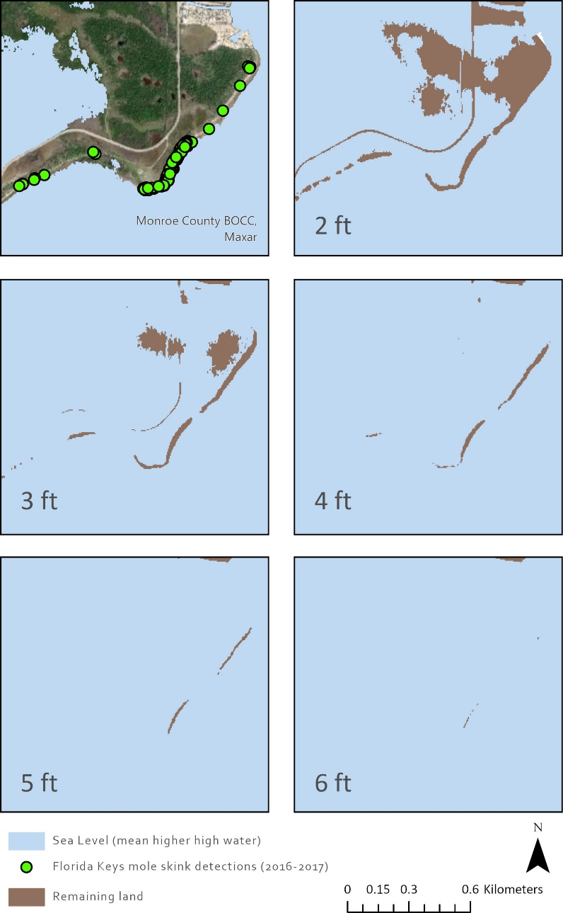
6.6 Conclusions and Recommendations
Overall, the land area of the Lower Keys is more susceptible to SLR inundation than the Upper Keys (Zhang et al. 2011, p. 15). That is, in general, the Lower Keys, which currently has the most populations of Florida Keys mole skinks, are anticipated to experience the effects of SLR before the Upper Keys. However, local elevation and topography also influence an island’s vulnerability to SLR. For example, Big Pine Key, in the Lower Keys, currently has higher resiliency than Key West in the Lower Keys, which is located at a higher elevation, but 60 percent of Big Pine Key is projected to be inundated under a 2 ft scenario by 2040, while just 25 percent of Key West (located at higher elevation) is projected be inundated in that scenario (Table 14 in Appendix D).
Based on our future condition results, targeted management and conservation efforts are best focused on the islands or areas where impacts of SLR are projected to be the least severe. However, areas where SLR will have the lowest impacts are also more likely to continue to see increasing human impacts. The SLR projections predict inundation only and do not model the complex set of shifts that are anticipated to be triggered over time as the effects of SLR are experienced. Vegetation is expected to convert more towards tidal and salt-tolerant species with fewer hammock and buttonwood species, which may have additional impacts on the Florida Keys mole skink. Human relocation upland and inland is projected as rising sea levels restrict development and human activities away from a receding shoreline. The Southeast Florida Regional Climate Change Compact (2012, p. 1) recommended in its vulnerability assessment for Southeast Florida and the Keys that critical infrastructures with “design lives” in excess of 50 years to use the upper curves (worst case scenario) for planning values. Applying such protective measures is the challenge in Keys with limited land availability for setbacks and landward moves off of current shorelines.
The Florida Keys mole skink occurs mostly in areas where the effects of SLR in the future are projected to be greatest, with most of the Lower Keys and Middle Keys losing large percentages of their land area even in the best-case (lowest SLR predictions) scenarios. Beaches, above which wrack lines form and are thought to be the most populous habitat for the Florida Keys mole skink, are already at risk of erosion, and their ability to persist given SLR and future storm events is unknown. In the Lower Keys, Middle Keys, and Upper Keys, where natural beach renourishment is slow and, beaches may disappear, become inundated or submerged due to SLR, Florida mole skink may become eliminated from many locations, even in areas where SLR projections are estimated to be low. In the Distal Sand Keys, where sands are more common, both the Marquesas Islands and Boca Grande are low-lying and at threat of inundation by just 2 ft of SLR. Loggerhead Key has no current population of Florida Keys mole skink, and while it is small, its higher elevations indicate that some beaches may persist.
While the Upper Keys are projected to fare better, given our SLR scenarios, few individuals have been detected on those islands. However, there are still many unknowns regarding the Florida Keys mole skink movements, dispersal, and specific habitat requirements. The species is semi-fossorial and cryptic, and the efforts to survey for the species have not covered all potential habitat. Therefore, there may be more individuals or more populations in places that have not been discovered yet.
Based on all of the above, the likely future scenario for the Florida Keys Mole Skink is further loss of habitat and continued degradation of existing habitat due to increasing SLR. The Lower Keys are projected to experience the greatest loss of potential habitat under all future scenarios. This is especially important given that most of the current population of Florida Keys mole skink are primarily found on islands in the Lower Keys. Based on our future condition analyses, we anticipate a continued reduction in resiliency, representation, and redundancy for the Florida Keys mole skink.

LITERATURE CITED
Adler, G., C. Austin, and R. Dudley. 1995. Dispersal and speciation of skinks among archipelagos in the tropical Pacific Ocean. Evolutionary Ecology 9:529–541.
Adolph, S.C. and W.P. Porter. 1993. Temperature, activity and lizard life histories. The American Naturalist 142(2):273–295.
Allen, C.R., D.M. Epperson, and A.S. Garmestani. 2004. Red Imported Fire Ant Impacts on Wildlife: A Decade of Research. American Midland Naturalist 152(1):88–103.
Bartlett, R.D. and P.P. Bartlett. 1999. A field guide to Florida reptiles and amphibians. Gulf Publishing Company; Houston, Texas.
Beever EA, O’Leary J, Mengelt C, West JM, Julius S, Green N, Magness D, Petes L, Stein B, Nicotra AB, Hellmann JJ. 2016. Improving conservation outcomes with a new paradigm for understanding species’ fundamental and realized adaptive capacity. Conservation Letters 9:131- 137.
Bradley, K.A. and G.D. Gann. 1999. Status summaries of 12 rockland plant taxa in southern Florida. Report submitted to U.S. Fish and Wildlife Service. Institute for Regional Conservation. Miami, Florida.
Branch, L., A. Clark, P. Moler, and B. Bowen. 2003. Fragmented landscapes, habitat specificity, and conservation genetics of three lizards in Florida scrub. Conservation Genetics 4:199–212.
Brandley, M. C., A. Schmitz, and T. W. Reeder. 2005. Partitioned Bayesian analyses, partition choice, and the phylogenetic relationships of scincid lizards. Systematic Biology 54:373–390.
Bull, J.J. 1980. Sex determination in reptiles. The Quarterly Review of Biology 55(1):3–21. Bull, J.J. 2015. Reptile sex determination goes wild. Nature 523:43–44.
Bull, J.J. 2015. Reptile sex determination goes wild. Nature: Volume 523, pp. 43-44.
Calver, M.C., J. Grayson, M. Lilith, and C.R. Dickman. 2011. Applying the precautionary principle to the issue of impacts by pet cats on urban wildlife. Biological Conservation 144(6):1895–1901.
Cangialosi, J.P., A.S. Latto, and R. Berg. 2017. Hurricane Irma. NOAA-NWS National Hurricane Center Tropical Cyclone Report. 51 pp. https://www.nhc.noaa.gov/data/tcr/AL112017_Irma.pdf
Carr, A. F., Jr. 1940. A contribution to the herpetology of Florida. University of Florida Publications. Biological Sciences 3:1–118.
Carr, M.H. and P.D. Zwick. 2016. Florida 2070 mapping Florida’s future – alternative patterns of development in 2070. GeoPlan Center at the University of Florida, Gainesville, Florida.
Carter, L.M., J.W. Jones, L. Berry, V. Burkett, J.F. Murley, J. Obeysekera, P.J. Schramm, and D. Wear. 2014. Pages 396–417 in J.M. Melillo, T. Richmond, and G.W. Yohe, editors. Southeast and the Caribbean. Climate Change Impacts in the United States: The Third National Climate Assessment, U.S. Global Change Research Program doi:10.7930/J0N– P22CB.
Center for Biological Diversity (CBD). 2010. Petition to list 404 aquatic, riparian and wetland species from the southeastern United States as threatened or endangered under the Endangered Species Act. 1,145 pp.
Church, J.A., P.U. Clark, A. Casenave, J.M. Gregory, S. Jevrejeva, A. Levermann, M.A. Merrifield, G.A. Milne, R.S. Nerem, P.D. Nunn, A.J. Payne, W.T. Pfeffer, D. Stammer, and A. S. Unnikrishnan. 2013. Sea level change. Chapter 13 in Climate Change 2013: The Physical Science Basis. Contribution of Working Group I to the Fifth Assessment Report of the Intergovernmental Panel on Climate Change, Cambridge University Press, Cambridge, United Kingdom and New York, NY, USA, 1535.
Christman, S.P. 1992. Florida Keys mole skink, Eumeces egregius egregius (Baird). Pages 178–180, in P.E. Moler, editor. Rare and endangered biota of Florida. Volume III. Amphibians and reptiles. University Press of Florida, Gainesville.
Christman, S.P. 2005. Densities of Neoseps reynoldsi on the Lake Wales Ridge. Final Report, Part 1 Surveys for Neoseps reynoldsi and Eumeces egregius lividus. Cooperative Agreement No. 401813J035, U.S. Fish and Wildlife Service, Vero Beach, Florida, USA. 62pp.
City of Key West, Florida. 2013. Comprehensive Plan. http://www.cityofkeywest-- fl.gov/egov/documents/1437006065_44167.pdf. Accessed January 27, 2017.
City of Marathon. 2005. Comprehensive Plan. http://www.ci.marathon.fl.us/government/planning/comprehensive-plan/. Accessed January 27, 2017.
Clark, R.R. 1990. The carbonate beaches of Florida: An inventory of Monroe County Beaches., p. 48 FL Beaches. Florida Department of Natural Resources Beaches and Shores Technical and Design Memorandum 90-1. 51 pp.
Clark, R.R. 1998 The Impact of Hurricane Georges on the Carbonate Beaches of the Florida Keys, Florida Department of Environmental Protection Post Storm Report, 19 p.
Cove, M.V., B. Gardner, T.R. Simons, R. Kays, and A.F. O’Connell. 2018. Free-ranging cats (Felis catus) on public lands: estimating density, movement, activity and diet. Biological Invasions. Pp. 333-344. https://doi.org/10.1007/s10530-017-1534-x
Crandall KA, Bininda-Emonds OR, Mace GM, Wayne RK. 2000. Considering evolutionary processes in conservation biology. Trends in Ecology & Evolution 15:290-295.
Cronin, J. 2003. Movement and spatial population structure of a prairie planthopper. Ecology 84(5):1179–1188.
Deconto, R., and D. Pollard. 2016. Contribution of Antarctica to past and future sea–level rise. Nature. 531: 591–610.
Dingler, J. R., S. A. Hsu, and A. L. Foote. 1995. Wind shear stress measurements in a coastal marsh during Hurricane Andrew. Journal of Coastal Research 21:295–305.
Drabeck, D. H., M. W. Chatfield, C. L. Richards–Zawacki. 2014. The Status of Louisiana's Diamondback Terrapin (Malaclemys terrapin) Populations in the Wake of the Deepwater Horizon Oil Spill: Insights from Population Genetic and Contaminant Analyses. Journal of Herpetology 48(1):125–136.
Duellman, W.E., and A. Schwartz. 1958. Amphibians and reptiles of southern Florida. Bulletin of the Florida State Museum 3:182–319.
Emerick, A. 2017a. Report on USFWS Projects Targeting the Keys Mole Skink (Plestiodon egregius egregius). 2014–2017. U.S. Fish and Wildlife Service Report.
Emerick, A. 2017b. Email to Layne Bolen. National Key Deer Refuge. March 27, 2017.
Emerick, A. 2017c. Email to Layne Bolen. National Key Deer Refuge. February 15, 2017.
Emerick, A. 2017d. Phone Conversation to Layne Bolen. National Key Deer Refuge. February 15, 2017.
Emerick, A. and Florida Fish and Wildlife Conservation Commission. 2017. Unpublished survey data of FL Keys mole skinks. National Key Deer Refuge and Florida Fish and Wildlife Conservation Commission, Tallahassee, Florida. Pers comms.
Enge, K. 2017. Email to Layne Bolen. Florida Fish and Wildlife Commission, Tallahassee, Florida. June 14, 2017.
Enge, K. M. 2005. Commercial harvest of amphibians and reptiles in Florida for the pet trade. Pages 198–211 in W. E. Meshaka, Jr., and K. J. Babbitt, editors. Amphibians and reptiles: status and conservation in Florida. Krieger, Malabar, Florida, USA.
Enge, K. 2021. Email to Billy Brooks. Florida Fish and Wildlife Commission, Tallahassee, Florida. February 22, 2021.
Enge, K. M., P. E. Moler, T. M. Thomas, and A. H. Greene. 2017. Unpublished poster: “t’s an island life for the Cedar Key mole skink”. Florida Fish and Wildlife Conservation Commission, Tallahassee, Florida.
Fauna Classifieds. 2017. http://www.faunaclassifieds.com/forums/archive/index.php/t-- 377155.html. Accessed March 16, 2017.
Florida Department of Economic Opportunity. 2015. Florida Keys Area of Critical State Concern Annual Report. http://www.floridajobs.org/docs/default–source/2015– community–development/community–planning/2015–cmty–plan–acsc/2015–florida–keys– area–of–critical–state–concern–annual–report.pdf?sfvrsn=2. Accessed February 2, 2017.
Florida Department of Environmental Protection (FDEP). 2012. Windley Key Fossil Reef Geological State Park. Unit Management Plan, March 1, 2012. http://www.dep.state.fl.us/parks/planning/parkplans/WindleyKeyFossilReefGeologicalSt atePark.pdf .
Florida Department of Environmental Protection. 2014. Florida Coastal Management Program Guide. https://www.dep.state.fl.us/cmp/publications/FCMP_Program_Guide_2014.pdf . Accessed April 13, 2017.
Florida Department of Environmental Protection (FDEP). 2020. Strategic Beach Management Plan: Florida Keys Region. https://floridadep.gov/sites/default/files/SBMP_Fl._Keys.pdf. Accessed
Florida Department of Environmental Protection (FDEP). 2021. Critical beach erosion is from
Florida Fish and Wildlife Conservation Commission (FWC). 2004. A conceptual management plan for the Florida Keys Wildlife and Environmental Area. Florida Fish and Wildlife Conservation Commission, Tallahassee, Florida.
Florida Fish and Wildlife Conservation Commission (FWC). 2011. Florida Keys mole skink biological status review. March 31, 2011. Tallahassee, Florida. 16pp.
Florida Fish and Wildlife Conservation Commission (FWC). 2013. A species action plan for the Florida Keys mole skink (Plestiodon egregius egregius). November 1, 2013 Final Draft. Tallahassee, Florida. 20pp.
Florida Fish and Wildlife Conservation Commission (FWC). 2016a. Draft Species Conservation Measures and Permitting Guidelines Florida Keys mole skink. http://myfwc.com/media/4070133/DraftFloridaKeysmoleskink-SpeciesGuidelines-- September2016.pdf. Accessed January 27, 2017.
Florida Fish and Wildlife Conservation Commission (FWC). 2016b. Florida’s Imperiled Species Management Plan. Tallahassee, Florida. 12 pp.
Florida Fish and Wildlife Conservation Commission and Florida Natural Areas Inventory (FWC and FNAI). 2016. Florida Cooperative Land Cover, Version 3.2. Data shapefile. Available at: http://fnai.org/LandCover.cfm.
Florida Keys Mosquito Control District. 2017. https://keysmosquito.org/. Accessed April 21, 2021.
Florida mole skinks Technical Team Working Group (Technical Team Working Group). 2016. Life history, species needs, and current condition Workshop. Facilitated by USFWS South Florida Field Office, December 8, 2016.
Florida Museum of Natural History (FLMNH). 2011. Search the herpetology master database. http://www.flmnh.ufl.edu/scripts/dbs/herps_pub.asp. Accessed November 14, 2016.
Florida Natural Areas Inventory (FNAI). 2001. Field Guide to the Rare Animals of Florida. http://www.fnai.org/FieldGuide/pdf/Eumeces_egregius_egregius.pdf. Accessed September 21, 2016.
Florida Natural Areas Inventory (FNAI). 2011. Florida Natural Areas Inventory tracking list. [BE1]. http://fnai.org/trackinglist.cfm. Accessed November 14, 2016.
Florida Rambler. 2017. http://www.floridarambler.com/florida-camping/best-tent-camping-in-- the-florida-keys/. Accessed March 15, 2017.
Florida State Parks. 2017. Florida State Park Regulations. https://www.floridastateparks.org/things-to-know/park-rules. Accessed April 17, 2017.
Forys, E.A., C.R. Allen, and D.P. Wojcik. 2002. Influence of the proximity and amount of human development and roads on the occurrence of the red imported fire ant in the lower Florida Keys. Biological Conservation 108:27–33.
Gallagher, A., Hammerschlag, N., Cooke, S., Costa, D., and D. Irschick. 2015. Evolutionary theory as a tool for predicting extinction risk. Trends in Ecology and Evolution. 30(2): 61–65.
Gianopulos, K. 2001. Response of the threatened sand skink (Neosesps reynoldsi) and other herpetofaunal species to burning and clearcutting in the Florida sand pine scrub habitat. Master of Science thesis. University of South Florida; Tampa, Florida.
Grinsted, A., S. Jevrejeva, R.E.M. Riva, and D. Dahl-Jensen, 2015. Sea Level Rise Projections for Northern Europe under RCP 8.5. Climate Research 64:15–23
Hall, J.A., S. Gill, J. Obeysekera, W. Sweet, K. Knuuti, and J. Marburger. 2016. Regional Sea Level Scenarios for Coastal Risk Management: Managing the Uncertainty of Future Sea Level Change and Extreme Water Levels for Department of Defense Coastal Sites Worldwide. U.S. Department of Defense, Strategic Environmental Research and Development Program. 224 pp.
Hamilton, W.T. and J.A. Pollock. 1958. Notes on the life history of the Red–tailed skink. Herpetologica. 14(1): 25–28.
Hino, M., Field, C., and K. Mach. 2017. Managed retreat as a response to natural hazard risk. Nature Climate Change. Published online March 27, 2017. doi: 10.1038/NClimate3252. 8pp.
Hoegh–Guldberg, H. 2010. Climate change and the Florida Keys. NOAA’s Coral Reef Conservation Program. Main Report. July21, 2010. 186 pp.
Holleley, C.E., D. O’Meally, S.D. Sarre, J.A. Marshall Graves, T. Ezaz, and K. Matsubara. 2015. Sex reversal triggers the rapid transition from genetic to temperature–dependent sex. Nature 523:79–82.
iNaturalist. 2020. Florida Keys Mole Skink (Plestiodon egregius ssp. egregious) observation. Observed July 19, 2020. https://www.inaturalist.org/observations/53603922. Accessed March 4, 2021.
Intergovernmental Panel on Climate Change (IPCC). 2013. Summary for Policymakers. In Climate Change 2013: The Physical Science Basis. Contribution of Working Group I to the Fifth Assessment Report of the Intergovernmental Panel on Climate Change [Stocker, T.F., D. Qin, G.–K. Plattner, M. Tignor, S.K. Allen, J. Boschung, A. Nauels, Y. Xia, V. Bex and P.M. Midgley, editors]. Cambridge University Press; Cambridge, United Kingdom and New York, NY, USA. pp.3–29.
Ji, X., L.H. Lin, L.G. Luo, H.L. Lu, J.F. Gao, and J. Han. 2006. Gestation temperature affects sexual phenotype, morphology, locomotor performance, and growth of neonatal brown forest skinks, Sphenomorphus indicus. Biological Journal of the Linnean Society 88:453–463.
Jackson, L.L., Foote, A.L. and Balistrieri, L.S., 1995. Hydrological, geomorphological, and chemical effects of hurricane Andrew on coastal marshes of Louisiana. Journal of Coastal Research, pp.306–323.
Jochimsen, D.M., C.R. Peterson, K.M. Andrews, and J.W. Gibbons. 2004. A literature review of the effects of roads on amphibians and reptiles and the measures used to minimize those effects. http://fishandgame.idaho.gov/public/wildlife/collisionAmphibRep.pdf. Accessed January 27, 2017.
Kasper, K.C. 2007. Hurricane Wilma in the Florida Keys. National Weather Service. http://www.weather.gov/key/wilma. Accessed January 27, 2017.
Keith and Schnars 2016. Monroe County comprehensive plan update. Monroe County, Florida, Division of Community Development, Tallahassee, Florida. http://www.monroecounty-- fl.gov/DocumentCenter/Home/View/4606. Accessed January 27, 2017
Kopp, R. E., R.M. Horton, C.M. Little, J.X. Mitrovica, M. Oppenheimer, D.J. Rasmussen, B. Strauss, C. Tebaldi. 2014. Probabilistic 21st and 22nd century sea-level projections at a global network of tide-gauge sites. Earth's Future, 2(8), 383-406.
Kopp, R. E., A.C. Kemp, K. Bittermann, B.P Horton, J.P Donnelly, W.R. Gehrels, & S. Rahmstorf. 2016. Temperature-driven global sea-level variability in the Common Era. Proceedings of the National Academy of Sciences, 201517056
Leeworthy, V.R. 2010. Office of National Marine Sanctuaries. http://sanctuaries.noaa.gov/science/socioeconomic/floridakeys/pdfs/key_west_profile_08. pdf. Accessed March 15, 2016
Lopez, R. R., N. J. Silvy, R. F. Labisky, and P. A. Frank. 2004. Hurricane impacts on Key deer in the Florida Keys. Journal of Wildlife Management 67:280–288.
Losos, J. and R. Ricklefs, editors. 2010. The theory of island biogeography revisited. Princeton University Press: Princeton, NJ.
Mangel, M. and C. Tier. 1993. A simple direct method for finding persistence times of populations and application to conservation problems. Proceedings of the National Academy of Sciences Feb 1993, 90 (3) 1083-1086; DOI: 10.1073/pnas.90.3.1083
Mays, J.D. and K.M. Enge. 2016. Survey of State–listed Reptiles in the Florida Keys. Final Report. Florida Fish and Wildlife Conservation Commission; Tallahassee, Florida.
McCoy, E., Richmond, H., Mushinsky, H., Britt, E., and J.S. Godley. 2010. Long generation time delays the genetic response to habitat fragmentation in the threatened Florida sand skink. Journal of Herpetology. 44(4): 641–644.
McCoy, E., Richmond, H., Mushinsky, A. Shrey, C. Eaglestone, and P. Wieczorek. 2020. Movement patterns and home range of the Florida sand skink, Plestiodon reynoldsi. Final Report to the USFWS. 34 pps.
Mengel, M., A. Levermann, K. Frieler, A. Robinson, B. Marzeion, & R. Winkelmann. 2016. Future sea level rise constrained by observations and long-term commitment. Proceedings of the National Academy of Sciences, 113(10), 2597-2602.
Mercier, K. 2017a. Email to Layne Bolen. University of Central Florida, Department of Biology, March 7, 2017.
Mercier, K. 2017b. Telephone conversation with Layne Bolen. University of Central Florida, Department of Biology. January 24, 2017.
Mercier, K. 2018. Unearthing the past and present of a semi-fossorial lizard: Conservation Genetics. Phylogeography, and Taxonomy of Pliestiodon egregious. Electronic Thesies and Dissertations 2004-2019. 6028. https://atara.library.ucf.edu/etd/6028
Miami–Dade County, Florida. 2016. GIS land coverage maps. http://gisweb.miamidade.gov/GISSelfServices/GeographicData/MDGeographicData.html Accessed February 14, 2017.
Mitchell, J. C. and R. A. Beck. 1992. Free–ranging domestic cat predation on native vertebrates in rural and urban Virginia. Virginia Journal of Science 43(1B) 197:208.
Moler, P. E. 2017. Email to Layne Bolen. February 15, 2017.
Monroe County, Florida. 2016a. GIS land coverage maps. Acquired by USFWS in 2016 from Monroe County GIS Department. Miami, Florida.
Monroe County, Florida. 2016b. Monroe County Year 2030 Compresnehsive Plan. Policy Document. Revision 5. April 13, 2016.
Monroe County Comprehensive Plan Land Authority. 2016c. Resolution number 07–2016. http://www.monroecounty-fl.gov/DocumentCenter/View/10724. Accessed February 2, 2017.
Mount, R. H. 1963. The natural history of the red–tailed skink, Eumeces egregius Baird. American Midland Naturalist 70:356–385.
Mount, R. 1965. Variation and systematics of the scincoid lizard, Eumeces egregius (Baird). Bulletin of the Florida State Museum 9(5):184–213.
Mount, R. H. 1968. Eumeces egregius (Baird). Catalogue of American Amphibians and Reptiles 73:1–2.
Mushinsky, H.R., McCoy, D. Earl, K. Gianopulos, K. Penney, and C. Meyer. 2001. Biology of the threatened sand skink on restored scrub habitat and its responses to land management practices. Integrative Biology Faculty and Staff Publications Paper 161. Available at: http://scholarcommons.usf.edu/bin_facpub/161
National Aeronautics and Space Administration Jet Propulsion Laboratory [NASA]. 2015. Warming seas and melting ice sheets. Science Daily. Science Daily, 26 August, 2015. [Accessed February 14, 2017]. Available at: https://www.sciencedaily.com/releases/2015/08/150826111112.htm
National Oceanic and Atmospheric Administration (NOAA). 2017a. Tides & Currents. Mean Sea Level Trend 9824580 Key West, Florida. Key Vaca: https://tidesandcurrents.noaa.gov/sltrends/sltrends_station.shtml?stnid=8723970 Key West: https://tidesandcurrents.noaa.gov/sltrends/sltrends_station.shtml?stnid=8724580. Accessed on February 9, 2017.
National Oceanic and Atmospheric Administration (NOAA). 2017b. Office of Response and Restoration (ORR). http://response.restoration.noaa.gov/oil-and-chemical-spills/oil-- spills/largest-oil-spills-affecting-us-waters-1969.html. Accessed April 22, 2021.
National Oceanic and Atmospheric Administration (NOAA). 2017c. Coastal Zone Management Act. Office of Coastal Management. https://coast.noaa.gov/czm/act/ . Accessed February 2, 2017.
National Oceanic and Atmospheric Administration (NOAA). 2017d. Method Description: Detailed Method for Mapping Sea Level Rise Inundation. January 2017. NOAA Office for Coastal Management. 5 pages.National Oceanic and Atmospheric Administration (NOAA). 2019. National Oceanic and Atmospheric Administration. 2018 State of U.S. High Tide Flooding with a 2019 Outlook. NOAA Technical Report NOS CO–OPS 090. [Sweet, W., Dusek, G., Marcy, D., Carbin, G., Marra, J. (eds)]. Silver Spring, MD.
National Oceanic and Atmospheric Administration (NOAA) National Hurricane Center. 2018. Tropical Cyclone Report: Hurricane Irma. 30 August—12 September 2017. Report AL112017.
National Ocean Service (NOS). 2017. www.https://shoreline.noaa.gov/glossary. Accessed April 25, 2017.
Neill, W.T. 1940. Eumeces egregius in Georgia. Copeia 4:266.
Nicotra, AB, Beever EA, Robertson AL, Hofmann GE, O’Leary J. 2015. Assessing the components of adaptive capacity to improve conservation and management efforts under global change. Conservation Biology 29:1268-1278.
Packard, G, R. Tracy, and J. Roth. 1977. The physiological ecology of reptilian eggs and embryos, and the evolution of viviparity within the class Reptilia. Biological Review. 52: 71–105.
Park, J. and W. Sweet. 2015. Accelerated sea level rise and Florida Current transport. Ocean Science 11:607–615.
Parkinson, C. L., M. DiMeo, and K. Mercier. 2016. Evaluating mole skink and salt marsh snake subspecific taxonomy in Florida using genomics. Interim Report Submitted to the U.S. Fish and Wildlife Service. September 30, 2016. 1–14 pp.
Parris, A., Bromirski P., Burkett, V, Cayan, D., Culver, M., Hall, J., Horton, R., Knuuti, K.,Moss, R., Obeysekera, J., Sallenger, A., and J. Weiss. 2012. Global Sea Level Rise Scenarios for the US National Climate Assessment. NOAA Tech Memo OAR CPO–1. 37 pp.
Rahmstorf, S., J. Box, G. Fuelner, M. Mann, A. Robinson, S. Rutherford, and E. Schaffernicht. 2015. Exceptional twentieth–century slowdown in Atlantic Ocean overturning circulation. Nature Climate Change 5:475–480.
Redford, K.H., G. Amato, J. Baillie, P. Beldomenico, E.L. Bennett, N. Clum, R. Cook, G. Fonseca, S. Hedges, F. Launay, S. Lieberman, G.M. Mace, A. Murayama, A. Putnam, J.G. Robinson, H. Rosenbaum, E.W. Sanderson, S.N. Stuart, P. Thomas, and J. Thorbjarnarson. 2011. What Does It Mean to Successfully Conserve a (Vertebrate) Species? BioScience, Volume 61, Issue 1, January 2011, Pages 39–48, https://doi.org/10.1525/bio.2011.61.1.9
Robert, K.A. and M.B. Thompson. 2009. Viviparity and temperature–dependent sex determination. Sexual Development 4:119–128.
Ross, M., O’Brien, J., and L. da Silveira Lobo Sternberg. 1994. Sea0level rise and the reduction in pine forests in the Florida Keys. Ecological Applications. 4: 144–156.
Saha, S, K. Bradley, M. S. Ross, P. Hughes, T. Wilmers, P. L. Ruiz, and C. Bergh. 2011a. Hurricane effects on subtropical pine rocklands of the Florida Keys. Climate Change. 107: 169-184.
Saha, A. K., S. Saha, J. Sadle, J. Jiang, M. S. Ross, R. M. Price, L. S. L. O. Sternberg, and K. S. Wendelberger. 2011b. Sea level rise and South Florida coastal forests. Climatic Change 107:81–108.
Sarre, S.D., A. Georges, and A. Quinn. 2004. The ends of a continuum: genetic and temperature–dependent sex determination in reptiles. BioEssays 26: 639–645.
Schrey, A., Ashton, K., Heath, S., Mushinsky, H., and E. McCoy. 2012. Range–wide genetic analysis of the threatened bluetail mole skink identifies similar genetic structure with sympatric lizards. Journal of Herpetology, 46(2): 241–247.
Schrey, A., Fox, A., Mushinsky, H., and E. McCoy. 2011. Fire increases variance in genetic characteristics of Florida sand skink (Plestiodon reynoldsi) local populations. Molecular Ecology. 20: 56–66.
Shaffer, M. 1981. Minimum population sizes for species conservation. Bioscience. 31(2): 131– 134.
Sheridan, K. 2015. As Florida Keys flood, property worries seep in. December 14, 2015. Florida Keys News. https://phys.org/news/2015-12-florida-keys-property-seep.html. March 20, 2017
Sgro CM, Lowe AJ, Hoffmann AA. 2011. Building evolutionary resilience for conserving biodiversity under climate change. Evolutionary Applications 4:326-337.
Slangen, A. B. A., M. Carson, C.A. Katsman, R.S.W. van de Wal, A. Köhl, L.L.A. Vermeersen, & D. Stammer. 2014. Projecting twenty-first century regional sea-level changes. Climatic Change, 124(1-2), 317-332.
Smith, A. and D. Green. 2005. Dispersal and the metapopulation paradigm in amphibian ecology and conservation: are all amphibian populations metapopulations? Nordic Society Oikos 28(1) 110–128.
Southeast Florida Regional Climate Change Compact (Compact). 2012. Inundation mapping and vulnerability assessment work group. August 2012. Analysis of the Vulnerability of Southeast Florida to Sea Level Rise. p. 103.
Sutton, P.E. 1996. A mark and recapture study of the Florida Sand Skink, Neoseps reynoldsi, and a comparison of sand skink sampling methods. Master's Thesis. University of South Florida; Tampa, Florida.
Staletovich, J. 2016. King tide countdown: six South Florida spots likely to flood and when. October 14, 2016. Miami Herald. http://www.miamiherald.com/news/local/environment/article108273657.html. Accessed March 20, 2017.
Sweet, W.V. and J.J. Marra. 2016. 2015 State of U.S. “Nuisance” Tidal Flooding. June 8, 2016.
Sweet, W.V., R.E. Kopp, C.P. Weaver, J. Obeysekera, R.M. Horton, E.R. Thieler, and C. Zervas. 2017. Global and Regional Sea Level Rise Scenarios for the United States. NOAA Technical Report NOS CO-OPS 083. NOAA/NOS Center for Operational Oceanographic Products and Services. https://tidesandcurrents.noaa.gov/publications/techrpt83_Global_and_Regional_SLR_Scenarios_for_the_US_final.pdf
Sweet, W.V., Dusek, G., J. Obeysekera, and J. Marra. 2018. Patterns and projections of high tide flooding along the US coastline using a common impact threshold. NOAA Technical Report NOS CO-OPS 086. NOAA/NOS Center for Operational Oceanographic Products and Services.
Sweet, W.V., G. Dusek, G. Carbin, J. Marra, D. Marchy, and S. Simon. 2020. 2019 State of U.S. High Tide Flooding with a 2020 Outlook. NOAA Technical Report NOS CO–OPS 092. Silver Spring, Maryland.
Sweet, W.V., S. Simon, G. Dusek, D. Marcy, W. Brooks, M. Pendleton, and J. Marra. 2021. 2021 State of High Tide Flooding and Annual Outlook. NOAA Technical Report NOS CO-OPS 098. Silver Spring, Maryland. https://tidesandcurrents.noaa.gov/publications/2021_State_of_High_Tide_Flooding_and_Annual_Outlook_Final.pdf
The Nature Conservancy (TNC). 2011. Initial estimates of the ecological and economic consequences of sea level rise on the Florida Keys through the Year 2100. The Nature Conservancy, Florida Chapter, Altamonte Springs. 35 pp.
Turner, K. 2021. Email to Billy Brooks, U.S. Fish and Wildlife Service. February 26, 2021.
University of Florida (Univ. of Florida). 2015. Sea Level Scenario Sketch Planning Tool. Phase 1 and 2. http://sls.geoplan.ufl.edu/documents-links/. February 23, 2017.
U.S. Census Bureau. 2017. Monroe County, Florida population estimates. https://www.census.gov/quickfacts/table/AGE115210/12087. Accessed March 27, 2017.
U.S. Census Bureau. 2021. Monroe County, Florida population estimates. https://www.census.gov/quickfacts/monroecountyflorida. Accessed
U.S. Department of Agriculture. 1955. Soil surveys of Monroe County, Keys, Area, Florida. Natural Resources Council. 83 pp.
U.S. Fish and Wildlife Service (Service). 2012. Costal Program Strategic Plan. https://www.fws.gov/coastal/pdfs/StrategicPlan2012_2016SummaryDocumentFinal.pdf. Accessed January 27, 2017.
U.S. Fish and Wildlife Service (Service). 2016. USFWS species status assessment framework: an integrated analytical framework for conservation. Version 3.4.8, August 2016.
U.S. Fish and Wildlife Service (Service). 2017. Climate change summary for south Florida. South Florida Ecological Services Office, Vero Beach, Florida. January 27, 2017. 8pp.
U.S. Fish and Wildlife Service (Service). 2021. Internal data files, including excel and ArcGIS shapefile data of historical, recent and current Florida Keys mole skink detections. Accessed February 2022.
U.S. Geological Survey (USGS). 2013. National Elevation Dataset (NED). Seamless 10 m resolution layers. http://ned.usgs.gov/about.html. Accessed March 23, 2021.
U.S. Geological Survey (USGS). 2017. South Florida Information Access (SOFIA). Climate and Oceanographic Setting. https://sofia.usgs.gov/. Accessed February 10, 2017.
Van Damme, R., D. Bauwens, F. Brana, and R.F. Verheyen. 1992. Incubation temperature differentially affects hatching time, egg survival, and hatchling performance in the lizard Podarcis muralis. Herpetologica 48: 220–228.
Vargas-Moreno, J. C., & Flaxman, M. 2010. Addressing the challenges of climate change in the greater everglades landscape. Massachusetts Institute of Technology, Department of Urban Studies and Planning. Project Sheet November.
Village of Islamorada, Florida. 2001. Comprehensive Plan. http://www.islamorada.fl.us/newsmanager/userfiles/file/Planning_Forms/100915_CompP lan_GOP_15-11_Update.pdf. Accessed January 27, 2017.
Wadlow, K. Florida Keys News. 2016. High king tides dampen some low–lying Keys roads. Florida Keys News. October 19, 2016. http://www.flkeysnews.com/news/local/environment/article109135147.html. Accessed April 28, 2017.
Walsh, J., D. Wuebbles, K. Hayhoe, J. Kossin, K. Kunkel, G. Stephens, P. Thorne, R. Vose, M. Wehner, J. Willis, D. Anderson, S. Doney, R. Feely, P. Hennon, V. Kharin, T. Knutson, F. Landerer, T. Lenton, J. Kennedy, and R. Somerville, 2014: Ch. 2: Our Changing Climate. Climate Change Impacts in the United States: The Third National Climate Assessment, J. M. Melillo, Terese (T.C.) Richmond, and G. W. Yohe, Eds., U.S. Global Change Research Program, 19–67. doi:10.7930/J0KW5CXT.
Warner, B.A. and R. Shine. 2008. The adaptive significance of temperature–dependent sex determination in a reptile. Nature 451:566–568.
Warren, K. 2021. Facebook post-will update with appropriate citation after May 2021.
Wolf. S., B. Hartl, C. Carroll, M.C. Neel, and D.N. Greenwald. 2015. Beyond PVA: why recovery under the Endangered Species Act is more than population viability. BioScience 65:200–207.
Yahoo Answers. 2017. Search for mole skink sales and trade. Https://answers.yahoo.com/question/index?qid=20080225135337AAdBhkI. Accessed March 16, 2017.
Zackay, A. 2007. Random genetic drift and gene fixation. [online] https://www.metaboliceconomics.de/pages/seminar_theoretische_biologie_2007/ausarbeitungen/zackay.pdf
Zambrano, R. 2021. Florida Fish and Wildlife Conservation Commission, West Palm Beach, Florida. Email to Billy Brooks, USFWS. February 10, 2021.
Zhang, K., J. Dittmar, M. Ross, and C. Bergh. 2011. Assessment of sea level rise impacts on human population and real property in the Florida Keys. Climatic Change 107:129–146.
Zwick, P. D. and M. H. Carr. 2006. Florida 2060, a population distribution scenario for the state of Florida. GeoPlan Center at the University of Florida, Gainesville, Florida.

APPENDICES

Appendix A. Opportunistic search data
Opportunistic searches for Florida Keys mole skinks from November 2016–January 2017.

Location | Hours  Searched | Mole skink  Located? Y/N* | Number of  searchers
Lower Sugarloaf | 1 | N | one
Long Key State Park | 4 | Y | two
Long Key State Park | 3 | N | one
Marquesas/Long Key | 5 | N | two
Marquesas/Long Key | 6 | N | two
Marquesas/Long Key | 6 | N | two
Content Key | 4.5 | Y (3 skinks) | three
Snipe Point | 2.5 | N | three
Snipe Point | 2 | N | two
Marquesas/Main/Third/Short | 6 | N | one
Cook Island | 1.5 | N | one
Cook Island | 1.5 | Y | two
Big Munson Key | 4 | N | two
Big Munson Key | 4 | Y(3 skinks) | two
Curry Hammock State Park  (Marathon) | 3 | N | two
Scout Key | 6 | N | three
Scout Key | 3 | N | two
Totals:
17 searches; 10 locations | 63 hours | 8 skinks; 4 locations | Average two  observers
*Y = 1 skink observed unless otherwise noted.

Appendix B. Technical Team members
Technical Team Working Group Members. Alphabetical Order:
Layne Bolen – USFWS biologist; Florida Keys mole skink Team Lead Billy Brooks – USFWS biologist; Cedar Key mole skink Team Lead Shana DiPalma – USFWS biologist; cartographer
Adam Emerick – USFWS biologist; Florida Keys Refuge Complex
Kevin Enge – Herpetological expert; Florida Fish and Wildlife Conservation Commission Andrew Gude – USFWS Cedar Key National Wildlife Refuge Manager
Jonathan Mays – Herpetological expert; Florida Fish and Wildlife Conservation Commission Katie Mercier – Master’s graduate student; University of Central Florida, Department of Biology Lori Miller – USFWS biologist; meteorologist; climate change specialist
Paul Moler – Herpetological expert; mole skink species expert; Retired Florida Fish and Wildlife Conservation Commission
Dr. Henry Mushinsky – Herpetological expert; mole skink species expert; Retired University of South Florida
Lindsay Nester – USFWS biologist
Dr. Christopher Parkinson – Professor; University of Central Florida, Department of Biology

Florida Keys and Cedar Key Mole Skinks Life History Needs and Current Conditions Technical Team Workshop held on December 8, 2016.

Appendix C. Current Condition Exposure Table
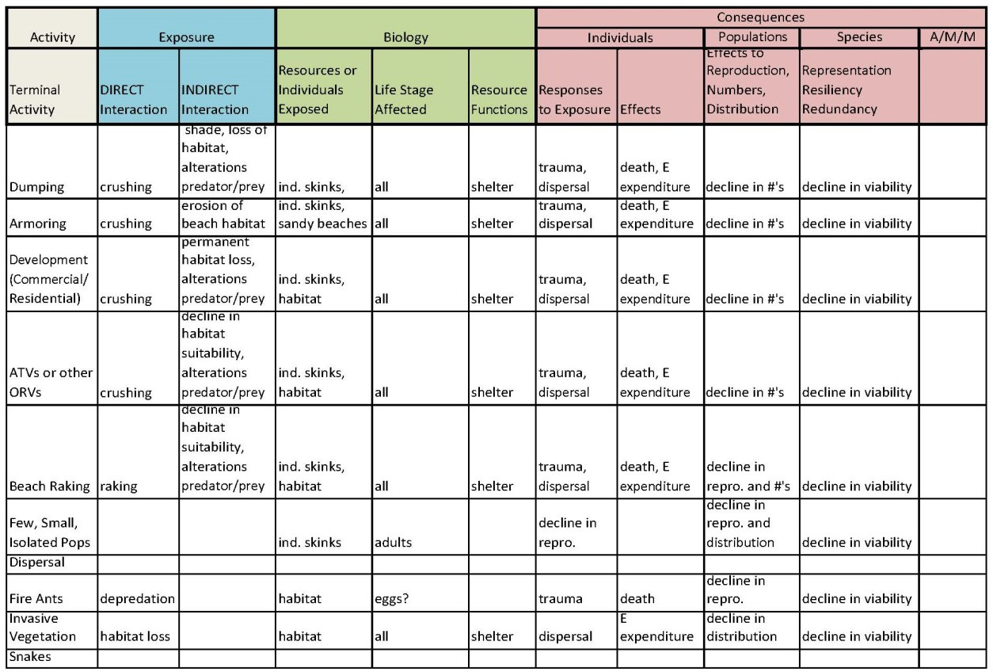

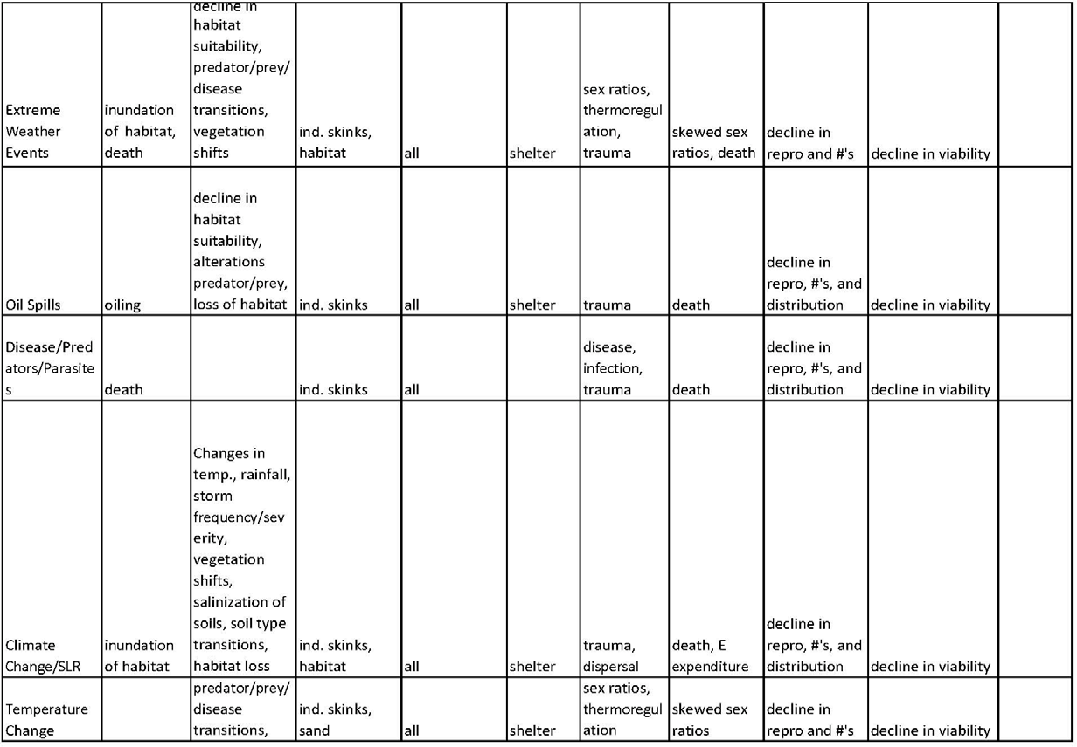

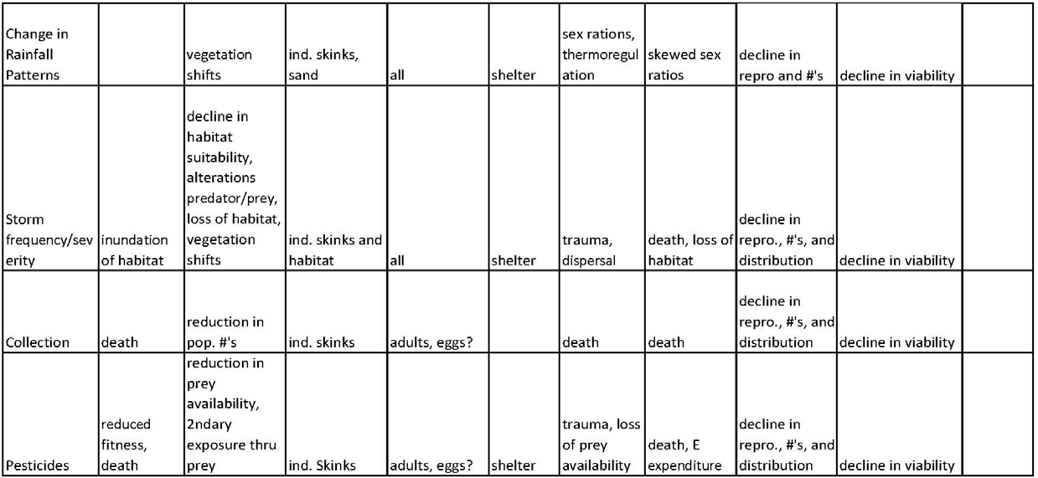

Appendix D. Additional sea level rise (SLR) data

SLR Tables
Table 13. Sweet et al.2017. Sea Level Rise estimates (in feet) for Vaca Key for the four scenarios used in this assessment at each 10-year interval until 2100. We analyze future condition for 2040 and 2060 (yellow highlight).

Table 14. Percent of potential habitat (total island area minus water, freshwater, and impervious cover habitat types [Monroe 2016, entire]) that would be lost to inundation given each foot of Sea Level Rise (Sweet et al. 2017, entire).
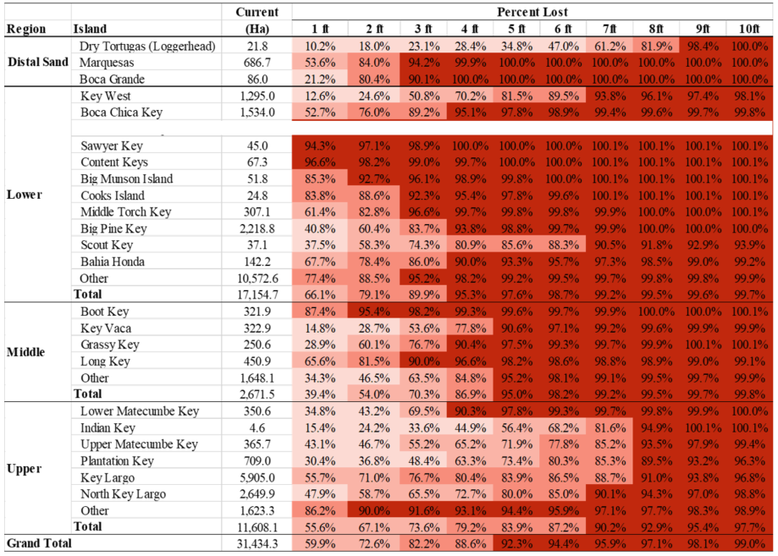

Table 15. Percent of preferred habitat types (Beach Berm and Hammock [Monroe 2016, entire]) that would be lost to inundation given each foot of Sea Level Rise ( Sweet et al. 2017, entire).
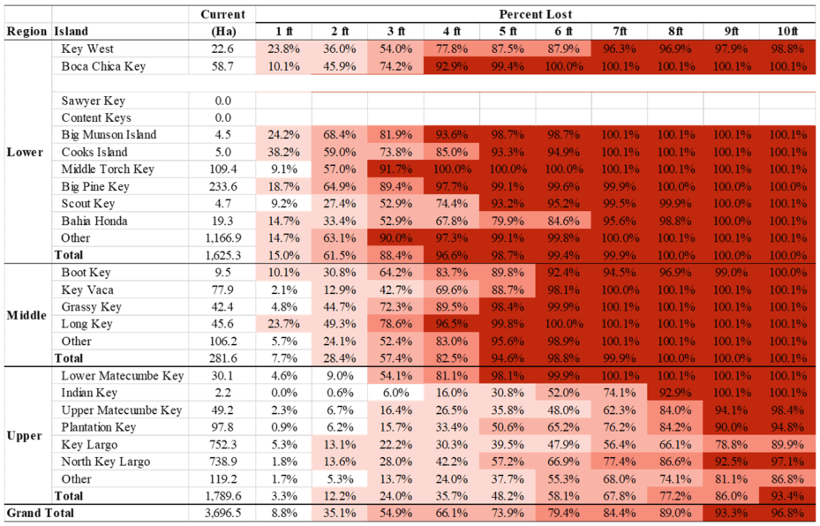

Table 16. Percent of preferred soil types (Bahiahonda fine sands and beach sands [Monroe 2016, entire]) that would be lost to inundation given each foot of Sea Level Rise (Sweet et al. 2017, entire).
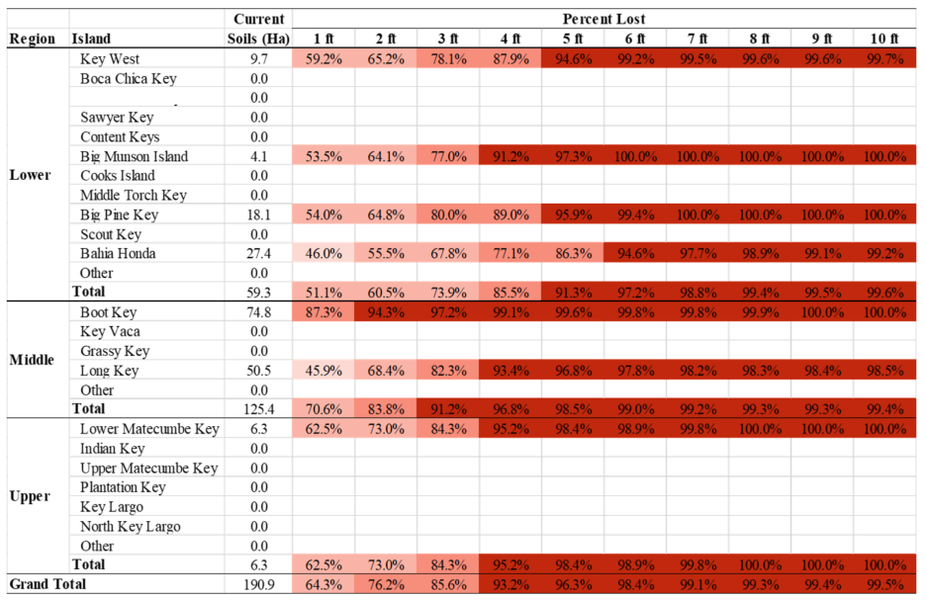

Tutorial: How to use this data
Step 1:
Choose the year and SLR scenario you are interested in projecting. Find the SLR estimate (in feet) in Table 14.

For instance, looking at the 2080 High scenario predicts a 5.74 ft rise in sea level (circled in green, below).

Step 2:
Round that value to the nearest foot to represent the sea level. Add an additional foot to predict the elevation of areas affected by high tide flooding.

For instance, for 2080 High scenario, the future sea level would be at 6 ft (rounded from 5.74), and the high tide flooding would reach 7 ft (6 ft plus 1 ft).

Step 3:
Using Tables 15 through 17, assess the percent of current potential habitat (Table 14), current preferred habitats (Table 15), and current preferred soils (Table 16) that will be lost to inundation (SLR estimate) and inundation plus high tide flooding (SLR estimate plus 1 ft) for that scenario using the rounded values from Step 2.

For instance, under a High SLR scenario for 2080, we can see that every population except the Dry Tortugas has lost over 50 percent of its potential habitat area (land area minus water and impermeable surfaces) to inundation (6 ft column, yellow arrow below). All of the populations in the Upper and Middle Keys have over 90 percent of the potential habitat area impacted by inundation plus high tide flooding (7 ft column, green arrow below).

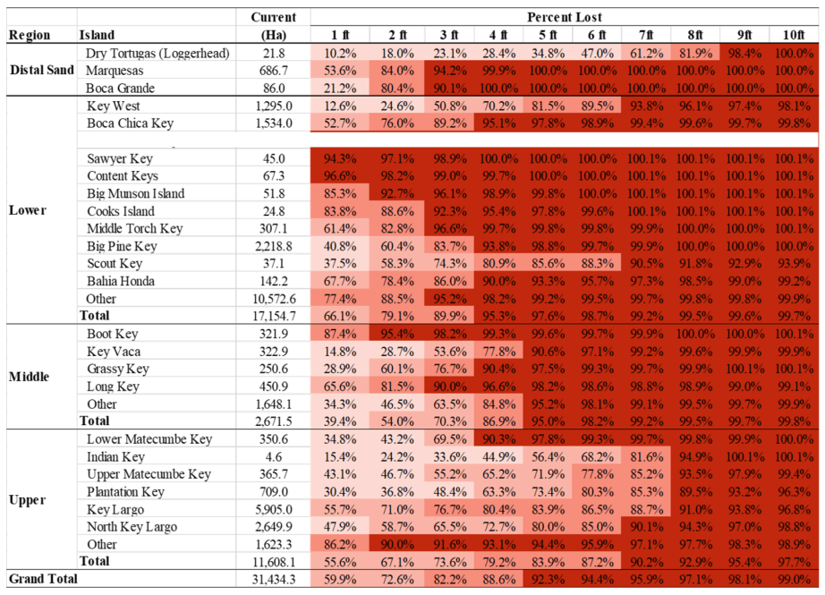
Percent of potential habitat inundated by SLR
Percent of potential habitat impacted by SLR and high tide flooding

