Early Detection and Monitoring of Non-Native Fishes in Lake Huron, 2023

Below is a summary of the USFWS-Alpena Fish and Wildlife Conservation Office’s Aquatic Invasive Species Program report titled Early Detection and Monitoring of Non-Native Fishes in Lake Huron, 2023.

To request the full document contact Matt McLean at Matthew_McLean@fws.gov or (989) 255-2386.

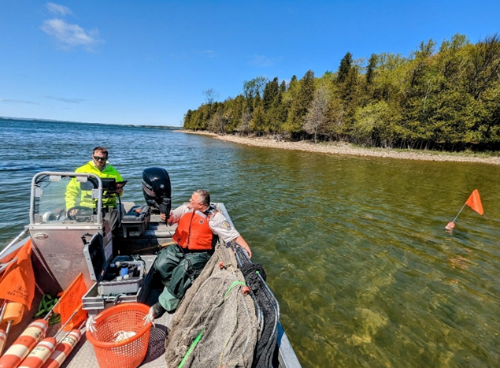
Summary:

This report provides a summary of Lake Huron early detection and monitoring (EDM) for previously undocumented non-native fishes and select benthic macroinvertebrates as implemented by the U.S. Fish and Wildlife Service’s (USFWS) Alpena Fish and Wildlife Conservation Office (FWCO) and partner agencies including Sault Ste. Marie Tribe of Chippewa Indians, Ontario Ministry of Natural Resources and Forestry, and the Department of Fisheries and Oceans Canada.

Lake Huron locations were prioritized for where a new non-native species was most likely to be introduced, as well as locations where non-native species were historically introduced. Eight
locations including the Au Gres River, Au Sable River, Cheboygan River, Eastern Upper
Peninsula, Rogers City, Saginaw Bay, St. Marys River, and Thunder Bay were sampled for
juvenile and adult fish using electrofishing, fyke nets, gill nets, and bottom trawls. Over 48,500
fish from 84 species were collected and examined from across 376 sites. No previously
undocumented non-native fish were captured.

