**Scope of Work: Fish Injury Data Gap Studies,**

**Koppers Delaware Superfund Site**

**Submitted to the Department of the Interior NRDAR Program by**

**Fred Pinkney, USFWS, Chesapeake Bay Field Office (CBFO) March 2023**

**Fred_Pinkney@fws.gov**

# Introduction

## Purpose of the Project

This Scope of Work is for fish injury studies to be funded by the Department of the Interior Natural Resources Damage Assessment and Restoration (NRDAR) Program. These studies address data gaps for the Koppers Delaware Superfund Site (Koppers) Injury Assessment. The site background and history are taken from the recently approved Preliminary Assessment Screen (PAS) which recommended proceeding with a NRDAR case (Pinkney et al. 2022).

## The Koppers Site

The Koppers Co., Inc. (Newport Plant) Superfund Site (Site) is comprised of approximately 121 hectares (ha) (=300 acres (ac)), located southwest of Newport, Delaware (**Figure 1a, b, 2**). In 1929, three parcels comprising the Site were conveyed by Lynam and Wright to the Delaware Wood Preserving Company, which began conducting woodtreatment operations on these parcels. Wood treatment operations continued at the Site, under various owners, until 1971. The Trustees are evaluating potential releases of hazardous substances and related injuries to natural resources within the Site boundary (which is defined here as the Assessment Area).

According to the U.S. Environmental Protection Agency (USEPA 2005), the major habitat types are uplands (66 ha = 163 ac), wetlands (55 ha = 136 ac) and three small freshwater ponds (total of about 0.4 ha = 1 ac). The wetlands include freshwater tidal marsh, non-tidal emergent wetlands, non-tidal forested wetlands, and non-tidal scrub/shrub wetlands. Wetland delineations were performed in 1994 by Woodward Clyde (1997) as part of the Blasland, Bouck & Lee Inc. (BBL 2003) Remedial Investigation (RI), and in 2005 as reported in the Langan (2008) Preliminary Design Report.

Hershey Run is a 4.7-kilometer (km) (2.9-mile (mi)) stream that originates in and adjacent to the town of Newport, DE and flows southward. As it crosses Newport Pike (Route 4), it becomes a tidal freshwater stream. It enters the Site after crossing the Amtrak railroad tracks through a culvert. Approximately 1.6 km (1 mi) of Hershey Run passes through the Site, where portions of the stream appear to be channelized.

The Site borders on White Clay Creek and the Christina River (**Figures 1a, b**). As detailed below, elevated concentrations of contaminants found at the Site are directly attributable to the onsite wood treatment operations. Other industries and hazardous waste sites (such as the DuPont Newport Superfund Site, about 1.6 km (1 mi) upstream on the Christina River) contribute contaminants to these waterbodies. By restricting the Assessment Area to the Koppers Site boundary, issues about whether contamination is site-related are avoided.

## History of the Koppers Superfund Site

Wood-treatment operations were conducted at the Site from 1929 through 1971. Wood treatment used a creosote coal tar solution, which was applied to railroad ties, telephone poles, and other wood products (BBL 2003, USEPA 2005). Pentachlorophenol with number 2 fuel oil was also used, but to a much lesser extent (USEPA 2005, 2006). Creosote (also referred to as “coal tar creosote”) is an oily complex mixture, typically composed of approximately 85 percent polycyclic aromatic hydrocarbons (PAHs) and 2 to 17 percent phenolics (Agency for Toxic Substances and Disease Registry 2002). The individual PAH compounds vary from lighter molecular weight compounds such as naphthalene to heavier compounds such as benzo(a)pyrene.

Koppers Company acquired the Site property in 1940 and reorganized in 1944 into the Koppers Company, Inc. (Koppers). Koppers continued wood-treatment operations at the Site until 1971, when the property was sold to DuPont. In December 2004, DuPont deeded the property to Beazer East, Inc. (Beazer), the successor corporation to Koppers and current owner of the Site (USEPA 2006). Beazer, Inc. identified by USEPA as the Responsible Party has funded the site investigations and will be conducting the remediation using contractors.

The Koppers Site was identified as a potential hazardous waste site in 1979 after the Subcommittee on Oversight and Investigations of the Interstate and Foreign Commerce Commission reviewed responses to a survey of the 53 largest domestic chemical companies on their waste disposal practices (USEPA 2006). Following investigations by USEPA and the State of Delaware in the 1980s, the Koppers Site was proposed for inclusion on the CERCLA National Priority List (NPL) in 1989, and formally listed in 1990. In 1991, Beazer and DuPont (the landowner at that time) agreed to conduct a Remedial Investigation/Feasibility Study (RI/FS) under the terms of an Administrative Consent Order with the USEPA (USEPA 2006). The RI was finalized in 2003 and showed that shallow soils, subsurface soils, groundwater, and sediment were contaminated with PAHs (USEPA 2006). The results of the Ecological Risk Assessment (ERA; USEPA 1997) conducted as part of the RI demonstrated that concentrations of PAHs in shallow soils, subsurface soils, groundwater, and sediment pose an unacceptable risk to upland, wetland, and aquatic communities at the Site (USEPA 2005). Several other contaminants present at the site were evaluated for potential risk as part of the ERA, but the predominant effects were due to the high concentrations of PAHs (USEPA 1997). Thus, the primary contaminants of concern (COCs) at the Site are PAHs.

In oil spills, PAHs are often the most toxic fraction to fish and avian receptors (King et al. 2021; Takeshita et al. 2021). According to the ROD, some areas of the Koppers Site have very high levels of contamination, including creosote, non-aqueous phase liquid (NAPL), and PAHs. This contamination is considered to be a principal threat waste since it is a continuous source for ground water contamination. USEPA (1991) defines principal threat waste as “source materials considered to be highly toxic or highly mobile that generally cannot be reliably contained or would present a significant risk to human health or the environment should exposure occur.”

## The Remedy

After the Feasibility Study (FS) report was finalized in 2004, the USEPA issued a Record of Decision (ROD), in which a remedial action was selected for implementation at the Site, in 2005 (USEPA 2005, 2006). Based on results of toxicity testing conducted as part of the ERA, USEPA (2005) determined that a sediment cleanup criterion of 150 mg/kg = parts per million (ppm) total PAHs and a soil cleanup criterion of 600 ppm total PAHs were appropriate levels to protect the environment.

The Administrative Order (USEPA 2006) directed Beazer to implement the remedial action selected in the ROD. As part of the Remedial Design Investigation, Langan (2008) recommended modifications to reduce the cost and complexity of the cleanup and still achieve the ROD objectives. These included reducing the depth of excavation and not using site sediments as part of a wetland mitigation bank (Langan 2019).

Beazer submitted a request for ROD Amendment in April 2019 and the ROD Amendment was issued in August 2022 (USEPA 2022). The ROD is “a final remedy for soils, sediments, and DNAPL in the saturated zone serving as a source for groundwater contamination; and an interim remedy for groundwater that will address certain risks presented by contamination but will not restore the groundwater to beneficial use. Selection of a comprehensive (final) groundwater remedy will take place in a subsequent decision document.” Although the Amendment modifies portions of the remedy selected in the 2005 ROD; the cleanup criteria remain the same (USEPA 2022). It is likely that remedial design work will be completed within 12 to 18 months of the issuance of the ROD. Thus, cleanup activities are projected to start in 2024 and finish in 2027 (D. Taylor, USEPA Region 3, personal communication).

The ROD identified areas of the site with high levels of liquid creosote in the groundwater. The liquid creosote is found in a NAPL with a density slightly greater than water. The remedy is intended to minimize the ongoing contamination of groundwater from the presence of NAPL in the saturated zone through removal and/or containment. The remedy will include the realignment of Hershey Run to avoid high contamination areas and where the containment area extends into the wetlands area and Upper Hershey Run (**Figures 2, 3**). Proposed remedial measures will affect both tidal (~ 3.2 hectares (8 acres)) and freshwater wetlands (~0.16 hectares (0.4 acres)). Surface water, sediments, and biota will be monitored to determine if risk has been reduced to acceptable levels and that the remedy continues to be effective (USEPA 2022).

## NRDAR

Natural Resource Damage Assessment and Restoration (NRDAR) is a regulatory process to determine the amount and type of restoration needed to compensate the public for injuries to natural resources resulting from the release of hazardous substances into the environment. The ultimate goal of the NRDAR is to restore natural resources that have been injured by a hazardous substance(s) to baseline, which is defined as the condition of the resource that would have existed if the hazardous substances were not released (43 CFR §11.14(e)) and obtain compensation for public losses pending restoration to that baseline condition. There are two categories of injury: 1) those that occur before the remediation (dating back to 1980 for CERCLA); and 2) those that occur resulting from the remediation. Because of the schedule for cleanup activities, the Trustees—Department of the Interior (DOI) led by the U.S. Fish and Wildlife Service Chesapeake Bay Field Office (CBFO), State of Delaware Department of Natural Resources and Environmental Control (DNREC), and Department of Commerce, National Oceanic and Atmospheric Administration (NOAA)—need to conduct data gap studies at an accelerated pace to be able to calculate injury.

DOI NRDA regulations provide definitions used to assess injuries to biological resources. As defined at 43 CFR §11.62(f), an injury to a biological resource has resulted from the discharge of a hazardous substance if concentration of the substance is sufficient to: 1) Exceed action or tolerance levels established under section 402 of the Food, Drug and Cosmetic Act, 21 U.S.C. 342 in edible portions of organisms, 2) Exceed levels for which an appropriate State health agency has issued directives to limit or ban consumption of such organism pursuant to 43 CFR §11.62(f)(1)(iii), or 3) Cause the biological resource or its offspring to have undergone at least one of the following adverse changes in viability: death, disease, behavioral abnormalities, cancer, genetic mutations, physiological malfunctions (including malfunctions in reproduction), or physical deformations pursuant to 43 CFR §11.62(f)(1)(i).

The Koppers PAS (Pinkney et al. 2022) was approved by all Trustees in December 2022. The Trustees have made a preliminary determination that the criteria specified in the CERCLA NRDAR regulations have been met. Furthermore, the Trustees have determined that there is a reasonable probability of making a successful claim for damages with respect to natural resources over which the Trustees have trusteeship. Therefore, the Trustees determined that a NRDAR is warranted. The schedule for the Data Gap Studies is triggered by the need to complete field work before the site is altered. According to Dan Taylor (USEPA Region 3, personal communication) the remedial action is likely to start in 2024 and be completed in 2027.

## Fish Injury

### Fish at the Koppers Site

The Koppers Site includes fish habitat in waterbodies including Hershey Run, the western central drainage, and the South Pond. As part of the Remedial Investigation in the 1990s, Woodward Clyde Inc. (1997, Appendix F) surveyed the drainages on the site. The ten listed taxa included: carp (*Cyprinus carpio*), brown bullhead (*Ameiurus nebulosus*), banded killifish (*Fundulus diaphanus*), mummichog (*F. heteroclitus*), bluegill (*Lepomus macrochirus*), pumpkinseed (L. gibbosus), shiner sp. (*Notropis* sp.) and the catadromous American eel (*Anguilla rostrata*). The Eastern silvery minnow (*Hybognathus regius*) was incorrectly listed as *Hybognathus nuchalis* (Mississippi silvery minnow) in the RI.

Four of these species were reported as commonly found in Hershey Run: American eel, mummichog, banded killifish, and carp (RI, Appendix F). It is likely that individuals of these four species would be year-long residents with little off-site movement. Movement data for both *Fundulus* species were reviewed by Pinkney and Perry (2022) who proposed a working home range of less than 0.8 km (0.5 mi). Mummichogs (**Figure 4**) are frequently used for East Coast fish tumor surveys because they have excellent site fidelity with home ranges estimated in the tens to hundreds of meters in tidal creeks (Abraham 1985). Evidence of a small home range for carp and banded killifish was developed by Pinkney and McGowan (2006). They showed that both species collected in the 78-ha (193-ac) tidal Quantico embayment of the Potomac River had a chemical signature that matched the sediments. In a study of a Massachusetts tidal creek, Ford and Mercer (1986) reported that 15 to 65 cm total length American eel had an average home range of 209 square meters with 93% moving less than 100 meters.

As a catadromous fish, the American eel is a NOAA (2022) Trust Species. The Delaware Wildlife Action Plan (DNREC 2015) lists three of the ten fish species as Species of Greatest Conservation Need (SGCN). Tier 1 species are in the highest need of conservation action. They include the rarest species in the state, those that are highly globally imperiled, and those with regionally important state populations that are also under high threat from climate change. American eel is a Tier 1 and the Eastern silvery minnow a Tier 3 SGCN. Tier 3 species are for the most part still relatively common in Delaware, but are listed for reasons, including documented population declines, high responsibility of the Northeast region for the global population, or continued need for monitoring and/or management. The mummichog, which is commonly found, is listed as a Tier 3 SGCN species “because of the high responsibility of the state and/or region for maintenance of healthy populations” of this ecologically important species. The USEPA (1997) ERA included assessment and measurement endpoints for fish. Measurement endpoint 5 reads, “Protection of fish populations and communities from direct toxicity and reproductive impairment.” Unfortunately, the embryo-larval toxicity test conducted for the ERA failed and the cleanup levels were based on invertebrate toxicity tests.

The other line of evidence that sediment contamination in Hershey Run affects the health of fish is the mummichog liver tumor survey conducted in 2002 and 2003 (Pinkney and Harshbarger 2006). They reported a liver tumor prevalence of 43 percent in 2002 and 10 percent in 2003 compared with less than 1 percent in uncontaminated sites.

### Data Gaps needed to Determine Biological Injury in Fish

* Reproductive effects in fish cannot be quantified because of the failure of the embryo-larval tests in the Ecological Risk Assessment
* The duration of the injury due to liver cancer in fish is uncertain because the last survey was performed in 2003

# Approach and Objectives

The primary objective is to determine contaminant-induced health impacts to fish (using mummichog as a model) in creosote-impacted reaches of Hershey Run and associated ponds and wetlands. These data will be used to estimate biological injury and as a baseline to monitor improvement following implementation of remediation projects. Mummichog is an excellent species for environmental monitoring as it is broadly distributed throughout the region of interest, but individually have very small home-ranges. Therefore, mummichogs can be used to monitor environmental quality at a spatial scale of ≤ 0.5 km (Lotrich 1975; Abraham 1985). Moreover, mummichog are short lived (3 – 4 yrs.), sexually dimorphic, easily field collected in numbers sufficient for statistical comparison, and readily held/bred in the laboratory (Burnett et al 2007). While recognized as highly tolerant to contaminated environments (Weis 2002), mummichog have also been found to be sensitive to persistent organic contaminants with liver lesions (e.g., tumors) common in adults (Vogelbein et al 1990, Pinkney and Harshbarger 2006), and developmental anomalies (e.g., cardiac (Incardona et al. 2004), cranial, and limb malformations) common following embryo-larval exposures (Ownby et al 2002). Gonad histopathology and differential maturation has also been reported in mummichogs in heavily and lightly contaminated sites (Bugel et al. 2010). Toxicity tests measuring hatching success, embryo-larval survival, and larval length will serve as a second line of evidence addressing reproductive health.

## Laboratory Toxicity Testing

Results of the sediment chemical analyses (see above) will be used to select eight sediments for laboratory toxicity testing. This subset is meant to reflect the variety, concentration range and spatial distribution of contaminants present. In particular, sediments will be selected to span a total PAH concentration gradient from severely toxic (>1,500 ppm) to presumably benign (e.g., <50 ppm). When conducted properly, these tests have been demonstrated to be sensitive and effective indicators of contaminant-induced effects (Burnett et al. 2007). Therefore, we propose to fill this data gap by conducting sediment toxicity tests using two fish species (sheepshead minnow *Cyprinodon variegatus* and mummichog *F. heteroclitus*). Fish will be tested following USEPA (2002) methods described in “Sheepshead Minnow, Cyprinodon variegatus Embryo-Larval Survival and Teratogenicity Test Method 1005.0” with modifications to incorporate sediment exposure of embryos within test vessels.

The sheepshead minnow has been used in USEPA-approved toxicity testing for >35 years, the species has a large toxicological database of known sensitivity to a variety of contaminants, and high-quality embryos are available from commercial research organism suppliers year-round for purposes of testing. Inclusion of this test species will employ a long-established toxicity testing procedure to allow estimation of fish injury and establish a benchmark of current conditions for reference during future site monitoring.

The mummichog is native to virtually all US East Coast estuarine and tidal freshwater systems (Robins et al. 1986) and has been extensively studied in historically contaminated urban/ industrial environments (Burnett et al. 2007). The species has been shown to be to sensitivity to embryonic PAH exposure with sub nanogram per gram (ppb) concentrations producing distinct cardiac developmental anomalies (Ownby et al. 2002). Inclusion of this test species will allow estimation of injury to a lower trophic level fish within the impacted system, will establish a benchmark of current conditions for reference during future site monitoring, and will allow comparison of effects to other historically impacted tidal and estuarine river systems.

Both tests have been modified to employ sediment exposure during sensitive embryonic developmental stages. Biological data collected at test termination include tabulation of mortality (including failure to hatch), malformation, and growth inhibition (delayed maturation and/or reduced stature). All are useful in estimating population level effect and calculating resource injury (Baker et al. 2020). Additional biological endpoints can also include extended time-to- hatch and altered locomotion.

Test methods for the sheepshead minnow embyo-larval test will follow USEPA “Sheepshead Minnow, Cyprinodon variegatus Embryo-Larval Survival and Teratogenicity Test Method 1005.0” (USEPA 2002) with modifications to incorporate sediment exposure within test vessels. Sheepshead minnow embryos will be sourced from Aquatic BioSystems (ABS) in Fort Collins, CO a well-regarded supplier of quality research organisms. Fertilized eggs will be shipped priority overnight for arrival at the toxicity testing laboratory at ≤ 24 hours post- fertilization. Eggs will be randomly sorted into groups of 15, then randomly placed into replicate beakers containing a 0.5 cm layer of sediment from the test, reference and control locations.

Eggs will be housed in 5 cm diameter glass cylinders with mesh bottoms (500 um) to allow eggs to contact sediment but not be buried. A 2–3 cm column of overlying water appropriate for sheepshead minnow embryologic development (10 ppt Crystal Sea® Bioasssay Grade sea salts, temperature 26 ± 1°C, dissolved oxygen ≥ 7.0 ppm, pH 7.5 – 8.5; hardness 12 – 20 ppm as CaCO3) will be maintained during the entire test with 80% of water volume siphoned and replaced daily. Time-to-hatch will be determined by counting viable larvae hatched every 12 hours beginning 5 days after initial introduction of embryos to sediment. Tests will be terminated 9 days after initial sediment exposure at which time total hatch and survival will be recorded and live larvae will be observed and scored for developmental anomalies and preserved in 10% neutral buffered formalin for subsequent measurement of total length. Measurement is non-destructive, allowing larvae to be archived for future histopathological investigation if deemed important.

Test methods for the mummichog embryo larval toxicity will follow those described above with several modifications. Embryos will be generated by stripping eggs and fertilizing with sperm sourced from adult mummichog collected from the Wye River, Queenstown, MD, a reference location with known low contaminant concentrations in water and sediment (Hartzell et al. 2018). Approximately 24-hour post fertilization eggs will be randomly sorted into groups of 15, then randomly placed into replicate beakers containing a 0.5 cm layer of sediment from the test, reference, and control locations. Eggs will be housed in 5 cm diameter glass cylinders with mesh bottoms (500 um) to allow eggs to contact sediment without being buried. Because of their unique spawning strategy of laying eggs during lunar-influenced high tides, proper maturation of mummichog embryos requires air exposure (Taylor et al. 1979). Therefore, a minimal layer of water (≤2 mm) will be maintained above the sediment surface to prevent desiccations but not allow eggs to become submerged. Freshwater will be added daily to account for evaporation.

Ten days after initial sediment exposure the water level will be increased to 2-3 cm above the sediment surface to simulate a flood tide and induce hatching. Tests will be terminated after an additional 24 hours (11 days after initial sediment exposure) at which time total hatch and survival will be recorded and live larvae will be observed and scored for developmental anomalies (including cardiac abnormalities Incardona et al. 2004) and preserved in 10% neutral buffered formalin for subsequent measurement of total length. Embryos not hatched 24 hours after inundation will be mechanically dechorionated, observed, and scored for developmental anomalies, and separately preserved in 10% neutral buffered formalin for subsequent measurement of total length.

## Fish Health

Mummichog are epibenthic forage fish consuming detritus as well as algae and aquatic plants and a variety of animal taxa (e.g., copepods, ostracods, amphipods, tanaids, insects, mollusks and more; Baker-Dittus 1978). They have substantial sediment contact during foraging and have been reported to burrow into sediment during winter (Chidester 1920). In this way they receive dietary, respiratory, and dermal routes of contaminant exposure. They also have a very small home range (Lotrich 1975; Abraham 1985). These characteristics make mummichog a useful indicator of regional environmental quality.

The liver is the primary target organ of chronic toxicity due to its significant roles in blood filtration and contaminant metabolism (Di Giulio and Hinton 2008). Therefore, lesions within the liver are a useful indicator of long-term contaminant exposure. In particular, mummichog liver pathology has been strongly linked to PAH-induced tumorigenesis (Vogelbein et al. 1990; Pinkney and Harshbarger 2006). Likewise, elements of reproductive health, such as ovarian morphology and oocyte development, are particularly sensitive to endocrine disrupting compounds (EDCs; see Blazer 2002; Blazer et al. 2013). Therefore, we will study the frequency and severity of liver and ovarian histopathological lesions in adult mummichog resident within the area of interest compared to the Newport Marsh population, used as a reference marsh by Pinkney and Harshbarger (2006). The number and precise location of populations to be targeted for collection will be determined following reconnaissance of sediment sample sites to determine access and fish abundance. At a minimum, one population each will be collected from Hershey Run and Newport Marsh. If applicable, discrete mummichog populations will be collected from Hershey Run and another from South Pond and the associated drainage area.

Mature mummichog (total length ≥70 mm) will be collected with seines and baited minnow traps from the several identified sample locations (n = 30 male and 30 female/location), euthanized by immersion in a lethal dose of tricaine methanesulfonate (MS-222; Sigma Chemical Co.), sexed, measured for total length, weighed, and examined grossly for external lesions. Liver and ovary will be removed and weighed for calculation of hepatosomatic and gonadosomatic indices, respectively, then preserved in Davidson’s fixative for a minimum of 48 hours before being processed by routine methods for paraffin histology (Luna 1992). Handling of fish during collection, transport, holding, euthanasia, and tissue dissection will be in accordance with approved American Veterinary Medical Association (AVMA 2020) and UMD Institutional Animal Care and Use Committee (IACUC) protocols. Histological processing and evaluation of hepatic and ovarian lesions will be performed by Dr. John Harshbarger, George Washington University Medical Center, Washington, DC.

## Data Analysis

For the toxicity tests, USEPA (2002) will be followed regarding the criteria for test acceptability, which states the control survival should be at least 80 percent. Section 12.2.1.2 states that the test endpoints are based on total mortality, combined number of dead embryos, dead larvae, and deformed larvae with a possible focus on cardiac abnormalities (Incardona et al. 2004). Additional sublethal endpoints for consideration are time-to-hatch and total length.

Survival data will be arcsine square root transformed and tested by one-way analysis of variance (ANOVA) followed by the Dunnett (1955) multiple pairwise comparison test. Data not satisfying normality or homogeneity of variance requirements for parametric statistics will be tested using Kruskal-Wallis one-way ANOVA on ranks followed by Dunn’s multiple pairwise comparison. Treatment means will be compared to both in-system (Newport Marsh) and out-of- system (Wye River) reference sediments. Endpoints can be calculated using Probit analysis for effective concentrations (EC) values. Lowest Adverse EC and No Adverse EC are determined with hypothesis testing, based on sediment total PAH concentrations, with acknowledgment that concentrations of metals which will be measured, and unmeasured analytes may affect the results. If appropriate, Pearson product-moment correlation coefficients will be computed to determine strength of association between observed toxicity test survival and measured chemical parameters. Statistical analyses will be performed using Sigma-Stat version 12.0 (Systatsoftware.com) with significance set at p < 0.05.

For the tumor surveys, biological data (length, weight, condition factor (K), and hepatosomatic index (HSI)) will be compared by use of analysis of variance (ANOVA). If necessary, log transformation will be to used to meet the assumptions for parametric statistics. If such assumptions cannot be satisfied, a Kruskal–Wallis H-test will be used to compare the median values. Either Tukey’s multiple comparison test (ANOVA) or Dunn’s method (Kruskal–Wallis test) will be used to identify significant differences (p<0.05) between collections. Following Pinkney and Harshbarger (2006), histopathological data will be summarized as the prevalence of the various types of liver lesions among the collections of mummichogs. A logistic regression approach similar to Pinkney et al. (2019) will be explored to evaluate possible covariates such as sex, length, and HSI. If there are no significant covariates, differences between collections will be determined with two-tailed extensions of Fisher’s exact tests (Sokal and Rohlf 1981) with a p value of 0.05.

## Quality Assurance/Quality Control

All field-collected information will be recorded in GPS units, bound field notebooks, and field forms, which will be signed and dated. To ensure quality of data, two forms of QA will occur: 1) manual transcription verification to ensure that all information from field data sheets is accurately recorded in electronic files, and 2) automated screening of entries to identify values that fall outside the range of likely possibilities (e.g., mapping all GPS coordinates to ensure none were entered wrong; identifying numeric entries at the extreme ends of potential ranges, possibly indicating the entry was in the wrong units). Laboratory QA is described below.

### Sediment chemistry supporting the fish toxicity tests

Approximately fourteen (14) locations within Hershey Run, South Pond and the adjacent wetland drainage areas will be targeted for sediment collection. Sediment will also be collected from Newport Marsh, a wetland bordering the Christina River, approximately 2 km downstream from the region of contamination, to serve as an in-system reference, as was the case in Pinkney and Harshbarger (2006). The Wye River on Maryland’s Eastern Shore, with no industrial history, limited imperviousness and a modest population density, will serve as an out-of-system reference for provision of clean sediments. Sediments from this source have been used for many years by Dr. Yonkos and colleagues from UMCP (L. Yonkos, personal communication). Selection of samples at the Koppers Site will be based on several criteria including spatial coverage within and adjacent to the region planned for remediation, reflection of the concentration range and variety of contaminants based on previous chemical analyses, suitability of sediment characteristics for aquatic vertebrate embryo-larval toxicity testing, safe accessibility of the location by boat, personal water craft (e.g., kayak, canoe) or on foot using waders, proximity to appropriate habitat for collection of resident *Fundulus heteroclitus*. Up to 20 potential sample sites will be identified based on aerial images and results of previous sediment contaminant analysis. These sites will be reconnoitered prior to sampling to determine the subset of 14 that best satisfy other selection criteria.

Depending on location, accessibility and tidal stage, sediments will be collected by boat mounted Ponar® grab sampler, or by hand via Petit Ponar® or Ekman® grab sampler. The top five (5) cm of multiple grab samples from each location will be combined in a stainless steel bowl and homogenized before being apportioned to pre-cleaned and labeled I-Chem® certified amber glass jars for chemical analysis and to pre-cleaned 1 L stainless steel paint cans with lids for sediment toxicity testing. A sufficient number of grab samples will be taken at each location to yield a final homogenized volume of approximately 6 L, allowing preparation of five 1 L test aliquots (with minimal head space) after removal of media for chemical analysis. The number of grab samples necessary at each site will depend on sample apparatus employed (e.g., 5-6 for Ponar, 8-10 for Petit Ponar/Ekman). If wetland sediments are exposed at low tide, they may be collected directly to a depth of 5 cm using a stainless steel scoop. All samples will be placed on ice immediately after collection and during transport to the laboratory before storage at -20°C.

### Analytical procedures for sediments

Sediment samples will be analyzed through the Service’s Analytical Control Facility (ACF). A metals scan (Table 1) will be run at the AWH laboratory (Mansfield, MA) and an aromatic scan (Table 1) at SGS AXYS (Sidney, British Columbia, Canada). Although PAHs are the primary constituent of concern, metals such as zinc have been detected in sediment samples at Koppers (USEPA 2005). Zinc is of particular concern, based on its frequent detection in Christina River sediments and its documented lethality to early life stages of mummichogs (Guy et al. 2006). Grain size and total organic carbon will be analyzed.

### Analytical Laboratory Quality control/Quality Assurance

Quality control (QC)/quality assurance (QA) procedures included the analysis of standard reference materials, laboratory duplicates, procedural blanks, internal standards, surrogates, and matrix spikes. A QA review of the data will be performed by U.S. Fish and Wildlife Service, Analytical Control Facility (ACF) chemists, Danunetta Jones and Steve Boateng and included in the laboratory reports. For sediments, a field duplicate will be collected so that relative percent difference (RPD) can be calculated. For fish tissues, a lab-generated duplicate will serve the same function. A full data validation (USEPA Stage 4, according to USEPA 2017 guidance) will be conducted by EcoChem, Inc., Seattle, WA.

For shipping, the samples will be packed with bubble wrap around the sample jars and dry ice pellets equivalent to the total sample weight. A top layer of gel packs will be placed in the cooler to maintain temperature in case of shipping delays. A signed chain of custody form will accompany the shipment. The laboratory will document sample temperature at the time of arrival and note that information on a sample receiving form. A temperature blank (plastic bottle containing tap water) will be labelled and included with each cooler.

## Quantifying NRDA Fish Injury

Results of the fish toxicity tests and histopathology surveys will be used to quantify losses in habitat and ecological services. These types of data have been used in injury assessments such as Portland Harbor (Stratus 2010), Hanford Site (Hanford Natural Resource Trustees 2013), and St. Lawrence River (Natural Resource Trustees of the St. Lawrence River Environment 2012). In general, toxicity test results in relation to laboratory controls and background are translated to service or habitat losses (Cacela et al. 2005). The prevalence of liver lesions that have been linked with PAH exposure (see Pinkney et al. 2019) and are elevated above background are interpreted as service losses.

Two common approaches to scaling in injury assessment are Habitat Equivalency Analysis (HEA) and Resource Equivalency Analysis (REA; described in Baker et al. 2020). In both approaches, a service loss is calculated based on biological data. The public is made whole through restoration of the amount of habitat (HEA) and/or biota (REA) needed to return the injured resource to baseline conditions and if necessary to compensate for any interim losses. Cacela et al. (2005) provided a framework for HEA that accounts for the type and severity of effects and whether it is at the cellular, individual, or population level. In the mummichog tests we propose, effects such as failure to hatch or lack of larval survival would rank highest. Decreased larval growth might rank somewhat lower although severely shortened larvae would be unlikely to reach the juvenile stage. The prevalence of liver lesions that have been linked with PAH exposure (see Pinkney et al. 2019) would be interpreted as service losses according to elevation above background (Cacela et al. 2005).

Recently, Baker et al. (2020) developed Habitat based Resource Equivalency Method (HaBREM) as a procedure for sites with multiple habitat types and multiple injuries. Thus, this procedure may be appropriate for the Koppers Site. According to Patrick Lee (DOI, Office of Policy Analysis, personal communication) DOI economists have used HaBREM at several NRDA sites. Mr. Lee is the economist assigned to the Koppers site and will play a critical role in determining how to apply these models to the data gap studies and existing data to scale ecological service losses, determine injury, and help identify restoration projects.

## Schedule, Deliverables

Spring 2023: Site reconnaissance, collect sediment samples, send to laboratory for rapid turnaround Analyze data and submit interim report. Select samples for toxicity tests.

Summer 2023: Conduct sheepshead minnow embryo-larval test

Summer 2023: Collect adult mummichogs for liver and gonad histopathology survey

Fall 2023: Receive pathology data and analyze all available data

Spring 2024: Conduct mummichog embryo-larval tests

Summer 2024: Prepare draft and final fish report with detailed responses to comments. Prepare fact sheet and release to the public.

Sept 30, 2024: Closeout

## Key Personnel (Resumes are available)

Dr. Fred Pinkney, U.S. Fish and Wildlife Service Chesapeake Bay Field Office will serve as Principal Investigator

Dr. Lance Yonkos, Department of Environmental Science and Technology, University of Maryland College Park will direct the fish and frog toxicity tests. He will collaborate with Dr. Pinkney on the collection of the chemistry and histopathology samples.

Dr. John Harshbarger, Department of Pathology, George Washington University Medical Center will perform the mummichog histopathology.

# References

Abraham, B.J. 1985. Species profiles: Life histories and environmental requirements of coastal fishes and invertebrates (mid-Atlantic): Mummichog and striped killifish. Biological Report 82-4 (11.40). Coastal Ecology Group, US Army Corps of Engineers, Vicksburg, MS and National Wetlands Research Center, US Fish and Wildlife Service, Slidell, LA.

Agency for Toxic Substances and Disease Registry. 2002. Toxicological profile for wood creosote, coal tar creosote, coal tar, coal tar pitch, and coal tar pitch volatiles. Atlanta, GA.

American Veterinary Medical Association (AVMA). 2020. AVMA Guidelines for Euthanasia in Animals —2020 Edition. AVMA, Schaumberg, IL. <https://www.avma.org/sites/default/files/2020-02/Guidelines-on-Euthanasia-2020.pdf>

Baker, M., A. Domanski, T. Hollweg, J. Murray, D. Lane, K. Skrabis, R. Taylor, T. Moore, and

L. DiPinto. 2020. Restoration scaling approaches to addressing ecological injury: The Habitat-Based Resource Equivalency Method. *Environmental Management* 65:161–177.

Baker-Dittus, A.M. 1978. Foraging patterns of three sympatric killifish. *Copeia (1978)*:383–389.

BBL, Inc. 2003. Remedial Investigation Report. Former Koppers Co., Inc. Newport Site,

Newport, Delaware. Volume 1 of 3, Revised draft. BBL, Inc., Syracuse, NY.

Blazer V.S. 2002. Histopathological assessment of gonadal tissue in wild fishes. *Fish Physiology and Biochemistry* 26:85-101.

Blazer, V.S., A.E. Pinkney, J.A. Jenkins, L.R. Iwanowicz, S. Minkkinen, R.O. Draugelis-Dale, and J.H. Uphoff. 2013. Reproductive health of yellow perch *Perca flavescens* in selected tributaries of the Chesapeake Bay. *Science of the Total Environment* 447:198-209.

Bugel, S.M., L.A. White, and K.R. Cooper. 2010. Impaired reproductive health of killifish (Fundulus heteroclitus) inhabiting Newark Bay, NJ, a chronically contaminated estuary. *Aquatic Toxicology* 96:182-193.

Burnett, K.G., L.J. Bain, W.S. Baldwin, G.V. Callard, S. Cohen, R.T. Di Giulio, D.H. Evans et al. 2007. Fundulus as the premier teleost model in environmental biology: Opportunities for new insights using genomics. *Comparative Biochemistry and Physiology – Part D: Genomics and Proteomics* 2:257-286.

Cacela, D. J. Lipton, D. Beltman, J. Hansen, and R. Wolotira. 2005. Associating ecosystem service losses with indicators of toxicity in Habitat Equivalency Analysis. *Environmental Management* 35:343-351.

Chidester, F.E. 1920. The behavior of Fundulus heteroclitus in the salt marshes of New Jersey.

*American Naturalist* 54:244–245.

Delaware Department of Natural Resources and Environmental Control. 2015. 2015-2025 Delaware Wildlife Action Plan. Dover, Delaware, USA.

Di Giulio, R.T. and D.E. Hinton (editors). 2008. *The Toxicology of Fishes*. Boca Raton: CRC Press, Taylor and Francis Group. 1071 p.

Dunnett, C.W.1955. Multiple comparison procedure for comparing several treatments with a control. *Journal of the American Statistical Association* 50:1096-1121.

Ford, T.E. and E. Mercer. 1986. Density, size distribution and home range of American eels, *Anguilla rostrata*, in a Massachusetts salt marsh. *Environmental Biology of Fishes* 17: 309-314.

Guy, C.P., A.E. Pinkney, and M.H. Taylor. 2006. Effects of sediment-bound zinc contamination on early life stages of the mummichog (*Fundulus heteroclitus* L.) in the Christina Watershed, Delaware, USA. *Environmental Toxicology and Chemistry* 25:1305-1311.

Hanford Natural Resource Trustees. 2013. Hanford Natural Resource Damage Assessment Injury Assessment Plan. 428 p. https:/[/www.hanford.gov/page.cfm/HN](http://www.hanford.gov/page.cfm/HNRTC)R[TC](http://www.hanford.gov/page.cfm/HNRTC)

Hartzell, S.E, M.A. Unger, G.G. Vadas, and L.T. Yonkos. 2018. Evaluating porewater PAH- related toxicity at a contaminated sediment site using a spiked field-sediment approach. *Environmental Toxicology and Chemistry* 37:893-902.

Incardona, J.P., T.K. Collier, and N.L. Scholz. 2004. Defects in cardiac function precede morphological abnormalities in fish embryos exposed to polycyclic aromatic hydrocarbons. *Toxicology and Applied Pharmacology* 196:191-205.

King, M.D., J.E. Elliott, and T.D. Williams. 2021. Effects of petroleum exposure on birds: A review. *Science of The Total Environment* 755:142834.

Langan, Inc. 2008. Preliminary Design Report —Excavation/Capping of Soils and Sediment, Hershey Run Remediation, Relocation, and Restoration. Former Koppers Company, Inc. Newport Site, Newport, Delaware. Volume I. Philadelphia, PA. 95 p.

Langan, Inc. 2019. Final Remedy Modification and Record of Decision Amendment Technical Document Remedial Design and Remedial Action Former Koppers Company, Inc. (Newport, Delaware) Site**.** Philadelphia, PA. 60 p.

Lotrich, V.A. 1975. Summer home range and movements of Fundulus heteroclitus (Pisces: Cyprinodontidae) in a tidal creek. *Ecology* 56:191-198.

Luna L. 1992. Histopathologic methods and color atlas of special stains and tissue artifacts.: American Histolabs, Inc, Gaithersburg, MD.

National Oceanic and Atmospheric Administration (NOAA). 2022. NAO 216-123: NOAA Mitigation Policy for Trust Resources. (<https://www.noaa.gov/organization/administration/noaa-administrative-orders-chapter-216-program-management/nao-216-123-noaa-mitigation-policy-for-trust-resources>).

Natural Resource Trustees of the St. Lawrence River Environment 2012. Natural Resource Damage Assessment Restoration and Compensation Determination Plan and Environmental Assessment. Industrial Economics, Inc. Cambridge, MA. 479 p. [https://www.gc.noaa.gov/gc-cd/2345889-v1-](https://www.gc.noaa.gov/gc-cd/2345889-v1-Alcoa_cd_appendix_A_RCDP_FILED.pdf) [Alcoa_cd_appendix_A_RCDP_FILED.pdf](https://www.gc.noaa.gov/gc-cd/2345889-v1-Alcoa_cd_appendix_A_RCDP_FILED.pdf)

Ownby D.R., M.C. Newman, M. Mulvey, W.K. Vogelbein, M.A. Unger, and L.F. Arzayus.

2002. Fish *(Fundulus heteroclitus)* populations with different exposure histories differ in tolerance of creosote-contaminated sediments. *Environmental Toxicology and Chemistry* 21:1897–1902.

Pinkney, A.E. and J.C. Harshbarger. 2006. Tumor prevalence in mummichogs from the Delaware Estuary watershed. *Journal of Aquatic Animal Health* 18:244-251.

Pinkney, A.E. and P.C. McGowan. 2006. Use of the p,p’-DDD: p,p’-DDE concentration ratio to trace contaminant migration from a hazardous waste site. *Environmental Monitoring and Assessment* 120:559-574.

Pinkney, A.E. and E.S. Perry. 2022. Polychlorinated Biphenyl and Organochlorine Pesticide Concentrations in Whole Body Mummichog and Banded Killifish from the Anacostia River Watershed: 2018-2020. CBFO-C21-02. U.S. Fish and Wildlife Service, Chesapeake Bay Field Office, Annapolis, MD.

Pinkney, A.E., J.C. Harshbarger, M.A. Rutter, and P.C. Sakaris. 2019. Trends in liver and skin tumor prevalence in brown bullhead (*Ameiurus nebulosus*) from the Anacostia River, Washington, DC, and nearby waters *Toxicologic Pathology* 47:174-189.

Pinkney, A.E., S. Ciparis, O. Griffin, and R. M. Wetzel. 2022. Preliminary Assessment Screen: Koppers Delaware Superfund Site. U.S. Fish and Wildlife Service, Chesapeake Bay Field Office, Annapolis, MD.

Robins C.R., G.C. Ray, and J. Douglass. 1986. A Field Guide to Atlantic Coast Fishes of North America. The Peterson Guide Series, Volume 32. Houghton Mifflin Company, Boston, MA.

Stratus Consulting. 2010 Portland Harbor Superfund Site. Natural Resource Damage Assessment Plan. 165 p. [https://pub-data.diver.orr.noaa.gov/portland-](https://pub-data.diver.orr.noaa.gov/portland-harbor/20100601_FNLAssessmentPlan_0930.pdf) [harbor/20100601_FNLAssessmentPlan_0930.pdf](https://pub-data.diver.orr.noaa.gov/portland-harbor/20100601_FNLAssessmentPlan_0930.pdf)

Takeshita, R., S.J. Bursian, K.M. Colegrove, T.K. Collier, K. Deak, K.M. Dean, S. De Guise et al. 2021. A review of the toxicology of oil in vertebrates: what we have learned following the Deepwater Horizon oil spill. *Journal of Toxicology and Environmental Health, Part B* 24:355-394.

Taylor M.H., G.J. Leach, L DiMichele, W.H. Levithan, and W.F. Jacob. 1979. Lunar spawning cycle in the mummichog, *Fundulus heteroclitus* (Pisces: Cyprinodontidae). *Copeia (1979)*: 291– 297.

U.S. Environmental Protection Agency (USEPA). 1991. A guide to principal threat and low level threat wastes. Superfund publication 9380.3-06FS, Office of Solid Waste and Emergency Response, Washington, DC.

U.S. Environmental Protection Agency (USEPA).1997. Final Ecological Risk Assessment. Former Koppers Company Inc. Site, Newport, DE. US EPA, Environmental Response Team, Edison, NJ.

U.S. Environmental Protection Agency (USEPA). 2002. Method 1005.0: Sheepshead Minnow, Cyprinodon variegatus, Embryo-Larval Survival and Teratogenicity Test; Chronic Toxicity. Excerpt from Short-term Methods for Estimating the Chronic Toxicity of Effluents and Receiving Waters to Marine and Estuarine Organisms. 3rd edition. Office of Water. EPA-821-R-02-014.

U.S. Environmental Protection Agency (USEPA). 2005. Record of Decision. Koppers Co. Inc. (Newport Plant) Superfund Site. Newport, New Castle County, Delaware. U.S. EPA Region 3, Philadelphia, PA

USEPA. 2006. Administrative Order for Remedial Design/Action. In the Matter of Koppers, Co., Inc. (Newport Plant) Superfund Site. Docket No. CERC-03-2006-0266DC. [https://semspub.epa.gov/work/03/2068465.pdf Accessed August 2022](https://semspub.epa.gov/work/03/2068465.pdf%20Accessed%20August%202022).

U.S. Environmental Protection Agency (USEPA) 2017. National functional guidelines for organic Superfund methods data review. OLEM 9355.0-135. EPA-540-R-2017-001.

U.S. Environmental Protection Agency (USEPA). 2022. Record of Decision Amendment Koppers Co., Inc (Newport Plant) Superfund Site, Newport/New Castle County, Delaware. <https://semspub.epa.gov/work/03/2330854.pdf>

Vogelbein, W.K., J.W. Fournie, P.A. Van Veld, and R.J. Huggett. 1990. Hepatic neoplasms in the mummichog *Fundulus heteroclitus* from a creosote-contaminated site. *Cancer Research 50:*5978–5986.

Weis, J.S. 2002. Tolerance to environmental contaminants in the mummichog, *Fundulus heteroclitus*. *Human & Ecological Risk Assessment* 8:933-953.

Woodward Clyde, Inc. 1997. Remedial Investigation Report. Former Koppers Co., Inc. Newport Site, Newport, Delaware. Volumes 2 and 3. Woodward Clyde, Inc., Blue Bell, PA.

# TABLES

Table 1. Sediment samples: List of analytes, detection limits, and laboratory method citations.

|  |  |  |
| --- | --- | --- |
| Polynuclear Aromatic Hydrocarbons | | |
| *Standard PAH Parents and Select Alkylated PAHs determined by linearity* | | |
| Acenaphthene | 1-Methylnaphthalene | C1-Biphenyls |
| Acenaphthylene | C1-Naphthalenes | C2-Biphenyls |
| Anthracene | 1,2-Dimethylnaphthalene | C1-Acenaphthenes |
| Benz(a)anthracene | C2-Naphthalenes | 2-Methylfluorene |
| Benzo(b)fluoranthene | 2,3,6-Trimethylnaphthalene | C1-Fluorenes |
| Benzo(j/k)fluoranthenes | C3-Naphthalenes | 1,7-Dimethylfluorene |
| Benzo(a)pyrene | 1,4,6,7-Tetramethylnaphthalene | C2-Fluorenes |
| Benzo(e)pyrene | C4-Naphthalenes | C3-Fluorenes |
| Benzofluoranthenes | 2-Methylphenanthrene | 2/3-Methyldibenzothiophenes |
| Benzo(ghi)perylene | 3-Methylphenanthrene | C1-Dibenzothiophene |
| Chrysene | 9/4-Methylphenanthrenes | 2,4-Dimethyldibenzothiophene |
| Dibenzo(ah)anthracene | 2-Methylanthracene | C2-Dibenzothiophene |
| Dibenzothiophene | C1-Phenanthrenes/Anthracenes | C3-Dibenzothiophene |
| 2,6Dimethylnaphthalene | 1,7-Dimethylphenanthrene | C4-Dibenzothiophene |
| Fluoranthene | 1,8-Dimethylphenanthrene | 3-Methylfluoranthene/ Benzo(a)fluorene |
| Fluorene | 2,6-Dimethylphenanthrene | C1-Fluoranthenes/Pyrenes |
| Indeno(1,2,3-cd)pyrene | 3,6-Dimethylphenanthrene | C2-Fluoranthenes/Pyrenes |
| 2-Methylnaphthalene 1 | C2-Phenanthrenes/Anthracenes | C3-Fluoranthenes/Pyrenes |
| 1-Methylphenanthrene | 1,2,6-Trimethylphenanthrene | C4-Fluoranthenes/Pyrenes |
| Naphthalene | C3-Phenanthrenes/Anthracenes | 1-Methylchrysene |
| Perylene | Retene | 5/6-Methylchrysenes |
| Phenanthrene | C4-Phenanthrenes/Anthracenes | C1-Benz(a)anthracenes/Chrysenes |
| Pyrene | Biphenyl | 5,9-Dimethylchrysene |
| C2-Benz(a)anthracenes/Chrysenes | | |
| 2,3,5- |  | C3-Benz(a)anthracenes/Chrysenes |
| Trimethylnaphthalene |  | C4-Benz(a)anthracenes/Chrysenes |
| 7-Methylbenzo(a)pyrene | | |
| C1-Benzofluoranthenes/ Benzopyrenes | | |
| C2-Benzofluoranthenes/ Benzopyrenes | | |
| *Metals* | | |
| Aluminum, Arsenic, Barium, Beryllium, Boron, Cadmium, Chromium, Copper, Iron, | | |
| Lead, Manganese, Mercury, Molybdenum, Nickel, Selenium, Strontium, Thallium,Vanadium | | |
| Zinc | | |
| *Other analyses* | | |
| Total organic carbon, grain size | | |

PAHs: detection limit: 0.1-0.2 parts per billion (µg/kg) dry weight sediment:

Laboratory: SGS AXYS, Sidney, British Columbia, Canada

SGS AXYS (2021). METHOD MLA-021 REV. 12 VER. 07: ANALYTICAL METHOD FOR THE DETERMINATION OF POLYCYCLIC AROMATIC HYDROCARBONS (PAH), ALKYLATED POLYCYCLIC AROMATIC HYDROCARBONS, AND ALKANES SGS AXYS Method MLA-021

Metals: Minimum acceptable detection limits parts per million (mg/kg) dry weight sediment:

Be, Cd – 0.10; Hg – 0.0125; As, Se, Cr, Cu, Ni, Pb, Sr, Tl, V – 0.50; Ba, Zn –1.0; B, Mo –2.0; Al, Fe – 5.0.

Laboratory: AWH, Inc. Mansfield, MA

Metals, Grain Size, Total Organic Carbon: AWH, Mansfield, MA

AWH Method 002 (Inductively Coupled Plasma-Mass Spectrometry) for all metals except for mercury by AWH Method 004 Cold Vapor Atomic Absorption Spectroscopy;

Grain size: AWH Method 052 Grain Size with Hydrometer Particle Size with hydrometer is determined according to "ASTM Method D6913-04 (re-approved 2009) and D7928-16.

Total Organic Carbon: AWH Method 005. Solid samples are dried, acidified with phosphoric acid, loaded into an aluminum tin, and introduced into a furnace for combustion in a pure oxygen environment. CO2 is produced in the combustion zone and non-target elements are removed by scrubbing

All method summaries available upon request

# FIGURES

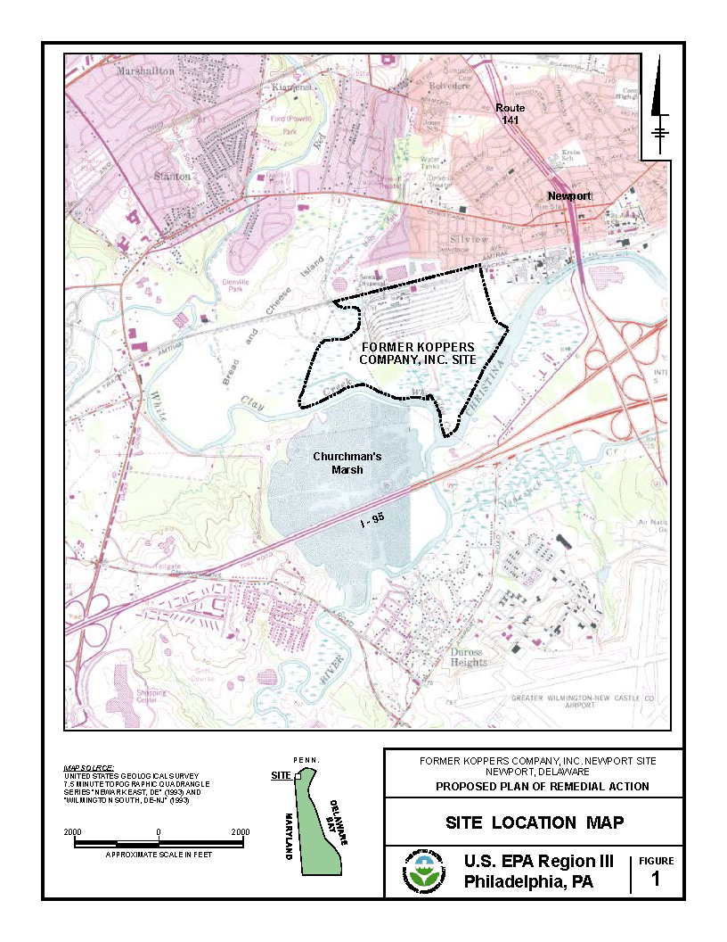

Figure 1a. Location of the Koppers Newport, DE Superfund Site (from USEPA 2022)

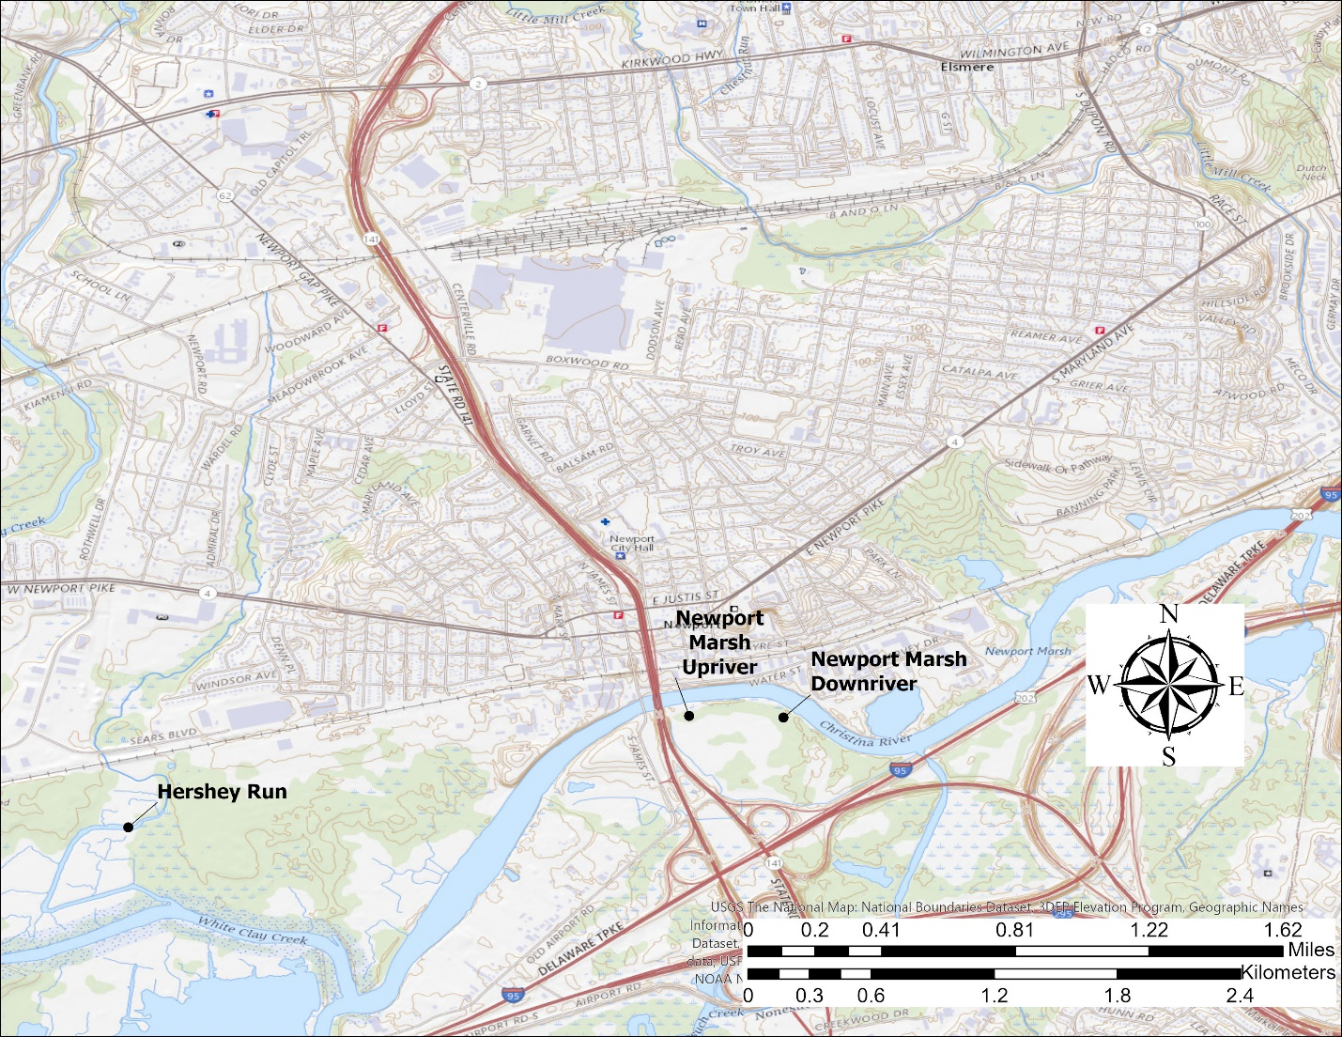

Figure 1b. Location of the Koppers Newport, DE Superfund Site showing Hershey Run and nearby Newport Marsh to be used as a reference area.

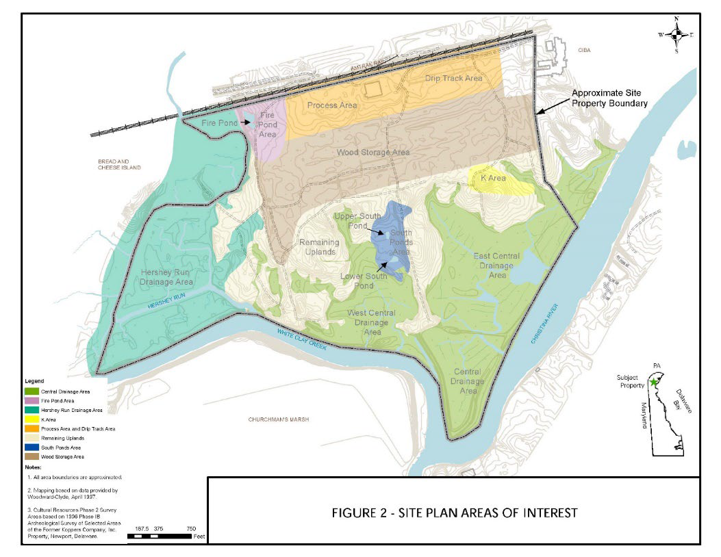

Figure 2. Site plan areas of interest (from USEPA 2022)

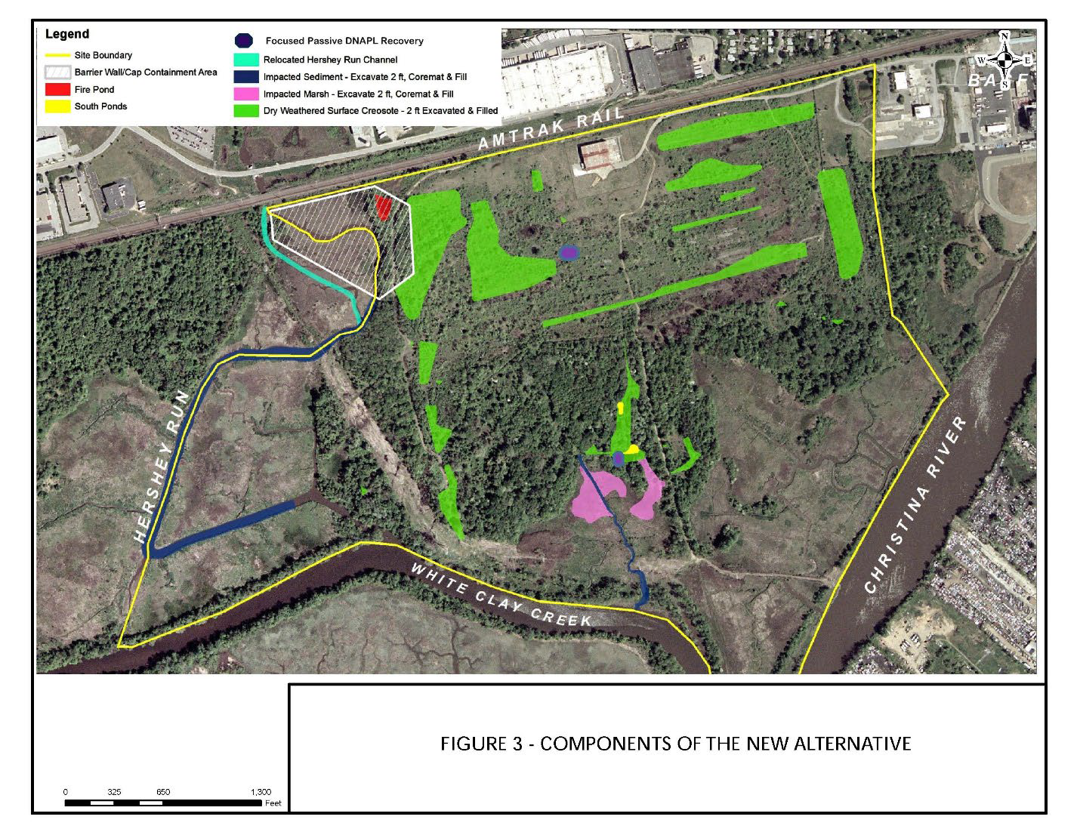Figure 3. Components of the new alternative (from USEPA 2022)

Two frozen mummichog fish individuals, typical female specimen on left and typical male specimen on right. 

Figure 4. Adult mummichogs (*Fundulus heteroclitus*); Female (L), Male (R).