Scope of Work: Bird Injury Data Gap Studies
Koppers Delaware Superfund Site
Submitted to the Department of the Interior NRDAR Program by
Fred Pinkney, USFWS, Chesapeake Bay Field Office (CBFO) March 2023
Fred_Pinkney@fws.gov

Introduction

Purpose of the Project
This Scope of Work is for bird injury studies to be funded by the Department of the Interior Natural Resources Damage Assessment and Restoration (NRDAR) Program. These studies address data gaps for the Koppers Delaware Superfund Site (Koppers) Injury Assessment. The site background and history are taken from the recently approved Preliminary Assessment Screen (PAS) which recommended proceeding with a NRDAR case (Pinkney et al. 2022).

The Koppers Site
The Koppers Co., Inc. (Newport Plant) Superfund Site (Site) is comprised of approximately 121 hectares (ha) (=300 acres (ac)), located southwest of Newport, Delaware (Figure 1a, b, 2). In 1929, three parcels comprising the Site were conveyed by Lynam and Wright to the Delaware Wood Preserving Company, which began conducting wood treatment operations on these parcels. Wood treatment operations continued at the Site, under various owners, until 1971. The Trustees are evaluating potential releases of hazardous substances and related injuries to natural resources within the Site boundary (which is defined here as the Assessment Area).

According to the U.S. Environmental Protection Agency (USEPA 2005), the major habitat types are uplands (66 ha = 163 ac), wetlands (55 ha = 136 ac) and three small freshwater ponds (total of about 0.4 ha = 1 ac). The wetlands include freshwater tidal marsh, non-tidal emergent wetlands, non-tidal forested wetlands, and non-tidal scrub/shrub wetlands. Wetland delineations were performed in 1994 by Woodward Clyde (1997) as part of the Blasland, Bouck & Lee Inc. (BBL 2003) Remedial Investigation (RI), and in 2005 as reported in the Langan (2008) Preliminary Design Report.
Hershey Run is a 4.7-kilometer (km) (2.9-mile (mi)) stream that originates in and adjacent to the town of Newport, DE and flows southward. As it crosses Newport Pike (Route 4), it becomes a tidal freshwater stream. It enters the Site after crossing the Amtrak railroad tracks through a culvert. Approximately 1.6 km (1 mi) of Hershey Run passes through the Site, where portions of the stream appear to be channelized.
The Site borders on White Clay Creek and the Christina River (Figures 1a, b). As detailed below, elevated concentrations of contaminants found at the Site are directly attributable to the onsite wood treatment operations. Other industries and hazardous waste sites (such as the DuPont Newport Superfund Site, about 1.6 km (1 mi) upstream on the Christina River) contribute contaminants to these waterbodies. By restricting the Assessment Area to the Koppers Site boundary, issues about whether contamination is site-related are avoided.

History of the Koppers Superfund Site
Wood-treatment operations were conducted at the Site from 1929 through 1971. Wood treatment used a creosote coal tar solution, which was applied to railroad ties, telephone poles, and other wood products (BBL 2003, USEPA 2005). Pentachlorophenol with number 2 fuel oil was also used, but to a much lesser extent (USEPA 2005, 2006). Creosote (also referred to as “coal tar creosote”) is an oily complex mixture, typically composed of approximately 85 percent polycyclic aromatic hydrocarbons (PAHs) and 2 to 17 percent phenolics (Agency for Toxic Substances and Disease Registry 2002). The individual PAH compounds vary from lighter molecular weight compounds such as naphthalene to heavier compounds such as benzo(a)pyrene.
Koppers Company acquired the Site property in 1940 and reorganized in 1944 into the Koppers Company, Inc. (Koppers). Koppers continued wood-treatment operations at the Site until 1971, when the property was sold to DuPont. In December 2004, DuPont deeded the property to Beazer East, Inc. (Beazer), the successor corporation to Koppers and current owner of the Site (USEPA 2006). Beazer, Inc. identified by USEPA as the Responsible Party has funded the site investigations and will be conducting the remediation using contractors.
The Koppers Site was identified as a potential hazardous waste site in 1979 after the Subcommittee on Oversight and Investigations of the Interstate and Foreign Commerce Commission reviewed responses to a survey of the 53 largest domestic chemical companies on their waste disposal practices (USEPA 2006). Following investigations by USEPA and the State of Delaware in the 1980s, the Koppers Site was proposed for inclusion on the CERCLA National Priority List (NPL) in 1989, and formally listed in 1990. In 1991, Beazer and DuPont (the landowner at that time) agreed to conduct a Remedial Investigation/Feasibility Study (RI/FS) under the terms of an Administrative Consent Order with the USEPA (USEPA 2006). The RI was finalized in 2003 and showed that shallow soils, subsurface soils, groundwater, and sediment were contaminated with PAHs (USEPA 2006). The results of the Ecological Risk Assessment (ERA; USEPA 1997) conducted as part of the RI demonstrated that concentrations of PAHs in shallow soils, subsurface soils, groundwater, and sediment pose an unacceptable risk to upland, wetland, and aquatic communities at the Site (USEPA 2005). Several other contaminants present at the site were evaluated for potential risk as part of the ERA, but the predominant effects were due to the high concentrations of PAHs (USEPA 1997). Thus, the primary contaminants of concern (COCs) at the Site are PAHs.
In oil spills, PAHs are often the most toxic fraction to fish and avian receptors (King et al. 2021; Takeshita et al. 2021). According to the ROD, some areas of the Koppers Site have very high levels of contamination, including creosote, non-aqueous phase liquid (NAPL), and PAHs. This contamination is considered to be a principal threat waste since it is a continuous source for ground water contamination. USEPA (1991) defines principal threat waste as “source materials considered to be highly toxic or highly mobile that generally cannot be reliably contained or would present a significant risk to human health or the environment should exposure occur.”

The Remedy
After the Feasibility Study (FS) report was finalized in 2004, the USEPA issued a Record of Decision (ROD), in which a remedial action was selected for implementation at the Site, in 2005 (USEPA 2005, 2006). Based on results of toxicity testing conducted as part of the ERA, USEPA (2005) determined that a sediment cleanup criterion of 150 mg/kg = parts per million (ppm) total PAHs and a soil cleanup criterion of 600 ppm total PAHs were appropriate levels to protect the environment.
The Administrative Order (USEPA 2006) directed Beazer to implement the remedial action selected in the ROD. As part of the Remedial Design Investigation, Langan (2008) recommended modifications to reduce the cost and complexity of the cleanup and still achieve the ROD objectives. These included reducing the depth of excavation and not using site sediments as part of a wetland mitigation bank (Langan 2019).
Beazer submitted a request for ROD Amendment in April 2019 and the ROD Amendment was issued in August 2022 (USEPA 2022). The ROD is “a final remedy for soils, sediments, and DNAPL in the saturated zone serving as a source for groundwater contamination; and an interim remedy for groundwater that will address certain risks presented by contamination but will not restore the groundwater to beneficial use. Selection of a comprehensive (final) groundwater remedy will take place in a subsequent decision document.” Although the Amendment modifies portions of the remedy selected in the 2005 ROD; the cleanup criteria remain the same (USEPA 2022). It is likely that remedial design work will be completed within 12 to 18 months of the issuance of the ROD. Thus, cleanup activities are projected to start in 2024 and finish in 2027 (D. Taylor, USEPA Region 3, personal communication).
The ROD identified areas of the site with high levels of liquid creosote in the groundwater. The liquid creosote is found in a NAPL with a density slightly greater than water. The remedy is intended to minimize the ongoing contamination of groundwater from the presence of NAPL in the saturated zone through removal and/or containment. The remedy will include the realignment of Hershey Run to avoid high contamination areas and where the containment area extends into the wetlands area and Upper Hershey Run (Figures 2, 3). Proposed remedial measures will affect both tidal (~ 3.2 hectares (8 acres)) and freshwater wetlands (~0.16 hectares (0.4 acres)). Surface water, sediments, and biota will be monitored to determine if risk has been reduced to acceptable levels and that the remedy continues to be effective (USEPA 2022).

NRDAR
Natural Resource Damage Assessment and Restoration (NRDAR) is a regulatory process to determine the amount and type of restoration needed to compensate the public for injuries to natural resources resulting from the release of hazardous substances into the environment. The ultimate goal of the NRDAR is to restore natural resources that have been injured by a hazardous substance(s) to baseline, which is defined as the condition of the resource that would have existed if the hazardous substances were not released (43 CFR §11.14(e)), and obtain compensation for public losses pending restoration to that baseline condition. There are two categories of injury: 1) those that occur before the remediation (dating back to 1980 for CERCLA); and 2) those that occur resulting from the remediation. Because of the schedule for cleanup activities, the Trustees—Department of the Interior (DOI) led by the U.S. Fish and Wildlife Service Chesapeake Bay Field Office (CBFO), State of Delaware Department of Natural Resources and Environmental Control (DNREC), and Department of Commerce, National Oceanic and Atmospheric Administration (NOAA)—need to conduct data gap studies at an accelerated pace to be able to calculate injury.
DOI NRDA regulations provide definitions used to assess injuries to biological resources. As defined at 43 CFR §11.62(f), an injury to a biological resource has resulted from the discharge of a hazardous substance if concentration of the substance is sufficient to: 1) Exceed action or tolerance levels established under section 402 of the Food, Drug and Cosmetic Act, 21 U.S.C. 342 in edible portions of organisms, 2) Exceed levels for which an appropriate State health agency has issued directives to limit or ban consumption of such organism pursuant to 43 CFR §11.62(f)(1)(iii), or 3) Cause the biological resource or its offspring to have undergone at least one of the following adverse changes in viability: death, disease, behavioral abnormalities, cancer, genetic mutations, physiological malfunctions (including malfunctions in reproduction), or physical deformations pursuant to 43 CFR §11.62(f)(1)(i).
The Koppers PAS (Pinkney et al. 2022) was approved by the Trustees in December 2022. Through the PAS, the Trustees have made a preliminary determination that the criteria specified in the CERCLA NRDAR regulations have been met. Furthermore, the Trustees have determined that there is a reasonable probability of making a successful claim for damages with respect to natural resources over which the Trustees have trusteeship. Therefore, the Trustees have determined that a NRDAR is warranted. The schedule for the Data Gap Study is triggered by the need to complete field work before the site is altered (presumably in 2024) by the remedial action.

Rationale for the Bird Data Gap Study
According to the Remedial Investigation, over 100 species of birds that have been observed on or near the Koppers Site, with eBird observations from the nearby Russell Peterson Wildlife Refuge (about 6.4 km (4 miles) upstream), 194 bird species are listed (see Pinkney et al. 2022). These include migratory birds which are Department of the Interior Trust Resources. Both aquatic and non-aquatic species utilize the various habitats at the Koppers Site.
Birds that feed and breed on the site are likely to be exposed to PAHs and other contaminants that are present in water, sediments, invertebrates, fish, and amphibians. For example, herons are likely to feed on mummichogs (Fundulus heteroclitus) (Post 2008) that are abundant in Hershey Run (Woodward-Clyde 1997). Upland and marsh species would feed on earthworms, insects, spiders, and other invertebrates.
The Remedial Investigation did not adequately assess risk to birds because it focused on exposure through the food chain (Woodward Clyde 1997). Whereas PAHs in creosote are not biomagnified, birds can be exposed chronically to these compounds through the diet, especially through invertebrates which have a far lower ability to metabolize PAHs than fish (Logan 2017, Paruk et al. 2016, 2022). This was demonstrated by Paruk et al. (2014, 2016) who showed that common loon (Gavia immer) overwintering in the Gulf of Mexico had detectable concentrations of PAHs in blood, indicating recent exposure. Those studies were conducted several years after the 2010 Deepwater Horizon release and the authors theorized that exposure occurred through releases of sediment in storms and by consuming invertebrates. Paruk et al. (2016) reported that lower body mass was significantly related to higher blood PAH concentrations. In another Deepwater Horizon study, Fallon et al. (2018) reported that several bird species experienced oxidative injury to erythrocytes, had decreased volume of circulating erythrocytes, and showed evidence of a regenerative hematological response in the form of increased reticulocytes compared with reference populations. Such findings are consistent with the definition of injury specified in 43 CFR §11.62(f)(3). Songbirds are susceptible to exposure to and effects of PAHs, as demonstrated by recent studies on Gulf Coast seaside sparrows (Perez-Umphrey et al. 2018, Bonisoli-Alquati et al 2020, Angel 2020).
According to Malcolm and Shore (2003), eggs provide a good tissue to monitor PAHs in birds because they contain higher concentrations than tissues with efficient metabolism. In a literature review, Albers (2006) reported that multiple studies detected PAHs in wild bird eggs. For example, Shore et al. (1999) reported total PAH concentrations of 1.59 to 8.44 ng/g in a survey of seabird species in Great Britain. Higher concentrations (total PAHs of 21.20 ng/g to 461.08 ng/g) were reported in peregrine falcon eggs collected in Spain after the Prestige oil spill (Zuberogoitia et al. 2006). The authors stated that these concentrations were high enough to be lethal to embryos. Albers (2006) stated that 4 to 6-ring PAHs [which are found in creosote] were the most embryotoxic compounds. Based on laboratory studies, Albers (2006) concluded that minute quantities of PAHs are highly toxic to embryos.

Approach and Objectives
In winter and spring 2022-23, a site visit will be conducted to observe the species of birds that are present, feeding behavior in the various habitats on the site (uplands, marshes, Hershey Run, creek banks and mud flats). The Trustees will also investigate the presence and locations of prey items such as earthworms, insects, snails, and spiders. Based on home ranges and abundance, the most likely bird receptor species will be American Robin (Turdus migratorius, from the upland areas) and Red-winged Blackbird (Agelaius phoeniceus, from the marsh; D. Cristol, College of William and Mary, personal communication; Figure 4). Robins return to the same site year after year to breed and utilize mud as part of their nesting materials (https://www.wild-bird-watching.com/Robins.html). The typical breeding season is from April to July and the territory is about 0.55 hectares (https://www.rspb.org.uk/birds-and-wildlife/wildlife-guides/bird-a-z/robin/territory/). In the breeding season, red-winged blackbirds are found in small trees and bushes along freshwater, estuarine, and saltwater marshes and watercourses, in agricultural areas and dry meadows. https://animalia.bio/red-winged-blackbird). They feed on seeds, fruit, berries, insects, spiders, mollusks, worms, snails, mussels, crayfish, frogs, lizards, nestlings, and birds' eggs. Their territories are about 0.2 hectares (http://www.biokids.umich.edu/critters/Agelaius_phoeniceus/#:~:text=Home%20range%20and%20territory%20size,along%20with%20many%20other%20females ).
We have identified two possible reference sites, both of which are on state land in New Castle County: Augustine State Wildlife Management Area (https://dnrec.maps.arcgis.com/apps/MapSeries/index.html?appid=680db83c087a4adea2975de40eedd226) and Blackbird Creek National Estuarine Reserve https://dnrec.maps.arcgis.com/apps/MapSeries/index.html?appid=f1e51517c01f44ebb1415c20dc5b1b70). Based on eBird data and discussions with DNREC wildlife specialists and managers, it is likely that adequate numbers of these species will be available. These reference areas are approximately 32 km (20 miles) from the Koppers Site (Figures 1b, 5).
In spring 2023, the Trustees will prepare a Work Plan and conduct studies when both species breed. The objectives are to determine whether there is evidence of bird injury as defined in 43 CFR §11.62(f)(3). Exposure and response to PAHs will be compared between Koppers and Blackbird Creek and with literature values (e.g. Zuberogoitia et al. 2006). For exposure, PAH concentrations will be measured in invertebrates (prey), bird blood, and eggs. Response will be determined through blood clinical chemistry and other blood parameters.

Methods

General
Procedures for capture of the birds, blood sampling and egg sampling procedures will be provided in the Work Plan, based on the selection of the target species. Animal care protocols used in previous U.S. Geological Survey research projects will be followed and updated as needed. To the extent possible, the methods will consist of non-lethal blood sampling and release, as well as partial clutch collection to minimize population effects. Standard blood collecting protocols used by the U.S. Geological Survey will be used. The target is to collect blood samples from 20 birds of each of the two species from each location (Site and reference). To the extent possible, both sexes will be sampled. This sample size is the minimum that would provide a robust comparison between sites, while keeping effort and analytical costs reasonable.

Avian density
Standard “point count” surveys will be carried out by a skilled technician who can identify all local bird species by vocalization and estimate distance to each detected bird. Locations will be >150 m apart, randomly placed across the landscape in a manner that maximizes coverage. For a site this small, coverage will be nearly complete. Each survey point will be visited early in the morning for 10 minutes, three times, during the last week of May and first week of June (after migration but before song volume has decreased due to young-rearing activities). These data will be used in the evaluation of injury for NRDAR purposes.
Egg collection and analysis
Nests will be located, beginning in early May, by observing behavior of parents during nest-building or searching appropriate habitats. The same technician doing the bird surveys in mornings can search for nests throughout the day. When nests are located, they will be checked until an egg is laid, and then visited upon clutch completion for collection of two eggs (leaving 2-3 eggs for parents to raise). Eggs will be kept chilled until contents can be removed from shell under clean, well-ventilated conditions, using acid-washed jars and dissection tools cleaned with distilled water, acetone, and xylenes. Both eggs from a clutch will be combined into one sample jar and frozen at -25° C, until being shipped to SGS AXYS for analysis of PAHs (see Table 1). The same number of eggs of the same species will be collected from the reference site to establish baseline reproductive exposure. Quail eggs from a commercial source will be included for QAQC to detect contamination from a source other than the collected egg tissue.

Blood Chemistry
Blood chemistry samples will be analyzed under the supervision of Drs. Anthony Provatas and Christopher Perkins at the University of Connecticut, Center for Environmental Science and Engineering (Storrs, CT) using a slightly modified version of previously published work (Paruk et al. 2014; Provatas et al. 2015). The analytes are listed in Table 2. Standard quality assurance procedures will be employed including analysis of duplicate samples, method blanks (Blank), post digestion spiked samples, laboratory control samples, and standard reference materials where available (Standard Reference Material (SRM)-2974a and SRM-1947; National Institute of Standards and Technology). Method Detection limits are compound specific but will range from 0.5 to 8.5 ng/mL.

Hematology and Plasma Biochemistry
Biochemistry analyses will be conducted in the laboratory directed by Dr. Carolyn Cray, Department of Pathology & Laboratory Medicine, University of Miami Miller School of Medicine, Miami, FL. Hematology samples to be analyzed will consist of whole blood and two air dried blood smears. Additional biochemistry analyses will be conducted on plasma include a broad panel of analytes (Table 3) as well as haptoglobin and ferritin. Analyses will be conducted as described in Dean et al. (2017).

Invertebrate sampling and analysis
Based on the reconnaissance, appropriate invertebrate species will be collected for PAH analyses (Table 1) in the upland and marsh habitats at Koppers and Blackbird Creek/Augustine State Wildlife Management Area (Blackbird/Augustine; Figures 1b, 5) in spring 2023. In the upland, these will most likely be earthworms, although if they are not abundant, insects will be collected as well. In the marsh, we will target species such as fiddler crabs, crayfish, or snails. It is possible that separate samples will be collected if a single species is not adequate for tissue analyses. A total of 10 samples are targeted in each habitat at each site.
These data will be used to document potential exposure of birds and compare concentrations across the Koppers and Blackbird/Augustine sites. Invertebrates are far less efficient at metabolizing PAHs (Logan 2017); thus, tissue concentrations have been used as a monitoring tool in various species of shellfish such as oysters and mussels in monitoring programs such as Mussel Watch (Sericano et al. 1995). The number and species of invertebrate samples will be determined based on the site reconnaissance. The analysis for sediment PAHs is applicable to tissue samples

Data analysis
For each bird species and tissue (blood and egg), and for the invertebrates, summary statistics will be prepared for the indicators of exposure, i.e. individual PAHs, as well as parent and alkylated alkylated PAHs, 2-3 ring vs. >4 ring PAHs, and total PAHs). An analogous approach will be used to summarize the blood response data. Comparisons between locations will follow standard statistical approaches, including exploration of possible covariates such as sex.
Program DISTANCE (or comparable R software package) will be used to estimate density of breeding territories for each common species on the contaminated site. Population surveys will not be carried out on the reference site because only the population at the contaminated site is relevant to injury quantification, i.e., there is no hypothesis of change in standing population size due to exposure given the high dispersal ability of birds, their meta-population structure, and the likelihood that new birds will quickly settle on territories vacated by injured individuals.

Quantifying NRDA Bird Injury
Results of the bird studies will be used to quantify losses in habitat, resources, and ecological services. By choosing upland and marsh species with excellent site fidelity, separate calculations can be made for each habitat type. Bird injury assessments have been conducted in many relevant NRDA cases involving exposure to PAHs through oil spills (Deepwater Horizon and Exxon Valdez) and chronic releases from hazardous waste sites (e.g., Metro Container, along the Delaware River). A brief review of pathways for PAH exposure in birds is provided in the Metro Container PAS (NOAA et al. 2022).
Two common approaches to scaling in injury assessment are Habitat Equivalency Analysis (HEA) and Resource Equivalency Analysis (REA; described in Baker et al. 2020). In both approaches, a service loss is calculated based on biological data. The public is made whole through restoration of the amount of habitat (HEA) and/or biota (REA) needed to return the injured resource to baseline conditions and if necessary to compensate for any interim losses. Cacela et al. (2005) provided a framework for HEA that accounts for the type and severity of effects and whether it is at the cellular, individual, or population level. Recently, Baker et al. (2020) developed Habitat based Resource Equivalency Method (HaBREM) as a procedure for sites with multiple habitat types and multiple injuries. Thus, this procedure may be appropriate for the Koppers Site. According to Patrick Lee (DOI, Office of Policy Analysis, personal communication) DOI economists have used HaBREM at several NRDA sites. Mr. Lee is the economist assigned to the Koppers site and will play a critical role in determining how to apply these models to the data gap studies and existing data to scale ecological service losses, determine injury, and help identify restoration projects.

Schedule, Deliverables
Spring: 2023; Site reconnaissance and develop work plan
Spring 2023: Conduct bird field work and obtain blood, egg, and invertebrate samples
Summer 2023: Receive laboratory results from bird blood analyses
Fall 2023: Analyze data and submit interim report
Winter 2024: Prepare draft final report
Spring/Summer 2024: Prepare final report with detailed response to comments. Prepare fact sheet and release to the public.
September 30, 2024: Closeout

Key Personnel (Resumes are available)
Dr. Fred Pinkney, U.S. Fish and Wildlife Service Chesapeake Bay Field Office will serve as Principal Investigator
Dr. Dan Cristol, Department of Biology, College of William and Mary will direct the bird sampling efforts.
Dr. Barnett Rattner, U.S. Geological Survey, Eastern Ecological Science Center at the Patuxent Research Refuge, will provide expertise on study design, data analysis, and interpretation. He will assist on the bird sampling.
Dr. Carolyn Cray, University of Miami Medical Center, will analyze the blood for clinical chemistry and evidence of damage.
Dr. Anthony Provatas, University of Connecticut, Center for Environmental Sciences and Engineering, will conduct the blood tissue chemistry analysis.

References
Agency for Toxic Substances and Disease Registry (ATSDR). 2002. Toxicological profile for wood creosote, coal tar creosote, coal tar, coal tar pitch, and coal tar pitch volatiles. Atlanta, GA.
Albers, P.H. 2006. Birds and polycyclic aromatic hydrocarbons. Avian and Poultry Biology Reviews 17:125-140.
Angel, A., 2020. Oxidative stress response in the seaside sparrow (Ammospiza maritima) following the Deepwater Horizon oil spill. Masters thesis, Louisiana State University.
Baker, M., A. Domanski, T. Hollweg, J. Murray, D. Lane, K. Skrabis, R. Taylor, T. Moore, and
L. DiPinto. 2020. Restoration scaling approaches to addressing ecological injury: The Habitat-Based Resource Equivalency Method. Environmental Management 65:161–177.
BBL, Inc. 2003. Remedial Investigation Report. Former Koppers Co., Inc. Newport Site,
Newport, Delaware. Volume 1 of 3, Revised draft. BBL, Inc., Syracuse, NY.
Bonisoli-Alquati, A., W. Xu, P.C. Stouffer, and S.S. Taylor. 2020. Transcriptome analysis indicates a broad range of toxic effects of Deepwater Horizon oil on Seaside Sparrows. Science of the Total Environment 720:137583.
Cacela, D. J. Lipton, D. Beltman, J. Hansen, and R. Wolotira. 2005. Associating ecosystem service losses with indicators of toxicity in Habitat Equivalency Analysis. Environmental Management 35:343-351.
Dean, K.M., S.J. Bursian, D. Cacela, M.W. Carney, F.L. Cunningham, B. Dorr, K.C. Hanson-Dorr, K.A. Healy, K.E. Horak, J.E. Link, and I. Lipton. 2017. Changes in white cell estimates and plasma chemistry measurements following oral or external dosing of double-crested cormorants, Phalacocorax auritus, with artificially weathered MC252 oil. Ecotoxicology and Environmental Safety 146:40-51.
Delaware Department of Natural Resources and Environmental Control (DNREC). 1999. Delaware national estuarine research reserve estuarine profiles. Dover, DE.
Fallon, J.A., E.P. Smith, N. Schoch, J.D. Paruk, E.A. Adams, D.C. Evers, P.G.R. Jodice, C. Perkins, S. Schulte, and W.A. Hopkins. 2018. Hematological indices of injury to lightly oiled birds from the Deepwater Horizon oil spill. Environmental Toxicology and Chemistry 37:451-461.
King, M.D., J.E. Elliott, and T.D. Williams. 2021. Effects of petroleum exposure on birds: A review. Science of The Total Environment 755:142834.
Langan, Inc. 2008. Preliminary Design Report —Excavation/Capping of Soils and Sediment, Hershey Run Remediation, Relocation, and Restoration. Former Koppers Company, Inc. Newport Site, Newport, Delaware. Volume I. Philadelphia, PA. 95 p.
Langan, Inc. 2019. Final Remedy Modification and Record of Decision Amendment Technical Document Remedial Design and Remedial Action Former Koppers Company, Inc. (Newport, Delaware) Site. Philadelphia, PA. 60 p.
Logan, D.T. 2007. Perspective on ecotoxicology of PAHs to fish. Human and Ecological Risk Assessment 13:302-316.
Malcolm, H.M. and R.F. Shore. 2003. Effects of PAHs on terrestrial and freshwater birds, mammals and amphibians. In: PAHs:An Ecotoxicological Perspective, P. Douben, editor, John Wiley & Sons, Cambridge, U.K. pp. 225-242.
National Oceanic and Atmospheric Administration (NOAA), United States Department of the Interior Fish and Wildlife Service Commonwealth of Pennsylvania Fish and Boat Commission and Department of Environmental Protection. 2022. Preassessment Screen Determination for the Metro Container Superfund Site Natural Resource Damage Assessment. NOAA, Silver Spring, MD.
Paruk, J.D., D. Long, C. Perkins, A. East, B. Sigel, D. Evers. 2014. Polycyclic aromatic hydrocarbons detected in common loons (Gavia immer) wintering off coastal Louisiana. Waterbirds 37:85-93.
Paruk, J.D., E.M. Adams, H. Uher-Koch, K.A. Kovach, D. Long IV, C. Perkins, N. Schoch, and D.C. Evers. 2016. Polycyclic aromatic hydrocarbons in blood related to lower body mass in common loons. Science of the Total Environment 565:360-368.
Paruk, J.D., H. Uher-Koch, K. Kovach, A. Byrd, A. Dolley, C. Cray, J.A. Hernandez, and N.I. Stacy. 2022. Evidence of Subclinical Inflammation Relates to PAH Exposure in Overwintering Common Loons (Gavia immer). Waterbirds 44:317-323.
Perez-Umphrey, A.A., C.M.B. Burns, P.C. Stouffer, S. Woltmann, and S.S. Taylor. 2018. Polycyclic aromatic hydrocarbon exposure in seaside sparrows (Ammodramus maritimus) following the 2010 Deepwater Horizon oil spill. Science of the Total Environment 630:1086-1094.
Pinkney, A.E., S. Ciparis, O. Griffin, and R. M. Wetzel. 2022. Preliminary Assessment Screen of the Koppers Delaware Superfund Site for Natural Resource Damage Assessment.. U.S. Fish and Wildlife Service, Chesapeake Bay Field Office, Annapolis, MD.
Post, W. 2008. Food exploitation patterns in an assembly of estuarine herons. Waterbirds
31:179-192.
Provatas, A.A., A.V. Yeudakimau, C.A. King, E.L. Gatley, J.D. Stuart, D.C. Evers, C.R. Perkins. 2015. Rapid QuEChERS extraction with novel phospholipid cleanup: A streamlined UHPLC-UV approach for screening PAHs in avian blood cells and plasma. Journal of Separation Science 38:2677-2683.
Sericano, J.L., T.L. Wade, T.J. Jackson, J.M. Brooks, B.W. Tripp, J.W. Farrington, L.D. Mee, J.W. Readmann, J-P. Villeneuve, and E.D. Goldberg. 1995.Trace organic contamination in the Americas: an overview of the US National Status & Trends and the International ‘Mussel Watch’programmes. Marine Pollution Bulletin 31:214-225.
Shore, R.F., J. Wright, J.A. Horne, and T.H. Sparks. 1999. Polycyclic aromatic hydrocarbon (PAH) residues in the eggs of coastal-nesting birds from Britain. Marine Pollution Bulletin 38:509-513.
Takeshita, R., S.J. Bursian, K.M. Colegrove, T.K. Collier, K. Deak, K.M. Dean, S. De Guise et al. 2021. A review of the toxicology of oil in vertebrates: what we have learned following the Deepwater Horizon oil spill. Journal of Toxicology and Environmental Health, Part B 24:355-394.
U.S. Environmental Protection Agency (USEPA). 1991. A guide to principal threat and low-level threat wastes. Superfund publication 9380.3-06FS, Office of Solid Waste and Emergency Response, Washington, DC.
U.S. Environmental Protection Agency (USEPA).1997. Final Ecological Risk Assessment. Former Koppers Company Inc. Site, Newport, DE. US EPA, Environmental Response Team, Edison, NJ.
U.S. Environmental Protection Agency (USEPA). 2005. Record of Decision. Koppers Co. Inc. (Newport Plant) Superfund Site. Newport, New Castle County, Delaware. U.S. EPA Region 3, Philadelphia, PA
U.S. Environmental Protection Agency (USEPA). 2006. Administrative Order for Remedial Design/Action. In the Matter of Koppers, Co., Inc. (Newport Plant) Superfund Site. Docket No. CERC-03-2006-0266DC. https://semspub.epa.gov/work/03/2068465.pdf
U.S. Environmental Protection Agency (USEPA). 2022. Record of Decision Amendment Koppers Co., Inc (Newport Plant) Superfund Site, Newport/New Castle County, Delaware. https://semspub.epa.gov/work/03/2330854.pdf
Woodward Clyde, Inc. 1997. Remedial Investigation Report. Former Koppers Co., Inc. Newport Site, Newport, Delaware. Volumes 2 and 3. Woodward Clyde, Inc., Blue Bell, PA.
Zuberogoitia, I., J.A. Martínez, A. Iraeta, A. Azkona, J. Zabala, B. Jiménez, R. Merino, R. and G. Gomez. 2006. Short-term effects of the prestige oil spill on the peregrine falcon (Falco peregrinus). Marine Pollution Bulletin 52:1176-1181.

TABLES

Table 1. Invertebrates and bird eggs: List of PAHs, detection limits, and laboratory method citation.

Polynuclear Aromatic Hydrocarbons
Standard PAH Parents and Select Alkylated PAHs determined by linearity
Acenaphthene | 1-Methylnaphthalene | C1-Biphenyls
Acenaphthylene | C1-Naphthalenes | C2-Biphenyls
Anthracene | 1,2-Dimethylnaphthalene | C1-Acenaphthenes
Benz(a)anthracene | C2-Naphthalenes | 2-Methylfluorene
Benzo(b)fluoranthene | 2,3,6-Trimethylnaphthalene | C1-Fluorenes
Benzo(j/k)fluoranthenes | C3-Naphthalenes | 1,7-Dimethylfluorene
Benzo(a)pyrene | 1,4,6,7-Tetramethylnaphthalene | C2-Fluorenes
Benzo(e)pyrene | C4-Naphthalenes | C3-Fluorenes
Benzofluoranthenes | 2-Methylphenanthrene | 2/3-Methyldibenzothiophenes
Benzo(ghi)perylene | 3-Methylphenanthrene | C1-Dibenzothiophene
Chrysene | 9/4-Methylphenanthrenes | 2,4-Dimethyldibenzothiophene
Dibenzo(ah)anthracene | 2-Methylanthracene | C2-Dibenzothiophene
Dibenzothiophene | C1-Phenanthrenes/Anthracenes | C3-Dibenzothiophene
2,6Dimethylnaphthalene | 1,7-Dimethylphenanthrene | C4-Dibenzothiophene
Fluoranthene | 1,8-Dimethylphenanthrene | 3-Methylfluoranthene/ Benzo(a)fluorene
Fluorene | 2,6-Dimethylphenanthrene | C1-Fluoranthenes/Pyrenes
Indeno(1,2,3-cd)pyrene | 3,6-Dimethylphenanthrene | C2-Fluoranthenes/Pyrenes
2-Methylnaphthalene ¹ | C2-Phenanthrenes/Anthracenes | C3-Fluoranthenes/Pyrenes
1-Methylphenanthrene | 1,2,6-Trimethylphenanthrene | C4-Fluoranthenes/Pyrenes
Naphthalene | C3-Phenanthrenes  /Anthracenes | 1-Methylchrysene
Perylene | Retene | 5/6-Methylchrysenes
Phenanthrene | C4-Phenanthrenes/Anthracenes | C1-Benz(a)anthracenes/Chrysenes
Pyrene | Biphenyl | 5,9-Dimethylchrysene
C2-Benz(a)anthracenes/Chrysenes
2,3,5- Trimethylnaphthalene |  | C3-Benz(a)anthracenes/Chrysenes
7-Methylbenzo(a)pyrene |  | C4-Benz(a)anthracenes/Chrysenes
C1-Benzofluoranthenes/ Benzopyrenes
C2-Benzofluoranthenes/ Benzopyrenes
Detection limit for PAHs: 0.1-0.2 parts per billion (µg/kg)
Laboratory: SGS AXYS, Sidney, British Columbia, Canada
SGS AXYS (2021). METHOD MLA-021 REV. 12 VER. 07: ANALYTICAL METHOD FOR THE DETERMINATION OF POLYCYCLIC AROMATIC HYDROCARBONS (PAH), ALKYLATED POLYCYCLIC AROMATIC HYDROCARBONS, AND ALKANES SGS AXYS Method MLA-021

Table 2. Bird blood: List of parent and alkyl PAHs (C. Perkins, University of Connecticut).
Detection limits range from 0.5 to 8.5 ng/mL. ª

Parent PAHs | Alkyl PAHs
Naphthalene | 2-methyl naphthalene
Acenaphthylene | 2,6-dimethyl naphthalene
Acenaphthene | 1,3-dimethylnaphthalene
Fluorene | 1,5-dimethylnaphthalene
Phenanthrene | 2,3,5-trimethylnaphthalene
Anthracene | 1-methylfluorene
Fluoranthene | 3-methylphenanthrene
Pyrene | 1-methylchrysene
Benzo(a)anthracene | 4-methylchrysene
Chrysene | 3,11-dimethylchrysene
benzo(b)fluoranthene | 7,12-dimethylbenz(a)anthracene
Benzo(k)fluoranthene | 1-methylbenz(a)anthracene
benzo(a)pyrene
Indeno(1,2,3-cd)pyrene
Dibenzo(a,h)anthracene
benzo(g,h,i)perylene
------------------------------------------------------------------------------------------------------------------------
ªAfter processing, samples will be analyzed using an Agilent 6890 gas chromatograph equipped with a Restek Rxi-5Sil MS column (30 m) using splitless injection coupled to a Waters Quattro Micro triple quadruple mass spectrometer. All peaks will be quantified against an internal standard of chrysene-d12, and extraction efficiency will be evaluated using surrogate standards of naphthalene-d8 and perylene-d12. See Paruk et al. (2014) and Provatas et al. (2015).

Table 3. List of blood parameters (University of Miami School of Medicine, Carolyn Cray)
Plasma, approximately 0.4-0.5ml, frozen at -80C and shipped on dry ice as a batch.
Testing: haptoglobin, ferritin, general chemistry panel (= advanced avian panel)
Whole blood, 0.1-0.2ml and 2 freshly made blood smears need to ship for next day delivery
Testing: Complete Blood Count (CBC): inclusive of White Blood Cell (WBC) Count, Red Blood Cell (RBC) count, Packed Cell Volume (PCV), White Blood Cell differential, polychromasia evaluation, hemoglobin

FIGURES

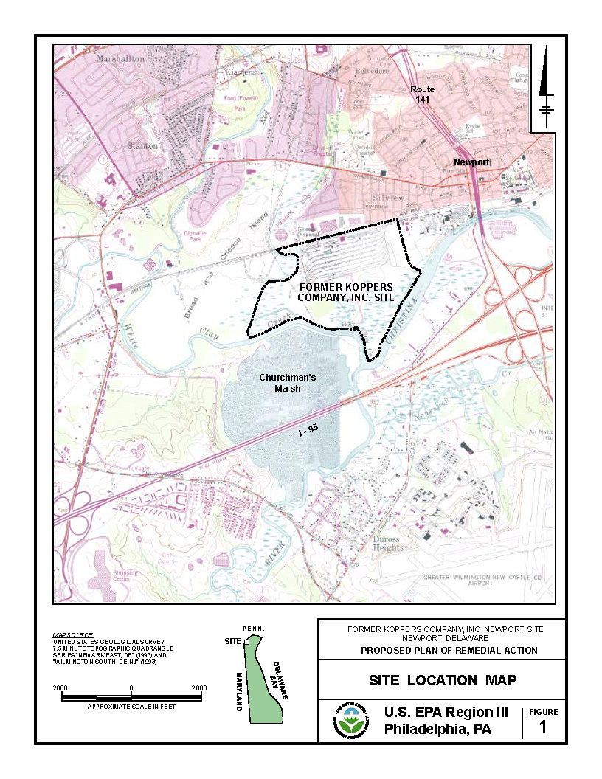
Figure 1a. Location of the Koppers Newport, DE Superfund Site (from USEPA 2022).

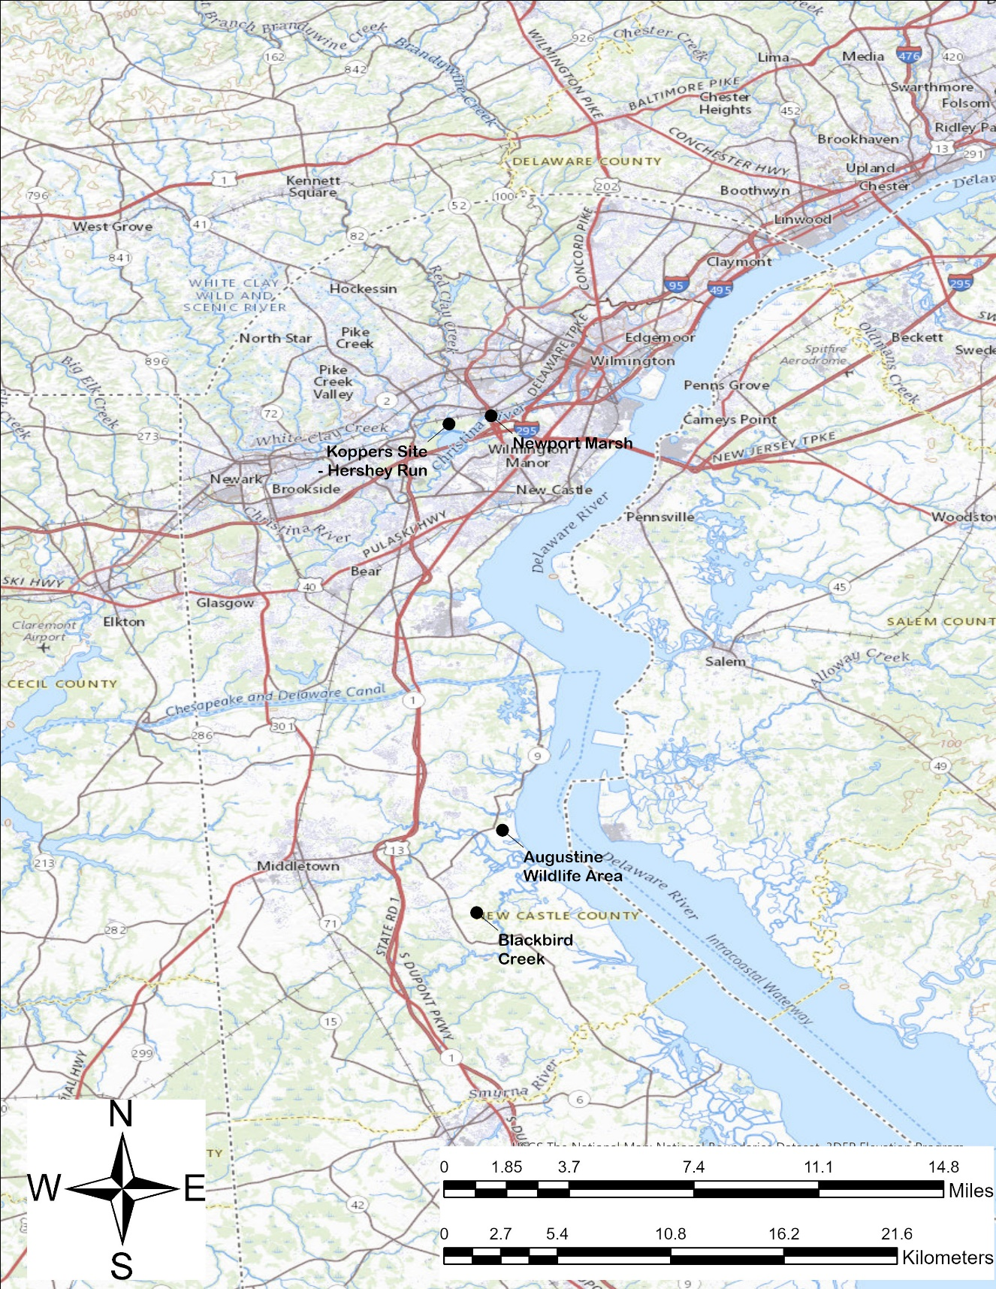
Figure 1b. Location of the Koppers Newport, DE Superfund Site showing Hershey Run, Newport Marsh (reference area for fish and amphibian studies) along with Blackbird Creek and Augustine Areas (serving as bird reference areas).

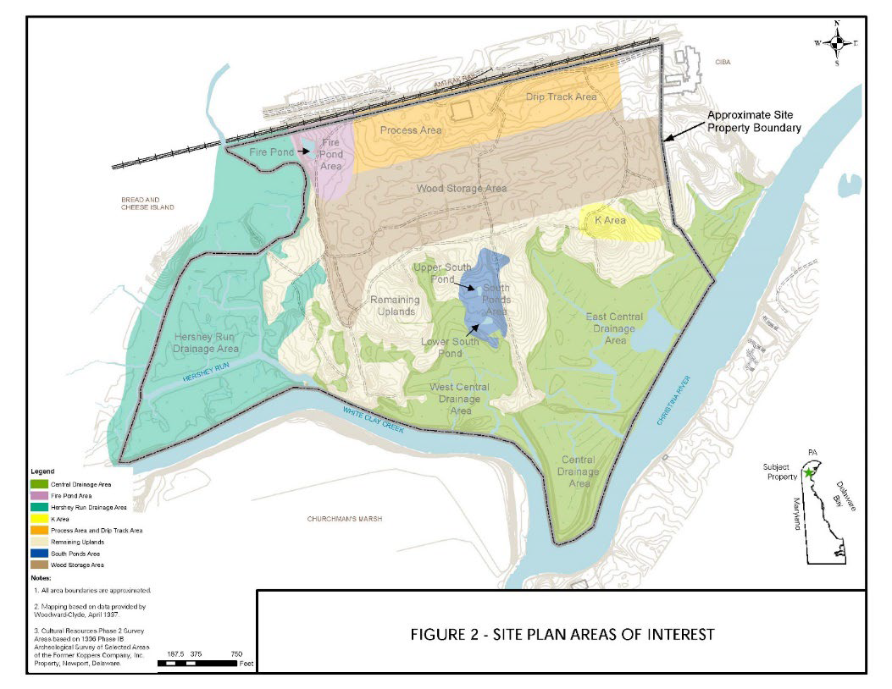
Figure 2. Site plan areas of interest (from USEPA 2022)

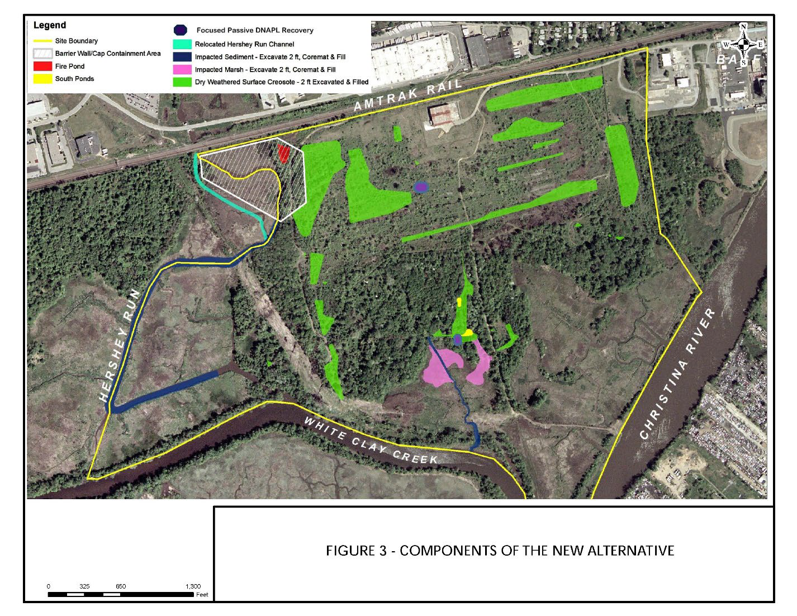Figure 3. Components of the new alternative (from USEPA 2022)

Figure 4. Red-winged Blackbird (Agelaius phoeniceus, male, left); American Robin (Turdus migratorius, male, right)
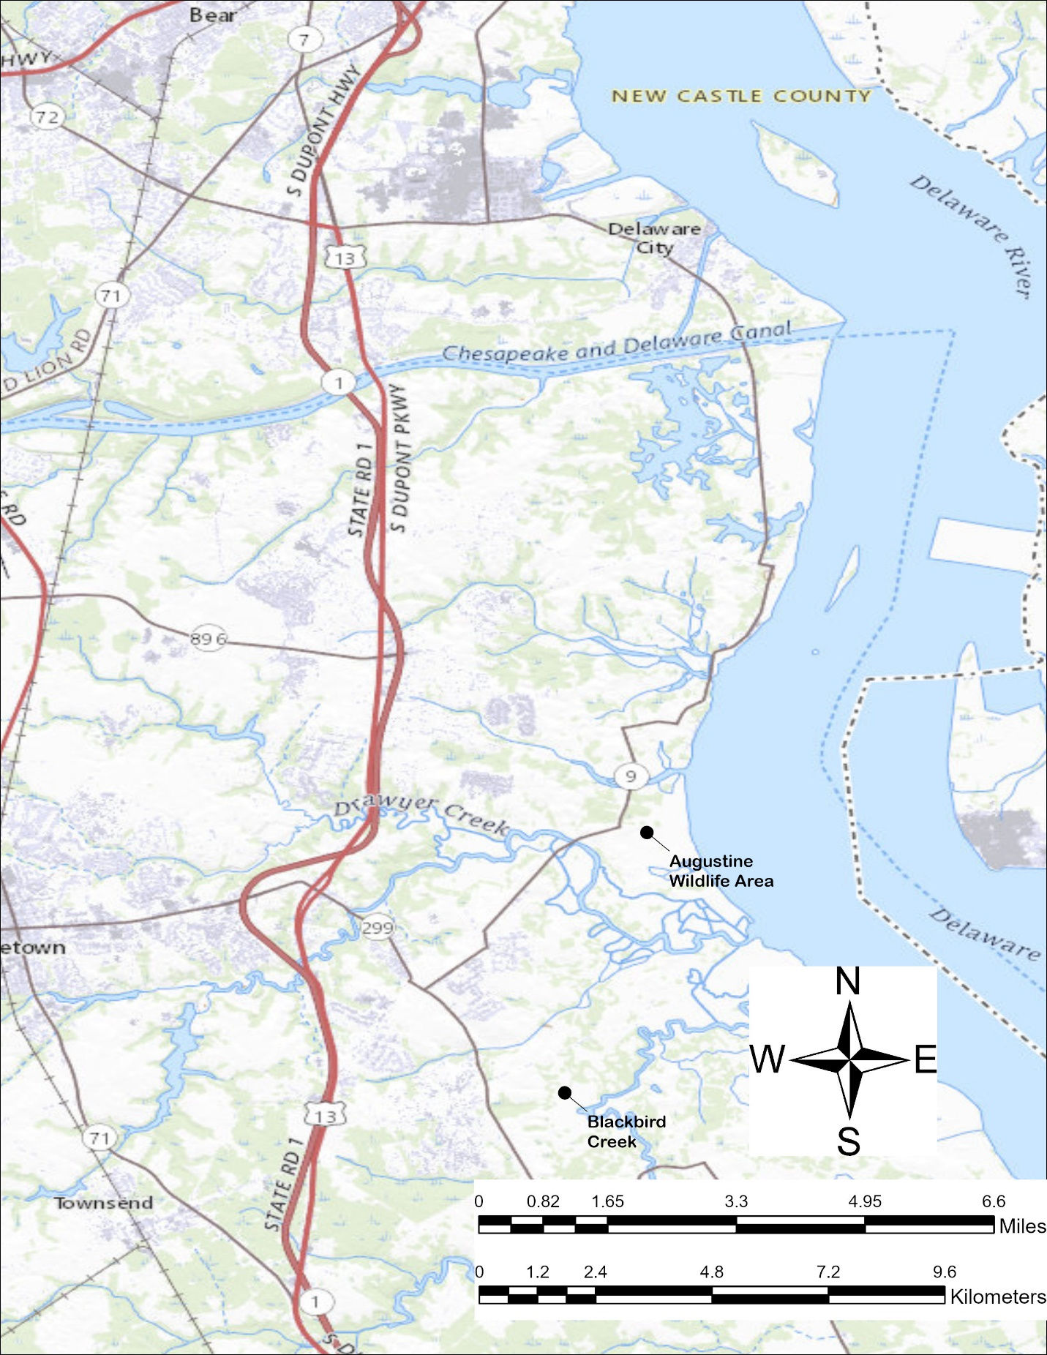
Figure 5. Blackbird Creek National Estuarine Research Reserve and Augustine State Wildlife Management areas.

