Attention Grazers
Refuge Seeks Agricultural Producers for Cooperative Agriculture Program
The U.S. Fish and Wildlife Service (Service) is seeking an agricultural producer (Cooperator) for a Cooperative Agriculture Agreement at Grays Lake National Wildlife Refuge (Refuge) in Wayan, Idaho. The producer will graze on the refuge for a period of three years as a Cooperator with the Service.
Applicants must fill out applicable portions of FWS Form 3-1383-C and FWS Form 3-1384. The applicants must address in their application how the applicant will meet the criteria outlined in the announcement.
Background
Grays Lake NWR was established in 1965 under the authority of a Memorandum of Understanding with the Bureau of Indian Affairs (BIA) and Refuge Use and Cooperative Agreements with 22 ranchers that owned property adjacent to Grays Lake. The current approved refuge boundary was established in 1972 by the Migratory Bird Conservation Commission. The refuge’s purposes are broadly stated as the conservation of native birds and other wildlife and to further the purposes of the Migratory Bird Treaty Act. Specifically, the purposes for Grays Lake NWR mentions providing quality habitats for sandhill cranes, Canada geese, and ducks.
The 20,000-acre Grays Lake (which is actually a large, shallow marsh) is the core of the Refuge. There are areas of open water at the south and north end of Grays Lake, with scattered small ponds throughout the marsh. Although the federal government manages the majority of the 13,000-acre lakebed, water levels are currently managed according to a 1964 agreement between the Service and the Bureau of Indian Affairs (BIA) and the 1990 Fort Hall Indian Water Rights Agreement. Because of shallow water and BIA’s consistent water draw down schedule, much of the marsh is dominated by hardstem bulrush with some cattails and other emergent aquatic plants.

In addition, the Refuge manages about 5,800 acres of upland grasslands; wet meadows; and temporary, seasonal, and semi-permanent wetlands. Grazing and prescribed fire are two tools used to manage grasslands and wet meadows to modify habitat structure, in order to improve habitat conditions for wildlife species dependent upon short-grass meadow conditions.
Our goal is to protect, maintain, and enhance 2,600 acres of managed short-grass meadow habitat to provide nesting, feeding, and stopover habitat for the benefit of greater sandhill cranes, American avocet, cinnamon teal, white-faced ibis, long-billed curlew, Canada geese, grasshopper sparrow, and other meadow-dependent wildlife. The purpose of using grazing as a management tool is to improve upland and meadow complex habitat conditions at Grays Lake NWR to meet the life history requirements for a variety of wildlife species which are a management focus for the Refuge, while maintaining healthy plant communities.
In order to achieve the desired short-grass habitat conditions on these 2,600 acres, the Refuge proposes to implement the following management actions:

During the 2026 grazing season, graze Parcels 8 thru 11 with a grazing intensity (AUMs) that will fall within the CAA Supplemental Information Sheet. AUMs will be adjusted to achieve habitat objectives.
The Cooperative Agriculture Program has been deemed an appropriate, compatible use and has undergone an Environmental Assessment. These plans provide guidance to employ grazing as a habitat management tool on the Refuge, which may be used to meet resource management objectives on units of the National Wildlife Refuge System, consistent with the Service’s Biological Integrity, Diversity, and Environmental Health policy. The Refuge is administered by the U.S. Fish and Wildlife Service within the Department of the Interior.
The Proposed Cooperative Agriculture Agreement
The selected Cooperator will enter into a Cooperative Agricultural Agreement (CAA) with the Refuge, which will include a Plan of Operations that defines the process by which the grazing program will be administered and further delineates the requirements and restrictions of the Cooperator. The Cooperator will work with the Refuge staff on a future 3-year agreement. At the end of each year, pasture use and condition will be assessed, and changes may be incorporated into the following year’s rotation.
General Operating Requirements:
- Grazing plans may be altered through consensus by both the Deputy Project Leader and Cooperator throughout the grazing season.
- The Cooperator shall provide all necessary work, maintenance, and equipment to keep cattle within their assigned grazing units.
- Use of insecticides including applicators, sprays, dust bags, etc., will not be permitted on the Refuge. Insecticide-treated ear tags will be permitted if implanted before cattle are delivered to the Refuge.
- All liability relating to grazing and pasture management to include all persons working for the Cooperator, whether related, hired, or as a partner is strictly that of the Cooperator as listed on the CAA.
- The Cooperator must have or acquire liability insurance that covers the equipment used on Service lands. A copy of the liability insurance must be provided to the Deputy Project Leader (or designee).
- All equipment for grazing, including tractors, trucks, ATVs, and UTVs, must be clean and free of invasive species plant material including seeds before entering any Refuge or Service easement. The Deputy Project Leader (or designee) reserves the right to inspect and deny the use of any equipment/vehicle/horse etc. that appears to contain invasive species plant material or seeds. Equipment must meet all safety regulations and must be in good working condition.
- Grazing privileges may not be sold, transferred, or sublet, except by transfer to heirs in the event of the death of the Cooperator.
- Non-use of grazing parcels, in whole or in part, shall be cause for cancellation of a Cooperator's privileges at the discretion of the Deputy Project Leader unless non-use has previously been approved.
- A three-year plan for grazing rotations and annual work plans will be developed by the Deputy Project Leader and the Cooperator prior to the period of operations.
Cooperator Selection
The producer(s) will be selected through an open and competitive process where applications will be scored and ranked by Refuge Complex staff using the following criteria:
- Experience in pasture management and grazing, especially personal experience on NWRS lands or comparable conservation lands, including knowledge of wet meadows.
- Ownership or access to the proper equipment, desired amount of cattle, or other resources to participate in the Cooperative Agriculture Agreement (equipment and personnel).
- Proximity of personnel to monitor cattle and respond to escaped cattle or pasture issues.
- Positive references regarding past performance, experience, and abilities related to prescribed grazing in government natural resource programs.

Parcels Available
Parcels 9 thru 10 are available to bid on:
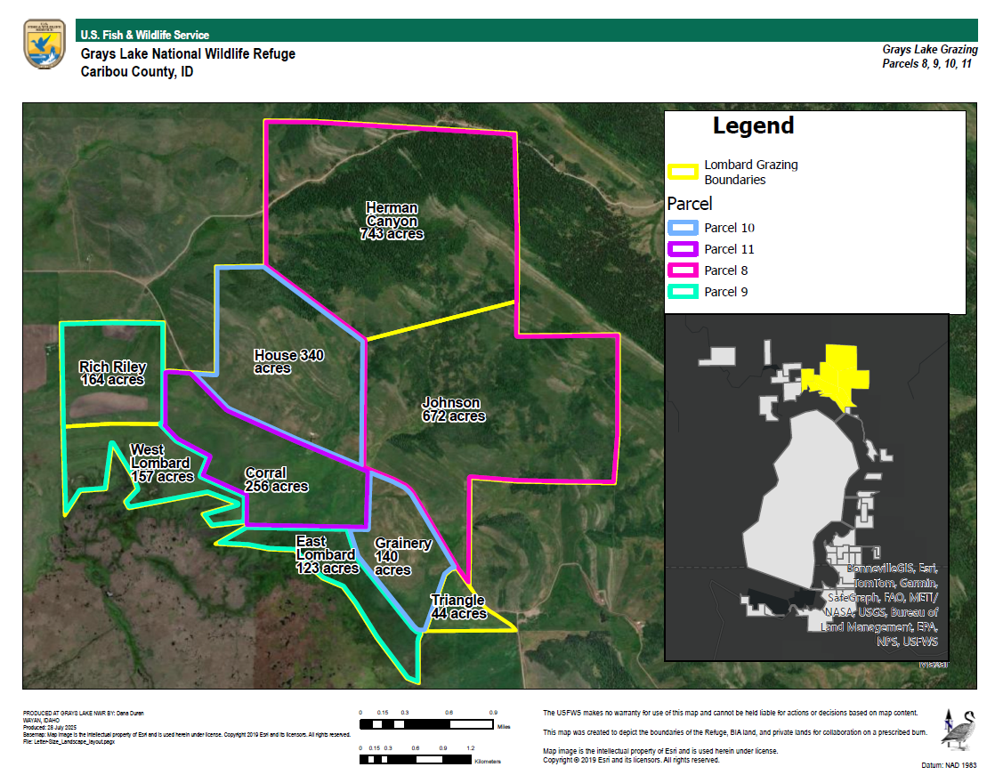

Applications
To apply, complete application package; including FWS Form 3-1383-C and FWS Form 3-1384 (https://www.fws.gov/service/agriculture or https://www.fws.gov/refuge/grays-lake). Hard copies can be requested by emailing Jeremy Trimpey (Deputy Project Leader) at jeremy_trimpey@fws.gov. Mail completed applications to Southeast Idaho NWR Complex, Grays Lake NWR, Cooperative Agriculture Proposal, 4350 South Cliffs Drive, Pocatello, ID 83204.
The Cooperator will be selected through an open and competitive process where applications will be scored and ranked by a panel of Refuge Complex staff.
Proposals will only be accepted between now and December 31, 2025. Proposal envelopes must be received in the office by December 31, 2026 at 5:00 pm. All proposals will be opened on January 15, 2026. The individual with the highest ranked proposal will be notified within 3 weeks of their selection.

